**WESTBURN PARISH  
 MAGAZINE**

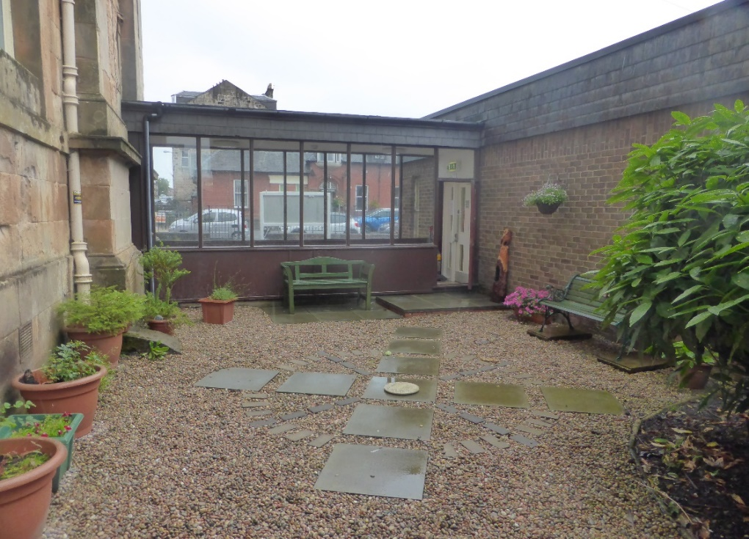

**AUTUMN 2018**



“ **WORSHIP,FRIENDSHIP, ACTION – a kirk that cares. “**

**Welcome to the Autumn Magazine 2018**

With the lovely summer we had let’s hope everyone had an enjoyable and restful time, whether at home or away. There were lots of happy comments as we enjoyed those many lovely sunny days. “ Who needs to go away with weather and scenery like this!” and “ We are having a BBQ , again to-night“

Certainly sunny Greenock was enjoyed by many.

The Cruise ship visitors enjoyed visiting Westburn again this year, enjoying our history and the sanctuary was well admired. Thanks to all those who volunteered.

Convenors and Leaders of committees and organisations have been working hard to prepare our winter activities. Worship, Social Events, Guild Syllabus, Organisations acivities. There are lots going on in Westburn, check it out and enjoy friendship and fellowship, a warm welcome awaits you.

We are delighted to have our Trainee Minister, William Boyle with us, He introduced himself in the last magazine, and we look forward to his input in this one. William has been getting to know some of the congregation and looks forward to meeting many more..

Brian Lindsay from the Communications Committee produces the magazine and appreciates your input helping to make the magazine interesting, please keep this up.

1

**FROM THE MANSE**

Dear Friends

What’s your favourite kind of dancing ? Ballroom, disco, Scottish Country, ballet, tap, ceilidh ? Many kinds of dancing involve not just one partner but two partners or a group or dancers forming a set. When dancing we have to work with others, look out for others, rely on others, complement each other, sometimes move together, sometimes move away from each other, sometimes synchronize our moves, sometimes have individual moves which contribute to the whole picture.

In many ways the image of dancing is a good image for the life of the church and the different partnerships that involves. Henri Nouwen , when talking about people working together, says it requires closeness as well as distance “ It is like dancing, sometimes we are very close, touching or holding each other; sometimes we move away from each other and let the space between us become an area where we can freely move . “

Partnerships are central in our lives : we are in partnerships with colleagues, friends, siblings, in church and some of us in marriage. The bible speaks of a covenant relationship and partnership between God and God’s people. “This is the covenant that I will make….declares the Lord. I will put my laws in their minds and write them on their hearts. I will be their God and they will be my people.”( Jeremiah 31 ) At the beginning of his letter to the Philippians, Paul prays with joy for the partnership between him and the church in proclaiming the gospel.

God calls us to live in community , to work in partnership, sharing and living out God’s love. WE live in an individualistic world and from that an unhelpful theology grows that being a disciple is about ‘Jesus and me ‘ when it should be more about ‘Jesus and us’ . We are created to be together, work together. Partnerships can be joyful, creative, life giving, a true sign of God’s kingdom. We can mutually play to each other’s gifts, rejoice and learn from them and discover that we have blind spots which require the vision, wisdom and generosity of others. In partnerships we learn to say sorry, to listen to different perspectives, to put our own agendas aside for the bigger purpose.

Mother Theresa said “ I can do things you cannot, you can do things I cannot; together we can do great things. “

Let us join in the dancing

Yours

Karen Harbison

2

**A DAY TO REMEMBER**

On Thursday 5th of July after four years at University, i officially graduated with a BA honours in Theological Studies from Highland Theological College which is part of the University of the Highlands and Islands. I studied as a distance learner, logging in to class firstly from home and then from HTC’s new campus at the Wynd Centre in Paisley.

Before the ceremony began a meal was prepared for all the students and our families at the college. This was a great example of gathering round the table together, praying with each other and supporting each other before the big event, as we were all very nervous. I had actually felt quite calm about the event up until a few weeks before when the university had informed us all that the Chancellor would be presenting us with our certificates. The Chancellor being H.R.H the Princess Royal.

After the meal was over, it was time to pose for our official photographs and to try on our gowns and academic hoods. The staff and students were excellent, and our student support officer was on hand if we needed to talk or pray with her before the event began. The support I have received throughout has been amazing. Although I was a distance learner, I in no way felt distant from the fellowship, support and prayer that was provided at HTC.

Before processing over to Dingwall Free Church where the graduation was held, we all stood on the large stair case at the college and had a very special photograph taken with each other and the Princess Royal. We then processed across the street as locals from Dingwall stood at either side clapping as we entered the church. I haven’t worked out yet if the applause was for us or the Princess Royal.

The ceremony began with a church service, we sang, prayed and listened to scripture and a powerful sermon. Then, the lecturer invited each student up individually and he said a bit about who we were, where we were from and something about our background, for example work life and family. We were then capped by the Principal of UHI and turned to receive our certificates from the Princess Royal. Despite already hearing about our backgrounds, she stood and chatted with every single student and took a real interest in what she heard and asked questions. She really did make you feel at ease and then wished each of us the very best for the future. It was an amazing moment, but due to nerves also a complete blur.

3

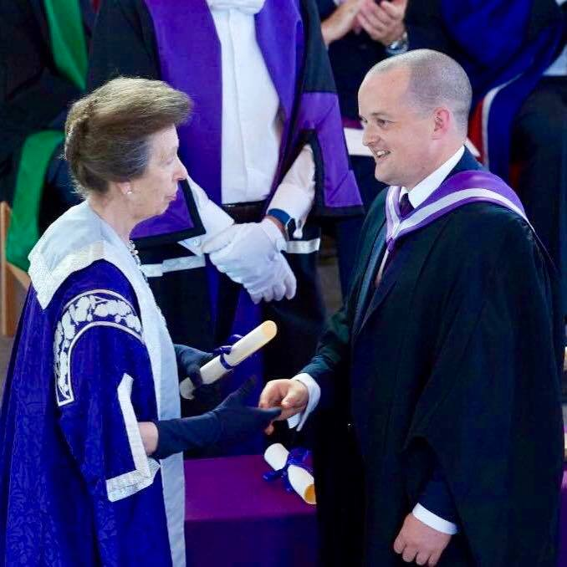

The day ended again with time together round the table, enjoying tea, coffee and of course cake, reflecting on the day with each other and our families. It truly was a memorable and special day. Despite being a distance learner I always felt supported and encouraged and this was helped by how important gathering together as a group round the table had become with a real focus on meeting up for meals and fellowship, gathering round the table with strangers who I had only ever seen on a screen who then became close friends who supported each other through this important part of our lives.

That theme of gathering round the table is so prominent in the Bible. In the book of Ruth, Boaz sat around the table with his workers, inviting an unknown Moabite woman to eat of his bread. In Psalms David celebrated God’s banquet table. And in the New Testament, Jesus gathered around tables with friends and sinners, and then he instituted his memorial supper around over the Passover meal as he and his disciples ate. Hospitality, fellowship and feasting are hallmarks of our Christian faith. Yet in our busy culture, we often only ever use the table for birthdays and Christmas or use it for office space. By gathering round the table with friends, family or the stranger there is huge benefits as I found out for myself from my time at Highland Theological College. Who will you invite to join you at your table this week?

God Bless - William Boyle

4

**STEWARDSHIP AND FINANCE**



This autumn we are having a Stewardship campaign. On the four Sundays between 16 September and 7 October we will be looking at Stewardship themes.

Along with this magazine all members will have received an invitation to our Stewardship Gathering on Sunday 30 September. There will be a light lunch after the service and a chance to see what happens in the life of our congregation.

We would like to thank you for your contributions towards the work of the congregation and invite you to take this opportunity to review your givings.

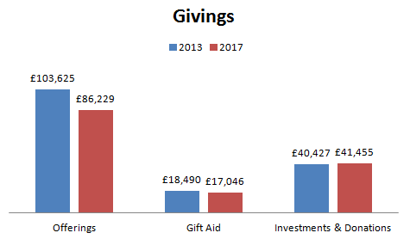

5

**BOWLING NIGHT**

Saturday25th August saw our return to Ardgowan Bowling club for our Bowling /Quiz and Supper evening,

Once again we were lucky with weather wise the sun shone and the midges stayed away.

Our numbers were up again and fifty + members of all ages and friends enjoyed the evenings fellowship and fun.

Our thanks for your support year by year and especially all our helpers who made the night such a success.

The Fellowship Committee.

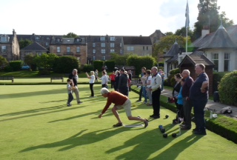

6

**CHURCH OUTING 12 AUGUST 2018**

On a rather wet and dreary day we headed to Lomond Shores for our annual Church Outing. We arrived just in time to see the final of the Gents 25K swim on Loch Lomond in the Euro Championships final day.

We split into several groups and some of us had a stand up Picnic as can be seen from the photograph. Others went to other areas to have their lunch.

William and some of the boys and parents went for a game of crazy golf as at this time the rain had eased off a little.

Others went for some retail therapy.

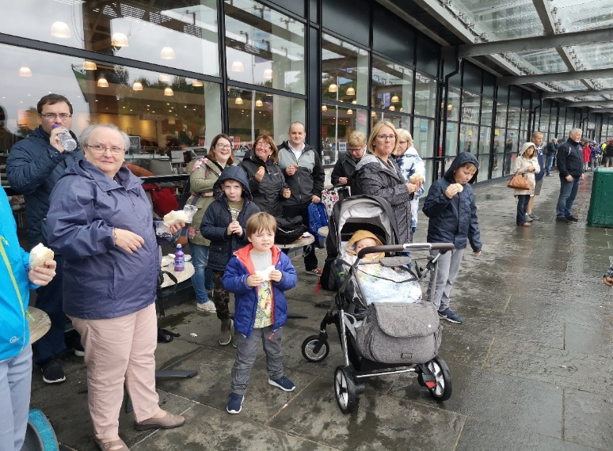

Despite the weather all had a good time. A big thanks to Lynne for organising the day.

**NEWS FROM PRESBYTERY**

Safeguarding training officers for presbytery have now been appointed (Mrs Gail Abraham and Mrs Anne Craig). Presbytery commends use of the Prayer 24-7 website [www.24-7prayer.co.uk](http://www.24-7prayer.co.uk)

A worship leaders’ training course will take place at the Cornerstone, Bishopton from 30th September to 4th November. Congregations are encouraged to be involved in this.

7

Presbytery commends the 2018 World Mission stamp appeal, which will support day centres run by the Reformed churches in Transcarpathia, Ukraine. These centres provide support for young people with disabilities. Stamps can be handed in to the Presbytery of Glasgow office at Renfield St. Stephen’s Church. I mention this in case it might be a potential beneficiary of our own ongoing stamp appeal.

The World Mission and Ecumenical relations Committee commends to congregations an order of service for an ecumenical prayer vigil designed to take place across the globe on 24th of every month. The specific purpose of this vigil service is to promote peace in the Middle East. The material for worship is available in the resources section of the presbytery website.

Our former locum and interim moderator, Rev Morris Coull, now minister at St Margaret’s Parish Church, will retire in October.

Coming up: presbytery will be arranging local meetings to discuss the projected imminent acute shortage of ministers. This is a matter of concern and importance. It will affect how our church evolves and develops in order to deliver its message and be effective in coming times. We should all be ready to be involved in these discussions, and to think about how our church will continue its mission in our world.

Douglas Scot

**TIME FOR PRAYER**

As Christians we have hope and faith that the Holy Spirit can transform and invigorate our lives. Let us pray.

In our world there is much sorrow, and many people weep: we pray for the spirit of joy.

In our world there is much jealousy, and many people think only of themselves: we pray for the spirit of solidarity.

In our world there are many lies, and many people who deceive, malign and slander others: we pray for the spirit of truth.

In our world there is much hatred, strife and war: we pray for the spirit of peace.

In our world there are many who fear and despair: we pray for the spirit of hope.

In our world there are many who are bewildered and bedazzled: we pray for the spirit of faith. Amen.

Douglas Scott

8

**UPDATE ON VENDA**

Vhutshilo Mountain School continues to thrive and move forward under the guidance of Khatu,  who worked closely with Susie for many years. She keeps in touch on  a regular basis to let us know how things are progressing in Venda.

Her recent report talks about an additional room which was being added to the school,  which is now almost completed. This new building will allow the school to help support youths who are HIV+ but are too old to attend the school and will give the space to do this without any disruption to the pre school children.

Khatu also plans to rent the room for events at the weekends, which will help provide a source of income for the school.

On 17th March, the school hosted a support group for 38 young teenagers,  living with HIV/AIDS. The aim of this was to encourage and promote the importance of taking their medication and positive living.They were also taught skills to help with their self confidence. Khatu states that she found the experience of being involved in this " very  humbling "

The pre school class now has 63 children.

The 20 children in the grade R class are all doing well-gaining in confidence and most are able to read and write.The little ones are also developing well, with almost everyone in this group able to write their name ( even if some still write their alphabet upside down)There are a few children with additional challenges and they are being given the extra support they require.

The 15 babies are also developing well and out of the 15, only 2 are still wearing nappies  - quite an achievement!  The babies enjoy reciting rhymes.

Khatu would once again like to acknowledge the continued support from the Church of Scotland and in particular Westburn Church  and Wellpark Midkirk Church in Greenock and St. John's Church in Gourock. Thank you all very much, your support is invaluable to the running of the school.

Susie continues to fight her own battle with illness. She is at present undergoing treatment in hospital in Johannesburg and Khatu asks that you all remember her in your prayers.

9

**BIBLE STUDY**

The Discipleship Committee is arranging a short series of meetings for bible study. These meetings will be led by our assistant minister, William Boyle.

The meetings will take place at 12.00 noon, from Wednesday 12th September until Wednesday 17th October. We will meet in the new Gathering Place, and at the first meeting we will have an informal get together, and find out about the themes to be explored in subsequent weeks.

ALL WELCOME. AND YOU CAN BRING A FRIEND.

Douglas Scott

**PASTORAL CARE COMMITTEE**

1. The Committee met on Wednesday, 15th August 2018 and will meet again on Wednesday, 17th October 2018. The Committee has 2 new Members Monica McNeil and Cathy Thompson and also welcomed William Boyd to our meetings.
2. **District 22 –** the Committee regularly visitour Members who are in nursing or care homes stretching from Bagatelle Nursing Home, Balclutha Nursing Home, Alt-na-Craig, Bellaire Nursing Home, Glenfield Nursing Home and Larkfield View. The visits can be hard, but all are rewarding, although a small bar of chocolate does help on occasions.  
   In addition, Karen, our Minister is also visiting Members in hospital and at home.
3. **Annual June Outing** – was held on Monday, 18th June 2018. It was all change this year with buses hired to take our Members on a trip to Largs and the time was changed to an afternoon. We had 26 Members including 7 escorts on the rip to Largs and then 3 other Members joined for a beautiful afternoon tea in the Church Hall. The day was voted a success and the Members are looking forward to next year’s event. A big thank you to all who helped make the day a success.
4. **Harvest Thanksgiving** – is on Sunday, 16th September 2018, when the Congregation will be invited to put a monetary gift in an envelope marked “South Africa” during the offering. There will be an opportunity to donate up to and including Communion on Sunday, 7th October. The money will go to Venda, Cotlands and Sunshine Centre.
5. **October Communion Afternoon Service** – Sunday, 7th October 2018 in the Lounge at 3.00pm. If you wish transport to and from Church in the afternoon, can you contact your Elder or any member of the Pastoral Care Committee.

Bill Dempster

10

**GUILD REPORT FOR MAGAZINE**

Although the Guild finished at the end of March, as in past years a number of us have been meeting fortnightly to “knit and natter”. The new session starts on October 2nd with our ‘at home meeting@ where we catch up with what has been happening over the summer months.

The Guild theme for 2018-2021 is “One Journey Many Roads”. We have been putting our programme together for 2018-2019 and hope that it will appeal to members old and new. Feel free to come along and join us.

The Projects for the next three years are;

Crossreach -- Join up the dots

World Mission Council - Journeying Together Empowering Teenage Mothers in Zambia

Sailors’ Society -- A Chaplain for our Ports

Three Free To Live Trust’s (FTLT) -- Seema’s Project

Malawi Fruits -- Growing the future

The Boy’s Brigade -- Faith in Young People

Date for your Diary -- Annual Coffee Morning 17th. November. Your support for this is always appreciated.

**Guild Programme 2018-08-24**

October 2nd At Home

October 9th. Opening Evening

October 16th. Watch this space

October 23rd. Autumn Rally – Wellpark Mid Kirk at 2pm. Speaker Jack McHugh

October 30th. Slow Boat to China

November 6th. Forensic Science - Ewart Orr

November 13th. Project

November 17th. Coffee Morning

November 20th. Chocolate Factory

November 27th. Disbursement of Funds

December 4th. Christmas Celebrations at St. John’s Gourock at 2pm.

December 11th. Afternoon Tea (in house)

Anna Seggie

**NATIONAL COUNCIL REPORT SEPTEMBER 2018**

I’ve been very busy the last few weeks and for the forthcoming weeks so my apologies for not submitting a full report. Hopefully I’ll be able to do so for the next magazine.

Since the last magazine I’ve attended the Ecumenical Forum for Christian Women (EFECW) in Serbia, the National Youth Assembly (NYA) at Gartmore House, Stirlingshire and I’m preparing for the Guild Annual Gathering in Dundee on the 1st September. The

speakers for the event are the Right Rev Susan Brown, Moderator of the General Assembly, Tamsin Dingwall, Moderator of the NYA. We will also hear from representatives of the 6 new projects. For the first time in the history of the Annual Meeting of the Guild we will be celebrating Communion in the form of an Agape Meal.

I will report on all these events plus others which I’ll have attended by the next magazine.

Patricia Robertson

**SAFEGARDING REPORT SEPTEMBER 2018**

We met at the beginning of the summer holidays and reviewed the register of those with PVG certificates who are currently working with different groups in our church. We updated our register to reflect those who have ceased to be part of our groups. We are now required to notify the Safeguarding Service of the Church of Scotland when people cease to do regulated work within the church.

New trainers, Gail Abraham and Anne Craig, have been appointed by Presbytery and they will begin offering training courses for volunteers this autumn. The first dates have been advertised and are as follows:

Sunday 30th September 2018 in Paisley Stow Brae Church 2pm - 4.30pm

Sunday 7th October 2018 in Johnstone St Paul's 2pm - 4.30pm

Sunday 4th November 2018 in Paisley Stow Brae 2pm - 4.30pm.

Anyone wishing to attend, please contact us as seen as possible as numbers are limited to 25 per event at present. Priority will be given to new volunteers who have not yet attended training.

Safeguarding Panel: we are required to have a Safeguarding Panel to support our work. We are reviewing the membership and are looking at new names for people to join the panel. We will update the Kirk Session once this has been completed.

Two new members have joined the Pastoral Care Committee to help with visiting. PVG forms have been completed and we are expecting their clearance imminently. With Kirk Session approval their names will be entered into the Congregational PVG Register.

If you need any advice or help on Safeguarding please contact us:

Jennifer Boag - Tel: 01475 720125 e-mail: jenniferboag@hotmail.com

Sheila Tait - Tel: 0748 418 2757 e-mail: sheilatait172@btinternet.com

Jennifer Boag and Sheila Tait

Safeguarding Co-ordinator

12

[](https://www.google.co.uk/url?sa=i&rct=j&q=&esrc=s&source=images&cd=&cad=rja&uact=8&ved=2ahUKEwjEhPKqnITdAhUB-YUKHSmLDXgQjRx6BAgBEAU&url=http://www.netherleechurch.org/campaigns/&psig=AOvVaw2UBaxx5t5VY7ySzEFWmzsc&ust=1535149670437175)

**Coffee Morning**

**in Westburn Parish Church Hall**

**Saturday, 22nd September 2018**

**10am – 12 noon**

**Tickets £2.50**

**Craft stall, home baking stall and more.**

**[](https://www.google.co.uk/url?sa=i&rct=j&q=&esrc=s&source=images&cd=&cad=rja&uact=8&ved=2ahUKEwiGi9qrnYTdAhVHQRoKHbZbBqYQjRx6BAgBEAU&url=https://www.pinterest.co.uk/pin/27021666488705720/&psig=AOvVaw2ejH3vPIu_NHJPtjKvggxa&ust=1535149934650252)**

**Donations of home baking gratefully received.**

**Please contact Simon Hutton (Community Links Committee)** [**simonhutton2007@googlemail.com**](mailto:simonhutton2007@googlemail.com) **or 07513 838 590**

**13**

**BEAVER , CUB AND SCOUT REPORT**

**All sections started back on the week of the 20th. August. From the 6th. Of September All sections will meet on a Thursday Night as follows;**

**Beavers Thursday   6pm. – 7pm.**

**Cubs       Thursday   7pm -   8pm.**

**Scouts    Thursday   8pm-   10pm.**

**This allows all the leaders to meet on a Thursday.**

**Scouts enjoyed a very successful Summer Camp at Hesley Wood Scout Activity Centre near Sheffield participating water activities , hiking , climbing and much more.**

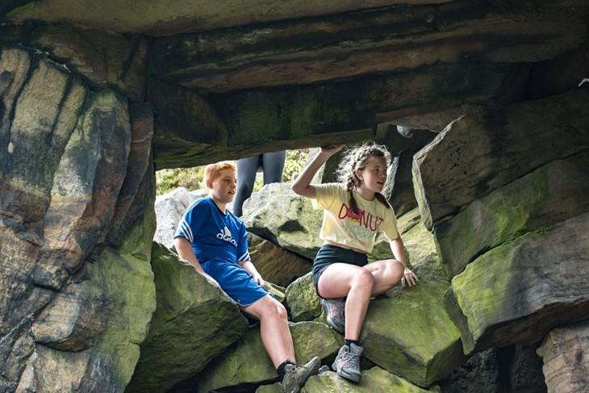

**We currently require a new Beaver scout leader . Matt our previous leader has moved on to take up a job in Japan Any help would be much appreciated**

**Campbell Cairns**

14