

WELCOME to the Christmas magazine. Yes it is far too early to be sending the Christmas message – OR IS IT ? Those of us who are very well organised will already be well ahead with their preparations. Cards bought, some presents selected and maybe even wrapped ! Children already counting the days to Christmas and the media and shops reminding us of the number of shopping days to go. One of my friends finding some unplanned time in October baked her Christmas cake and Christmas pies, now that is what you call being organised! In our Christian Calendar it is not too early as we take time to journey to Christmas through Advent, celebrating Hope, Joy, Peace and Love ensuring that we are well prepared to celebrate The birth of our Lord.

Once again we report in the magazine, renovations in the sanctuary, there are also details of our worship for November and December which will be in Lyle Kirk’s Esplanade building, details in the Minister’s letter and a worship calendar at the end of the magazine.

The Communication Committee wish you all a Happy and Peaceful Christmas Season.

Material for the next magazine is due by last week in January 2012 either to
Joe Craig or Cath Barbour at cathbarbour@btconnect.com
© 2007



The Manse
October 2011

Dear Friends,
This magazine comes to you as we begin the build up once again towards Christmas. It is hard to believe that we are at that stage of the year already and with such a poor summer and wet autumn it feels as if it is going to be a long winter. However we should not let that get us down for there is plenty going on in the Church at the moment to keep our minds occupied.

I cannot write without mention of the sanctuary ceiling. At long last after some detailed negotiations with the General Trustees in Edinburgh the work has begun. It is going to be a slow process as the plasterer cleans out the debris lying above the ceiling and then repairs the plasterwork. This all has to be completed prior to re-decoration. It was my hope that we would be back in the sanctuary long before Christmas but this seems a forlorn hope, - in fact I know it won’t happen. Meanwhile we continue to worship in the hall which has some advantage. I do like the gathering space in the centre vestibule where people meet and chat, both before and after worship. In fact some Sundays it is difficult to get people to move into the hall in time for the worship to begin. Within the hall itself there is a friendly atmosphere as people sit closer together and sit with members that they would not normally sit beside or talk to on a Sunday morning. Such was the level of conversation that I have asked people to hold the chat until after the Bible has been removed from the hall. Worship begins when we open the word of God as the Beadle brings the Bible into the Church and ends when we take that word out into the world.

Having said all that, I still miss worship in the sanctuary and to that end the Kirk Session have asked the Kirk Session of Lyle Community Kirk for the use of one of the empty sanctuaries from 6th November till the end of the year. We are grateful for their help and we will worship in the former Old West Kirk on the esplanade. They say that history repeats itself. In the 1850’2 the Old West Building was in need of repair and the congregation built a new church in Nelson Street. In 2011 we are in need of a temporary new home.

Elsewhere I have highlighted the Calendar for the rest of this year and hope that many of you will be able to come and share in worship. It was very kind of Greenock West United Reform Church to invite us to share with them in worship on the last Sunday in September and I hope that when we are back in our sanctuary that they may respond to an invitation to come and share with us.

It is hard to imagine that 5 years have passed since we united with St George’s North and we will mark that anniversary on communion Sunday 6th December. Again I hope that as many of you as possible will come and share in that worship as a thanksgiving for the past and a commitment towards the future.
One of the highlights in recent years has been the service for the Hospice Christmas Tree. Under the banner of Light up a Life we proclaim the good news that Jesus has come to dispel the darkness and to give us hope. Once again this year the service will be held in the church garden (weather permitting) on Sunday 27th November at 6.30pm.

On a similar theme of “lighting up a life” we are pleased once more to support Greenock Rotary in the Shoebox appeal. These gifts will go to families in Eastern Europe. We also support families nearer home in our gift service held on Sunday 11th December. The gifts from this will go to local health visitors to distribute among families in Inverclyde.

Amid all the doom and gloom of an economic downturn it is good that in small and simple ways we can still give to those in need. It may be some time till Christmas but I wish you God’s blessing through this time of preparation and waiting, and pray that we may respond to all that we have been given by giving of ourselves to God and to others.

Yours faithfully,

Bill
YOUTH WORKER

On Sunday 7th October we were able to welcome Emily Buck as the Youth Worker attached to our congregation for the next four years. Emily comes from Norwich and has begun a degree program at International Christian College in Glasgow. She will be with us for 20 hours a week on placement and two days a week at college. We look forward to her working with us and with her help we hope to build up the Youth Work which we do here in Westburn and in the wider community.


CHURCH NEWS BOOK

The Church News Book which recently has been in the centre vestibule will be in a suitable place when we worship in Lyle Kirk, if you have information for the minister and can’t locate the book, please speak to one of the duty team..

CHURCH DIARIES
The Church Diaries have arrived in good time this year, and will be available at Worship from mid November, the usual donation of 50p.applies.


Life and Work
Life and Work is available on the last Sunday of every month priced £1.60
Subscriptions available.

Please contact Shelagh Hendry Tele. 794667.
Delivery can be arranged if you are unable to get to church.

Greenock Westburn Church Web Site
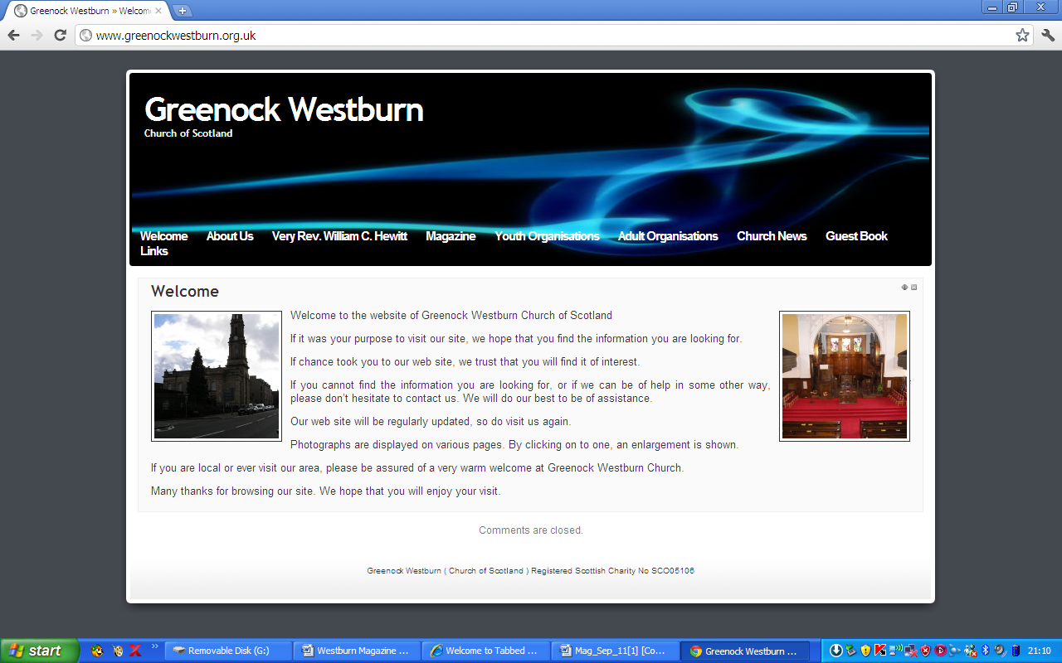
Have you put your syllabus, planned activities, or interesting comments about your organisation or group on your web page. If not it may look as though you’re not doing anything interesting. Have you looked at your page on the web, can you make it more interesting, add photographs, make comments, ask one of your members to write about what it is they enjoy about your group. Jim Bell will be happy to update your page.

A similar invitation is made to any church member who feels that they can assist in making the web site more interesting.

Our church web site can be found at - http://www.greenockwestburn.org.uk/ Please visit it and view it's contents.

Further information can obtained from Jim Bell ( 01475 799381 or all.the.bells@ntlworld.com )

Find us on FACEBOOK

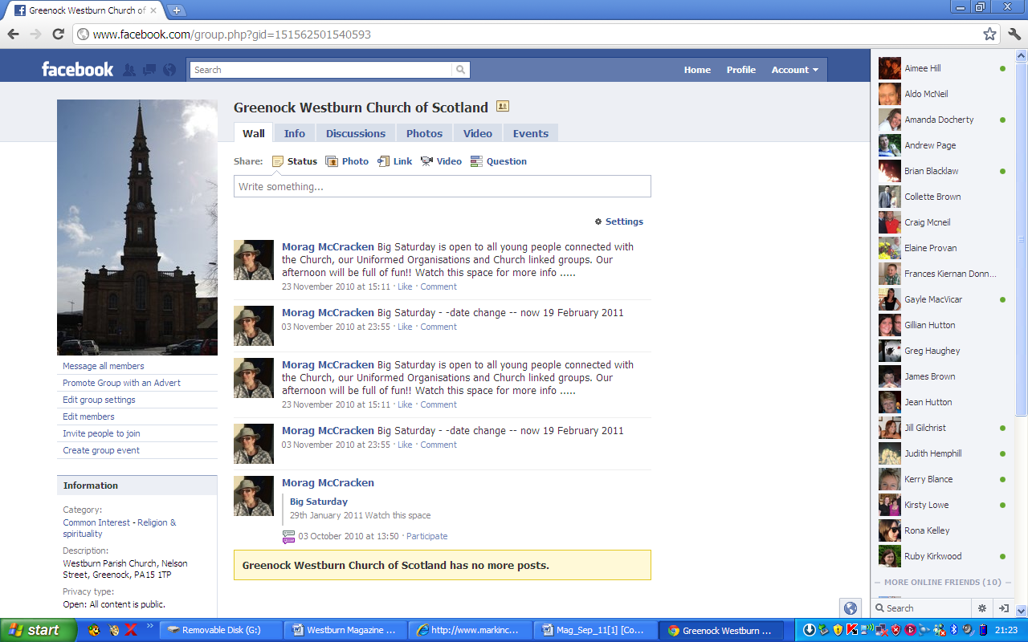
Search on FACEBOOK for “Greenock Westburn Church of Scotland” and join the social media revioution.

Pastoral Care Committee

- Harvest Thanksgiving – approximately 120 plants were distributed to Members of the Congregation after the Service on Sunday, 9th October 2011. Many thanks to the Members who distributed the plants.

- The Members of the Pastoral Care Committee continue to visit those Members who are in Nursing Homes or housebound.
- December Communion - Sunday, 4th December 2011, please note that there will be an afternoon service in the Old West Church at 3.00pm.
- The date of our next meeting is on Monday, 12th December 2011 at 2.30pm in the lounge. If any Member of the Congregation would like to attend, they will be made most welcome.

Bill Dempster

Weekly Freewill Offering

Along with the magazine, members, who contribute through The Weekly Freewill Offering Scheme, should have received their new set of envelopes for 2012. If you do not receive your envelopes , please contact me as soon a possible at Tel:- 720554

It would be helpful if you have your WFO number at hand. If any member of the congragation wishes to join the scheme, or if there any other problems, please contact me either directly at above number or through your District Elder.

John H Munro
WFO Treasurer.
REPORT OF PRESBYTERY OF GREENOCK AND PAISLEY
AUTUMN 2011

Paisley Christian Social Action Centre Homelessness Project

This Project has been set up using the funds derived from the sale of the former Paisley Christian Action Centre. This was a charity set up " to relieve the poverty and promote the welfare of homeless persons in the Paisley area. "
This new Project has established a Draft Agreement among the following partners

Presbytery of Greenock and Paisley Unity Enterprise
Scottish churches Housing Action Renfrewshire District Council

The overall aims of the Project are : - a. to support homeless people b. to assist in tenancy sustainment. c. setting up a mentoring programme. d. involving local churches. e. developing a volunteer data base.

The service will be accessed from case workers to Unity. When acquiring a new home tenants will be expected to be involved in the process by attaining some basic training in home decoration and maintenance.
Unity will work with SCHA to identify volunteers within the churches to be part of a mentoring service for young people. Volunteers will be Disclosure checked and take part in full induction before working with service users.
A partnership with Reid Kerr College is envisaged to identify education courses , work experience etc.

The desired outcome for this service is to give the service users a sense of achievement, self worth and being valued as a citizen within their community.

NOTE : If you know of anyone with a church connection looking for experience as a way back to work or someone newly retired looking to be involved in community outreach this very professional service would suit them.

It is based within the Renfrewshire area but how many of us think nothing of going to Braehead, Silverburn Azda etc !

NOTICES :- Rev Stuart Steell, Renfrew Trinity Kirk, was installed as the new Moderator. Rev Dr Peter McEnhill was appointed Clerk to the Presbytery of Greenock and Paisley.
Kirk Sessions are reminded of their responsibilities with regard to Safeguarding.

Safeguarding Training Dates :
Old Gourck and Ashton- 26.11.11- for volunteers 10-lpm
St. Ninian's Paisley 29.11.11 -for coordinators 10-4pm

The congregations of Inverkip and Skelmorlie&Wemyss agreed to a Basis of Linkage.

Margaret Crawford
Presbytery Elder

CHURCH FLOWERS

Another year is coming to an end and we have enjoyed beautiful floral displays in the Sanctuary and recently in the hall Sunday by Sunday.We would like to take this opportunity to thank all those responsible, the donors, flower arrangers and those who deliver to our members. There will be a note in the Order of Service when and where the Flower Calendar for 2012 will be available.

Patricia Robertson and Linda Murray ( Flower Convenors )

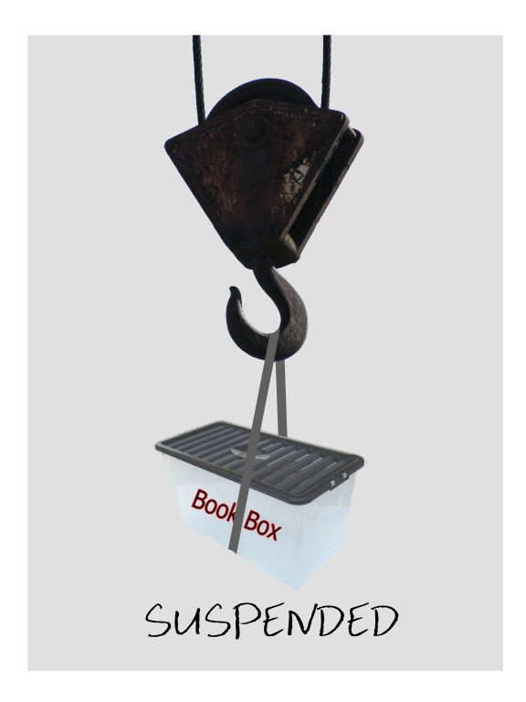
Church Library

Its great to see that many of you are enjoying the books in the church library. Thanks you for your support and for the comments you have made about the books.

Because we're going to be worshipping elsewhere for a few months, its been decided to suspend the Book Box service until we're back in the Westburn building.
But don’t panic !

. If you already have a book out and haven’t finished it – then just keep it till we’re back in the building!
. If you really want to return a book then hand itr to a member of the Adult Education Committee.
. If you are a slow reader – now’s the time to take a book – you’ve got a while to read it!

But don't panic!

If you already have a book out and haven't finished it - then just keep it until we're back in our own building!
If you really want to return a book, then hand it to a member of the Adult Education Committee.
If you are a slow reader - now's the time to take a book - you've got a while to read it!

Thanks for your patience.

Thank you for your patience
Adult Education Committee

We see our mission as serving God and serving the congregation of this church and to that end, we've decided that we'd like to know what you want us to provide for you!

In the past we've held various bible study evenings, a prayer event, organised a church library, given you the chance to look at bible study notes, and other bits and pieces.

BUT
What do you want?

We'd like your suggestions about what we should be doing.

Do you have an idea you'd like to share with us?
Is there an aspect of Christianity you'd like more information on?
Are there projects you think we should be undertaking?

Whatever you have in mind, please get in touch.

Phone Liz Smith - 783041 or email - familystory@live.co.uk

Alternately, you can use the tear off slip below and just pop it in with your envelope on a Sunday morning

To - Adult Education Committee

My thoughts on the matter are -

Please phone or email me at above (optional)
Sanctuary Ceiling Update– October 2011

Following written notification of a decision of the Church of Scotland Fabric Committee work was able to begin on the actual repair to our Sanctuary Ceiling on 11th October, two months later than the original planned timescale. At the time of writing it is too early to determine an “end-date” to the sequence of re-plastering, redecoration, clean-up, gallery seat cushions and carpeting. Hopefully by the time this is being read a new target-date for return to our Sunday “home” could be available.
Regular updates on progress will be made through Sunday intimations or the Order of Service

Andrew Borland

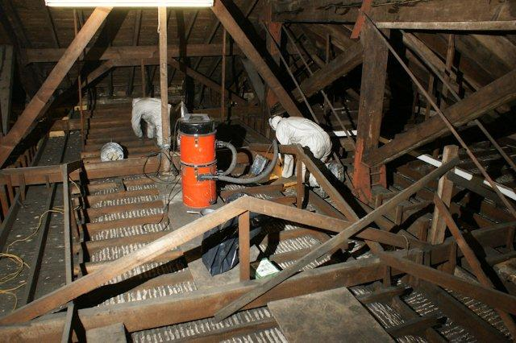

TIME FOR PRAYER

What gift would you like to receive this Christmas? How about a jewel that can never be destroyed? Do we not get something like that through our faith in Jesus? Here is a seasonal prayer from 12th century France.

What is this jewel that is so precious?
I can see it has been quarried not by men, but by God.
It is you, dear Jesus.
You have been dug from the rocks of heaven itself
To be offered to me as a gift beyond price.
You shine in the darkness.
Every colour of the rainbow can be seen within you.
The whole earth is bathed in your light.
Infant Jesus, by being born as man
You have taken upon yourself the pain of death.
But such a jewel can never be destroyed.
You are immortal.
And by defying your own death, you shall deliver me from death.

Amen

Douglas Scott.
WESTBURN CHURCH CRADLE ROLL

You may have noticed that the new Cradle Roll Scroll for Westburn Church is now framed, and is displayed just outside the Church Officers Office. This scroll will now be updated on a regular basis.

The Creche, is for children under 3 years old, and continues to have several children each Sunday with a few visitors throughout the year. In an effort to keep our toys current, and in a safe condition, this year we have invested in a new Early Learning Centre Rocket and Robot. Although these are great new additions it is still the big trucks, the Garage and the Prams than remain firm favourites.

The Creche is held in the Lounge, and operates every Sunday during the 11 o’clock Church Service. Up until recently the children were very fortunate with the amount of space they had to play in, as all the chairs in the lounge were stacked away and the children had the whole of the lounge to play in. Since our Services have been moved into the Church Hall and the Lounge is once again being used for coffee, the space in which the children have to play in has been quartered, but this does not seemed to have altered their enjoyment of coming along each Sunday.

After quite a number of years there are a few volunteers stepping down from the Creche Rota and I would like to take this opportunity to thank these members very much for their reliability and assistance over the years.

As a result of losing these members we now need new volunteers to add to the new Rota, which begins in January 2012. The Creche is run by 2 volunteers each Sunday. There is a rota system and the more volunteers we get the less duties each member has to do throughout the year.

If you wish to join us or need any further information, please speak to Fiona Crossan, Tel No: 805825 or email: Fiona.Crossan@sky.com

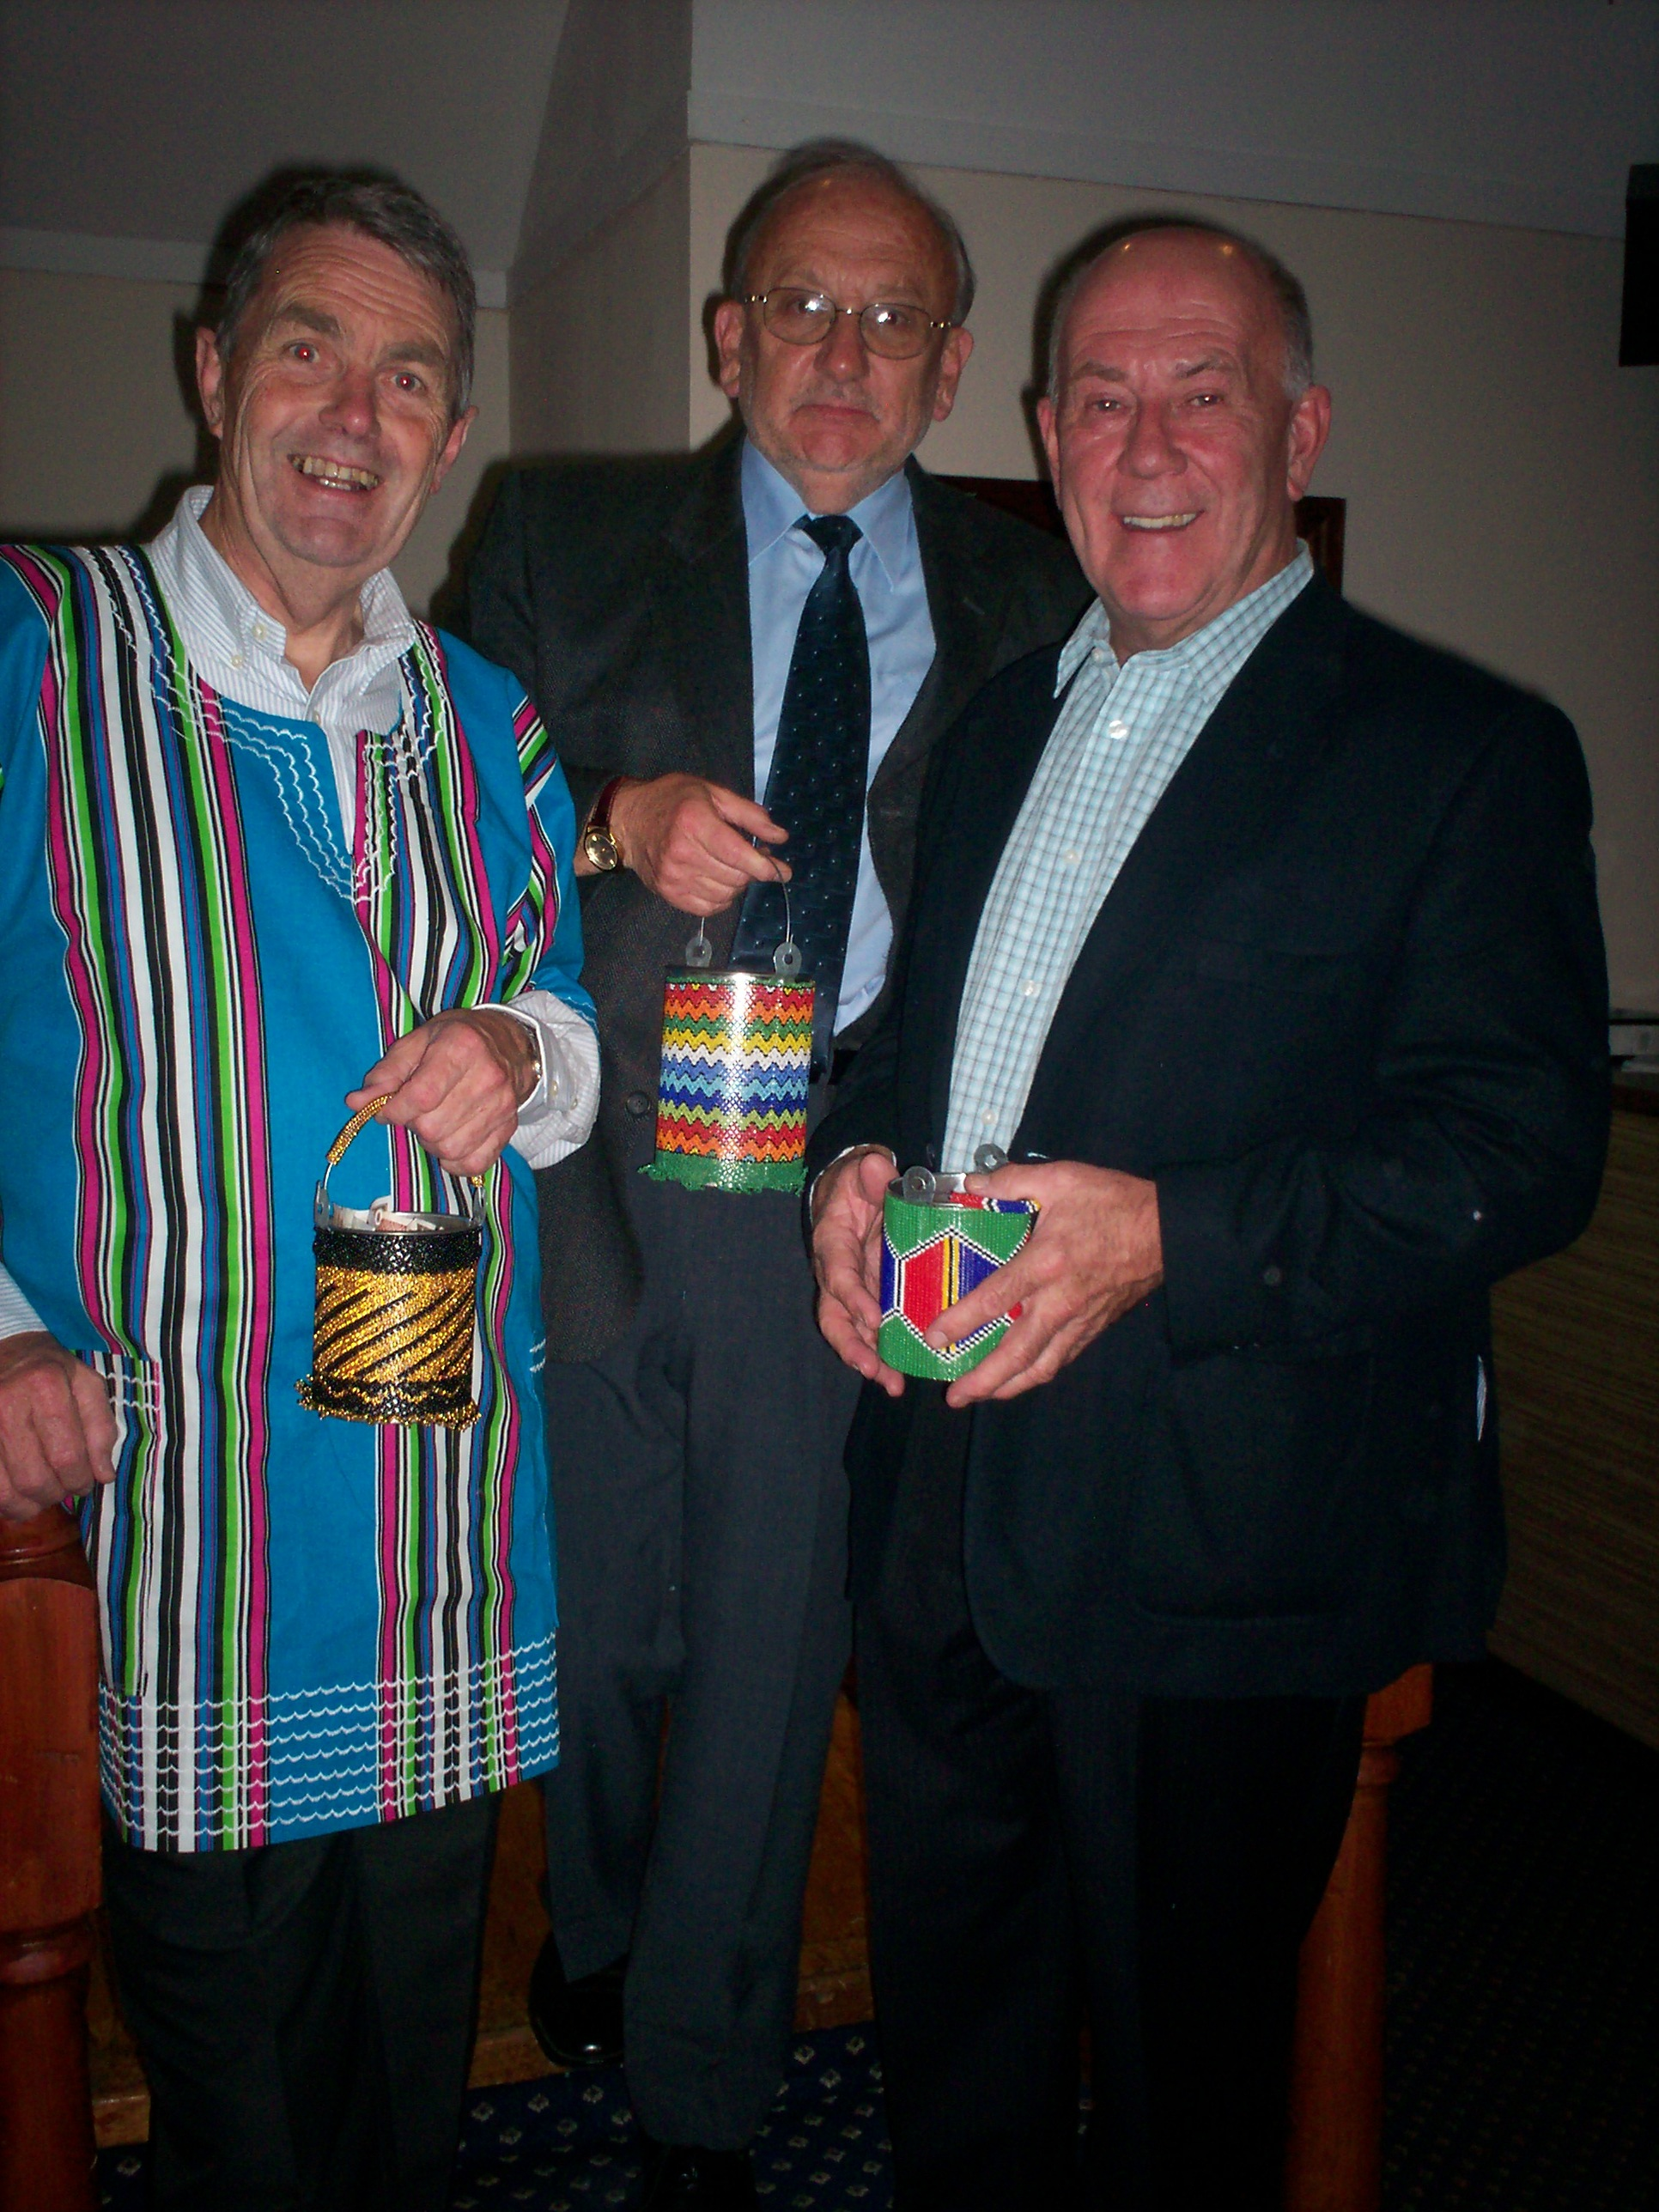
Venda Fund Raising Dunner
On the 22nd September members of various churches and friends attended a Fund Raising Dinner in The Kip Marina organised by Iain Mc Crorie. The purpose of the dinner was to raise funds for Venda. A cause very dear to Iain’s heart as he, Westburn’s session clerk Stuart Robertson and Rev Jill Clancy all attended to opening of The Vhutshillo Mountain School
This proved to be an enjoyable evening of friendship and fellowship Monica Mc Neill told of how it all began through her son Fraser and of her experiences on her visits to the school. Peter Nimmo also spoke of his visit to Venda and his involvement with the School.
We were well entertained by pupils from Clydeview Academy and the sum of …… was raised thanks to a generous donation from Gourock Rotary. This was also a chance for our minister to wear his Venda Shirt which was given to him when he visited during his Modatorial year.
The accompanying picture shows the colourful shirt as he, Stuart Robertson and Les McNeill happily and willingly encouraged everyone to support this fund raising evening.

CONGRATULATIONS

Congratulations to Westburn’s Elder Hugh Thomlinson, who is a Greenock Martial Arts Instructor. Hugh recently passed a gruelling grading test and achieved his 5th Dan black belt with the Shoto Budo Organisation.

Hugh a senior instructor and club member for more than 20 years received his award at a National grading weekend in Largs, which involved three days of gruelling training and testing in many aspects of martial arts. A spokesman from the club said “There are few in the martial arts world who will achieve this level of excellence.”

WELL DONE HUGH.
THE GUILD

The Guild started on 27th September and the attendance from our members has been very good. On 11th October we held a Hymn Along singing some old favourites including some hymns that some of us sang in Sunday School including the actions. It was a very successful and happy evening. We have good speakers and some demonstrations throughout 2011/12.

We are also holding a Burns Supper on 31st January and this will be open to Church members and friends. More information about this will be announced later. New members would be made most welcome or if there is anyone you would like to hear please come along.

By the time you receive this we will all be thinking of Christmas, so from The Guild we wish you a very merry Christmas and may Gods blessings be with you all.

Senga Currie
Leadership Team Co-ordinator.

Guild Syllabus - 2012

January

10 Local Views Mr. T. Robertson
17 Access at Ardgowan Hospice (visiting)
24 Project - Crossreach Speaker t.b.a.
31 Burns Supper

February

7* Presbyterial Council ABM in St John's, Gourock
14 Visiting Lyle Community Kirk, Union Street, Guild
21 ABM and Bible Study with Bring and Buy Sale
Very Rev. W.C. Hewitt
28 Changing Times Rev. K. Forrest

March

6 Malawi Mr. C. Rebecchi
12(Mon) Presbyterial Council Spring Rally in
St Andrew's, Port Glasgow
20 Easter Goodies Miss S. Downie
27 Closing Social Largs Gaelic Choir

Date marked * begins at 2.00 pm.
All other meetings at 7.30 pm.

CHURCH CALENDAR
Calendar for November and December all services will be held in Lyle Kirk’s Esplanade building ( formally Old West Kirk)
Nov 6th 9.30am Early Service
11am Morning worship including Baptism

Nov 13th 10.45am Remembrance Service

Nov 20th 9.30am Early Service
11am Morning worship

Nov 27th 9.30am Early Service
11am Morning worship
6.30pm Light up a Life (Service at Westburn)

Dec 4th 11am Service of Holy Communion
3pm Service of Holy Communion

Dec 11th 9.30am Early Service
11am Gift Service

Dec 18th 11am Family Service

Dec 24th 10.30pm Christmas Café
11.15pm Christmas Carols
11.30pm Watchnight Service

Dec 25th 11am Family Service
Once Christmas celebrations are over, we very quickly move to another year, will 2012 be any less hectic for us, will we have time to do the things we always mean to do, how often do we say we meant to this or that, but we didn’t have time !

TIME IS A GIFT FROM GOD


We stand once more on the threshold
Of a shining and unblemished year,
Untouched yet by time and frustration,
Unclouded by failure and fear –
How will we use the days of this year
And the time God has placed in our hands,

Will we waste the minutes and squander the hours
Leaving “no prints behind in time’s sands” …
Will be vainly complain that life is so swift,
That we haven’t the time to do good,
Our days are too crowded, our hours are too short,
To do all the good things we should….

We say we would pray if we just had the time
And be kind to all those in need,
But we live in a world of ”planned progress”
And our national password is “speed”

God grant us the grace as another year starts
To use all the hours of our days
Nor for our own selfish interests
And our own willful, often wrong ways,
But teach us to take time for praying
And to find time for listening to You
So each day is spent well and wisely
DOING WHAT YOU MOST WANT US TO DO

FROM THE ROLL-KEEPER

DEATHS

Mr. A. Powrie 1 Finnart Rd. 3 Died Sep..
Mrs. F. Clements 14 Juno Lane 12 Died Sept.
Mrs. A. Malcolm 162 Burns Rd. 12 Died Oct.
Mrs. E. Adams 17 Roxburgh Way 18 Died Aug.
Mrs. E. McBride 116 Leven Rd. 19 Died May
Mr. R. McFarlane Bagatelle Nursing Hm. 22 Died Sept.

NEW MEMBERS by TRANSFERENCE

Mrs. K. Cochrane 19 Kenmore Pl. 12 from St. Ninian's
Mr J. MacKinnon 66 Kylemore Ter. 12 from St. Ninian's
Mrs. J. MacKinnon 66 Kylemore Ter. 12 from St. Ninian's

CHANGES of ADDRESSES

Mr. & Mrs. S. Bruce 41 Fletcher Ave., Gourock 11 from D6
Mrs. J. Roe F16, JGH, 19 Inverkip St. 18 from D2
Mrs. J. King F3, JGH, 4 Duncan St. 18 from D2
Mrs. N. McFarlane F34, JGH, 2 Duncan St. 18 from D6
Mrs. F. Sweeney 18 Lurgenbouy Rd., 21 stays 21
Castlederg. NI
Mrs. M. Capon Balclutha 22 from D14
Mrs. M. Dunlop Glenfield 22 from D4
Mrs. M. Durand Dunrod Unit, Ravenscraig 22 from D2

MOVED WITH NO FORWARDING ADDRESS

Mrs. M. Shand 126 Whinhill Ct. 30

IN ORDER TO KEEP THE CHURCH RECORDS UP TO DATE, IT WOULD BE GREATLY APPRECIATED IF ANY MEMBER WHO IS MOVING INFORMS THEIR ELDER, THE SESSION CLERK, OR THE ROLL KEEPER OF THEIR NEW ADDRESS.

