


WELCOME to the Summer Magazine.

YES summer in some ways it seems so far off, but by the time you receive your magazine we are heading to our June Communion and hopefully warmer weather. Whether you will be at home or away we hope the sun shines and you have a relaxing summer. There is lots in the magazine from our various committees, everyone working hard for the good and wellbeing of Westburn church. The summer for all our convenors and leaders we hope is a relaxing time for them and a time to recharge their batteries ready for next Session. Our Nominating Committee will not be so lucky as they continue to seek for a new minister, our prayers and support are with them in this very important duty on our behalf.
MESSY CHURCH – Saturday 4.00pm – 6.00pm - What is it? If you haven’t been at worship recently you may not be aware of Westburn’s Messy Church. The first one was Saturday 23rd March, the second one was Saturday 27th May and a third one will be held on June 8th. It is planned monthy again starting in the Autumn. What is it? It is an alternative fun, all age church experience. Meeting at 4.00pm with an hour of activities, followed by a short act of worship then a meal together finishing at 6.00pm. Messy church has been a great success why not give it a try, it is suitable for age group ( 0 to 100+! ) that’s you!! With your children, your grandchildren or on your own, you won’t be alone for long. Come to Westburn’s Messy Church you will be made most welcome.

The material for the next magazine is due by Sunday 25th Aug. 2013
e-mail to cathbarbour@btconnect.com

© 2007

From the Interim Moderator

Just these words………………………………………………………………………………………………
………………………to say that it seems mildly uncomfortable to be writing for what is effectively the summer edition of our church Newsletter whilst the TV weather report is forecasting more snow coming our way! Perhaps by the time you read this we will be basking in glorious sunshine and with the temperature up in the seventies. Well, it’s good to dream dreams – and summertime is a good time for doing just that – dreaming dreams about where we are headed in life and what the future might hold for us.
Thoughts of the future and what it might hold for us are pretty high up on our agenda right now.

The General Assembly of the Church of Scotland meets from May 18 – 24 to make informed decisions on important matters that determine our way forward at both national and parish level. Remember the Commissioners in your prayers at what may well be a critical juncture in the Church’s understanding of both the nature and the calling of it’s ministry.

Meanwhile our own Nominating committee continues with great diligence to seek out and present to the congregation a sole nominee to be voted upon as the new minister for Westburn Church. The requirement for patience in this matter of a new minister is not unrelated to decisions regarding Ministry being asked of the General Assembly.

These are uncommon times in the life of the church and as the number of vacancies increase so does the passage of time taken to fill them. What we can be sure of is that God has a surprising way of electing leaders – just take the time to read through 1st Samuel chapter 16.
For back-up here is Jeremiah 1verse5… ’Before I formed you in the womb, I knew you, before you were born I set you apart; I appointed you.’

Pray for the Commissioners to the Assembly! Pray for the members of your Nominating Committee! Pray for the Minister of God’s choosing!

And hold me in your prayers as I hold you in mine,

Your friend and (Locum) Minister
Morris Coull
CHURCH SERVICES MAY / JUNE
May Sunday 5th - 9.30am and 11.00am

Sunday 12th - 9.30am and 11.00am

Sunday 19th - 9.30am and 11.00am (Pentecost )

Sunday 26th - 11.00am Only

June Sunday 2nd 9.30am
11.00am We welcome to this Service the Revds.
David Coleman and Zam Walker along with members
Of West United Reformed Congregation.
3.00pm Scout Service

Sunday 9th - COMMUNION 11.00am and 3.00 pm (In Church Hall )

Sunday 16^{th-} 9.30am and 11.00am

Sunday 23rd - 9.30am and 11.00am

Sunday 30th - 11.00am Only Family Service

We look forward to welcoming you to any or all of these services
When I ask you to listen to me and you start to give me advice, you have not done what I asked.
When I asked you to listen to me and you begin to tell me why I shouldn’t feel that way, you are trampling on my feelings.
Perhaps that’s why prayer works for people; because God listens and doesn’t give advice.
He listens, and helps you work it out for yourself.

CHURCH NEWS BOOK

If you are aware of anyone who is ill or would benefit from a visit from the minister, please make an entry in the news book with their name and address. It is helpful if you sign your entry.

REMEMBER – If you want to advertise an event in our Local Internet Radio Station Contact :- David Faller, Inverclyde Radio direct at:-
www.inverclyderadio.com

Life and Work

Life and Work is available on the last Sunday of every month priced £2.00 Subscriptions available.

Please contact Shelagh Hendry Tele. 794667.
Delivery can be arranged if you are unable to get to church.

Greenock Westburn Church Web Site
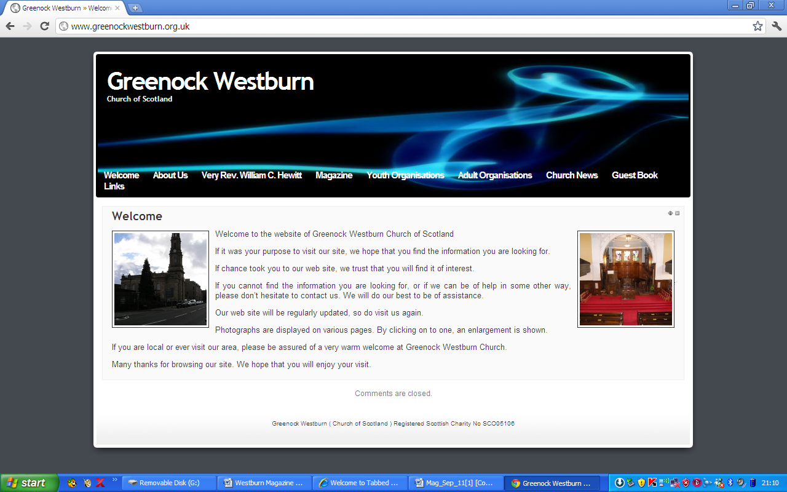
Have you put your syllabus, planned activities, or interesting comments about your organisation or group on your web page. If not it may look as though you’re not doing anything interesting. Have you looked at your page on the web, can you make it more interesting, add photographs, make comments, ask one of your members to write about what it is they enjoy about your group. Jim Bell will be happy to update your page.

A similar invitation is made to any church member who feels that they can assist in making the web site more interesting.

Our church web site can be found at - http://www.greenockwestburn.org.uk/ Please visit it and view it's contents.

Further information can obtained from Jim Bell ( 01475 799381 or all.the.bells@ntlworld.com )

Find us on FACEBOOK

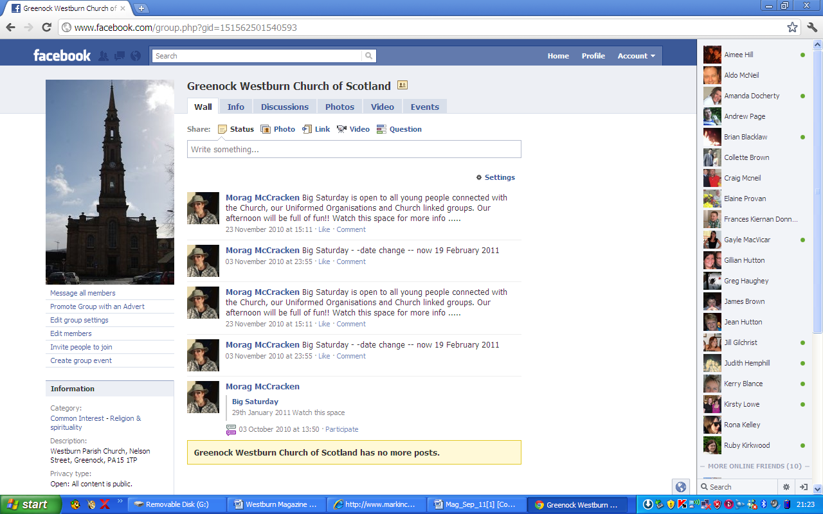
Search on FACEBOOK for “Greenock Westburn Church of Scotland” and join the social media revolution.


CHURCH FLOWERS

The Calendar for donating and list for delivering Church flowers are now available.

There are still dates available for donating and unfortunately there are many gaps for delivering. Please check the delivery list and see if there is any date you could manage to help.

This is a simple but very important task and The flowers are greatly appreciated by those who receive them.

If you would liike any further information about donating or delivering please speak to Patricia Robertson or Linda Murray
Or contact Patricia Robertson by telephone at 725451.


USED STAMPS

Please continue to bring your used stamps, there is a little red basket in the centre vestibule.

The money which is raised through donating our used stamps is very worthwhile and Evelyn Taylor keeps us up to date with the amounts raised and the projects World Mission are able to be involved with.

PRESBYTERY OF GREENOCK AND PAISLEY March/April 2012

VACANCY PROCEDURE COMMITTEE Greenock: Lyle Kirk have decided to use Newark St building as their main sanctuary with Union Street building as a second sanctuary when needed. The future of the Esplanade building is still to be decided.
Greenock: St.Margaret’s is to call a minister on a 7 year reviewable tenure.
Presbytery grants Greenock: Westburn an extension of leave to call until Oct.2013. This is a difficult time to secure a minister with over 200 vacant charges in Scotland and only a few new candidates available.

BUSINESS COMMITTEE A small committee under Rev A.MacLean has been set up to develop Presbytery fellowship and become a catalyst for mission within its bounds.
Rev Ken Gray will be the next Moderator of Presbytery from Sept.2013.

PROPERTY COMMITTEE General Trustees have approved the release of £135,728.85 from the consolidated Fabric Fund for repair and ronovation of the sanctuary ceiling in Greenock:Westburn.

MISSION AND DISCIPLESHIP Mellissa Colquhoun has been appointed Youth Rep. to the General Assembly 2013. A member of St.James she is a Girl’s Brigade Officer who after completing her degree at Glasgow University spent 7 weeks volunteering in Uganda.

Pray across Scotland :- Mon 13th May 7.30pm Pirrie Hall Lyle Kirk Esplanade. Congregations are encouraged to join this specific prayer focus on the General Assembly.

WORLD MISSION ZIMBABWE Presbytery instructed the Zimbabwe committee to explore the covenant between the two Presbyteries and report back. Congregations were congratulated on their generosity towards the bore well at Mbare which is a great
Boon to the community. There is a magazine on the Moderator’s visit which gives a pictorial account of their stay and gives a good picture of the work done in the name of the Covenent.

IF CAMPAIGN – ENDORSED BY ARCHBISHOP DESMOND TUTU
The campaign supported by Christian Aid and Tearfund was launched Jan 2013 and the event was attended by high profile speakers including Bill Nighy who reminded us that Hunger is the world’s most shocking problem but not an incurable disease or avoidable tragedy. He reminded us things in the past seemed unbeatable: the abolition of slavery or aparteid, but they DID happen. More info re this campaign is available from Christian Aid or Tearfund. We are asked to remember in our prayers Christians living in Pakistan – According to Human Rights Commission of Pakistan 2012 they live in constant fear of persecution by Sunni Muslims suffering economic, social and legal discrimination. While they represent 2% of the population many have been charged with blasphemy.

COMMUNITY INTERESTS The Committee wants to highlight the disgrace of people in Scotland being dependent on foodbanks and is very concerned about the ever widening gaps between rich and poor. As one minister said “ I never thought to see the day when I would run a soup kitchen from my church hall”
Inverclyde Foodbank is at 64Westblackhall St Greenock PA15 1XG
There are also foodbanks in Johnstone High Parish Church and Pt.Glasgow UF church.
Foodbanks interact with a wide variety of care professionals who identify people in crisis and issue them with food vouchers.

This committee is considering the Welfare Reform Bill and anyone who wishes a copy should contact me.

Margaret Crawford
Representative Elder

Church Cleaning

After an appeal a list was made up of 24 people who volunteered to help clean the church once a month. This has resulted in each team undertaking this task 4 times a year. The times this takes place is Wednesday morning, Wednesday evening, Thursday morning and Friday morning. If you feel you could help with this please contact me either at the church or phone 725451.

Thank you Patricia Robertson

Pastoral Committee

- The Committee met on 11th February 2013 and the next meeting will be on Tuesday, 14th May 2013.

- District 22 – all members who are in nursing or care homes are regularly visited by the Committee. In addition, our Interim Moderator is also visiting Members in hospital and at home. Joyce, Margaret Forbes, Ann Skedd, Georgina Dixon and I visited Megan Robertson during February at the nursing home in Saltcoats.
- Annual Car Run – will be held on Wednesday, 26th June 2013. Pro Formas will be issued in the Elder’s information pack.
- Harvest Thanksgiving – will be held on Sunday, 22nd September 2013. As in previous year’s, the congregation will be asked to the South African Projects.
- South African Projects – the Executive agreed to give £750 each to Cotlands Children’s Sanctuary and Sunshine Centre for disabled children.
June Communion Afternoon Service – Sunday, 9th June 2013 in the Lounge at
3.00pm

Bill Dempster

June 9th - Afternoon Communion

A warm invitation is extended to all to come along to

A short service of Worship with Communion
In the lounge
At 3 o’clock on Sunday 3rd March

Transport there and back will be available for anyone who needs it. Please speak to your elder if you need a lift and stay and join us afterwords for fellowship and a cup of tea.

We look forward to seeing you there.
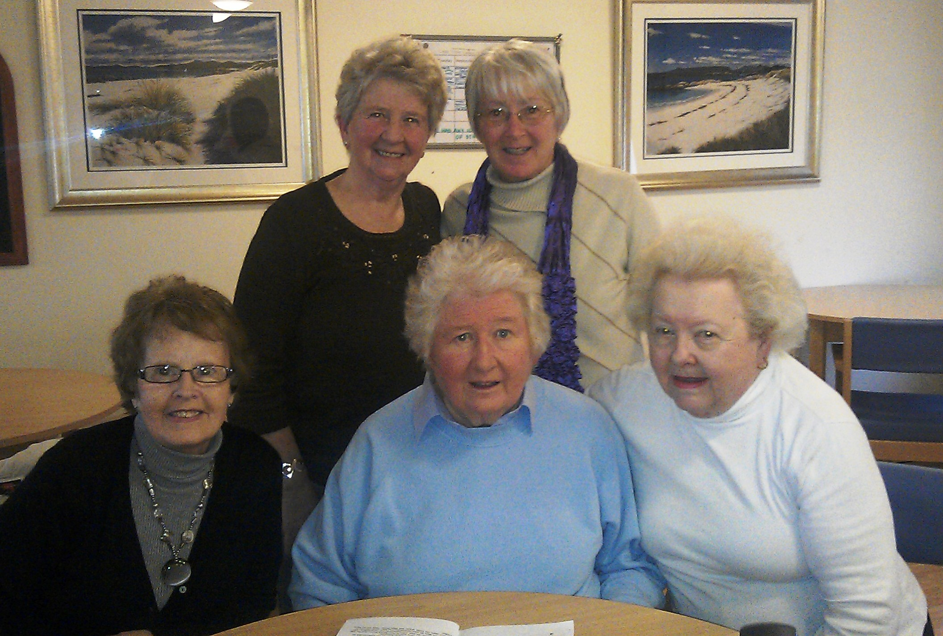
Pastoral committee and friends visit Megan in her Care Home in Saltcoats.

Church Officer

Jason Goodwin has recently joined our Church Officer’s team.
Jason who is age 34 lives in Skelmorlie. He is married to wife Anne and has a son Thomas age 5. Jason worked in this capacity in Skelmorlie and Wemyss Bay church for 4 years and previously in Holyrude in Stirling. In both of these churches the minister was Morris Coull, a nice coincidence.
We welcome Jason to Westburn and look forward to meeting Anne and Thomas at worship and Messy Church.
When on duty Jason’s contact no. is- 07772312547.
Jason and Danny share these duties while Ronnie is on sick leave.

Jason is a busy and energetic guy who also has a Handy Man, Home Repairs and Garden Work business, There is an advert located inside the back cover of the magazine . If you have a need for any of the services Jason offers he would be glad to hear from you.

GREENOCK WESTBURN CHURCH
PROPERTY COMMITTEE REPORT
MAGAZINE – SUMMER 2013

Recent work completed is re-pointing of the south boundary wall and repairs to the roughcast at rear of main halls. The Pulpit Chair has been recovered in red material (was originally blue)
With regard to the centre hall foyer, the floor cracks have been discussed with David Turnbull of ATK. His recommendation is to cut out the affected area and infill with new materials. A timescale for this work has still to be determined.

With the involvement of contractors, identified work likely to proceed in the near future is refurbishment of the centre hall foyer and the ladies toilet. The specification for the ladies toilet has been the subject of much discussion and has still to be finalised.
New window blinds have been fitted in the main hall, Room 1 and the rear corridors. We are grateful to the Guild for providing the finance for this work.

Volunteer labour contributes to a substantial cost saving in church expenditure. If any member would like to assist in any way, please contact Jim Bell (Tel No 799381)

PRAYTIME
A concert pianist said: “If I go for a day without practising, I notice it. If I go for two days without practising, my friends notice it. If I go for three days without practising, my audience notices it.”
Could there be an analogy there for us? If I go for a day without praying, God notices it. If I go for two days without praying, I feel it myself. If I go for three days without praying, everybody around me feels it.
from Douglas Scott, Presbytery Prayer Coordinator.

TIME FOR PRAYER

We are often told that Jesus wants us to be his friend. But being a real friend can require commitment, loyalty, hard work, patience and sometimes sacrifice, otherwise we end up being what is sometimes called a fair weather friend. And surely that is not what we want to be, nor what Jesus would expect us to be. Jesus, who died for us, was clearly no fair weather friend. Here is a humorous little prayer by a Methodist minister, David Head, whose sense of humour might occasionally help to jolt us out of our sense of complacency. We’re not like that, are we?
PS If after saying this prayer you haven’t been struck by a lightning bolt, maybe God does appreciate a sense of humour.
O Lord, so long as the weather is reasonably fine,
so long as I have no visitors,
so long as nobody asks me to do any work,
so long as I can sit on the back pew but one on the left,
so long as it isn’t a guest preacher planned,
so long as they don’t choose hymns I don’t know,
so long as my Joe is asked to recite at the Anniversary,
so long as I can get home in time for the play,
I will honour Thee with my presence at Church
whenever I feel like it.
Amen
Douglas Scott
Future Focus Report


Westburn’s Strapline

What is a strapline?
A strapline is something which makes you stand out in your marketplace, gives people a reason to remember you. A great strapline can become as recognisable as the brand itself as shown by these examples: “Every little helps”, “The world’s local bank” & “Just do it”.
Many congregations have a strapline, here are a few: “Making Jesus Known”, “Where Everyone Matters”, “Emerging Encouraging Equipping”.
The Future Focus Action Group want to give you the opportunity to choose a strapline that epitomises our congregation. We have come up with some suggestions and invite you to choose one or create a strapline of your own.

Tick (✓) your preference.
A ◻ A beacon for the Gospel
B ◻ The Kirk that cares
C ◻ Worship, Service, Friendship
D ◻ own suggestion:

Please select your preferred strapline and return this slip to box in the foyer by 9 June 2013.

Guild

By the time you receive this magazine the guild session for 2012/2013 will be over although we will still meet until the end of May every two weeks for a chat and a cup of tea. Some of the ladies are bringing their knitting along, perhaps we may see some of it at the fete.

Before the session ended we had a very successful night celebrating 125 years of The Guild Nationally, it was in the form of looking at the history of the Guild, guessing “who’s who” from old photographs and cutting a celebratory cake made for us by Sandra Downie, a member of the church. The cake was cut by our oldest member Mrs Jessie McRae. Hopefully there will be photographs on the church website soon.

Members attended 2 Presbyterial Council meetings where we heard about 2 of our projects both of which I gave details in the last magazine.

We had heard about the new Beacon Arts Theatre at the beginning of 2013 and this was the venue chosen for our final night, when we had a very enjoyable night with plenty of chat as well as good food. Perhaps this will become the start of many.

The National Guild held a successful Songs of Praise during the General Assembly last year to start the important milestone in the life of the Guild. Some of our members were able to watch in the Lounge as it was being shown live on the web site. To end this important year the National Guild has been asked to lead the opening worship at this year’s Heart and Soul, in Princes Street Gardens, some members of the congregation are attending as there is a bus being laid on.

The committee will have met by the time you receive this magazine to start compiling the syllabus for next session and we are indebted to Marian Anderson for all the hard work she puts in, although I must say the final one is not always what the committee had planned date wise but we do give Marian leeway as it is not an easy task.

I include the latest update of the monies raised for the latest 6 projects:-
From September 2012 to March 2013:
Comfort Rwanda: (Building a Better Rwanda) £18,338.49
Crossreach: (Heart for Art) £30,312.58
Mary’s Meals: (Making a difference in Liberia) £18,433.21
Ministries Council: (Passage from India) £6,070.29
Scottish Churches Housing Action: (Julius Project) £13,632.37
World Mission Council: (Out of Africa ….. into Malta) £13,681.83
Total: £100,468.77
As I conclude this report, may I on behalf of the members of the guild wish the congregation a relaxing summer and hope that the weather is kind for those who can get out and about.
Patricia Robertson

“Fish ‘n Chip Babies”
In the last magazine we reported a great success and response from members and friends of Westburn when almost 600 sets of baby garments were sent to Africa.
This project still continues under the new stewardship of Dorothy Murray- Tel 724791 and Anne and Susan Skedd Tel 724367. The next batch of knitting for shipment is finished and we are please to be sending over 300 sets . Thereafter the project continues.

Dorothy, Anne and Susan would like to thank knitters, who donated their time for this worthwhile project, particularly those from outwith our Church. Donations were received from The Hospice, Old Gourock and Ashton Church and Meigle WRI . Please keep knitting, for further information contact Dorothy, Susan or Anne.

SOCIAL COMMITTEE REPORT

Ceilidh.
We were disappointed in the interest shown for the Ceilidh from the congregation as we’d hoped it would be a fund raiser but had no other option than to cancel, although we did have over thirty tickets sold / accounted for. (Many of which were for friends from the old Ardgown Church.)

Stepping out in Faith
We are underway and have upwards of 40 members taking part. Doreen will keep us all up to date as to how far our steps have taken us and any correspondence we get from distant churches.

Bowling Night
We have contacted the Ardgowan Bowling Club in the hope we can once again enjoy an evening of bowling and games. We should hear from them as to when they think the bowling calendar will be clear.

Fashion Swap Evening
We are going to try a slightly different slant on this event.
We will invite the congregation to supply the fashion items prior to the event as usual and
On the evening come along and buy (with money and if they wish barter
/donate with food as well) anything that takes their fancy.
(Tinned /Dried Foods)
Now we don’t expect people to come laden with tins but any tins etc. brought along will be added to the items we propose to purchase for a local
Food Bank.

Linda Murray


WESTBURN CHURCH MEMBERS – “STEPPING OUT IN FAITH”

45 Members of the Congregation registered to step out on our virtual tour of the Church of Scotland Kirks which make up the Presbytery in Europe.

A collective distance of some 8,000 miles. We started counting our daily steps on 7th April. By the end of week 2 we had recorded 1,836,509 steps which converted to 1,083 miles from Greenock and virtually visited Amsterdam, Rotterdam and Bochum ( Germany ).

Congratulations to the folk stepping out and who hopefully are enjoying the exercise in both senses of the term.

It is likely that by the time you read this the walkers will be heading for either Budapest or for Rome. Why not keep track of our progress by checking the map in the main hall or on the Church website.

Doreen Borland


CHURCH FETE
- Saturday, 25th May 2013

Arrangements are now in place for the fete to be held on Saturday 25th May 2013. from 10.00 – 3.00. Entry ticket of £2 will include tea or coffee.


It will take place in the church halls and grounds.


All church related organisations have been approached to take part. There will be a range of stalls for all the family and will include:-

Tea Room, Lunches, Home Baking, Fancy Goods, Bric a Brac, Books/CD’s, Plant Stall, Barbeque, Bouncy Castle, Zorb Ball, Face Painting, Tuck Shop and Sweets in a Jar

Make sure to come along and enjoy a fun filled day.

FROM THE ROLL-KEEPER

DEATHS

Mr. D. McKinlay 31a Newton St. 2 died Mar.
Mr. W. Climie 46a Ardgowan St. 6 died April
Mr. R. Beaton 54 Union St. 7 died April
Mrs. M. Dunn 79 Battery Park Ave. 9 died Mar.
Mr. K. McLeod Alt-na-craig 22 died Feb.

CHANGES OF ADDRESS

Mrs. N. Thomas St Margaret's Ct. 99 Grieve Rd. 13 from D15
Mrs. J. Bain 74 Royal Ct. 18 from D19
Mr. T. McKenzie 6 Hadfield Ct., Eglinton Ter. 20 from D16
Mrs. G. McKenzie 6 Hadfield Ct., Eglinton Ter. 20 from D16
Mrs. L. Park Marchmont 22 stays D22
Mr. G. Thomas Alt-na-Craig 22 from D15

DISJUNCTIONS

Mr. & Mrs. T. McKenzie 6 Hadfield Ct., Eglinton Ter.SKEL 20
to Skelmorlie & Wemyss Bay Church
ADDED TO LAST KNOWN ADDRESS LIST

Miss D. McBride 136 West Blackhall St. 1

TRANSFERRED TO SUPPLEMENTARY ROLL

Mrs. J. Dowds 77 Kirn Drive 11
Miss L. Dowds 77 Kirn Drive 11
IN ORDER TO KEEP CHURCH RECORDS UP TO DATE, IT WOULD BE GREATLY APPRECIATED IF ANY MEMBER WHO IS MOVING INFORMS THEIR ELDER, THE
SESSION CLERK OR THE ROLL-KEEPER OF THEIR NEW ADDRESS.

