

WELCOME to the December edition of the Magazine, bringing the Christmas message to all.
It is hard to get our head round Christmas this early when we are enjoying the lovely Autumn colours ( particularly on the few sunny days we had recently ) and now that the clocks have changed our attention turns to Hallowe’en and Guy Fawkes and we feel that we are really settling into the winter routine.
Yes it is a little early to be thinking of Christmas and all the preparation we have to do. Will we start early? when will we put up the tree? What to eat? What gifts to give? It is good to have time to prepare and plan. The visitors to that lowly stable in Bethlehem, all those years ago, didn’t have time to prepare, they didn’t have much time to plan what gifts they could give, “ they gave what they could afford.”
Whether shepherd or king, rich or poor they hurried when they heard the good news, they followed that bright star, they hurried to celebrate the birth of a baby born to be king, they knelt in awe and wonder….. what joy, what love, what peace was theirs. So it is in our Christian preparations as we journey through Advent we take time to celebrate Hope, Joy, Peace and Love, ready to greet our Saviour on Christmas morn.
Wishing a Blessed and Happy Christmas to all.

The material for the next magazine is due by Sunday 27th January2013
e-mail to cathbarbour@btconnect.com

e-mail to cathbarbour@btconnect.com or to Joe Craig.
© 2007


From the Manse

Just these words……………………………………………………………………………
………………...to say thank you to everyone who participated in and everyone who has responded to the Stewardship Programme this autumn – you are making a difference in the life and work of your church! If you have not yet responded then I do hope that you will give the matter your earnest consideration.

They say that some things are sent to try us and the Presbytery Plan Reviews that are ongoing across the face of the Church are certainly trying our patience. It does appear that the movement of Ministers in response to vacancies will remain hampered until such time as the Plans are fully in place. Nominating Committees are coming to realise the virtue of Patience along with that of Confidentiality. Continue to uphold the Convener, Clerk and members of your Nominating Committee in your prayers as they continue with due diligence in the search for a new Minister.

And so to Advent and Christmas. Martin Luther saw three miracles in Christ’s Nativity: God became human, a virgin conceived and Mary believed. In Luther’s mind the greatest miracle was the last…Mary said ‘Yes’ to God. There’s always a moment, isn’t there, when we have to say one way or the other – either ‘yes’ or ‘no’ – either ‘I’ll stay’ or ‘I’ll go’. Well, we are all celebrating Christ’s birth because Mary said ‘Yes’.
It’s amazing what can happen when someone says ‘Yes’. Not everyone does. Some would like to, but just can’t find the way. Some people say ‘Sure, I said ‘Yes’ to something once – but it didn’t work’. But how do they know – maybe they should have given it more time.

Perhaps we can learn from this thousand year-old story from India. It’s about a farmer who has only one horse to pull his plough, and the horse runs away. His neighbours say; ‘That’s terrible!’ The farmer says; ‘Maybe it is, maybe it’s not.’ The next day the farmer comes back with two horses. His neighbours say; ‘That’s wonderful!’ The farmer says; ‘Maybe it is, maybe it’s not’. His son tries to break-in the horses and ends up breaking his own leg. ‘Oh, that’s horrible!’ say the neighbours. ‘Maybe it is, maybe it’s not.’ says the farmer.
The next day the army shows up to take all the men to war, but they can’t take his injured son. Now the neighbours say; ‘Oh, you’re so lucky!’ What do you think his response was? ‘Maybe…’ And the story goes on and on, just like life. If you believe in something and it hasn’t worked out yet, then maybe you’re judging too soon. When you think you’re in trouble, maybe you’re not - maybe it’s only temporary.

‘And the angel said to Mary ’With God, nothing will be impossible.’ With what is done through Mary, nothing will be withheld by God. There is no distance God will not go, no depth to which he will not stoop in his wild pursuit of humankind.

Advent – preparing for the birth of Christ in our lives is beyond reason. But then:

‘This is the irrational Season,
When love blooms bright and wild,
Had Mary been filled with reason
There’d have been no room for the child.’

May the Joy and Peace of the Christmas Season be yours,
And every blessing for a Good New Year!

Hold us in your prayers, as we hold you in ours.

I am, your friend and (Locum) Minister,

Morris Coull

Pastoral Record
Baptisms

    - James and Lisa’s son : Jack

    - Schuyler and Katherine Anne’s daughter : Evelyn Nicole

    - Ewan and Elyse’s daughter : Eve Mary Catherine

21.10.2012 Craig and Joanne’s son : Fraser Craig

Pastoral Care Committee

1. Harvest Thanksgiving – approximately 120 plants were distributed to Members of the Congregation after the Service on Sunday, 14h October 2012.
Many thanks to the Members who distributed the plants.

2. The Members of the Pastoral Care Committee continue to visit those Members who are in Nursing Homes or housebound.

3. December Communion - Sunday, 2nd December 2011 at 3.00pm in the lounge.

4. Christmas Cafe –will be held in the Church Hall on Monday, 24th December 2012 from 10.00pm.
Donations of Christmas pies etc will be greatly appreciated and details for donating will be intimated nearer the time. Transport will be available to and from Church. If you would like transport, please pass your name to your Elder.

5. The date of our next meeting is on Monday, 19th December 2012 at 2.30pm in the lounge. If any Member of the Congregation would like to attend, they will be made most welcome.

Bill Dempster
December 2nd - Afternoon Communion

A warm invitation is extended to all to come along to

A short service of Worship with Communion
In the lounge
At 3 o’clock on Sunday 2nd December

Transport there and back will be available for anyone who needs it. If you would like a lift , then –

Speak to your elder
Or contact Ruth Gillies : Tel:- 639008

Please stay and join us afterwords for fellowship and a cup of tea.

We look forward to seeing you there.

Nominating Committee

Since the committee was appointed on 20th May this year, members have travelled on many Sundays to listen to possible candidates for our vacancy.

The committee are well aware of the responsibility placed upon them, at this time, and will continue to work towards bringing the correct person forward as Sole Nominee.

Stuart Robertson
Convener of Nominating Committee

The Kirk Session held a successful Coffee Morning in September to raise funds for Borderline (a former Guild project for homeless Scots in London). The sum achieved was £652 and a letter of thanks has been received from Borderline.

Once again thanks are due to all who helped in anyway to make this successful.

Stuart Robertson
Session Clerk

The Gathering

Thank you to all who attended The Gathering on 30th September. It was good to see so many members enjoying the fellowship in the hall following the service and presentation.

The response to the presentation has been very positive and forms are still coming in. We are now busy sorting the returned forms so the ones that need any follow up can be actioned.

If you have not replied for any reason then you can still drop your response in the box at the church or you can post them to the treasurer c/o Westburn Church.

Elizabeth Irvine
Stewardship Committee


CHURCH NEWS BOOK

If you are aware of anyone who is ill or would benefit from a visit from the minister, please make an entry in the news book with their name and address. It is helpful if you sign your entry.

.
Life and Work

Life and Work is available on the last Sunday of every month priced £1.60
Subscriptions available.

Please contact Shelagh Hendry Tele. 794667.
Delivery can be arranged if you are unable to get to church.

Greenock Westburn Church Web Site
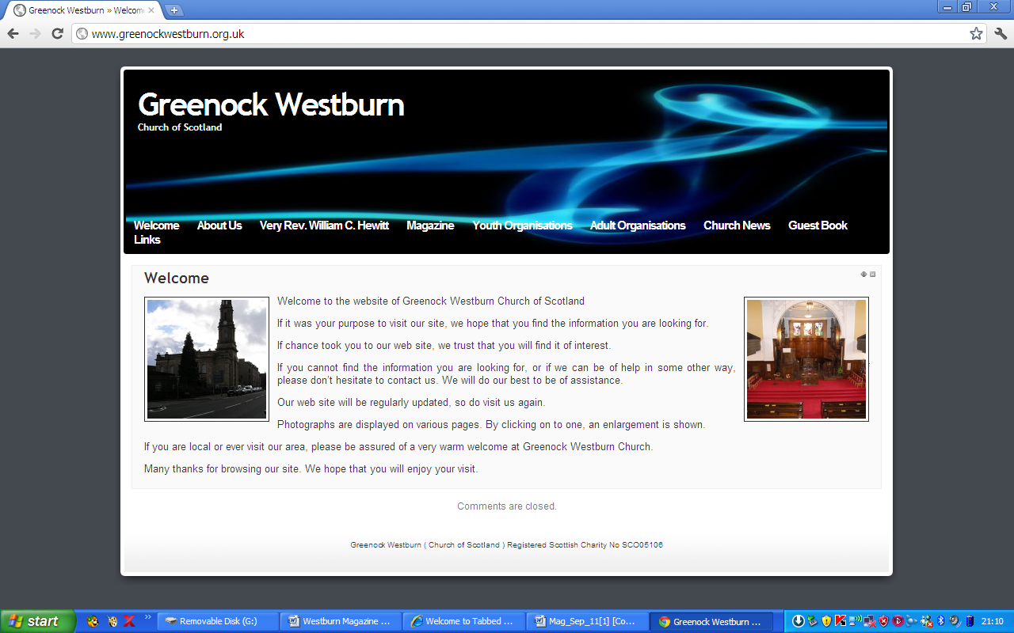
Have you put your syllabus, planned activities, or interesting comments about your organisation or group on your web page. If not it may look as though you’re not doing anything interesting. Have you looked at your page on the web, can you make it more interesting, add photographs, make comments, ask one of your members to write about what it is they enjoy about your group. Jim Bell will be happy to update your page.

A similar invitation is made to any church member who feels that they can assist in making the web site more interesting.

Our church web site can be found at - http://www.greenockwestburn.org.uk/ Please visit it and view it's contents.

Further information can obtained from Jim Bell ( 01475 799381 or all.the.bells@ntlworld.com )

Find us on FACEBOOK

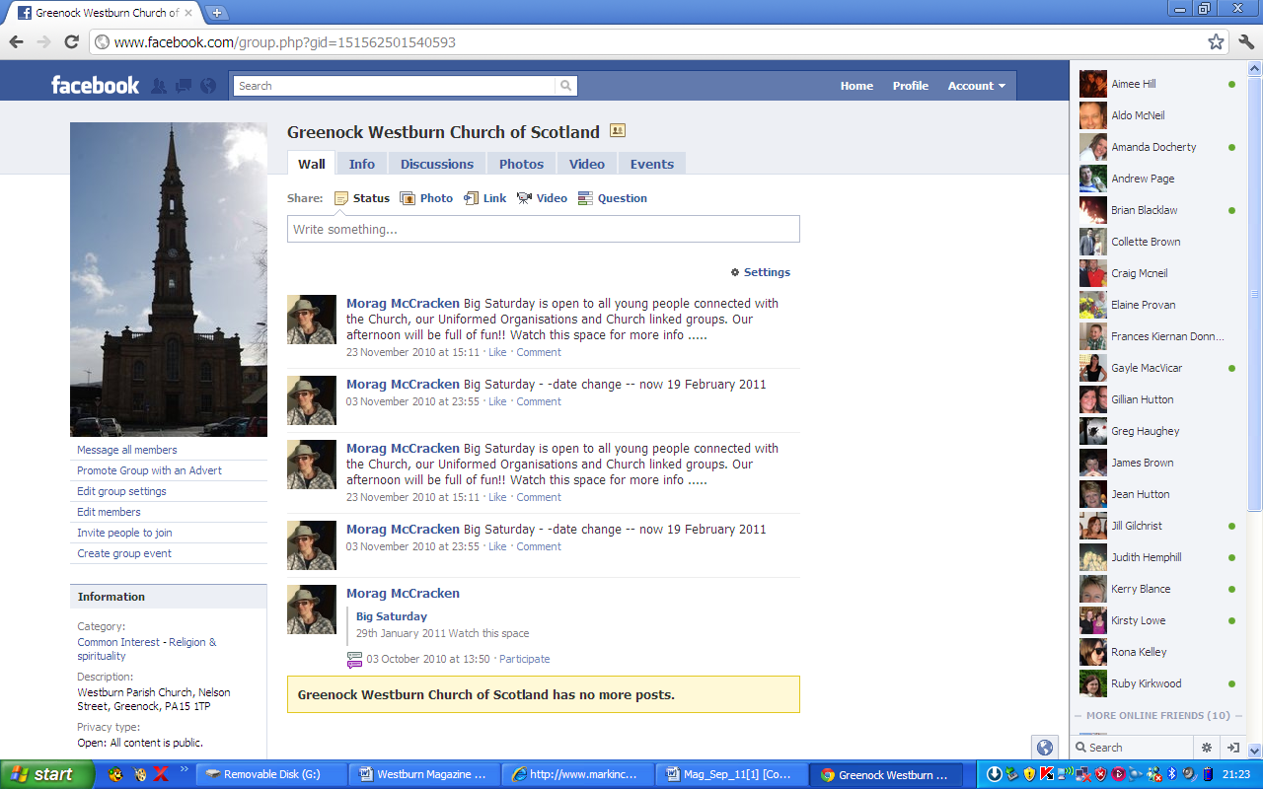
Search on FACEBOOK for “Greenock Westburn Church of Scotland” and join the social media revolution.


CHURCH FLOWERS

We are nearing the end of 2012 and we would like to thank those who donated flowers to enhance the Sanctuary Sunday by Sunday, those who arranged them and those who delivered them after the service. The flowers are greatly appreciated by those who receive them.

The calendar for 2013 will be available on Sunday 2 December, when anyone wishing to donate can put their name against the date which has a special meaning for them. If you are unable to come to church but would like to donate flowers on a particular date please telephone me (Patricia Robertson) the number is 725451.

Once again a special plea is being made for people to deliver the flowers after the service as it has fallen often to the same people and for a congregation our size it seems very unfair. There is a list available at the same time as the Flower calendar, we know that it is not always easy to commit to a particular Sunday months ahead but if members could look at the list from time to time particularly when you think you could be available to help out, it would be greatly appreciated.

Again many thanks to all who have been involved.

Linda Murray
Patricia Robertson
Flower Conveners


Church Library

It is good to see that many of you are enjoying the books which we have available in the church library stand.
Some new titles were added in the autumn.

Liz Smith (familystory@live.co.uk)


USED STAMPS

On behalf of World Mission many thanks to all members who have donated used stamps this past year.
Please continue to bring your stamps. The appeal for 2012 World Mission is to support an Argricultural Training Centre in Southern Lebanon. This centre runs courses for Palestinian refugees on topics such as planting vegetables and caring for fruit trees. They would also like to transform an old building to offer an opportunity to raise chickens.
Please continue to put your used stamps in the little red basket in the centre vestibule .

The amount already collected this year is over £2,000

Thank you. Evelyn Taylor

PROPERTY COMMITTEE REPORT
Winter 2012

The redecoration of the Sanctuary is now almost complete.

Recently the Chancel floor has been sanded and varnished. It is now back to it’s natural oak finish after the removal of nearly one hundred years of grime.

Work has started in the staining of the floor area around the pews.

As previously reported, to comply with Health & Safety Regulations, a smoke detection system has been installed throughout our premises. We are still in the process of putting procedures for fire alarm drills and evacuation to be put in place.
It should be emphasised that the system is live so the alarms can be activated

Work should start with lifting & relaying of the slabbed pathways on the frontage and side of the church early in November. Hopefully the disruption will not be too great as people come and go at the Centre door.

Similarly, it is hoped that the Centre doors will be replaced early in November. This is due to requirements of Health & Safety. Be aware that the new doors will be outward opening.

We took part in Inverclyde Doors Open Day over the week end of 8th – 9th September. As a first experience, it is thought that it was reasonably successful.

On the Saturday, there was an attendance of 46 over the day. On the Sunday afternoon, 7 people attended. After Morning Service, a number of the congregation took the opportunity to view the displays.

As the manse is now vacant, a programme of work has been put in place to carry out improvements necessary prior to a new minister taking up residence.

Jim Bell
Property Convenor

Interesting Facts about Our Church

We have included in the centre of the magazine a copy of a leaflet which was used at our Open Doors in September. This leaflet has interesting facts about our Church building both outside and inside and also includes a timeline from 1839 – 2006. Those on duty and those who visited found this leaflet very interesting we hope you do too.

WEEKLY FREEWILL OFFERING

Along with this magazine, members who contribute through Weekly Freewill Offering Scheme, should have received their new set of envelopes for 2013. If you do not receive your envelopes, please contact me as soon as possible at Tel: 720554
It would help if you have your W.F.O. number to hand so that I can get envelopes to you before the New Year.
If you have any problem please contact me at the above number or through your District Elder.

John. H. Munro WFO Treasurer

Church Cleaning

After an appeal a list was made up of 24 people who volunteered to help clean the church once a month. This has resulted in each team undertaking this task 4 times a year. The times this takes place is Wednesday morning, Wednesday evening, Thursday morning and Friday morning. If you feel you could help with this please contact me either at the church or phone 725451.

Thank you
Patricia Robertson

TIME FOR PRAYER

Here is a short but very powerful and evocative poem/prayer for Christmas by Gerard Manley Hopkins. Although it is short, it offers us much to ponder about the message of advent. If we heed that message, the Bethlehem star will lead us away from the weaknesses, faults and blemishes of our past, and on to meet Jesus, who came to meet us and make us better. If Jesus came to us at advent to make us purer, he must have had confidence in us, and we should respond to that confidence by showing our faith in him. But this short prayer says all that much more clearly and simply, so read on:

Moonless darkness stands between.
Past, O Past, no more be seen!
But the Bethlehem star may lead me
To the sight of him who freed me
From the self that I have been.

Make me pure, Lord: thou art holy;
Make me meek, Lord: thou wert lowly;
Now beginning, and alway:
Now begin on Christmas Day.

Amen.

Douglas Scott

The Guild

As I write this article, the guild has only met 4 times, one of which was the Presbyterial Council Autumn Rally at Inverkip when the Rev David McCarthy addressed us on our theme “A Faith to Proclaim” which was excellent and Communion was celebrated and led by Rev Iain Currie locum at Inverkip Church where out of just over 60 attending 21 were from Westburn Guild, well done ladies.

Next year’s syllabus is included in the magazine and the members would be delighted to welcome you to any of our meetings during the session (this includes men)
I said in the last magazine that we were now supporting 6 new projects; I will give some information into 2 of them in this magazine

Comfort Rwanda – Building a better Rwanda
In 1994 Rwanda endured an appalling genocide. Now, out of the ashes of horror, God’s people are demonstrating remarkable acts of repentance, forgiveness and reconciliation.

Comfort Rwanda is delighted to work with the guild to build a village of 100 homes in East-Central Rwanda for survivors (mainly widows) of the genocide. Our partner, The Healing and Reconciliation Ministry of Rwanda, brings together perpetrators of the genocide and survivors of the families they killed, for spiritual and practical support. Through the power of the gospel healed communities are being formed. Comfort Rwanda provides funds to build low-cost houses (£1000 each) for genocide survivors of these communities whose homes were destroyed and never rebuilt. “Whose we are and whom we serve” came from the mouth of Paul, a “violent aggressor” (1 Tim1:13) whom God transformed into a preacher of peace. Now from his teaching the reconciliation of the cross is taught to ex-perpetrators and survivors and the fruit of the peace and provision for widows is the result.

CrossReach/Social Care Council (Church of Scotland) – Heart for Art

Significant international research has identified that there are enormous benefits to using Creative Arts. This enables people with dementia to connect with society and express themselves, whilst breaking down the barriers of preconception, stigma and discrimination promote creativity, self worth and achievement. From the early stages of the project the benefits of active life long learning, acting with purpose and the concentration on creative tasks has been visible. The Heart for Art project is designed through early intervention
The project offers the opportunity for people with dementia and their carers throughout Scotland, to build supportive relationships and access support and advice from CrossReach staff. The National Dementia Strategy for Scotland predicts a huge increase in the number of people with dementia over the next two decades.
CrossReach has a history on innovation in dementia care, opening the first service exclusively for people with dementia within a homely environment in 1983. The Heart for Art project continues this trend, focusing on citizenship and opening up another avenue in promoting the abilities and potential of people with dementia.
By the time you receive this magazine the annual fund raiser of the Guild, namely the Coffee Morning will be over but I would hope to have seen many of you at the Coffee Morning.
Date for your Diary Sunday 18th November
Songs of Praise in our church at 3pm. This is being hosted by the Presbyterial Council to commemorate the 125th Anniversary of the Guild. It is open to all members of the congregation once again including men. There will be a cup of tea afterwards in the hall.

Patricia Robertson
Leadership Team Co-ordinator.

Guild Syllabus for 2013

January
8 Beacon Arts Ms. J. Ellan
15 Storytime Mrs. E. Murdoch
22 In House
29 Norfolk Broads Rev. D. Young

February
5* Presbyterial Council ABM
Old Gourock & Ashton
12 Project - Heart for Art Mrs. M. Cassidy
19 AMB and Bible Study with Bring and
Buy Sale Revd. M. Coull
26 A Peek behind the Festival Mrs. A. Reid
Lyle Kirk Guild visiting

March
5 Guild 125th Anniversary
11(Mon) Presbyterial Council Spring Rally
Hamilton Bardrainney, Port Glasgow
19 Oberammergau Mr. I. Milne
26 losing Meal

Date marked * starts at 2.00 pm.
All other meetings start at 7.30 pm

The Guild looks forward to welcoming you to all or any of our meetings.

5th Greenock and District Scout Group.
The group has been increasing at the top end, i.e. Scouts and Explorers, with four Cubs moving up and a few Scouts into Explorers and their enthusiasm has only increased. In October we had a 'night hike' with 12 Scouts/Explorers taking part with 3 leaders. The hike took them over the hills to Everton where they camp out overnight, or at least, what was left of it! We also had a day hike at Bridge of Orchy, just beyond Tyndrum, by 6 of our Scouts. Both events went smoothly with a great time being had by all. Two very good Scouting outings.
Unfortunately, the gain of the Scouts means a loss for the Cub section and we currently only have 2 boys regularly turning up. Within the Beaver section we have only 3 boys regularly turning up and for the time being, we're having combined Beaver and Cubs meetings on a Friday night so we are able to have crafts and games as normal. We had a leaflet drop at the end of September and are currently working with the local schools to create new members through the Curriculum for Excellence Programme so we're hopefull for new members over the coming months. We'll just have to be patient!
As you read this we will all be in the throws of Christmas activities, yet again. I hope you and yours have a pleasant and peaceful Christmas and New Year and are able to look forward to 2014 with fresh hope and enthusiasm.
Yours in Scouting,
Ricky Martin GSL

Local Internet Radio Station
The following communication was received, if this is of interest to you, either to listen to, or advertise a coming event please contact direct, as detailed below.

Hello I am David Faller I am from Inverclyde Radio www.inverclyderadio.com we have just started broadcasting online.

Is there any chance you could please put a wee bit of info about our Internet radio station in your next magazine to let people know Inverclyde now has its own local Internet Radio station broadcasting online at www.inverclyderadio.com We will also add your website you our links page http://www.inverclyderadio.com/links.html
The main aim of Inverclyde Radio is to bring you as much audio content about our area as possible, plus a varied mixture of music chosen by our enthusiastic presenters.

We will seek information about community events in and around our area here in the West of Scotland. Interview groups and individuals who have something to tell our listeners, be it about their organisation, hobby, event or music.

With so much talent throughout our area, we will also be encouraging theatre groups to let us know what they are up to and in particular, we will feature local music and gigs too.
Is there any up and coming events or meetings at Greenock Westburn Church I could add to our what's on guide.

Thank you for your time
Kind Regards

David Faller
Inverclyde Radio
www.inverclyderadio.com
twitter.com/DavidRFaller

CHURCH SERVICES FOR ADVENT.

Dec. 2^{ND -} Communion - 11 am
and 3 pm in Hall

Dec 9^{th -} Worship - 9.30am and 11 am.

Dec 16th Gift Service - 11am

Dec 23rd Family Service – 11am

Dec 24th - Fellowship with Tea and Christmas pies – 10pm
Carols - 11.15pm
Watchnight Service - 11.30pm

Dec 25th - Short Christmas day Service 11am.
( Bring a toy )

Dec 30th - 11am

We look forward to welcoming you to these services as we journey through Advent together.

The Story of a Christmas Carol
From Stories of the Christmas Hymns by Helen Salem Rizk

‘O Little Town of Bethlehem’
Phillips Brooks, 1853 – 1893

The dramatic birth of this popular Christmas hymn was as sudden as the Announcement of the angelic hosts, concerning the birth of Christ, to the Shepherds in the fields outside Bethlehem. The seeds of the hymn were sown in 1865 when on Christmas Eve in Bethlehem, Phillips Brooks, noted Episcopal Bishop, attended services in the ancient basilica claimed to have been built by Emperor Constantine in the 4th century. He was a young minister, at the time, and the beauty of the simple service made a permanent impression on his heart.
Three years later, while rector of Holy Trinity Church, Philadelphia, at the Request of the children of the Church School, Phillips Brooks wrote a new Christmas Song. His trip to the Holy Land came back to mind vividly and He penned these beautiful words: O Little town of Bethlehem How still we see thee lie;
The thought of the little town of Bethlehem was so strong in his mind, that Brooks completed the entire hymn in one evening.
The next day when Lewis Redner, Organist and Church
School Superintendent, came to his study, Phillips Brooks game him the poem and asked if he could write some music for it so that it could be sung during the Christmas season. Redner waited for inspiration, but none came. On the night before Christmas he woke suddenly, in the middle of the night, the melody of the song ringing in his ears like happy bells. Seizing the nearest piece of paper he wrote down the music that was so clear in his mind, and went back to sleep. In the morning he harmonised the melody, and that same day the little children of Holy Trinity Church sang for the first time one of the most loved Christmas Carols.

O Holy Child of Bethlehem, Descend on us we pray;
Cast out our sin, and enter in; be born in us to-day
We hear the Christmas angels the great glad tidings tell;
O come to us, abide with us, our Lord Immanuel.

FROM THE ROLL-KEEPER

DEATHS
Mrs. | A. | Lower | 10 Sharp St. | 10 | died Sept.
Miss | M. | White | 3b Riverside Gdns. | 10 | died June.
Mr. | P. | Stalker | 120 Dunlop St. | 15 | died Sept.
Mr | R. | Bain | 122 Hawick Ct. | 19 | died Oct.
Mrs. | C. | Bincham | Bagatelle Nursing Hm. | 22 | died Sept.
Mr. | A. | Bovaird | Ravenscraig, Dunrod Unit | 22 | died Sept.
CHANGES OF ADDRESS
Dr. | C. | Barbour | 13 Ardgowan St. | 6 | from D30
Mrs. | F. | Loughran | F.A5, Elliot Ct., Carwood St. | 19 | stays D19
Mrs. | M. | Kennedy | Glenfield Nursing Hm. | 22 | from D8
Mrs. | V. | Paterson | Balclutha | 22 | from D8
Mrs. | M. | Robertson | Seabank Care Hm. SALTCOATS | 22 | stays D22
ADDED TO LAST KNOWN ADDRESS LIST
Mr.&Mrs. | M. | Coyle | 29b Eldon St. | 30 | from D7
FROM RESPONSES TO STEWARDSHIP CAMPAIGN
TRANSFERRED TO SUPPLEMENTARY ROLL
Mrs. | H. | Macdonald | 150 South St. | 3
Mrs. | M. | McQuat | 10 Denholm St. | 3
Mrs. | A. | Sutherland | 6 Drums Ter. | 8
Mrs. | L. | Conaghan | 14 Steel St. | 10
Mr. | A. | McNeill | 2 Cowal Pl. | 11
Mrs. | C. | Morrison | 2 Arran Rd. | 11
Mr.&Mrs. | A. | Jackson | 15 Skye St. | 13
Mr. | D. | Craig | 134 Old Inverkip Rd. | 14
Mr. | A. | MacNiven | 13 Mount Pleasant St. | 16
Mrs. | M. | Fulton | 62 Royal Ct. | 18

IN ORDER TO KEEP CHURCH RECORDS UP TO DATE, IT WOULD BE GREATLY APPRECIATED IF ANY MEMBER WHO IS MOVING INFORMS THEIR ELDER, THE SESSION CLERK, OR THE ROLL-KEEPER OF THEIR NEW ADDRESS.
PRESBYTERY OF GREENOCK AND PAISLEY SEP/OCT REPORT 2012
GENERAL ASSEMBLY REMITS: - Presbytery is instructed to investigate issues of
Food insecurity within their bounds and act ECUMENICALLY to establish
FOOD BANKS and also continue to provide support for HOMELESS PEOPLE
In their local area.
INSTALLATION OF NEW MODERATOR:- Retiring Moderator, Rev S. Steell was
Thanked for his service and Rev Alan Sorenson installed as new Moderator. He
Thanked Presbytery for the priviledge entrusted to him.
BUSINESS COMMITTEE :- Presbytery Planning Review Committee Convenor
Continues to have conservations with the PPGT answering concernsthey have about the Plan.
VACANCY PROCEDURE COMMITTEE:- Rev D. Young was granted permission to demit his charge on 28th Oct. Rev Lorna Hood is appointed as Interim Moderator for the duration of the vacancy. John Hawthornespoke on behalf of the congregation, He praised his youthful vitality and first class preaching.
He encouraged young people and supported different foems of worship.
PROPERTY COMMITTEE:- Greenock: Lyle Kirk was granted an extension until
June 30th 2013 to make a final decision on their buildings.
Grerenock: Westburn was given permission to install an integregated smoke
Detection system at a cost of £10,386. The manse requires internal improvements and redecoration costing £8,500 and external repair, repointing and repainting costing £16,500.
WORLD MISSION AND ECUMENICAL RELATIONS
We are encouraged to pray for the church in Syria.
HEALING ROOM:- IreneMunro spoke about this facility in the Mall but they had started off at Wellpark:Mid. They have an open approach and appeal with people with faith and no faith and sometimes because of their ministry people come to faith. They offer a service to people with cronic conditions like depression and sometimes people are healed. They have conversations about the Gospel if people wanr that.
AID FOR EDUCATION:- This is a charity working in Rwanda and Mount Kirk has an ongoing involvement with this project. Ther oproject supports an after school club and in their outreach to families encourage them to keep their children in school. Volunteers from Inverclyde go to Rwanda. They now have a full time teacher and Bible clubs. Their emphasis is on literacy so that children can read the Gospel.
MISSION AND DISCIPLESHIP:- SAFEGUARDING: The Presbytery is up to date in
Safeguarding Training. General Assembly remit: “ Instructs Presbytery to encourage congregations to make full use of Safeguarding Handbooks.”
The Safeguarding Handbooks come in sets of 4 and currently only Book 1 is
Available. Retrospective checking for volunteers already serving in position will begin on 20th Oct.2012. ( from Margaret Crawford Presbytery Elder )

Sun cream, sun glasses, ferry tickets – OK, ready for church!
In July this year I had the pleasure of visiting, Saint Andrew’s Scots Kirk on the Maltese Islands in the heart of the Mediterranean. The congregation is a partnership between the Church of Scotland and the Methodist Church of Great Britain.
The advent of Christianity on the Island of Malta dates back to the arrival of Saint Paul - who was shipwrecked on route to Rome. The inhabitants have remanded devoutly Christian ever since. Indeed there are 365 Catholic parishes in Malta – one for every day of the year.
Malta’s strategic importance at the centre of the Mediterranean made it a sought after jewel in the crown for many foreign powers. Protestant worship arrived on the island during the period of British Rule (1800-1974) when a variety of ministers were sent to serve the substantial British military presence.
While Anglican, Lutheran and other churches exist, Saint Andrew’s Scots Kirk is the only reformed church in Malta, providing English language services to regular worshippers from four – sometimes five – continents. The diverse congregation includes British ex-pats, holiday makers, African refugees as well as local Maltese people.
The church is based in the capital Valletta – a short ferry ride from the resort of Sliema – and the building is shared with a German Lutheran congregation who hold services in the afternoon following the English worship.
The current minister is the Rev. Doug McRoberts - formally of Keith North Parish Church in Banffshire. On his retirement, he will be replaced by a Methodist preacher. Interestingly prayer requests were noted in a little red book and these requests were incorporated into ‘Prayers for Intercession’ at each week’s service. Visitors and members were invited to add to this little red book and the congregation pledged to remain faithful in prayer to each request.
I would encourage anyone visiting Malta to go to the Saint Andrew’s Scots Kirk and share worship with them. For more information visit www.saintandrewsmalta.com.
Please remember the ministry and mission of the congregation of Saint’s Andrews Scots Kirk in Valletta in your prayers for others.
Simon Hutton

