

WELCOME to the Spring magazine. And once again it carries The Easter message a bit early . As you all know the magazine comes out in time for elders to do their pre-Communion visits, Communion Sunday being Sunday the 4th March it makes the Easter Message very early. Perhaps it is not a bad thing that we take more time to reflect on Easter. Easter is a time for mixed emotions with Jesus’s betrayal, his painful journey to the cross, the pain and horror we still feel when we recollect our Lord’s crucifiction nailed to a cross on that lonely hill, and yet we wonder at his ability to ask his father’s forgiveness of his perpetrators and then what absolute joy as we celebrate Easter with that good news “ Our Lord is Risen HE IS RISEN INDEED !”
For us in Westburn this magazine will bring for us a time of mixed emotions a time for sadness and loss as our minister moves on to pastures new and the congregation starts on a journey of change of moving on , this journey will take longer than the Easter journey but with faith, hope, commitment and sticking together we will move on to a new stage in the life of Westburn.
We have enjoyed the last eighteen years of Bill’s ministry, and will be sorry to lose him, we will certainly miss his preaching and we will miss Bill and Moira and all the family who have become our friends .
Our Love our Prayers and very good wishes go with them, and we wish Bill God’s Blessing as he seeks to serve God in Interim Ministry.

The next magazine material is due by 22nd April. e-mail to cathbarbour@btconnect.com or to Joe Craig.

WELCOME to the Christmas magazine. Yes it is far too early to be sending the Christmas message – OR IS IT ? Those of us who are very well organised will already be well ahead with their preparations. Cards bought, some presents selected and maybe even wrapped ! Children already counting the days to Christmas and the media and shops reminding us of the number of shopping days to go. One of my friends finding some unplanned time in October baked her Christmas cake and Christmas pies, now that is what you call being organised! In our Christian Calendar it is not too early as we take time to journey to Christmas through Advent, celebrating Hope, Joy, Peace and Love ensuring that we are well prepared to celebrate The birth of our Lord.

Once again we report in the magazine, renovations in the sanctuary, there are also details of our worship for November and December which will be in Lyle Kirk’s Esplanade building, details in the Minister’s letter and a worship calendar at the end of the magazine.

The Communication Committee wish you all a Happy and Peaceful Christmas Season.

Material for the next magazine is due by last week in January 2012 either to
Joe Craig or Cath Barbour at cathbarbour@btconnect.com
© 2007



The Manse
January 2012

Dear Friends,

It is hard to believe that almost 18 years ago I wrote my first letter for the St Luke’s Church Congregational Leaflet. One of the advantages of being a hoarder is that I still have a copy of that magazine, dated March 1994; one of the disadvantages is that we have 18 years of hoardings to sort out and decide what to move and what to take to the dump. I think I will become very friendly with the staff at Pottery Street over the next few weeks!
In that magazine I commented on the warmth of the welcome that we had received on our arrival in Greenock and I want to thank all those who over the past 18 years have made our stay here so happy. It has been a hard decision to leave but one that I believe is right for the congregation. I remember well being asked by the vacancy committee if I planned to stay for more than 5 years. I think I replied that I didn’t know how long I would stay. I now think that the time is right for someone new to come and take the congregation into the next chapter of its history. It would have been easy to stay and gently work towards retirement but I think the congregation needs new focus and maybe I do too. I strongly believe in the call of God and I hope that I can offer something to this new area of service.
During these last 18 years there have been so many good times and the support and the encouragement and the loyalty which I have enjoyed have been truly a blessing. I know that there are so many people that I owe a debt of gratitude to, but allow me to mention first of all Alex Cameron who led me into the life of the congregation and then Stewart Robertson who has been the best Session Clerk any minister could hope for. To the whole congregation I want to say thank you for allowing me to be your minister, to share the good times as well as some of the sad ones. Thank you for your forbearance and for all your encouragement especially during the Moderator’s year when I know so many people were enthusiastically supporting Moira and I in thought and prayer.
Westburn Church is rightly held up as a lively active outgoing congregation. It is seen as an example of how unions between churches can work successfully and I thank the members of St Luke’s and St George’s North who have played a full part in making this union work so well. Having taken these last five years to grow together it is time to plan for the next five and beyond and this time of vacancy will allow the Kirk Session to decide what direction the congregation must go and who might be the right person to lead them.
Again my sincere thanks. I pray that God will richly bless you and that you will continue to serve him here in this place, an open welcoming community of God’s people. I hope that we will not lose touch and I will watch with interest the future developments of Westburn Church.

Yours faithfully
Bill Hewitt

The Very Rev. W. C. Hewitt BD Dip PS

Greenock: St. Luke’s and Greenock: Westburn

1994 – 2012

On Sunday 4th March, the Very Rev. W. C. Hewitt will preach for the last time as minister, after 18 years of service to the church and community here in Inverclyde. Demitting office on Monday 5th March, Mr. Hewitt will join the Interim Ministry team of the National Church and be placed where most needed in West of Scotland area..

There will be an opportunity to say farewell to the Hewitt family at a Buffet lunch, after Communion and prior to the official presentation.

I do hope, all members of the congregation will be able to attend and be part of what will be a memorable occasion and an appropriate end to a ministry of the Very Rev. W. C. Hewitt here in Greenock.

Stuart Robertson
Session Clerk
Introducing our new Youth Worker
EMILY BUCK !

Emily is a student at the International Christian College in Glasgow, studying to become a youth worker. Emily will be with us for a period of four years (minimum) working twenty hours a week while she studies at college .

Emily has already made links with Clydeview Academy and Ardgowan Primary School. Emily is within a chaplaincy team at Clydeview and has already taken two assemblies within the school with the entire first year.
She hopes to make further inroads with the school soon by starting a lunchtime club for S1’s or by making another valued contribution to the school.

At Ardgowan Primary she hopes to start an after school club for P7 which in time will allow her to set up a stronger relationship with Clydeview and establish a link with the pupils as they progress through the education system.

Within our own congregation Emily is trying to set up a youth club for P7 to S3 and will visit our uniformed organisations often, she is currently assisting the bible class leader Gaie Brown every Sunday and quickly established a strong bond with the members.

Emily is going to be leading children’s church regularly towards the end of each month and will be involved in The Big Saturday youth event where we hope she will be socialising and getting to know the young people within the church.

We wish Emily luck in her time at Westburn and hope that both she and the church will profit from her efforts.

All our congratulations and good wishes go to Emily on the news of her recent engagement.


CHURCH NEWS BOOK

If you are aware of anyone who is ill or would benefit from a visit from the minister, please make an entry in the news book with their name and address. It is helpful if you sign your entry.

.



Life and Work
Life and Work is available on the last Sunday of every month priced £1.60
Subscriptions available.

Please contact Shelagh Hendry Tele. 794667.
Delivery can be arranged if you are unable to get to church.

Greenock Westburn Church Web Site
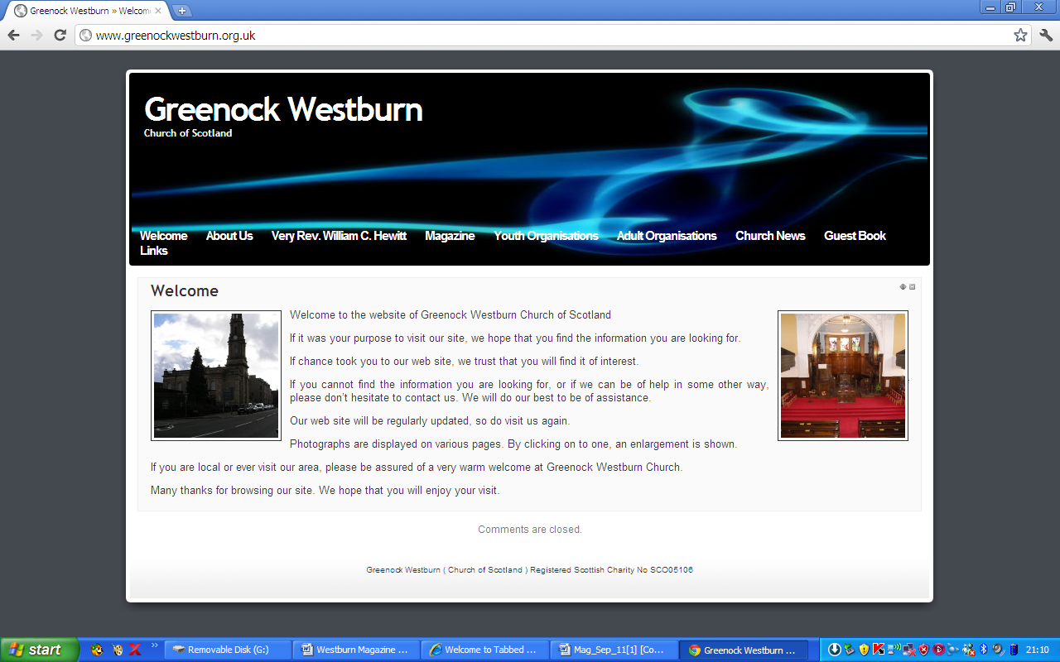
Have you put your syllabus, planned activities, or interesting comments about your organisation or group on your web page. If not it may look as though you’re not doing anything interesting. Have you looked at your page on the web, can you make it more interesting, add photographs, make comments, ask one of your members to write about what it is they enjoy about your group. Jim Bell will be happy to update your page.

A similar invitation is made to any church member who feels that they can assist in making the web site more interesting.

Our church web site can be found at - http://www.greenockwestburn.org.uk/ Please visit it and view it's contents.

Further information can obtained from Jim Bell ( 01475 799381 or all.the.bells@ntlworld.com )

Find us on FACEBOOK

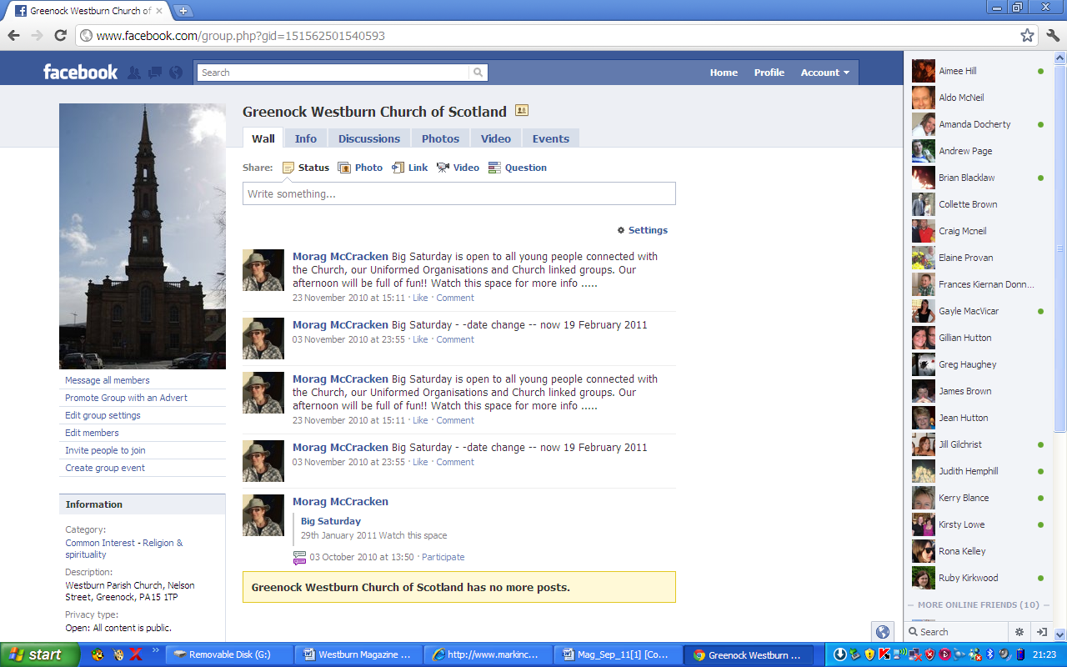
Search on FACEBOOK for “Greenock Westburn Church of Scotland” and join the social media revolution.

PRESBYTERY REPORT NOV/ DEC 2011

Notices :- The Moderator thanked the Readers for their work both in preaching and pastoral care within the Presbytery

Ordained Local Ministry : - There will soon be 2 OLMs in Presbytery . Applications for their assistance should be submitted in writing with details of how they should be deployed.
Business Committee :-Presbytery noted the intention of Very Rev Bill Hewitt from Greenock Westburn to den⁻tit his charge on 5th March 2012 to become part of the Interim Ministry team. It was agreed to enter into a pilot of the Ministry Council delegated budget procedures during January to April 2012.

Zimbabwe :- The twinning of St. Andrew's Bulawayo and Greenock Lyle Kirk was approved and the committee was instucted to consult with the Presbytery of Zimbabwe over the renewal of the covenant.

Mission and Discipleship : Euan Paterson from Port Glasgow : St Andrew's has been elected as Moderator of the National Youth Assembly.

Community Interests : - We are asked to " Pray for our Projects " in particular "Talk it over Group " a support group for mothers with post - natal depression. This group won the Herald Society award for Health Provider of the Year and are available for Presentations to any Guild or interested group - also the ongoing development of the Paisley Christian Social Action Centre for homeless people.

Property :- Presbytery approved replacement windows at Greenock Westburn manse together with other works at a cost of £12,000. The windowl:rwere seriously damaged last year and repairs have to comply with the requirements of being in a conservation area.

Margaret Crawford Representative Elder

Pastoral Care Committee

- Christmas Café – the Café was well attended by Members, Friends and Members of other Congregations. Many thanks to those who donated Christmas pies, Shortbread etc and to the Ladies for providing tea and coffee.
- District 22 – all members were visited before Christmas including a visit from the Minister.

- Meetings - the next meeting will be held on Monday, 27th February 2012 at 2.30pm in the lounge.
4 Communion – 4th March – as there is no afternoon Communion, transport will be available to those Members who normally attend the afternoon Communion.

If you would like to come and attend Bill Hewitt's last service, and you require transport, please tell your Elder or contact Bill Dempster.
Thanks,

5. Home Visits – the following Members have advised that they visit members of the congregation in their homes - Margaret Watkins; Ann Mills. Sandra Cook visits Glenfield.

Bill Dempster


CHURCH FLOWERS
It would be appreciated if more members of the congregation would volunteer to deliver the flowers after the service on a Sunday. Those receiving them are grateful for this service particularly those who don’t get out and are pleased to be kept up dated with the life of Westburn.
Your names can be added to the sheet on the table in the centre foyer while we worship in the centre hall and at the foot of the north gallery stairs when we return to the sanctuary. If you cannot find it a member of the duty team can direct you.
Members can also add their names to the donor list which can be located in the same place.
Thank you in anticipation
Patricia Robertson
Reports from The Property Committee

Sanctuary Ceiling Update–(21st January 2012 )
This project, which was original planned to run for some 13 weeks from August until early November, ‘11, only really started with the repair work on 11th October!
The plaster company then worked in the premises for 11 weeks until the 23rd December and our amended return to the Sanctuary in time for the 4th March Communion seemed highly unlikely.
Following discussions with the Edinburgh Church Art adviser, the Painting Contract Manager and ourselves, paint colours etc were agreed, approved and ordered together with an additional, special sealant, considered necessary by Dulux, as vital to initially cover the lime plaster-crack repairs over the entire ceiling.
Painting work began on 9th January and with the assistance of their Contract Manager a new timetable (which included Saturday working on 14th, 21st and 28th January) was produced which, dependant on Painters, Scaffolders and Commercial Cleaners, should allow the previously uplifted downstairs carpets to be refitted a few days prior to Communion Sunday.
It will not be possible to fit the new Gallery carpeting and cushions until two or three weeks later and the patch-plastering, matching-painting of the Entrance Foyer and Stairwells no earlier than mid April. Volunteer labour from congregation members is likely to be required during the first three days of March to reposition Communion Tables, Fonts and other furnishings

Late December Storm Damage
All the Church Buildings, including the Manses, suffered damage to a greater or lesser extent during the recent storm winds and accompanying downpours.
The Main Hall flat roof suffered damage in that the Nelson Street facing cap metal was torn off and some 9 metres of it deposited against the boundary wall on the Nicolson Street side of the Centre Facility. For some time parts of the structure of the actual roof appeared likely to follow.
The Church Tower has 9/10 windows cracked, broken or completely removed, some of which will required scaffolding to access and replace. The Sanctuary building roof was damaged in very many places. Lead ridge flashing was partially removed and twisted or torn off and moved and the lead subject to damage through being pierced or holed by flying slates. A large, recently replaced lead gulley appears to be one of the severely damaged areas.
The Main Hall was made watertight in hugely difficult circumstances by volunteer labour on the 2/3rd and photographs for Insurance purposes taken from the Sanctuary Ceiling loft and from the actual roof, prior to having it made provisionally watertight.
Repair/replacement quotes have been obtained and a visit from the Insurance Company Loss Adjuster is awaited .

Andrew Borland

TIME FOR PRAYER

In the last issue we had a Christmas prayer from 12th century France. Here to follow on is an Easter prayer from the same time and place. With vivid imagery this short prayer reminds us of the stark choice that we all have between good and evil. Jesus’ resurrection at Easter proclaims to us the final victory of the power of good. Will we rise up with him or will we be with those who are pushed downwards? Jesus has given us the example, and shown us the way; now the choice is ours.
EASTER

I see the flames of orange, yellow and red
shooting upwards to the sky, piercing the white clouds.

I see the clouds themselves chasing the flames upwards,
and I feel the air itself reaching for the heavens.

Down below I see great, grey rocks beating against the earth,
as if they were pushing their way down to hell.

At your resurrection that which is light and good rises up with you,
and that which is heavy and evil is pushed downwards.

At your resurrection goodness breaks from evil,
life breaks free from death. Amen.

Douglas Scott.

USED STAMPS

On behalf of World Mission may thank all members who have donated used stamps this past year.
As the period ends in February the amount which will be given to this year’s project ‘Mount Olivet Boys Home’ will be in the region of £3,100, so many thanks indeed.
World Mission will select a new project for 2012 which we will hear about in due course, so please continue to put your used stamps in the little red basket in the centre vestibule .

Evelyn Taylor

EASTER HOLIDAY CLUB

Any adult interested in helping out at our Easter Holiday Club should contact Morag McCracken (our Youth Committee convenor) who is arranging adult assistance for this event. Parents wishing to reserve a place for their child should contact Morag on 07963871810. First come places reserved!! Watch this space for Emily giving more details of the activities that will be on offer over the week!!!



Venda
The congregation recently donated funds to our various African projects. One of these donations went to The Vhitshilo School in Venda. You may remember Sue-Anne and her daughter Wavho visited Greenock and spoke to the congregation about the progress at the school. We were delighted to receive this thank you e-mail from Sue Anne addressed to Monica McNeill who arranges the donation to be sent to the school.
Tuesday 20th December, 2011
Thanks to Church
Dear Monica,
Please thank the members of the congregation for the generous donation. The money will come in very useful as we need to send out quite a few food parcels over the long holidays. We try to give the needier families a parcel before Christmas and then another one in January as the school only re-opens on the 18th. This is usually a bad month as the families have to buy school uniforms for the older siblings. At least we can now ensure that they will have some food until those children under our care are able to receive their 2 meals every day. The parcels are supplemented with fresh vegetables from our school garden.
We wish you all the best for a wonderful Christmas and a happy, healthy and prosperous New Year
Warm regards
Sue-Anne, staff and children

THE GUILD

By the time you receive this we will have started our 2012 meetings.
On 1st. November we had Union 3+1 visiting. Almost 100 members and friends of visiting guilds including our own Guild members enjoyed a wonderful musical evening by a group who are Guild members from Lenzie. We held our annual Coffee Morning and raised £690. Our thanks to everyone who helped and also those who came along to support our fundraiser. Again due to the weather being stormy and wet we had to cancel our meeting with Rev Dr.G.A. Chestnutt. Last years cancellation was due to the snow so maybe next year it will be dry and we can hold our talk on Guild Theme. Our Christmas evening went ahead although it was a very wintry night and our ladies all enjoyed their Christmas meal followed by singing carols.

I would like to advise you that at our Closing Social on 27th March we are being entertained by the Largs Gaelic Choir and tickets will be on sale to all church members and friends.
Senga Currie
Leadership Team Co-ordinator.

Guild Projects update

As the final year of the 3year strategy reaches its conclusion I would like to give you the latest figures for the support of these projects. The 6 new projects will be announced in April and I will tell you what they are in the first magazine after the announcement along with the final totals for the current projects.

Totals to December 2011
- CrossReach - On the other side (Scotland) - £127,530.34
- HIV Programme - A New Hunger (various countries) - £77,211.09
- International Justice Mission - Terrify No More (Cambodia) - £107,412.32
- Ministries Council - A Place for Hope (UK) - £64,003.99
- Mission Aviation Fellowship - Mission Run (Madagascar) - £87,018.32
- World Mission- Interfaith Support (Israel/Palestine) - £58,667.40
Total: £521,843.46
FROM THE ROLL-KEEPER

DEATHS

Mr. L. Stewart 43 Finnart St. 5
Mr. D.Y. Evans F24, Seafield 7
Mrs. M. Pollock Flat 1/2 Manor Ct. 92 Manor Crescent 10
Mrs. F. Campbell 4 Roxburgh Ave. 18
Mr. A. McQuarrie 86 Hawick Ct. 19
Mrs. N. Galbraith COS Care Home, Clarkston 21
Mrs. N. Galbraith COS Care Home, Clarkston 21
Dr. A. Pow Bagatelle Nursing Hm., 47 Eldon St. 22

DISJUNCTIONS

Mrs. D. McMahan 30 Brisbane St. 5
to Baptist Church
Mrs. E. Blackley 24 Blair Gdns. 11
to St. John's, Gourock
Mrs. A. Christie 10 Cumberland Ave., Helensburgh. 21 to St. Andrew's Kirk, Helensburgh

CHANGES of ADDRESS

Mr. D. Scott 26 Stewart House 1 from D14
Ms. F. Campbell 19 Robertson St. 5 stays D5
Mr. N. Macdonald 29 Dun More Ave., Lochgilphead 21 from D30
Mrs. R. Barbour Alt-na-craig 22 from D7
Mrs. M. Shand Larkfield View Burns Rd 22 from D17
Care Hm.

To LAST KNOWN ADDRESS list

Mrs. L. Rebecchi 93 South St. 30 from D3
Mr.&Mrs. J Small 3 McPherson Dr. 30 from D11

IN ORDER TO KEEP THE CHURCH RECORDS UP TO DATE, IT WOULD BE GREATLY APPRECIATED IF ANY MEMBER WHO IS MOVING INFORMS THEIR ELDER, THE SESSION CLERK, OR THE ROLL KEEPER OF THEIR NEW ADDRESS.

