

“WORSHIP, FRIENDSHIP, ACTION – a kirk that cares. “

Welcome to the Christmas Magazine 2013

It’s very difficult to think of Christmas this early, although I know some folks have already started their preparation, whether it’s sorting out Santa’s list for the children, or inviting guests to share at your Christmas table there are a lot of things to plan and to think about to make our Christmas celebrations a happy time.

It won’t be long before we start to prepare for Christmas in Westburn as we journey through Advent in preparation to celebrate the birth of our Lord , a meaningful and special journey, a happy time – a great christian celebration.

As we look forward to a new year there are a lot of preparations to think about in Westburn to make sure we have everything in place to celebrate and welcome our new minister Rev Karen Harbison MA BD
‘ A HAPPY TIME AND A GREAT CHRISTIAN CELEBRATION ‘

Material for next magazine is due by Sunday 18th January 2014
e-mail to cathbarbour@btconnect.com



From the Interim Moderator

Just these words
……………………………..to say CONGRATULATIONS! You have a Minister–elect: the Revd. Karen E. Harbison, MA, BD.
At the Congregational Meeting held immediately after she preached as Sole Nominee on Sunday 27th October 2013 Karen was elected and appointed as minister to the vacant charge of Greenock; Westburn. We now await the procedure to be followed that will bring forward a date for Karen’s Induction as your Minister by the Presbytery of Greenock & Paisley. We will notify you as soon as we know.
Thanks to the good offices of Stuart Robertson, Session Clerk (who was also the Convener of the Nominating Committee) all member households should have received a leaflet giving some background information about Karen and her family. I’m sure that more will be revealed at the Social which will follow the Presbytery Service of Induction in Westburn Church. (Possibly early to mid-January 2014). The future calls us.

And so to Advent and Christmas. We live in an age when the challenge to the Christian faith cannot be underestimated. It is recorded that at a Baptismal Service when a baby was baptized in the name of Jesus a little child present in the congregation asked “Why name the baby with a swear word?” If we were in any doubt about the decline of the Christian faith in 21st century Britain (it still remains the fastest growing faith throughout the world) then that child’s question should clarify our thinking. The name of Jesus is associated with nothing more than a curse in the minds of many in our society.

“Why name the baby with a swear word?”. That child’s question is particularly poignant at this time of Advent. The four weeks of Advent give us an opportunity to prepare for the coming of Christmas by focusing our attention
on the question “What do we really want for Christmas?” (apart from a new minister). And to separate the things we want from the things we most deeply need. Advent begins with a pretty realistic look at this world of ours, and goes on to speak of the hope that God’s word brings to us. The hope that no matter how long the road, how dark the night… yet the dawn will rise, the light will come and God’s will shall be done on earth as in heaven.

Jesus Christ! Not a curse, but a blessing for you and for me and for the world that God loves.

May the joy and peace of Christmas be yours,

And every blessing for a Good New Year!

Hold us in your prayers as we hold you in ours,

Morris Coull (Interim Moderator & Locum Minister)

Special Services through to Christmas and the New Year.

Dec. 1 11.00am Holy Communion
3.00pm Short Communion in Lounge

Come Celebrate Christmas

Dec. 15 11.00am Christmas Gift Service

Dec. 22 11.00am Family Nativity Service

Dec. 24 10.00pm Fellowship with Tea and Christmas pies
11.15pm Carols
11.30pm Watchnight Service
Dec. 25 11.00am Short Christmas Day Service
(Children can bring a toy)
Dec. 29 11.00am Last Sunday of the year

2014

Jan. 5 11.00am First Sunday of the New Year

Pastoral Record

Baptism
8.09.2013 Denise and John’s son: Jack Foley

Wedding
18.10 2013 Brian and Louise Lawlor (nee Hall)

Nominating Committee

It is my pleasure both as Session Clerk and Convener of the Nominating Committee to inform you that after 16 months of hard work we were able to bring the Rev Karen Harbison, MA., BD. forward as Sole Nominee on Sunday 27th October. There was a good attendance and by an overwhelming majority Karen was elected as the next minister of Westburn.
We wait to hear from Presbytery when her induction will take place and ask that you keep Karen and her family in your prayers as they prepare to leave Trinity Church, Hamilton after 22 years. Also we should remember the members of Trinity Church, Hamilton and how they are feeling at this time, knowing that their minister is leaving and they will eventually be going through the same process we have just completed.

Stuart Robertson
Session Clerk/Convener of Nominating Committee


CHURCH NEWS BOOK

If you are aware of anyone who is ill or would benefit from a visit from the minister, please make an entry in the news book with their name and address. It is helpful if you sign your entry.

Life and Work

Life and Work is available on the last Sunday of every month priced £2.00 Subscriptions available.

Please contact Shelagh Hendry Tele. 794667.
Delivery can be arranged if you are unable to get to church.

Find us on FACEBOOK

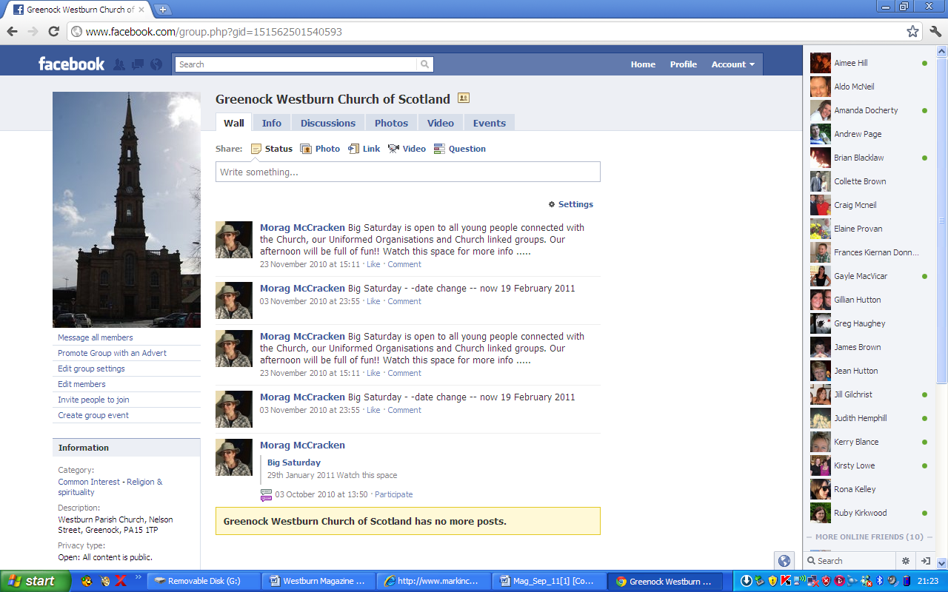
Search on FACEBOOK for “Greenock Westburn Church of Scotland” and join the social media revolution.

Greenock Westburn Church Web Site
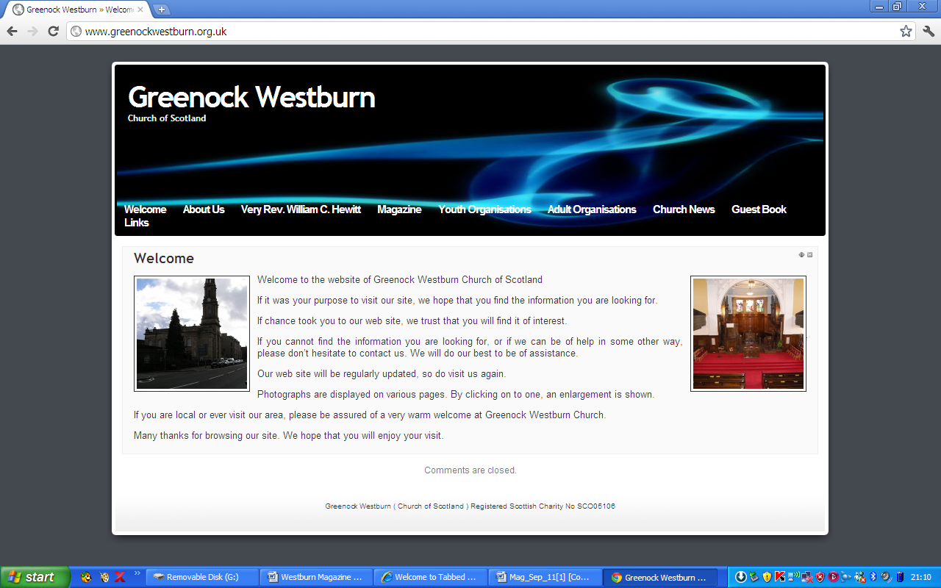
Have you put your syllabus, planned activities, or interesting comments about your organisation or group on your web page. If not it may look as though you’re not doing anything interesting. Have you looked at your page on the web, can you make it more interesting, add photographs, make comments, ask one of your members to write about what it is they enjoy about your group. Jim Bell will be happy to update your page.

A similar invitation is made to any church member who feels that they can assist in making the web site more interesting.

Our church web site can be found at - http://www.greenockwestburn.org.uk/ Please visit it and view it's contents.

Further information can obtained from Jim Bell ( 01475 799381 or all.the.bells@ntlworld.com )

Church of Scotland World Mission

USED STAMPS

The money which is raised through donating our used stamps is very worthwhile and Evelyn Taylor keeps us up to date with the amounts raised and the projects World Mission are able to be involved with.

Please continue to bring your used stamps, there is a little red basket in the centre vestibule.

PRESBYTERY OF GREENOCK AND PAISLEY Sep/Oct REPORT

THANKS AND INSTALLATION – Rev. A Sorenson was thanked for his year in office and Presbytery approved the proposal of Rev. Kenneth Gray minister of Bridge of Weir Freeland as next Moderator.

DISSENT AND COMPLAINT AGAINST GREENOCK: LYLE KIRK BUILDING DECISION:- The motion that Presbytery should dismiss the complaint was carried – 48 in favour and 18 against and the previous decision re buildings remains. Pam Noonan is to be ordained to Greenock: Lyle Kirk.

BUSINESS COMMITTEE:- Rev. E. Manson is appointed as Interim Moderator at Greenock:- St.Margaret’s. Ministers are encouraged to consider how to respond to requests for Humanist and civil funerals on church premises ( being aware of Presbytery guideline paper ) copy available on request.
STEWARDSHIP AND FINANCE Presbytery noted the proposed Ministries and Mission contributions ( see Presbytery noticeboard )

WORLD MISSION AND ECUMENICAL RELATIONS –
World Mission Stamp 2013 appeal : The Living Water project. This is a project run by a congregation from ECCB in the Czech – Morovian Highlands. Money raised will go to restoring an old well and building a small lake. Please continue to collect your used stamps.

MISSION AND DISCIPLESHIP:- Safeguarding – Presbytery’s Safeguarding Team is praised by Church of Scotland’s Head of Safeguarding and other Presbyteries should use the same model of working.

PRESBYTERY PRAYER CO-ORDINATOR:- Douglas Scott has resumed regular e-mailings of “Prayertime” to congregation prayer contacts. He is willing to visit and encourage prayer groups in Presbytery.

COMMUNITY INTERESTS :- Invercclyde Foodbank has helped 2500 in the last 12 months. Care professionals identify people in crisis and issue them with a voucher to be exchanged for 3 days supply of emergency food. They also signpost people to agencies able to solve the longer term problem.

Margaret Crawford Representative Elder

CHURCH FLOWERS
We are nearing the end of 2013 and we would like to thank those who donated flowers to enhance the Sanctuary Sunday by Sunday, who arranged them and delivered them after the service. The flowers are greatly appreciated by those who receive them.

The Calendar for 2014 will be available on Sunday 1st December, when anyone wishing to donate can put their names against the date which has a special meaning for them. If you are unable to come to church but would like to donate flowers on a particular date please telephone me ( Patricia Robertson ) the number is 725451.

Once again a special plea is being made for people to deliver the flowers after the service as for a congregation our size it seems very unfair that is it the same people who deliver. There is a list available at the same time as the Flower calendar, we know it is not always easy to commit to a particular Sunday months ahead but if members could look at the list from time to time particularly when you think you could be available to help out, it would be greatly appreciated.
Again many thanks to all who have been involved.
Linda Murray
Patricia Robertson
Flower Conveners.

Pastoral Committee

- The Committee met on Tuesday, 17th September 2013 and the next meeting will be held on Monday, 2nd December 2013.

- District 22 – there are now 27 members who are in nursing or care homes. These Members are regularly visited by the Committee. In addition, our Interim Moderator is also visiting Members in hospital and at home.
- Harvest Thanksgiving – plants were distributed Members in Care Homes and Housebound after the Service on Sunday, 22nd September 2013. The Pastoral Care Committee has received various letters of thanks. Our thanks also go to the Communications Committee for producing the card which was included with the Church Prayer Card.
- December Communion Afternoon Service – Sunday, 1st December 2013 in the Lounge at 3.00pm. Elders are encouraged to ask members who to would like to attend the afternoon Communion. Anyone wishing transport is asked to contact Bill Dempster or any member of the Pastoral Care Committee.
- Christmas Cafe –will be held in the Church Hall on Tuesday, 24th December 2013 from 10.00pm. Donations of Christmas pies etc will be greatly appreciated and details for donating will be intimated nearer the time.

Bill Dempster


GREENOCK WESTBURN CHURCH
PROPERTY COMMITTEE REPORT
MAGAZINE – Christmas 2013

Decoration of the Foyer, Ladies and Disabled Toilets has been completed.

A quotation has been obtained to upgrade the Gents Toilet to a standard similar to the ladies.
As the same contractor is renovating the manse kitchen, work will be delayed to early 2014.

Discussion regarding the installation of an audio/visual system is ongoing and a preferred supplier has been selected. We have asked Church of Scotland (CARTA) for their comments and approval.

The Quatercentenary Board showing the timeline of St. Luke’s, is now some 22 years old. The colours are fading in some areas (particularly the ‘red’). Enquiries to establish if it can be restored in any manner, is still being pursued. It was removed from the wall at the time of redecoration and will not be re-instated until a way ahead is agreed


At the manse and in preparation for the arrival of the Rev Karen Harbison and her family, considerable work in the way of decoration, fitting of a new kitchen and floor coverings is underway.

A range of minor work is continually ongoing. Volunteer labour contributes to a substantial cost saving in church expenditure. If any member would like to assist in any way, please contact Jim Bell (Tel No 799381)

TIME FOR PRAYER

In our society today, the spirit of Christmas means different things to different people. Sometimes that spirit has strayed very far from the original gospel message. The original message sought to bring new hope to a world steeped in cruelty and wracked in despair. Some people heard that message, but very many turned away in contempt, thought that they knew better, and preferred to live by the values of greed and one-upmanship.
But you and I are Christians, so let us keep up our Christian spirit. Through the tinsel and the glitter we have to shine brightly, to show the world what we are about and that we mean business: that we are a kirk that cares. Here is an anonymous prayer from Germany which tries to put us back in touch with the original Christmas message.

Lord Jesus Christ,
You came to us as a homeless child and found space for shelter in a manger in a cattle shed. You wanted to live among us, but we turned you away. You came with a message of joy for the world, but only some poor shepherds listened and believed your message. Help us now to listen and come to you. Through your poverty may we perceive your true richness, in your weakness may we recognise your pity, and through your helplessness may we see your glory and the way

Douglas Scott

Messy Church at Westburn

Messy Church takes place on the second Saturday in the month
and runs from 4 pm to 6 pm it is for all ages and all family and friends will be made most welcome.

The afternoon starts with tea, coffee, juice and a biscuit and we then have around 8 activities that we can all take part in, these have been decorating cakes, folding and flying paper aeroplanes, making an edible Eden, decorating an egg to name only a few.
We then all move through to the lounge for a worship celebration of our theme and activities and from there back to the main hall where the tables are set for a meal and we all sit together and share in the food that has been prepared for us.

Our Messy dates for 2014 will be as follows

11 January
8 February
8 March
12 April


Please free to join us for one or all of our Messy Church celebrations. We look forward to seeing you there.

Messy Ch ch
What is missing from Messy Church?
UR !!!

PRAYTIME

In a busy office, some of the staff noticed that a certain young man, on entering every day, used to stand, seemingly staring into space for a few moments, before settling down to his work.
Finally, one day a curious colleague asked him what he was up to, and he replied: “ Whenever I’m about to do something important or difficult, I pause for a moment of silent prayer. Then I know that however hard a task I’m facing, I’m never doing it alone or without support.”
A helpful hint for all of us?

(from Douglas Scott, presbytery prayer coordinator: )

GUILD

The guild began the new session on 1st October with an “At home” when the members caught up with what had been happening during the summer. We were entertained by the Clydesiders and it was a very good night with a lot of participation from guild members. The Presbyterial Autumn Rally was hosted by Westburn Guild this year and our speaker was the National Vice-convener, Mrs Kay Keith who spoke on the theme “A Fellowship to Proclaim”. Kay’s late husband was the minister at Elderslie Kirk before Bill Hewitt. The Sacrament of Holy Communion as celebrated with the Revd. Morris Coull officiating and we were delighted to have him present and thanked him for we know he is a very busy man. The attendance was poor but once again the ladies of Westburn were out in force and I thank them most sincerely for their support.

We have been invited to Lyle Kirk Guild on Tuesday 5th November, after that the meetings will be held in the lounge until 3rd December when we attend the Presbyterial Council “Christmas Celebrations” meeting. At that meeting the guilds participating in the gifts for the prisoners in Greenock Prison will hand in their donations. This year after consultation with the Prison Governor we will be collecting toothpaste (tubes) and soap (bars not soap on a rope), if any member of the congregation would like to donate to this project there will be a box available in the foyer from Sunday17th November until 1st December. It should be pointed that this is the only gift the prisoners are allowed to open without them being checked by the prison authority as they are wrapped in the presence of the Prison chaplain. This project was started by Rev Alex Chestnut many years ago when he was the chaplain and saw the merits of such a project. I’m aware that not everyone agrees with it but “there but for the grace of God go I”
The Guild Coffee Morning is on Saturday 16th November from 10am – 12 noon, tickets are priced £1.50. If you receive your magazine before the Coffee Morning we will be very pleased to see you at the fund raising event. This is the means of fundraising in order that we can give something usually in kind to the church.
Our National Convener, Marjorie Paton attended the National Youth Assembly and informed us by email that the young people attending want to be associated with the guild. At their dinner & ceilidh she presented them with a certificate making them an honorary Guild group. They want closer links with the Guild and they are impressed with the Guild projects so much that they asked delegates to put in a basket the amount they would have paid for their dinner and the money donated was to be divided between the 6 projects. The total raised was over £2400.
The latest update for the projects is as follows:
Comfort Rwanda – Building a better Rwanda £45,502.79

CrossReach/Social Care Council £72,993.39
(Church of Scotland) – Heart for Art

Mary’s Meals – Making a difference in Liberia £46,288.38

Ministries Council (Priority Areas) £17,588.89
(Church of Scotland) – Passage from India

Scottish Churches Housing Action – Julius Project £35,702.24

World Mission Council (Church of Scotland) £35,650.02
– Out of Africa ……. Into Malta

Total to date £253,743.71

The Guild Syllabus for next year is listed below, everyone is welcome to attend any of our meetings.
I wish our members a Happy Christmas and every good wish for 2014.

Patricia Robertson.

Guild Syllabus for 2014

January
14 Girls Brigade
21 Project - Passage from India
28 Burns Evening

February
4 Presbyterial Council ABM in Lyle Kirk
11 A Fellowship to Build (visiting Guilds)
Miss S. McFarlane
18 District Police Court Stories Mrs. S. Kelly
25 ABM, Bible Study and Bring & Buy

March
4 World Travel Mr. A. Shaw
10(Mon) Presbyterial Council Spring Rally in
St Andrew's, Port Glasgow
18 Langbank Singers
25 Closing Meal

Vhutshilo Mountain School
PO Box 737 Tel: 015 973 0284

We have been sent a very lengthy report from Venda, here is a small extract. Anyone who wishes to read the full report, please speak to Cath Barbour.

VMS NEWSLETTER 2012



In January VMS celebrated its 10th anniversary and how we have grown over the last decade! From a modified, dilapidated mobile home that had borne the brunt of the 2000 floods, with an enrolment of 3 bewildered orphans, an unqualified and equally lost teacher/driver/administrator, and her loyal domestic worker/cook/gardener… to a “proper” school with a staff of 12 dedicated and committed women. Three contract drivers daily deposit their precious loads of 59 young students to the school. And VMS monitors 115 HIV+ children from 19 villages as part of the outreach program!!! What an amazing journey we have all had, and what a lot we have learned.

The educational programme forges ahead…

VMS was forced to drop Grades 1-3, due to the incompetence of our Provincial Dept. Of Education (which has since been taken over by the National DOE) and so we reverted to being a pre-school. It took a while to get used to all the tiny tots running around the school with no older children to help us keep an eye on them during break time and lunch!
There was a lot more wailing and screaming for the first few days as the newcomers were left in this strange place with new faces, and the worst of all, being left with a “mukhuwa” (white) woman while their grateful “goggos” (Grannies) scuttled away in relief.
The toddlers, 18mths to 3yrs are schooled in the dormitory of the Halfway House by Teacher Joyce who joined VMS earlier this year. And the pre-schoolers (aged 3 to 4) are being taught by Memory, a young Zimbabwean who has been attending workshops and training with an Oxfam partner, the Thusanang Trust. The Trust is a leading Early Childhood Development (ECD) organisation in Limpopo Province with accredited qualifications and skills training. Memory returns to school brimming with new ideas and full of enthusiasm.

The ECD course includes regular site visits from Trust assessors and we had to modify the classroom to meet their requirements. Fortunately VSA (Volunteer Students abroad) students from Glasgow University were visiting. They painted the classroom a fresh sky blue and donated money for cupboards and shelves.
What a pleasure it was to remove the unsightly (and difficult to clean) planks and bricks that had been used as shelving since the school started in 2005.

My daughter, Vhuhwavho (Woo for short!), the initiator of the children’s ARV support group has made a name for herself as a young aids activist. In December we were approached by a cape based magazine group (Cape Media) to ask if they could publish a feature story of her life. Imagine our amazement and pride when her picture appeared on the front cover. Next year she will attend Ridgeway College as a member of the Sumbandila Scholarship Trust and will continue to empower and educate HIV+ children.



( Many of us will remember Vhuhwavho visiting Westburn with Susie, it’s great to see how she has grown and how well she is doing. )
An important facet of the ARV children’ support group is the regular meetings with the caregivers. It seems a bit pointless keeping the children informed and up to date with HIV/AIDs and not including the people who have the task of looking after them. These caregivers are usually elderly traditional Goggos and as the children reach puberty other problems (besides the usual teenage issues) begin to surface: older boys demanding the foster grants be given to them to spend as they wish, and in one case, a young girl demanding she gets paid to take her meds-!! Discipline is a problem for these elderly folk who have the formidable task of bringing up their grandchildren when they should be spending their twilight years in relative peace and serenity.
Last year five caregivers attended a three day Home Based Care course through a local NGO called the Far North Community Care and Development Organisation. They learned basic nursing skills for HIV+ children and adults, completed a general First Aid Course and received their certificates in January. This has given them a lot of confidence and enhanced the quality and range of care they are able to provide. They take turns looking after ailing youngsters at the Halfway House making their new skills even more valuable.

The year ends on high note...

The children were extremely lucky as they received Christmas gifts from two sources: Even though stricken by their own personal loss with the death of their husband and father, Arlene Wolpret and her two daughters, Stacey and Jessica once again gave of their time and money to buy gifts of clothing, toys and shopping vouchers for the older children. Local representatives from an organisation called Santa’s Shoe Boxes also came to hand out presents. These beautifully wrapped and individually labelled gifts from both these donors were not only for the 59 children at the school but also for the 115 youngsters in the outreach program. Oxfam and Netcare Johannesburg gave cash donations to ensure that the more destitute families had substantial food parcels over the long holiday period. We are very grateful to all of them for bringing such wonderful Christmas cheer to our children and their families.

Grateful thanks to all of you from the VMS team. With your generous support, we are transforming our community.
FROM THE ROLL-KEEPER

DEATHS

Mrs. M. Gorry 25 Stewart House 1 died Aug.
Mr M. Dale 10 Lyle Place 9 died Sep.
Mrs. H. Murdoch 94 Old Inverkip Rd. 14 died Sep.
Mrs. M. Thomson 69 Waverley St. 15 died Oct.
Mr R. Lang Glenfield Nursing Hm. 22 died Oct.
Mrs. E. Munro Belleaire 22 died Oct.

CHANGES OF ADDRESS

Mrs. D. Ferguson 7 Buccleugh St. 1 from D1
Mrs. A. Lyle 8 Dunlop St. 14 from D19
Mr. D. Quayle 57 Wallace St. 15 stays D15
Mrs. G. Jackson Belleaire 22 from D17
Mrs. A. Osborne Larkfield View Care Hm. 22 from D1
Mrs. E. Pow Warren Park. Nurs. Hm. 22 from D9

DISJUNCTIONS

V. Rev. W.C. Hewitt 60 Woodlands Grv. 21 to Kilmarnock
Mrs. M. Hewitt 60 Woodlands Grv. 21 to Kilmarnock
Mrs. R. O'Neill c/o 60 Woodlands Grv. 21 to Kilmarnock

IN ORDER TO KEEP CHURCH RECORDS UP TO DATE, IT WOULD BE GREATLY
APPRECIATED IF MEMBERS WHO ARE MOVING INFORM THEIR ELDER, THE
SESSION CLERK OR THE ROLL-KEEPER OF THEIR NEW ADDRESS

