


WELCOME to the Autumn Magazine.

With Summer ‘almost’ over, and what a great summer it has been. Hopefully we are all refreshed and ready to participate in all that Westburn has to offer. Many committee members and leaders have been busy preparing an interesting programme of activities, meetings and events.

In the centre of the magazine is a list of ‘What’s on in Westburn’ also the various committees have reported details of the social events they are planning. A lot of hard work goes into the planning of these programmes and events to make them successful they need your support.
Check it out and see what is of interest to you – come along and enjoy frienship and fellowship in Westburn you will be made most welcome.

Material for the next Magazine is due by Sunday 27th October e-mail to cathbarbour@btconnect.com
© 2007

From the Interim Moderator

Just these words
………………………to say that at the time of writing the Nominating Committee is working diligently and expectantly in the search for the new minister for Westburn Church. Do not flag in your prayers for a successful outcome! I say that because the procedure for calling a minister is complicated and drawn out and if this is irksome for congregations it is equally so for ministers. As far as I am aware, no other person in the community has to be elected to his or her position by hundreds of people who then sign a call in which they personally pledge their support and co-operation. No such undertaking is given to anyone else. Little wonder then that it is a complex and lengthy procedure. Not only does the minister have to be sure that he is really wanted, but the congregation have to be sure that they want him, and all of that takes time. Even then he cannot be their minister until his Presbytery release him and the next Presbytery agrees to induct him. The minister therefore is responsible to the Presbytery and not to his congregation. Such is our Presbyterian system, and it generally works out quite well.

As for ourselves, refreshed I trust by one of the better summers of recent years, we turn our attention to this new session in the life of our church. This is “Back to Church” time for our many organizations and we welcome the “buzz” that they bring about the place. The ‘Back to Church’ slogan reminds me of an article given to me by a sweet little Irish-American lady when I was on a ministry-exchange in up-state New York some years ago. Here it is….

“In order to make it possible for everyone to attend church next week we are planning a “No-excuse” Sunday.
1. Beds will be placed in the vestibule for those who say “Sunday is my only day for sleeping-in”
2. Eye drops will be available for those whose eyes are tired from watching TV too late on Saturday night.
3. We will have steel helmets for those who believe the roof will fall in if they show up at church.
4. Blankets will be made available for those who complain that the church is too cold. Electric fans will be on hand for those who say the church is too hot.
5. We will have hearing aids for the parishioners who say “the minister does not talk loudly enough”. There will be cotton wool for those who say “The minister is too loud”.
6. Score cards will be on hand for those who wish to count the hypocrites or to mark the sermon out of ten.
7. We guarantee that some relatives will be present for those who like to go visiting on Sundays.
8. TV dinners will be available for those who claim they cannot go to church and cook dinner also!
9. One section of the church will have some trees and grass for those who see God in nature, especially on the golf course.
10. The Sanctuary will be decorated with both Christmas poinsettias and Easter lilies to create a familiar environment for those who have never seen the church without them.
11. See you in church!

I am, your friend and (locum) minister, Morris Coull

Special Services to note this autumn…

Harvest Thanksgiving: Sunday 22nd September at 11.00am

Family Service with the Stedfast Band: Sunday 29th September at 11.00am

Holy Communion: Sunday 6th October at 11.00am and 3.00pm

Pastoral Record – Baptisms

4.08.2013 Gayle and Colin’s daughter: Eve Olivia

18.08.2013 Victoria and Simon’s son: Angus Oliver Westley
and daughter: Mallory Grace Templeton

CHURCH NEWS BOOK

If you are aware of anyone who is ill or would benefit from a visit from the minister, please make an entry in the news book with their name and address. It is helpful if you sign your entry.

Life and Work

Life and Work is available on the last Sunday of every month priced £2.00 Subscriptions available.

Please contact Shelagh Hendry Tele. 794667.
Delivery can be arranged if you are unable to get to church.

Find us on FACEBOOK

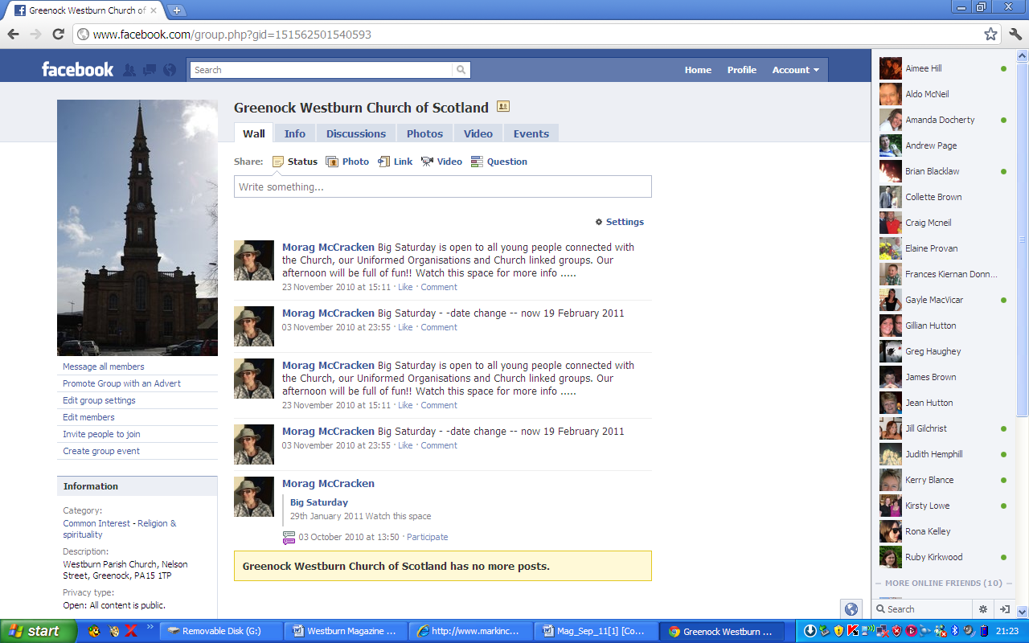
Search on FACEBOOK for “Greenock Westburn Church of Scotland” and join the social media revolution.

Greenock Westburn Church Web Site
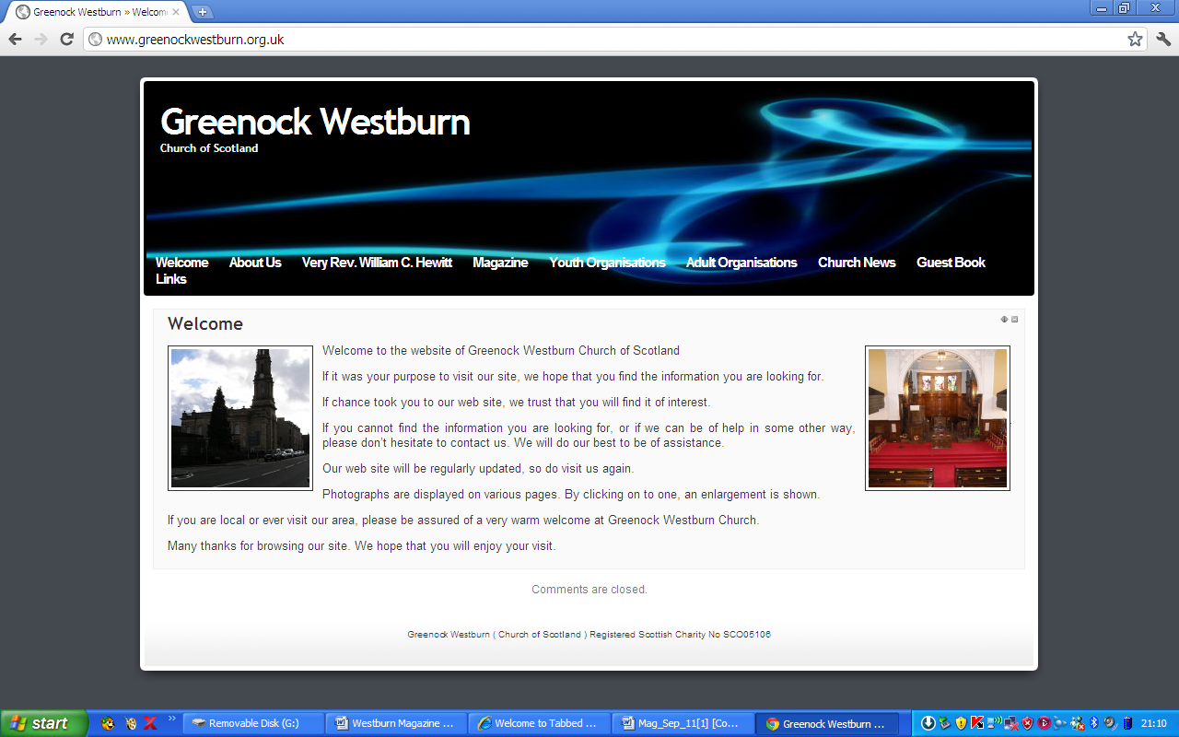
Have you put your syllabus, planned activities, or interesting comments about your organisation or group on your web page. If not it may look as though you’re not doing anything interesting. Have you looked at your page on the web, can you make it more interesting, add photographs, make comments, ask one of your members to write about what it is they enjoy about your group. Jim Bell will be happy to update your page.

A similar invitation is made to any church member who feels that they can assist in making the web site more interesting.

Our church web site can be found at - http://www.greenockwestburn.org.uk/ Please visit it and view it's contents.

Further information can obtained from Jim Bell ( 01475 799381 or all.the.bells@ntlworld.com )

Inverclyde Radio brings you a broad range of programming including Local Weather, travel, what's on info, Community News, Interviews and features. We also have a wide range of entertaining programmes from Rock n Roll to Country, Classical to New Music and American Old Time Radio to Tech News.

We are covering independence and how it would affect Inverclyde on our Talk of the Towns LIVE with Gus McLean programme on a Monday 10am-1pm and would be delighted to have listeners with views to join us either in person or via our Facebook, text or Twitter feeds.

Hillbilly Bob's Country music show is getting a lot of input from new country bands and singers, Hillbilly Bob now has a new programme featuring new Country music singers and bands, the programme is Hillbilly Bob's Country Music Catalogue it broadcasts Live on a Monday Night 7pm-8pm plus you can hear his Friday night programme with new and established Country music 7pm-9pm.

Fiona McNeill of Reely Jiggered has a brand new programme on a Wednesday night 9pm-11pm Fiona McNeill's Celtic and Folk Fusions LIVE
American Old Time Radio is back for a brand New series, Hear Gun Smoke, The Adventures of Philip Marlowe, It's Higgin's Sir and more on a Thursday night 10pm-Midnight and Repeated at other times.

On our Listen Again pages you can hear from the local councillors, event organisers and service providers and you can also hear about Sport, Schools, Your Voice, Theatre and Arts plus other General Topics.

You can Listen to Inverclyde Radio at www.inverclyderadio.com or via your smartphone or Internet radio using a free app such as Tune In.

Join us on Facebook and Twitter

David Faller
Inverclyde Radio
www.inverclyderadio.com
Victoria House Room 16
5 East Blackhall Street Greenock
PA15 1HD

Inverclyde Radio Office Number 01475 807110

.

Church of Scotland World Mission

USED STAMPS
What happens to the used stamps we put in the box at church.
Keith Scott runs the sdtamp centre which turns your used stamps into cash for our projects.
This year the project is ‘Living Water’ – church in the Czech Republic in a village in the Mavariasn Highlands. We find out from Keith just what his part in ther work with stamps involves.
There are no set times to deal with stamps each day, but approximately 10 hours per day are spoent sorting stamps into different categories i.e British, foreign etc. Stamps are collected from the Church of Scotland in bulk; approximately every five weeks.
There are people all over the world who collect stamps, so after they are sorted they are sold on to collectors and dealers worldwide.
All new and used stamps have a value, although some are worth more than others.
Any old stamp collections which are donated are valued separately from the bulk material and may be worth more to the Church of Scotland.
The most valuable stamp I have ever found is ‘ a penny black’ on average I have found one every 10 years. ( I have been collecting stamps for the Church Of Scotland for over 40 years) depending on condition they can be worth £20- £80.

Please continue to bring your used stamps, there is a little red basket in the centre vestibule.

The money which is raised through donating our used stamps is very worthwhile and Evelyn Taylor keeps us up to date with the amounts raised and the projects World Mission are able to be involved with.

PRESBYTERY OF GREENOCK AND PAISLEY May/June

VACANCY PROCEDURE COMMITTEE Presbytry approved the Basis of Linkage between Inverkip and Skelmorlie&Wemyss Bay.
Regarding the future use of buildings by Greenock: Lyle Kirk and subsequent Dissent and Complaint – Presbytery decided the best course was to appoint a Special Committee to confer with local parties and report back to Sep meeting when the Dissent and Complaint will be heard and Presbytery will come to a determination on the matter.

GUILD PRESBYTERIAL COUNCIL Mrs Marion Berekis gave a full report on the work of the Guild and the various projects in which they are involved, including self reliant groups in India, refrugees coming toMalta, Crossreach, Clyde Designs and Mary’s Meals. They also raised £172,606 for their projects. The Moderator thanked her for the work done in thids exciting and rewarding year.

WORLD MISSION AND ECUMENICAL RELATIONS We are encouraged to pray for the church in Chins, recognising the complex political economic situation there.
Churches are encouraged to consider the complex reasons behind the persecution of the Church in the East, and those linked to political power who can be involved in the persecution of other Christian groups.

MISSION AND DISCIPLESHIP A workshop on I.T. will be held in Erskine Parish Church on Sun 22nd Sep from 2-4pm led by Rev J Fleming. Ideas for Christmas and Harvest will also be exchanged.
Safeguard Training Dates
Co-ordinators – Sat 14th Sep 10am – 4pm
KIRK SESSIONS – In future Safeguarding training will be offered bi-annually
Ie Sun 27th Oct, Sun 27th April. Both will be held in Cornerstone at 2pm.
Thanks - Presbytery acknowledged the many hours, days, weeks and months of work given by our Safeguarding Trainers and expressed thanksto them.

COMMUNITY INTERESTS
Allocation of funding:-
£600 to Adams House
£580 to fcc-ccc, starter Packs, Star Project and Supporting Parents – an initiative of Greenock Eat End Parish now in its 3rd year.

Margaret Crawford
Representative Elder
On the morning of Friday 21st June, Patricia & I left for Dingwall to attend the Retirement Social for the Rev Russel Smith of St. Clement’s Parish Church, the church, we at Westburn, have developed an association with since “Roll away the Stone” at the General Assembly in 2010.

On arrival we went to see Margot Smith who is the instrumental figure from the St. Clement’s side along with our own Jim Bell in keeping the association alive.

After a tour of the church building by the Session Clerk, Ian Lovett, and a local historian we were taken to our overnight accommodation.

The Retirement Social was held in Dingwall Academy and was totally an “In-house” event, with I believe Patricia & I the only outsiders in attendance. Speeches from past and present office-bearers, fellow ministers mixed with musical items and a fabulous finger buffet brought a ministry at St. Clement’s to a very happy end.

Russel Smith was preaching for the final time on the Sunday of that week-end, and it was unfortunate that due to Nominating Committee business we had to return home on the Saturday.

I spoke at the social, giving the best wishes of Greenock Westburn to Russel Smith, his wife and family, which in turn was underlined by St. Clement’s, that at this time in our respective histories, when we are both now vacant, our association should not only continue but grow stronger.

I will certainly return

Stuart Robertson

Pastoral Committee

- The Committee met on Tuesday, 14th May 2013 and the next meeting will be held on Tuesday, 17th September 2013.

- District 22 – there are now 27 members who are in nursing or care homes. These Members are regularly visited by the Committee. In addition, our Interim Moderator is also visiting Members in hospital and at home.
- Annual Car Run – was held on Wednesday, 26th June 2013. Around 60 Members were taken to various places on a very nice summer’s night and then back to the Church Hall for supper. As in previous years, this was a very successful event. The fellowship was very much in evidence and enjoyed by Members and drivers, also folks had a chance to catch up with old friends. Many thanks to the drivers for looking after the Members and to the Ladies who provided an excellent supper.
- Harvest Thanksgiving – will be held on Sunday, 22nd September 2013. As in previous year’s, the congregation is being asked to donate to the South African Projects, which are Venda, Cotlands Baby Sanctuary and the Sunshine Association for children with disabilities. Donations can be placed in an envelope marked South Africa and placed in the offering. Members will have an opportunity to donate from Sunday, 22nd September up to and including the October Communion on Sunday, 6th October 2013.
- South African Projects – letters of thanks have been received from Cotlands Children’s Sanctuary and Sunshine Centre for disabled children for the donations of £750 each. A copy of each letter can be found elsewhere in this newsletter.
- October Communion Afternoon Service – Sunday, 6th October 2013 in the Lounge at 3.00pm. Elders are encouraged to ask members who to would like to attend the afternoon Communion. Members wishing transport are asked to contact Bill Dempster or any member of the Pastoral Care Committee.
Bill Dempster


GREENOCK WESTBURN CHURCH
PROPERTY COMMITTEE REPORT
MAGAZINE – Autumn 2013

Current work


Over the past two months, the main work has been the decoration of the Ladies Toilet and the Foyer including the disabled Toilet

Currently, we are considering upgrading the Gents Toilet to a standard similar to the Ladies.

A range of minor work is continually ongoing. Volunteer labour contributes to a substantial cost saving in church expenditure.

If any member would like to assist in any way, please contact Jim Bell (Tel No 799381)

Doors Open Day

Inverclyde, Doors Open Day will be held on the week end of 14/15th September 2013.

We will participate on Saturday 14th September. Volunteers are required to act as stewards on the day, also to help serve tea and coffee.

TIME FOR PRAYER

Nowadays there are many agencies which offer people expert counselling services, to help them to cope with and if possible to overcome various types of problems which afflict them.

Counselling can be offered for marital difficulties, for a variety of health problems, for employment or career issues and for many other of life’s dilemmas.
Practitioners in counselling can begin from various standpoints, including a Christian one.
Buttressed by our faith, surely all of us who profess to be Christians should be able and willing, should the need and circumstances arise, to offer at least a simple form of counselling or at least lend a sympathetic ear to those whom we know who may be anxious, in trouble or pained. In such situations, we can also offer to pray.
To help and guide us, a useful starting point might be a prayer like this one from Dr Roger Hurding, a Christian psychotherapist.

Lord Christ, I thank you for your love so strong
May that love flow through me to others
Mai I be patient when change comes slowly
May I be kind when life seems harsh
May I be gentle when others feel bruised
May I be humble when things go well
May I be peaceful when anger rises within
May I forgive when wronged
May I rejoice when the truth is discovered
Love never fails, but I do
May I hope when things seem hopeless
May I persevere when the way is hard. Amen.

Douglas Scott

Messy Church @ Westburn

Messy Church takes place on the second Saturday in the month
and runs from 4 pm to 6 pm it is for all ages and all family and friends will be made most welcome.
We started at Easter last year and have now had 3 in all.
The afternoon starts with tea, coffee, juice and a biscuit and we then have around 8 activities that we can all take part in, these have been decorating cakes, folding and flying paper aeroplanes, making an edible Eden, decorating an egg to name only a few.
We then all move through to the lounge for a worship celebration of our theme and activities and from there back to the main hall where the tables are set for a meal and we all sit together and share in the food that has been prepared for us.

Our Messy dates for this coming session 2013 to 2014 will be as follows
14 September
12 October
9 November
14 December
11 January
8 February
8 March
12 April

Please free to join us for one or all of our Messy Church celebrations. We look forward to seeing you there.

Messy Ch ch
What is missing from Messy Church?
UR !!!
Guild

As I write this report the schools have returned after the summer holidays and I think it can be said that we did indeed have a summer this year. I hope that you enjoyed the good weather this year and are looking forward to the coming session within the life of the church.

Once again the committee has been hard at work planning for the forthcoming session, in particular Marian Anderson, our secretary, who in her own manner manages to bring all our ideas together although the dates may not be as we decided at our first planning meeting. The committee hope that there is something to suit everyone and look forward to meeting up again and welcoming new members (including men as we are no longer the Women’s Guild just the Guild).

The theme for this session is “A Fellowship to Build” and the committee decided to invite members of other denominations who have ladies groups along to one of our meetings this will take place in the second half of the session.

I realise that the 125th Celebrations of the Guild ended in May but nevertheless Greenock Presbyterial Council contacted the local department and have had a floral display depicting the Guild Badge placed in the flower bed at the channelised junction in Gourock.

I’m taking the opportunity to tell you about the last 2 projects in this 3 year strategy

Mary’s Meals – Making a difference in Liberia
Mary’s Meals is an international movement to set up school feeding programmes in communities where poverty and hunger prevent children from gaining an education. It’s a simple idea that works. By providing a daily meal in a school, chronically poor children are attracted into the classroom where they can gain a basic education that provides an escape route from poverty for themselves and for their communities. Mary’s Meals currently provides over 600,000 children with a daily school meal in 16countries.
Liberia is a priority country for Mary’s Meals and is the second largest feeding programme. It is a country still recovering from the lingering effects of a ruinous and devastating civil war. Children as young as seven were recruited to fight in this war and sexual violence towards girls and even babies was not uncommon. Mary’s Meals are currently feeding 40,000 children in Liberia every school day. With the help of guilds, they plan to expand and bring hope and a future to over 60,000 children over the next few years.

Ministries Council (Priority Areas) (Church of Scotland) – Passage from India
Passage from India began with a life-transforming journey by 13 women to India in January 2011. They interacted with women who do not allow the harsh poverty to crush their aspirations for a better life for themselves and their families or wait for someone else to make change happen for them. Following their return, the women began 6 Self-Reliant Groups (SRGs) in Glasgow based on the Indian model. Some 40 women – many of whom are on benefits – are involved in the SRGs and the increase in their levels of self – belief, resilience and confidence has been amazing! The ethos of the SRGs is built around the notions that those who are striving to overcome poverty have a greater chance of doing it collectively and that more women have a key role to play in the economy, their families and communities. The project aims to establish 50 SRGs (involving over 500 women) over the next 3 years and support them by providing training in life skills, business planning and small business loans (called microcredit). It also aims to build the capacity of other organisations to start similar SRGs across Scotland.
A quote from Liz, Provanmill SRG “The Self-Reliant Group is a good way of getting something off the ground…. it’s a good idea to get a group of women together and to put ideas into a pot and see what comes out. I never expected all this to happen so quickly…”

Below are the amounts each of the projects has received to date:-

Comfort Rwanda – Building a better Rwanda £44,059.99

CrossReach/Social Care Council £71,589.29
(Church of Scotland) – Heart for Art

Mary’s Meals – Making a difference in Liberia £45,835.72

Ministries Council (Priority Areas) £17,231.03
(Church of Scotland) – Passage from India

Scottish Churches Housing Action – Julius Project £35,244.48

World Mission Council (Church of Scotland) £34,411.45
– Out of Africa ……. Into Malta

Total to date £248,371.96
Date for your diary Guild Coffee Morning – Saturday 16th November 2013 from 10- 12noon. Members would be delighted to see you at our fundraising event.

We remember all our members who are ill at this time, some who are undergoing treatment, those who are housebound, those who would like to attend our meetings but are unable and those who are coming to terms with bereavements.
We are also delighted to have sent good wishes to members who have celebrated special events since we last met.
Let us never forget the guild motto “Whose we are and Whom we serve”
Patricia Robertson

GUILD SYLLABUS FOR 2013

October
1 At Home
8 Clydeside Singers
15 Presbyterial Council Autumn Rally - Westburn
22 History of Shopping Bags Mrs. M. Dundas
29 Hallowe'en

November
5 Alison's Fashions (at Lyle Kirk, Union Street)
12 Storytime Mrs. E. Murdoch
16(Sat) Coffee Morning
19 Project - Mary's Meals
26 Disbursement of Funds and Talk on Guild Topic
Rev. D. McCarthy

December
3 Presbyterial Council Christmas Celebrations in
St John's, Gourock (this meeting is at 2.00 pm)
10 Christmas Evening

39th Greenock Guides start back on Tuesday 10th September. We look forward to seeing current members and welcoming new members. If you fancy coming along for lots of fun, games, crafts and other activities then join us on Tuesday nights from 7:30 - 9:15pm. Girls should be aged 10 - 14. More details from Marjorie 01475 727328."

ALL ARE WELCOME

For four weeks in May a small group met in our church to exchange our views on what is happening in our world today, and how we as individual Christians respond to these developments. Our meetings began by viewing a short film which highlighted some of the issues facing Christians today. This led to an animated but friendly discussion, moderated by Liz Smith.

All present were given space to express their thoughts, and were listened to, and sometimes opposed by people who had different views. People also had the opportunity to sit quietly if they wanted and listen to the exchange of views. Nobody was at any time under pressure either to speak up or to shut up, and the end result was, I think, an enriching experience for all present.

No problems were solved,. We still wondered why atrocities occur, why our world is still so unfairly divided, why Christian faith is not as strong as it used to be. But I’m sure that this opportunity to express our thoughts, to get things off our chest, or just to quietly listen to each other gave strength and reassurance to us all.
Lots of wildly different opinions were expressed, but nobody went away bruised. And the evenings were rounded up with convivial banter over coffee and cakes.

The Adult Education Committee intends to arrange further sessions like this, perhaps in the autumn- a chance to declare your thoughts, or to listen to others sounding off. Look out for announcements: you might well find it an enriching and worthwhile experience. At Westburn, we can blether with the best of them!

Douglas Scott
Acknowledgments from our South African Projects

Cotlands
Gauteng Kweazulu –Natal Eastern Cape, Western Cape,
Mpumalanga North West.

24 July 2013 Receipt number: 228968
Your reference number: 83753
Westburn Church of Scotland Mr D Dempster

Dear Mr Dempster,

Thank you so much, on behalf of everyone here at Cotlands, for your recent generous donation of R10, 018.38 received on 20 June 2013.
During the month of July we at Cotlands acknowledge the selfless contributions made by our former President Nelson Mandela for our freedom.
As Mandela dedicated 67 years of his life to fight for our political emancipation the Nelson Mandela Foundation has urged all South Africans and the international community to honour his legacy by dedicating 67 minutes of their time to doing something positive on his birthday - 18 July. By offering your support to Cotlands you have already contributed towards a lasting legacy.
As education is the centre of this year’s initiatives from both government and the Mandela Foundation, we at Cotlands encourage you to continue your support of our work in this fundamental area of development. The first five years of a child’s life are crucial to their development as it forms the building blocks for their future education. Your continued financial assistance enables us to improve the quality of education to those children who need it most.
So on behalf of everyone here at Cotlands, please accept our gratitude for your generous contribution and continued support.
Yours for the children,

Kelsley Sharpley Fund Development Manager Tel: 011 683 7200 e-mail: kelsley@cotlands.org
In terms of Section 18A of the Income Tax Act, 1962, this letter serves as an official tax receipt. Reference number 18/11/13/2029. Your donation will be used exclusively for Cotlands.
Vhutshilo Mountain School
PO Box 737 Tel: 015 973 0284
Sibasa 0970 Cell: 072 456 8929
Tshikombani ,Limpopo Fax: 015 963 1386
NPO# 021-664 vhutshiloschool@yahoo.com
The Minister and Congregation of Westburn Church

Once again I am moved by your generosity, and at a loss for adequate words of gratitude. With the economic crisis hurting people all over Europe you still manage to dig deep into your pockets to help the orphans and vulnerable children of Vhutshilo Mountain School.

With your consent I would like to add the money to our building fund for the new classrooms. In the beginning of this year I decided to take a great leap of faith and started the preparations to get the foundations laid knowing that somehow we would receive the balance to complete it. Incredibly over the past few months we have been receiving small grants and donations which has once again shown what we can accomplish with lots of prayers and positive thought. Thanks to those who generously contributed to the fund a few years ago and for their understanding and patience when the funds had to be diverted to transport, feed and educate the youngsters in our care. We have been able to recoup some of this money and replenish the building fund due to grants we received last year.

The building of the two classrooms has become a priority not only because we desperately need to move the toddler’s class out of the dormitory of the Halfway House so it can be used for its original intention ie the caring and training of HIV+ children who are sick due to defaulting on the ARV drug regime, but also because we need the second classroom for our expanding outreach program. Extra maths and English classes have been started for the older children and there is the possibility of funding for a computer lab to help them gain a much needed advantage in the employment market. The two rooms will be divided by a “concertina” type folding wall which we can fold back when we need a hall.

A few months ago I visited a site in Mpumalanga Province and saw an environmentally friendly house being built. Bags the size of small pillow cases are filled with river sand and packed between wooden struts and then covered with wood or cement cladding. The sand keeps the building cool in summer and warm in winter. The concept was originally designed for low cost housing and the package includes training a local supervisor. This will provide an income for the HIV+ support group as they will be paid for filling the bags. Building this way will not only show the community a better way of building but the quote for materials, labour and training is approximately a third of the price quoted to build in the conventional method !! Also, in the long term, this trained group of workers will be part of another income generating project as they will be able to assist local people with low cost housing. Oxfam, our funders for the outreach program, unfortunately do not assist with buildings but at a meeting earlier this week have promised to pay for the training of the supervisor and the wages for the sand packers as this falls into their staff capacity building and income generating activities. It seems I will be able to realise our dream of having the building complete by the end of the year…

On a more personal note: I will never forget the warm welcome we received in 2009 when my daughter and I visited Scotland, attended the church service and were able to meet and personally thank members of the congregation for their support. Wavho (called Woo these days! ) was 8 years old and I wanted to burst with pride as she stood up and spoke about her life as an HIV+ child. Last year she became a teenager and as a young AIDs activist is a great example of living positively with HIV. She is beautiful and confident and (to her immense delight!!) is almost as tall as me… This year she started high school as a weekly boarder at an independent school which follows the Cambridge curriculum. The change from her rural school to this upmarket institution has been an amazing experience for her: she looked through a microscope for the first time, does athletics, plays tennis and is a member of the Eco-club. Woo has never forgotten her poverty stricken days living with her granny in a hovel on the edge of a village. She is generous and compassionate, loves to bake biscuits for her rural family and always gives her old clothes and books to her less fortunate friends. Her favourite saying is “there but for the grace of God go I.” As for me I count my blessings daily that I have the privilege of being part of this remarkable child’s journey of life…

A huge thank you for your continuous support: in sponsoring so many children over the years and for the unexpected and much appreciated donations. Vhutshilo would not be what is today without your constant prayers and support.

Warm regards

Sue-Anne, staff and children.
SOCIAL COMMITTEE REPORT

Bowled Over.
A Surprising amount of people managed to come along for the bowling supper considering how wet it had been. The rain stayed away and everyone had fun some learning a new skill. The bowlers helping were patient and gave good advice. Whether it was your first time or not everyone had fun and we were made most welcome at Ardgowan Bowling Club.
We had a delicious supper and rounded off the evening with a prize giving.
Our thanks to everyone helping and look forward to the next bowling event.

Fashion Swap
Basically this is a clothes bring and buy. It’s likely more then a few of us have one or two things in the wardrobe we no longer use. So you could donate these items and at the same time see something you’d like to purchase for a small fraction of the actual cost when new. We held a successful similar event a few years ago.
Recycling good clothes makes sense and will hopefully make some money which will be put to a great use.
All funds realised will be donated to a local food bank and will help families struggling to make ends meet.
Information will be intimated later.

Linda Murray


WESTBURN CHURCH MEMBERS STEPPING OUT IN FAITH
On 7th April over 40 Westburn members began a virtual walk to each of the 12 CofS Churches based in the Presbytery of Europe, virtually led by our mascot, Westburn Westie. In just over 3 months our collective pedometers showed that a total of over 28 million steps had been recorded. Approximately 11,000 miles had been virtually covered and the route map in the Main Hall highlighted that the Group had returned to Nelson Street in sunny Greenock. Thanks must go to the enthusiasm and energy of the participants who seemed to enjoy their individual efforts going into the collective “pot” within the Church each Sunday.

On 23rd August, some 30 Steppers joined in a welcome home social, enjoying the music and sampling the tastes of the cities and countries visited. Many remarked on the beneficial effects resulting from socialising as a group yet often exercising
Individually. Should we consider other activity based projects? What do you think? Using and assisting the Venda School as an activity project has been mooted.

Thanks again to all who helped to make our Stepping-Out such an actual success.

Doreen Borland

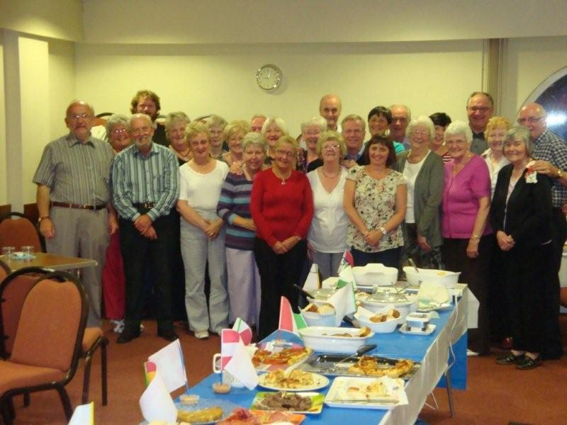

Steppers Welcome Home Supper

FROM THE ROLL-KEEPER

DEATHS
Mrs. | K. | McIntyre | 90 Forsyth St. | 4 | died July
Mrs. | M. | Morrison | 3 Bagatelle Ct. | 8 | died June
Mrs. | C. | Osborne | 186 Dunlop St. | 15 | died June
Mr. | L. | Phelan | 32 Nimmo a St. | 15 | died June
Mrs. | J. | McRae | F4, JGH 19 Inverkip St. | 18 | died July
Miss | M. | MacLachlan | Glenfield Nursing Hm. | 22 | died Jun.
Mr. | J. | Anderson | Larkfield View Burns Rd.Care Hm | 22 | died Aug
CHANGES OF ADDRESS
Mrs. | S. | Williamson | F13, Balmoral Ct., 29 Forsyth St. | 7 | from D4
Miss | C. | Colgan | 14a Roxburgh St. | 17 | from D16
Mr. | J. | Anderson | Larkfield View Burns Rd Care Hm. | 22 | from D14
Mrs. | J. | Hair | Larkfield View Care Home | 22 | from D16
Mr | R. | Lang | Glenfield Nursing Hm. | 22 | from D8
Mr. | R. | McNaughton | Rm. 25, Belleaire, 29 Newark St. | 22 | from D17
NEW MEMBERS by Profession of Faith
Miss | E. | Boag | 19 Nelson St. | 2
Mrs. | S. | Kane | 51 Shankland Rd. | 19
TRANSFERRED TO SUPPLEMENTARY ROLL
Mrs. | H. | McKelvie | ApartadoR/C J,Bloco B, | 21
 |  |  | Rua Cruz de Portugal
Mrs. | C. | McAulay | 124g West Blackhall St. | 1
DISJUNCTION
Mrs. | E. | McBay | 14 Kelly St. | 7 | Adherent

IN ORDER TO KEEP CHURCH RECORDS UP TO DATE, IT WOULD BE GREATLY APPRECIATED IF ANY MEMBER WHO IS MOVING INFORMS THEIR ELDER, THE
SESSION CLERK OR THE ROLL-KEEPER OF THEIR NEW ADDRESS.

