

“WORSHIP, FRIENDSHIP, ACTION – a kirk that cares. “

Welcome to the Summer Magazine 2014

It’s nice to think of Summer and to look forward to sunny days, we have already had some sunshine which soon helps us to forget the cold wet winter days. It’s amazing how quickly the months pass.

Karen our new minister has been with us now for 4 months and has been busy getting to know the congregation, visiting members at home and in hospital. Also visiting all the organisations and groups who use our buildings, Karen has also established good contacts with Ardgowan Primary and Clydeview Academy.
Under Karen’s ministry we had a very meaningful journey through Holy Week and look forward to continuing our Christian journey under her leadership.

There will be an opportunity to chat and get to know Karen and family at an Informal Social Gathering on Friday 3oth May
7.30 – 9. Details on an insert included in the magazine.

Material for next magazine is due by Sunday 20th April 2014
e-mail to cathbarbour@btconnect.com


From THE MANSE

Dear Friends

The garden at the manse is full of surprises for us. As the days get longer and the sun shines a bit more, new plants and flowers appear, leaves uncurl, blossom appears on the tree and bushes, colours we weren’t expecting pop up and we wonder what’s going to happen next. It’s interesting to see things grow and develop and for us, who know very little about gardening, to try to work out what we should be leaving and letting grow and what we should be weeding out or pruning back.
In these days after Easter, as we journey on with good companions at our sides, may we open our eyes and ears and hearts to the God who is full of surprises, who gives what is needed for growth, for new things to appear, for colours we weren’t expecting to pop up in our lives, in the lives of others and in the life of the world, to always have an excitement about what God is going to be doing next and how we can join in with that. I look forward to journeying with you through the seasons ahead.

Yours
Karen


Introducing ‘Spill the Beans ‘

Let me tell you a story…… the story of Spill the Beans. Spill the Beans is a worship and learning resource produced in Scotland and based on readings from the Revised Common Lectionary. A number of years ago, a group of people from the Church of Scotland and other denominations got together to explore Bible passages and to write worship and learning resources for their own congregations discovering this was good fun and triggered imagination and creativity as people worked together and shared ideas and insights. A few congregations piloted the use of the resources and after discussion and consultation, those involved in the process decided to continue to work together. Trinity Church in Hamilton was one of those pilot congregations and I was involved in the original Spill the Beans writing team, although we didn’t have a name at the very beginning. Over these last few years others have joined the writing team and we made the resources more widely available so that other people and congregations could dip into the resources and see if anything was useful to them. We have been amazed at the way Spill the Beans has developed and that so many people have found what we do and write for our own situations and congregations, is helpful to them in their very diverse congregations and situations. Spill the Beans was originally used by about 15 congregations and now each issue has a circulation of around 300 and , although mostly used in Scotland , goes as far afield as Australia, Canada and America.
We chose the name ‘Spill the Beans’ because when we spill the beans about anything, we tell the story of what happened and we share the story of what that means for us. The ethos statement of Spill the Beans says “ We believe story is the lifeblood of faith. In story we can tell the truth and speak with honesty about things for which there are not yet words. Story contains mystery and is the poetry that forms faith. Stories grow as we grow and can reveal new truths at different points in our lives. So we believe giving stories to people is one of the most important things we can do in sharing our faith. Children and adults hold stories in their being and keep coming back to them throughout life. Our culture is stored in story. The same is true for our faith.We believe faith stories ought to be able to mingle with our own life stories, our day to day experiences. We believe one story is the lens through which we hear other stories. We believe that as we grow we reflect in different ways on the faith stories we hold”

All of the resources in Spill the Beans are designed to engage people of all different ages and at all different stages , with the stories of faith and to do so in fresh ways which are relevant and participative and inclusive. In our journey through Lenten Landscapes, in worship and in Sunday School, we have been using Spill the Beans resources. For me personally , for the congregation at Trinity Church and for many congregations I’ve had contact with, the adventure of Spill the Beans has been exciting and enriching. I’m sure that will be the case for us here in Westburn Parish Church too and I look forward to spilling many beans with you.

Karen Harbison

From Morris and Ann Coull

We are delighted to have this opportunity to thank the Session Clerk, office bearers and congregation of Westburn Church for (and we choose our words carefully) the unbelievably generous cheque which for us was a clear indication of an affection and appreciation far beyond our deserving. For that, and for the cards and good wishes that we received, Ann and I express our most sincere gratitude.
What I think we enjoyed most of all, as I’m sure your Minister, Karen, is finding out, was the warmth and friendliness of the good folk of Westburn and of Greenock.
Indeed we were loath to leave hence my ready response to remain in the area and now it seems that as Minister-elect at Greenock St. Margaret’s Church Ann and I can look forward to being near neighbours with you. (At which point it might be worth saying that the cheque’s been cashed by the way!)
With love and affection,
Morris and Ann.

Church Web Site
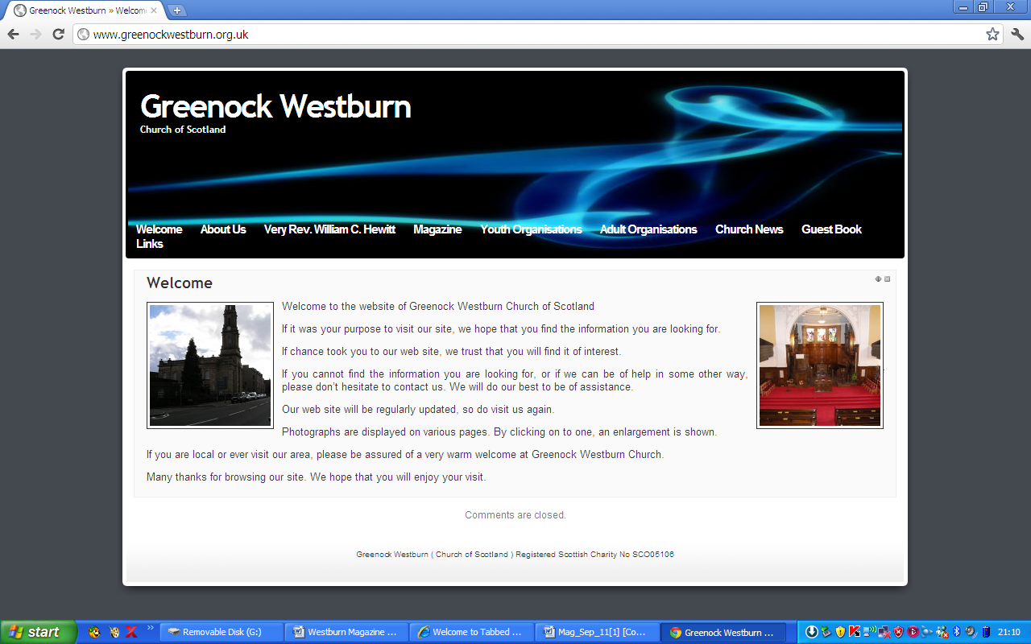
Have you put your syllabus, planned activities, or interesting comments about your organisation or group on your web page. If not it may look as though you’re not doing anything interesting. Have you looked at your page on the web, can you make it more interesting, add photographs, make comments, ask one of your members to write about what it is they enjoy about your group. Jim Bell will be happy to update your page.

A similar invitation is made to any church member who feels that they can assist in making the web site more interesting.

Our church web site can be found at - http://www.greenockwestburn.org.uk/ Please visit it and view it's contents.

Further information can obtained from Jim Bell ( 01475 799381 or all.the.bells@ntlworld.com )


CHURCH NEWS BOOK

If you are aware of anyone who is ill or would benefit from a visit from the minister, please make an entry in the news book with their name and address. It is helpful if you sign your entry.

Life and Work

Life and Work is available on the last Sunday of every month priced £2.00 Subscriptions available.

Please contact Shelagh Hendry Tele. 794667.
Delivery can be arranged if you are unable to get to church.

Find us on FACEBOOK

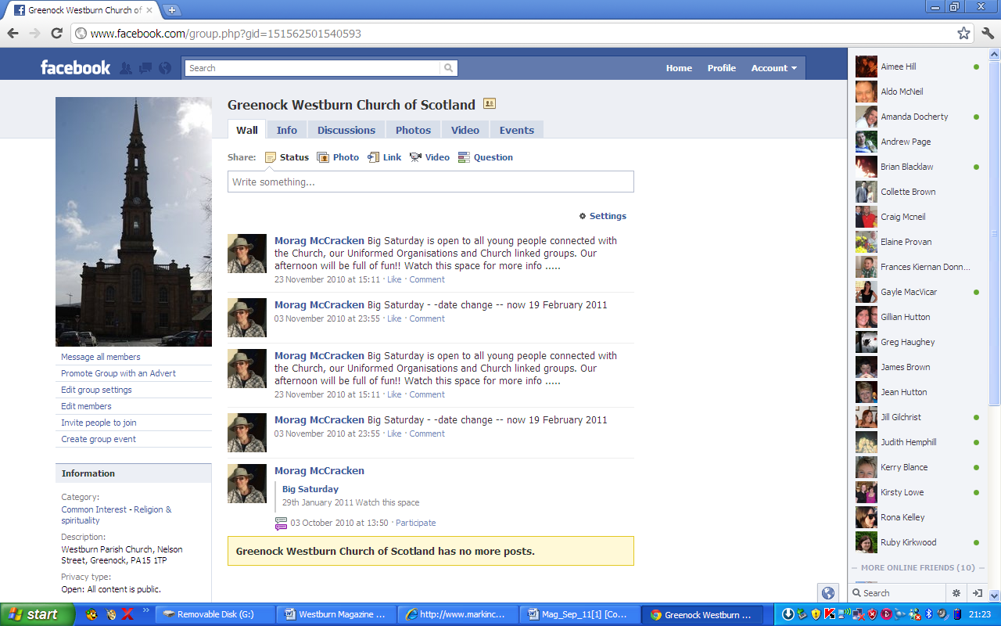
Search on FACEBOOK for “Greenock Westburn Church of Scotland” and join the social media revolution.

PRESBYTERY OF GREENOCK AND PAISLEY
Feb/|March/April 2014

WELCOME – The Moderator welcomed Rev. Karen Harbison to her first meeting of Greenock and Paisley Presbytery and looked forward to working with her.

LEAVETAKING -. The Moderator thanked Rev. I Johnson for the service he had given to Presbytery over the years and wished him well in his new charge.

Rev.DavidMcCarthy was thanked for his work and service in East End and was wished well in his new job with Faith Expressions.

BUSINESS COMMITTEE - Rev.Alistair Cook is appointed as Interim Moderator at Greenock East End New Charge Development during the vacancy.

Rev.Ritchie Gillon is to be the next Moderator of Presbytery from Sep.2014.

A committee has been set up to oversee the arrangements for the visit of the Moderator of the General Assembly and invites congregations to contact Presbytery Office if their church is celebrating a significant event in March 2015 to which the Moderator might attend.

VACANCY PROCEDURE COMMITTEE – Greenock Lyle Kirk was granted permission to call a minister on the basis of unrestricted tenure.

MISSION AND DISCIPLESHIP – Kirk Sessions and Safeguarding Co-ordinators are reminded of the instruction from the General Assembly of 2009 that “ each congregation shall appoint a Safeguarging Panel and that Panel members must attend training.”

Douglas Scott Prayer Co-ordinator, has organised a meeting for prayer support
Of the General Assembly at Lyle Kirk on Wed.14th May 7.30pm.

Anyone interested in hosting visitors from Zimbabwe in October please contact Rev.Archie Speirs ( archiespiers1@aol.com)

Presbytery approved the next stage of the upgrade programme at Lyle Kirk’s Newark St. Building.

WORLD MISSION AND ECUMENICAL RELATIONS - The Convenor and Moderator attended tghe ordination of the new Roman Catholic Bishop of Paisley, the Right Rev. John Keenan. He has been invited to attend and address a future meeting of Presbytery.

COMMUNITY INTERESTS – Notes the formal staement by the Church and Society Council on Religious Observance in schools. In this context there may be some value in considering a name change from “ religious observance” to “time for reflection” and looks forward to the General Assembly’s consideration of this matter.

PRESBYTERY PLAN REVIEW – A recommendation is to be sent to the Ministries Council that East End NCD be granted full status.
.
Margaret Crawford Representative Elder

THE CHURCH OF SOCTLAND
Stewardship and Finance Department

February, 2014

Dear brothers and sisters in Christ,

I write to thank you most sincerely for supporting the worship, mission and service of the Church through the money you give in your offerings. It is important that you should know what happens to this money and this letter intends to explain how your congregation’s Ministries and Mission Contribution will be used to enable the work of the Church in 2014.
Greenock & Paisley - Westburn

Total Contribution to Ministries and Mission for 2014
£ 78,037

Ministries ( 86%)

£67,112 of your total contribution will go towards the cost of providing over 1,000 ministers and other parish workers in communities throughout Scotland and in the Presbytery of England. This contribution also assists with the costs of recruitment and training.

The 2014 cost of a parish minister at the top of the stipend scale is £40,411 ( stipend plus employer’s national insurance and pension contributions ). If your contribution to Ministries is above this figure, then your church is meeting the full cost of your ministry and supporting other congregations. If it is less than £40,411, your congregation ( or linked charge ) is being supported by other congregations.

Mission ( 14% )

£10,925 of your total contribution will be used to support the Church’s work in: resourcing congregations for Christian education and outreach; providing social care services in Christ’s name to further the caring work of the Church to people in need; accompanying partners around the world on our shared Christian journey; contributing the Church’s opinion in public debate and on issues affecting Scotland and the World; providing central day-to-day service work in administration, financial and legal matters; and in planning the General Assembly and ensuring The Moderator represents the Church.

As you will see, the contributions your Church makes ensure a very diverse ministry is maintained and that the Gospel of Jesus Christ is shared in many ways and in many places. Many churches have made additional Ministries and Ministry contributions throughout the past year and these have also been gratefully received.

Should your church wish any support or resources from the Stewardship and Finance Department, please do not hesitate to contact me. The National Stewdardship Programme is now into it’s second year and our team of consultants are willing to guide your church through a stewardship programme, or simply to provide you with some ideas and advice. Please remember that the consultants will work with your church free of charge - there is no charge for their time.

I do look forward to assisting you in any way that I can.

Yours in Christ

Alan Gibson

Rev Alan W Gibson
Head of Stewardship
Congregation Number: 150815

Pastoral Care Committee

- The Committee met on 31st March 2014 and the next meeting will be on Monday, 7th July 2014.

- District 22 – all members who are in nursing or care homes are regularly visited by the Committee. In addition, Karen, our Minister has also been visiting Members in hospital and at home. Joyce, Margaret Forbes, and I visited Megan Robertson during March at the nursing home in Saltcoats.
- Harvest Thanksgiving – will be on Sunday, 28th September 2014, when the Congregation will once again be invited to put a monetary gift in an envelope marked “South Africa” during the offering. There will be an opportunity to donate up to and including Communion on Sunday, 5th October 2014. The money will go to Venda, Cotlands and Sunshine Centre
Bill Dempster

PROPERTY COMMITTEE REPORT
MAGAZINE – Summer 2014

The new Audio Visual system has been installed by Mediascape and is now operational. There is a dramatic improvement in the sound quality. Also use of the screens is proving to be a great advantage in enhancing the Morning Service.

Other than a new input connection, no alterations have been made to our existing Induction Loop System. Any defect being identified is an inherent problem. Comments have been made by users of static or buzz being picked up. Also there may be an issue with clarity of sound. This has been investigated and it is hoped that we may have achieved an acceptable level. Any user who is experiencing a problem, please advise Jim Bell Tel No 799381.

A new carpet has been fitted in Room No 1 (the blue room)


Over the summer months, the main work proposed is redecoration of the Main Hall, Youth Hall and painting of external down pipes.

Investigation is continuing with regard to the work required to address external stonework repairs as identified in the Presbytery Quinquennial Report.

Areas such as behind the pulpit, rear of stage and main hall cupboards have become a ‘dumping ground’ for left over or unwanted materials. A tidy up is in progress.

Any Convenor or organisation with a need for long term storage should speak to the Church Officer or the Property Convenor

A range of minor work is continually ongoing. Volunteer labour contributes to a substantial cost saving in church expenditure. If any member would like to assist in any way, please contact Jim Bell (Tel No 799381)

INVERCLYDE DOORS OPEN DAYS

Inverclyde Doors Open Days will be held on the weekend of 13 – 14th September 2014.

It has been decided that Westburn Church will participate on Saturday 13th from 10.00am to 3.00pm. in a similar manner to past years. Nearer the time, a request will be made for volunteers to act as stewards and to help with tea and coffee.

Glasgow 2014 - 20th Commonwealth Games

Congratulations to our own Joyce Dempster who has been chosen as one of the Queen’s Baton Bearers for the 20th Commonwealth Games, when the Baton will pass through Inverclyde on Monday, 14th July 2014. She will carry the Baton a distance of 200 metres.
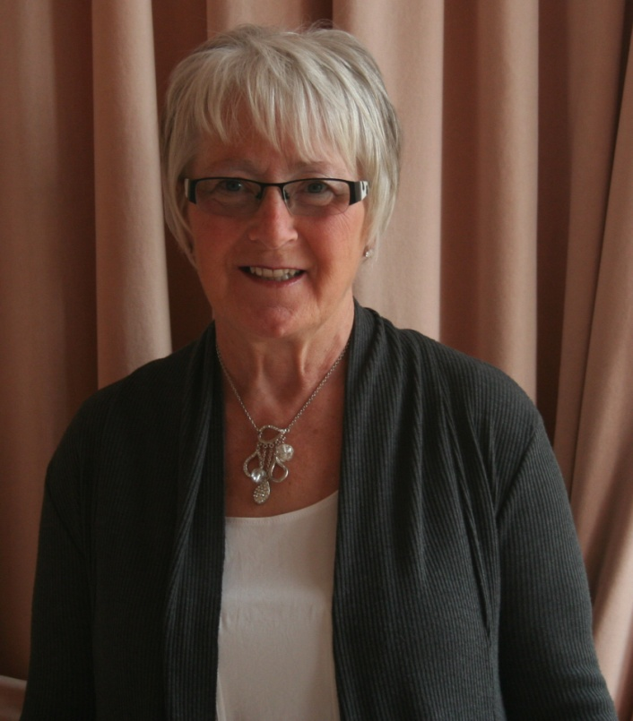

At this time we are still waiting on the exact route, but look out for further details.

TIME FOR PRAYER

At Westburn our motto is: Worship, Friendship, Action- a kirk that cares.
Will this prayer from Zimbabwe inspire us to live up to our motto and our ideals?

God,
Open up our eyes so that we can see when people are in pain.
Activate our hands to help to feed the needs of those who hunger.
Touch our hearts to bring solace to the despairing.
Instil in us magnanimity to reach out and welcome strangers.
Give us the power of that love which strengthens the ailing.
Help us to intercede to win back freedom for those who are unjustly in captivity.
Whenever we share with others our fears and our love, our poverty and distress as well as our blessings, that, God, is when you are closest to us. Amen.

Douglas Scott

PRAYTIME

CHILDLIKE PRAYER

Jesus was not pleased with his disciples when they tried to chase young children away from him. Here is a little story which shows how we might learn from young children something about our approach to God in prayer.
Before going off to bed, wee Freddy went for a last walk in the garden. He looked up at the apple tree and said: “You’ve made that really beautiful”. He sniffed the scent from the roses. “You made them beautiful too”, he said. He tasted a couple of the growing strawberries. “And how delicious you’ve made them”! he enthused. Then he went back inside, and his Granny took him upstairs to bed.
“Let’s say a wee prayer”, said his Granny.
“I’ve prayed already”, answered Freddy.

MAYBE WE SHOULD REMEMBER TO PRAY CONTINUOUSLY IN GRATITUDE FOR ALL THE BEAUTIFUL EXPERIENCES THAT SO OFTEN ENRICH OUR LIVES.

(from Douglas Scott, presbytery prayer coordinator: )

BIBLE STUDY

At our recent bible study meetings, we spent a lot of time thinking about the meaning and importance of forgiveness. We saw examples from the bible such as the woman caught in adultery, the prodigal son, Peter's denial of Jesus and the good Samaritan.
In a modern context, we heard from a woman who forgave her rapist, someone who was persecuted because of her race, and other victims of prejudice.

How often do we feel that we have been betrayed or snubbed by others? And what is our response? We can choose to retaliate or we can choose to forgive. We know what Jesus recommended, but forgiveness can be hard. Are we up to it?
Is forgiveness a surrender to bullies or a pathway to reconciliation? If you have ideas about this, come and join us when we continue our bible studies in autumn.

WESTBURN CHURCH MEMBERS – “STEPPING OUT IN FAITH”

Westburn Westie’s on the Move (again!)

Last year, around 36 brave souls of the congregation virtually walked around the Church of Scotland churches in Europe. We covered 9,566 miles in just a few months. A “Big Thanks” to all who participated. In response to many requests a further walk is being organised for this year. It will be slightly more ambitious, virtually taking us from Nelson Street to the Vhutshilo Mountain School, Venda, South Africa after visiting a few other places en route. Total miles on this trip are estimated at approximately 15,000
The format will be the same. Each morning attach your pedometer, record daily totals, then on Sunday bring the week’s total to church to be recorded. In the Main Hall there will be a map showing the full route and Westburn Westie’s progress. The intention is that the challenge would commence Sunday 1st June. If you wish to take up the challenge please register your intention to participate on the flipchart in the Centre Foyer on either Sunday 11th,18th , or 25th May. I, (Doreen) will be available on Sundays 11th and 25th to answer any questions or just encourage!!
As the Mountain School in Venda is close to our hearts and, as the school would benefit from having a computer, it has been suggested that we could use this walk as a fundraiser (without it being a compulsory outcome of registering for the walk!) What do you think. Let me have your thoughts and suggestions.

We look forward to seeing your name on the chart so Get Ready to start Walking, and to “Stepping Out in Faith Together”.

Doreen Borland

The following letter was received by Doreen Borland from Dr Gordon Lyon
Chairman of Trustees

SCOTTISH AID TO EASTERN EUROPE
( a Christian Development Project)

Thank you for the beautiful items knitted by The Shawl Group of Westburn Church and donated for the children in Oradea, Romania. They are beautiful and will be much appreciated, both by staff at Emanuel Hospice and by the poor children. Please be sure to thank everyone who worked so hard for this effort.

It is always a great source of encouragement to us to know how the Lord continues to meet our needs for the charity as we step out in faith. We are already well advanced with our arrangements for this year’s trip.
Within the next three or four weeks we plan to transfer the load to Glasgow to be uplifted and taken out, we then plan to fly out and help distribute the aid as well as arranging other projects in the area. Thank you again for your practical support
Church of Scotland World
Mission Stamp Appeal 2014

The GEC’S New Refuge House: Dorcas

The Greek Evangelical Church (GEC) has recently opened Dorcas, a brand new Refuge House for Women victims of Domestic Violence and their children in Milotopos, north Greece.

The GEC responded to requests from women seeking refuge from violent partners by buying a house in 2012, which has been fully renovated by February 2014.

Now finished, the house will provide a safe haven for women who have suffered domestic violence and their children. It’s first ‘tenant’ a young woman and her new-born baby moved in this Spring. The women will never be asked for any rent or money, as they are in financial need themselves, so the Church will cover all the running costs of the house.

You can help the Church to cover these costs, to ensure these women have a safe and comfortable place to call home by collecting your used stamps, which are sold to raise money.

Our red basket for your used stamps is always available in the centre vestibule. Thank you for continuing to support The Church of Scotland Stamp Appeal.

Evelyn Taylor.

GUILD

By the time you receive this magazine the guild session for 2013/2014 will be over although we will still meet every fortnight from 22nd April until 3rd June for a chat and a cup of tea.

We have had an interesting session finishing in the lounge with the Langbank Singers which was enjoyed by all attending. We ended the session with a meal in the Tontine.

The committee have met to start compiling the syllabus for next session our theme will be “A world to serve”. The task of contacting speakers and guests are in the hands of our new secretary Senga Currie. It is hoped that she doesn’t find it too daunting as we would like her to undertake this task for a few years.

I include the latest update of the monies raised for the latest 6 projects:-
From September 2012 to 20 February 2014:
Comfort Rwanda: £59,095.88
CrossReach: £90,359.90
Mary’s Meals: £67,837.29
Ministries Council: £36,471.72
Scottish Churches Housing Action: £54,534.94
World Mission Council: £53,380.58
Total: £361,680.31
During a recent service the minister commented on one of the Guild projects “Out of Africa into Malta” which is the World Mission Council above. More information about the projects are on the noticeboard in the foyer.
I conclude this report, and I on behalf of the members of the guild wish the congregation a relaxing summer and hope that the weather is kind.
Patricia Robertson

Some more details of some of the Guild Projects are included in the magazine. Comfort Rwanda, Mary’s Meals, and
‘Out of Africa .... into Malta

Boys’ Brigade

Two young men of the 7th Greenock Company the Boys ‘ Brigade, James Cliesham and Darren Mc Feeters will take part in a Rotary Youth Leadership Award Project at Blanefield Stirlingshire between 6th and 11th July this year.

Both lads who earlier in the session gained their President’s Badges will participate in a programme of physical and intellectual activities which will develop skills in teamwork, leadership, communications, problem solving and decision making.

Darren and James are looking forward to this course and the Company would like to thank the Rotary Club of Greenock who are sponsoring the boys for this event in and particular Billy Dempster for his help and encouragement.

Scout Report
Hi to all the Westies from the 5th and welcome to Karen (our new spiritual leader)and family.
'Things ain't wot they used to be' according to the song but also true for the Group. Our numbers hit an almost all time low by the end of last summer (single figures back in the late eighties was nearly our demise) but we have bounced back slightly since last summer. 'Big Saturday' can take some credit for that. We currently have five beavers and three cubs. We have temporarily combined the two sections to make it more interesting for our youngsters and so far it has worked well, but it isn't ideal.
The Scout Section is sitting about the same, at eight with explorers and Network in a healthier position. However, if the lower sections disappear, so ultimately will the senior sections. We need more young blood within our ranks.
Leaders are also a problem as we currently don't have a Cub Leader (I'm standing in) and I need a new Beaver leader to lighten the load on our current leaders, Jennifer and Louise Lindsay, without whom the bottom end would collapse!
That's the bad news. The good news is, those who do attend do so regularly and appear to be happy with what we do. We've really great kids and it's a shame we don't seem to be able to boost the numbers. Our Scouts did their annual West Highland Way hike again this Easter and are looking forward to summer camp in about ten weeks from now. It's that time already!
So, if there are any youngsters you know of, that would like to take up Scouting, please let me know. Sons, daughters, grandchildren, neighbourhood kids or any others you know of will be most welcome. Or if you fancy yourself as an aspiring leader please talk to me. As it says at the front of the Church on the notice board, 'All Are Welcome'.
Yours in Scouting,
Ricky Martin, GSL.

Funerals since March

1.3.14 Maureen Riley, 22 Robertson St.
4.3.14 Vary Fagel, 2 Kempock St.
6.3.14 Norman Macdonald,
Lochgilphead .
10.3.14 Elizabeth Swinney,
Larkfield View Nursing Home
11.3.14 Duncan McEachran,
6 East Shaw St.
31.3.14 Catherine Mills
Ailsa Lodge Care Home
3.4.14 Magnus Todd
Glenfield Nursing Home
9.4.14 Margaret McDonald
3 Bearhope St.
28.4.14 Nan Macfarlane
34 John Galt House
29.4.14 Margaret Hopkin
28 Westburn Buildings

Wedding

3.5.14 Janice Abbott and Craig Black.

Baptisms

30.3.14 Kai Duncan MacSwan son of Michelle and Mark
27.4.14 Robert Ferguson Carter son of Jacqueline and Johnny

FROM THE ROLL-KEEPER

DEATHS

Mrs. M. Campbell 1 Nimmo St. 15 January
Mr. N. Macdonald 29 Dun More Ave., Lochgilphead 21 February
Mrs. N. McFarlane F34, JGH, 2 Duncan St. 18 April
Mrs. C. Mills Ailsa Lodge Res. Hm., Bishopton 22 March
Mr. M. H. Todd Glenfield Nursing Hm. 22 March

DISJUNCTIONS

Mr. J. Hair 66 Broomberry Dr. 10 to Old Gourock
Mrs. V. Hair 66 Broomberry Dr. 10 and Ashton

NEW MEMEBERS by TRANSFERENCE

Rev. K. Harbison 50 Ardgowan St. 6 from Hamilton
Mr. C. Harbison 50 Ardgowan St. 6 Trinity
Mrs. I. Leith 12 Drumslea, Newark St 8 from Lyle Kirk
Mrs. M. Ramsay F7, Seafield, Esplanade 7 from Lyle Kirk
Mrs. C. Scott 0/1 10 Nelson St. 2 from Greenock East URC

NEW MEMEBERS by RESOLUTION of KIRK SESSION

Mrs. M. Edgar 60 Gateside Gdns. 13
Mr. R. Sproul 17 Roxburgh Ave. 18

TRANSFER to SUPPLEMENTARY ROLL

Mrs. R. Faulds 3 Linnhe Rd., 20

CHANGES OF ADDRESS

Miss Y. Campbell 4 Roxburgh Ave. 18 stays D18
Miss C.E. Currie Kincaid Hs. 22 from D15
Ms. J. Hyslop 23F Regent St. 18 from D14

IN ORDER TO KEEP CHURCH RECORDS UP TO DATE, IT WOULD BE GREATLY
APPRECIATED IF MEMBERS WHO ARE MOVING INFORM THEIR ELDER, THE
SESSION CLERK OR THE ROLL-KEEPER OF THEIR NEW ADDRESS

