**WESTBURN PARISH  
 MAGAZINE**

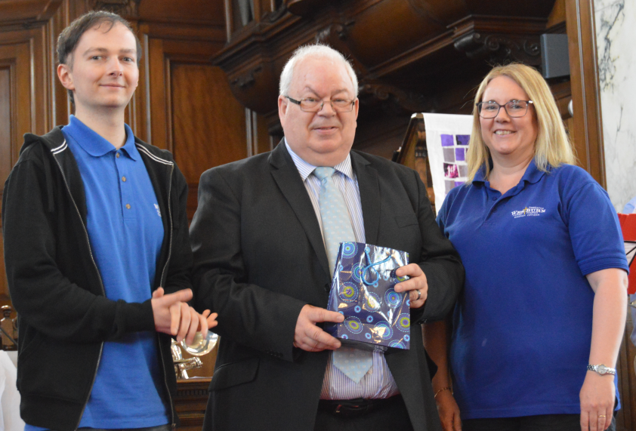

**Summer 2019**



“ **WORSHIP,FRIENDSHIP, ACTION – a kirk that cares. “**

**Welcome to the Summer Magazine 2019**

As the Summer magazine is being prepared we have had some lovely warm sunny days, let’s hope that is a sign of what is to come. The Spring gardens were looking their best as everything came to life. (without too much hard work yet )

Not so inside the church, there has been a lot of hard work taking place with the demolition and renovation of the foyer area, This area is also coming to life as the work and decoration has been completed enabling us to see what it will look like and we look forward to gathering together socially in our new Gathering Place and the Church

Officers are settled in their new office. While this was a big undertaking it was amazing how little disruption there was to groups and organisations who used our halls and premises,

Westburn continues to be very busy with all our organisations and committees working hard enjoying and sharing friendship and fellowship. Westburn is now a Dementia Friendly Church. We enjoy our music group and Stedfast band participating in our worship. Coffee mornings to socialise and help raise funds. Recent film shows were a great success and enjoyed by many and we look forward to the annual bowling night and other social activities. Once again this year we will welcome visitors from the Cruise Ships, Westburn is well admired by many visitors and we are grateful for the volunteers who help with this.

Brian Lindsay from the Communications Committee produces the magazine and appreciates your input helping to make the magazine interesting, please keep this up. Notification for material for the Autumn magazine will appear in the Order of Service.

Whether at home or away have a great summer hopefully enjoying lovely weather.

Cath

 CRUISE SHIPS

Once again Westburn Church will welcome visitors from Cruise Ships this year. We open the church from 10a.m. till noon for some of the big ships. We have interesting leaflets and prayer cards for our visitors. Our leaflets are also available in German and Italian and this year we will have our prayer cards in German thanks to Douglas Scott.

Our church is well admired by our visitors and we depend on volunteers to help with this. There is a list of the dates in the foyer if you are able to help please add your name to the list. If you wish any information please speak to Cath Barbour.

**FROM THE MANSE**

Dear Friends

Fuzzy is not usually a word we associate with church, but it has become such a word over the last wee while. Discussions have been taking place over the last eight or nine months , first between ministers, then also with Session Clerks, then also with Kirk sessions and most recently , on 13th April, with Elders from a number of Kirk Sessions coming together for a morning of conversation, studying the bible and daring to dream and imagine.

Fuzzy Parish has become the working title helping us to explore the possibilities of working more closely together with our friends in neighboring churches in the west of Inverclyde. Fuzzy Parish reflects the idea that some of the lines and boundaries we have drawn around ourselves might have to become more fuzzy and less distinct as we collaborate with one another in seeking to be the church and to be channels of God’s peace, love, hope and grace in our community. Some of the impetus for these discussions has come from the call from the 2018 General Assembly for the church to be more radical in facing the challenges which face us as the Church of Scotland in our time but working through these discussions we realize more and more that the call comes from Jesus himself to be his faithful disciples and the body of Christ in our time and place. There is much more work to be done as we go forward in playing our part in the Presbytery of Greenock & Paisley and in the Church of Scotland.

In the meantime, please come along to joint events and make connections with our friends from neighboring congregations as we seek together to be the body of Christ in this place.

Yours

Karen

**A DEMENTIA FRIENDLY CHURCH**

It is hard to believe that I have now been here at Westburn Parish Church as Probationary Minister for eight months. Where has the time gone? When I arrived last year, I mentioned to Karen that one of the topics I would really like to learn more about was Dementia and for very good reason.

Statistics show that 850,000 people have dementia in the UK, with numbers set to rise to over 1 million by 2025 and this will soar to 2 million by 2051. 225,000 will develop dementia this year, that's one every three minutes. 1 in 6 people over the age of 80 have dementia. (Source: Alzheimer UK).

Karen had mentioned that we have a group who meet here at the church run by Alzheimer Scotland and asked if I would like to volunteer with them each Friday, which I decided to do. From this simple meeting with the group, the next few months opened lots of opportunities.

With the help and support of Sean Caulfield the Dementia Advisor who runs the group, we firstly decided to investigate how we could become a Dementia Friendly church. Sean kindly walked round our church giving us suggestions on how we can do this. The biggest change you will see is the new signage throughout the church which is bright, light and has images attached (pictured). These signs

are temporary and will be replaced with proper signs in the future when our new welcome area is complete.

Sean has also come to the church to deliver two sessions of Dementia Friends training. Our pastoral care team, myself and Karen went through this and we then opened it up to the congregation. Dementia Friends training helps us to understand a bit more about dementia and the small things we can do to help people with the condition. From this training we also plan to have Dementia Champions with their main aim of making sure that we remain a dementia friendly church in to the future.

I also managed to visit Adams House in Elderslie which is run by Crossreach, the Church of Scotland’s charity arm. Adams house offers a specialised service to people who have been diagnosed as having dementia and who can no longer live safely at home. I was given a tour of the facility and great resources to help me in my continual learning about Dementia.

I also had the opportunity to learn about Playlist for Life from Lorraine who is a member of our congregation.

Playlist for Life wants everyone with dementia to have a unique, personal playlist - all the tunes that are most deeply

attached to your memories and emotions, gathered together in one place. More than 20 years of scientific research shows that listening to a personal playlist can make living with dementia easier and happier. (Source: Playlist for Life)

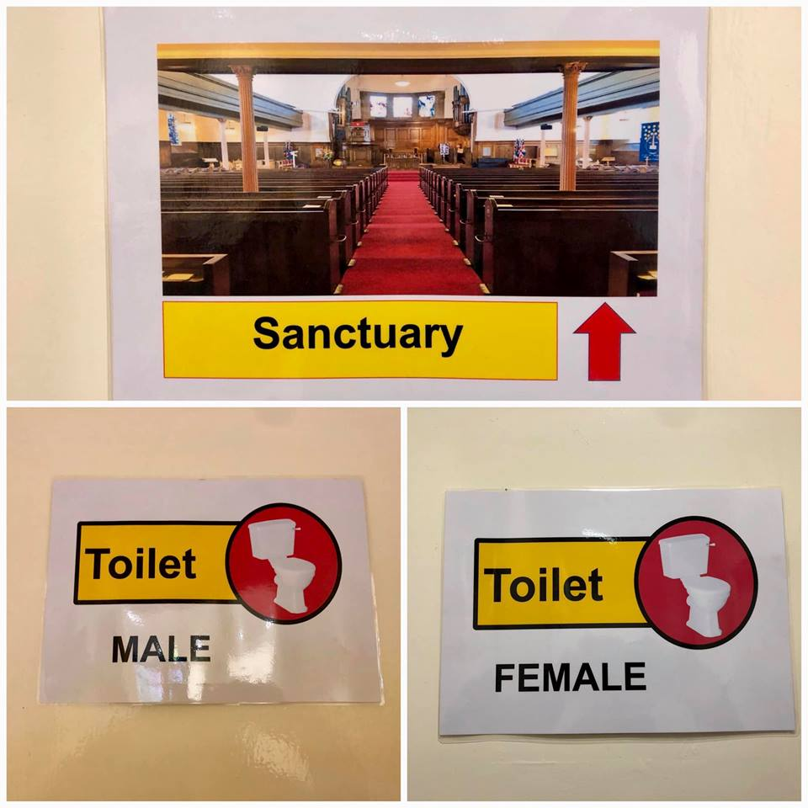

I set out on this placement to learn more about Dementia and with the help and support of various people and useful resources I have been able to achieve this however, there is still more to do. I want to thank our Finance Team and Kirk Session for approving a £500 budget towards dementia changes in our church, this is excellent and demonstrates how important Dementia is to us. It also helped highlight some of the changes we need to make to enable people with Dementia to enjoy visiting and using our building.

If you want to find out more about the above and the Dementia Friendship group which meets in our church, please speak to myself.

Kind Regards

William

Student Minister

**Session Clerk’s Report for Annual Stated Meeting on 24/3/2019**

Looking back on what has happened in Westburn Parish Church during 2018, there are 3 main headings that stand out for me – charity, stewardship and ministry.

**Outreach**:

As a church and through some of our organisations, we are involved in a lot of outreach work both locally and throughout the world. During last year we assisted with the work of Christian Aid through the local fundraising coffee

morning. We also provided ongoing financial support to our various South African charities and there were several retiring collections including for Mary’s Meals and the Red Cross Yemen Appeal.

The Guild raises a lot of money both nationally and locally, with support going to their designated projects including Crossreach, World Mission Council, Sailor’s Society, Malawi Fruits and the Boy’s Brigade.

This is in addition to what is done by individuals within our congregation. I could not begin to quantify the number of hours of voluntary work that are undertaken or the substantial amount of charitable donations that are made on an ongoing basis by our members.

**Stewardship**:

The falling number of members had led to a decline in the income received by the congregation. This was an area of concern for the Finance Committee and they took the step of running the Stewardship Campaign in the autumn. Although the full analysis of our givings has not yet been completed, the hope is that this will temporarily stem the decline in our income.

**Ministry**:

Since last summer, we have had William working alongside Karen in leading our ministry. William has thrown himself into the life and work of our church and it has been a joy to have shared in his work and enthusiasm. He has become a part of the Dementia Group that meets in our hall and has taken the congregation forward as a Dementia friendly congregation. He has also developed our interest in the NOOMA bible study programme and has left us the legacy of new leaders to take this forward when he moves to pastures new.

In addition to William, Morag has completed her worship leaders training and has now been certificated by the local presbytery to help lead worship within our church.

And as for Karen, I don’t have time to list all the work that she has done in the last year. Please do not underestimate

the amount of time that she spends working in the name of Westburn Church, but instead let’s support her efforts by doing our bit.

**Summary**:

There is so much that goes on here in our church buildings, week after week, and it is good that we open our doors to the community to allow these things to happen. Our new foyer area is making good progress and we look forward to it adding a new dimension to our hall space and usage in the weeks ahead.

News reports continually tell us that the church nationally is in decline, but it is important that we realise that the church will only decline if **we** allow it to happen. As we look at the way forward locally, the church will continue to change as it has always done, but with our help, it will stay very much alive.

In conclusion I sincerely thank everyone who has played any part in the work of Westburn Church during the last year.

Hazel M Munro

Joint Session Clerk

**SMALLS FOR ALL UPDATE**

Hazel and I attended a rotary meeting for the presentation of certificates to the 29 groups who had donated pants in 2018.

A representative from the organisation spoke to us about the charity which started in 2009 with Maria sending a shipment

of pants to Ethiopia. Over the years donations have increased that they needed to find a larger storage unit where volunteers sort and pack in readiness to ship abroad to 7 African Countries. The charity also sponsors girls to enable them to continue with their education and in 2017 the first girl sponsored in Kenya graduated from University of Nairobi.

Greenock Rotary collected over 5,000 pairs of pants in 2018 and in November 2018 Smalls for all sent its biggest ever shipment of underwear - **90,000** items to Malawi, Zambia, Somalia and the Gambia. At the beginning on 2019 a milestone was reached when the number of pants collected reached **1,000,000.**

It was really interesting to hear what a difference this charity makes to so many women and girls in Africa. Thank you to all who have donated.

Elizabeth Irvine

**NEWS FROM PRESBYTERY**

Having recently completed a short course in leading worship, Morag McCracken received a certificate from presbytery.

Presbytery heard a presentation from Rev Stuart Davidson, a recently appointed pioneer minister, who works mainly in Ferguslie and North Paisley, and is exploring alternative approaches to Christian service and worship. This involves getting to know individuals and groups in the community who have up to now had little or no contact or experience with the church.

Presbytery urges congregations to consider ways of supporting the Inverclyde Family Contact Centre. This is a local charitable organisation which seeks to facilitate contacts between members of families who have become separated. Their financial situation is becoming increasingly precarious.

from Douglas Scott

**TIME FOR PRAYER**

As Christians we have faith in God. But as children of God we should also have in ourselves, and maybe sometimes we forget that.

Eternal loving God,

We are your children, but sometimes we fail to have faith in ourselves.

We distrust ourselves, so we bury away our talents, and fail to develop our potential.

We pay too much attention to the judgments of others, and are all too readily led astray.

We yield to errant voices to avoid confrontation and conflict.

We don’t dare to stand up for what is good.

God, you have given us much. Give us too faith in ourselves, and the courage and conviction to acknowledge your way, to proclaim your message and to stand up for your kingdom.

Amen.

**DISCIPLESHIP COMMITTEE**

In February and March a second series of bible studies based on NOOMA was held, this time during the evening. There was good attendance and participation. We will probably arrange a new series of bible studies, again based on NOOMA, perhaps after Easter or towards the end of summer. The committee would welcome suggestions on timing (daytime or evening). We would also encourage anyone who may be interested in leading any of these sessions to get in touch with the committee.

We would also be happy to welcome anyone who might like to join us on our small committee.

Thy Kingdom Come is the name of a movement supported by the Church of Scotland, the Church of England and many others around the world. The stated aim is to encourage people, individually or in groups, to pray with a sense of togetherness in all parts of the world, especially between Ascension (30th May) and Pentecost (9th June). All Westburners are cordially exhorted to participate in this international gesture of solidarity through prayer.

from Douglas Scott

**FELLOWSHIP COMMITTEE**

Bowling Supper Night :

In the past few years the Bowling night at Ardgowan Bowling club has been a great success.

The numbers have grown and everyone has a chance to shine and have fun either on the Bowling green or during the quiz. It’s a light hearted family evening, hopefully rain and midge free.

Dates etc. to follow.

Car Treasure Hunt:

This year we’ll be testing your local knowledge with a Car Treasure Hunt. We have still to tie up all our ideas and dates etc. Don’t worry we’ll put all the details in the intimations and on Facebook as soon as possible.

Linda Murray

**NEWS FROM VENDA**

The following is a letter received by Monica from the School in Venda

Monica McNeil

Church of Scotland

Glasgow

25th January 2019

Dear Monica

Suzi’s passing was heart-breaking for us all, including members of the Tshikombani Community who had become very attached to her. It has been a very difficult and unsettling time, but we have gathered our strength and are moving forward, with the help from the support we have received from loyal “Friends of Vhutshilo” such as yourself and the congregation of your church.

Could you please convey our sincere gratitude for their very kind (and well timed!) donations. Attached is a photo of the

plaque which is lovely, but the writing is not clear enough so we are returning it so it can be re-done in black.

This Year the school is 13 years old and we are excited that the first class is now at university mostly doing second year. Just to mention people like Vhuhwvho studying degree in Social worker, Murangi in computer, Philly Diploma in carpentry.

Today the school got 50 learners divided into three groups, babies class aged 1 years to 2 (18) years, pre-school 3 years to 4 year(22)s and Grade R 5 years to 6 years (20) and we have 3 teachers and 1 assistant. Out of 50 children in our school 20 are paying and 30 are sponsored children.

Kind regards

Khathu Nemafhohoni

Acting Director

*On behalf of Team Vhutshilo*

Since receiving this, we have learned that Philly, one of the children who attended Vhutshilo from the start (and who has been sponsored by Stuart and Patricia Robertson for many years), has passed away.

Philly was living with HIV, and had been doing very well in recent years, studying for a diploma in carpentry and running marathons as a hobby.

Unfortunately, a local ‘prophet ‘ from his church, convinced Philly that he had cured him of HIV. Such occurrences are becoming increasingly common in the Venda region.

He stopped taking his antiretroviral medication and stopped attending his support group at the school. He died within months.

If this tragic event can teach us anything, it is that our support for the work that Vhutshilo school does, has never been more important.

Monica and Les

**PASTORAL CARE COMMITTEE**

The Committee met on Tuesday, 12th February 2019 and will meet again on Wednesday, 24th April 2019.

1. **District 22 –** the Committee regularly visitour Members who are in nursing or care homes stretching from Cochrane House, Johnstone, Bagatelle Nursing Home, Balclutha Nursing Home, Alt-na-Craig, Bellaire Nursing Home, Glenfield Nursing Home and Larkfield View. The visits can be hard, but all are rewarding, although a small bar of chocolate does help on occasions.  
     
   In addition, Karen, and William are also visiting Members in hospital and at home.
2. **South African Projects –** in addition to the funds raised for Venda, the Congregation sent £700 each to Cotlands and the Sunshine Association. Letters of acknowledgment are attached to this report and includes a photograph of Nthabiseng Nkutha, who has Cerebal Palsy and our donation will help with her school fees. It is great to see our donations being put to a very worthy cause.   
     
   Pastoral Care Committee



Westburn Parish Church of Scotland

Nelson Street

Greenock

Scotland 30 January 2019

Dear Rev Karen Harbison and Congregation of Westburn Church of Scotland, On behalf of the 21 132 beneficiaries we wish to express our gratitude for the donation of ZAR 12 114,44 which was received in our bank account on 29 January 2019. We are completely reliant on benevolent and kind hearted people such as yourself to sustain the work we do in poor and rural communities in South Africa. Cotlands celebrates its 83 birthday this year and has always served vulnerable children.

Your donation will be used to support the meals for children in a playgroup in Johannesburg, South Africa. Since 2012 we have introduced playgroups in communities where children have no access to early childhood education

programmes. The playgroup programme is aimed at improving children’s school readiness. It is supported by a toy library that provides all the resources needed to implement a quality our play-based programme. Included in the services we provide is breakfast and lunch. Parents are also supported with regards to their parenting and we offer health services to the children attending our groups. In addition, we also do a number of capacity building workshops aimed at improving service delivery to children. In our last financial year, we reached 15 120 children and 6 012 adults through a number of programmes we run. Your prayers for the work we do continue to be a source of strength for the 185 staff members employed by Cotlands. We do this work because we are called to serve children, who as you know, are important in God’s kingdom.

Kindest regards

Dr Monica Stach

Chief Executive Officer

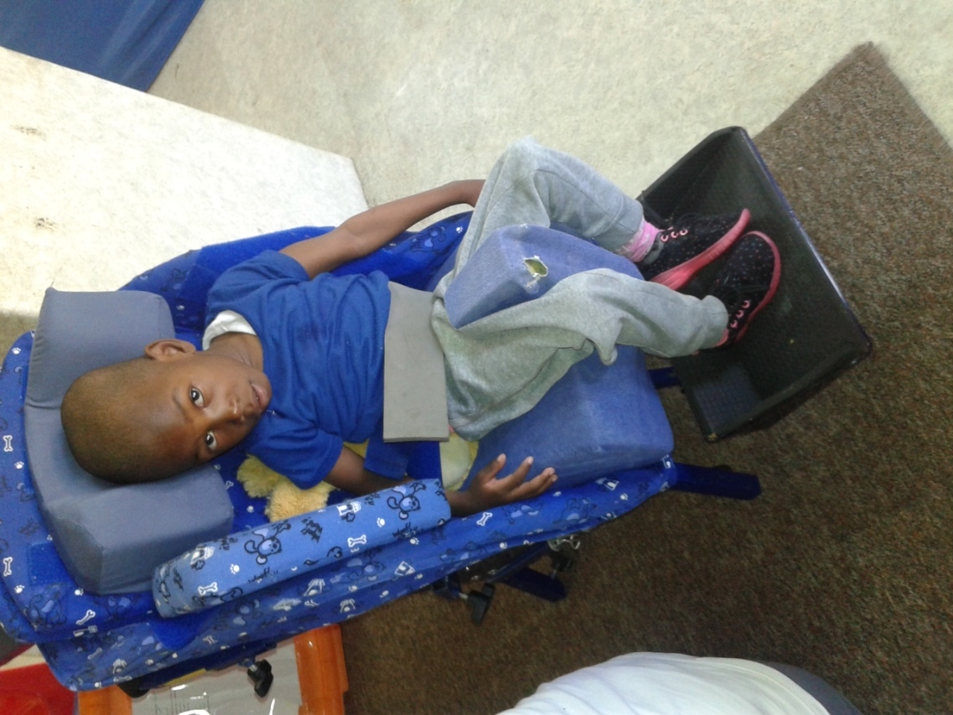

**Copy of letter from the Sunshine Association**

6th February, 2019

Rev Karen Harbison

Congregation of Westburn Church of Scotland

Nelson Street

Greenock

Scotland

Dear Rev Harbison,

Donation – R12, 115.21

Please accept our heartfelt thanks for the magnificent donation of R12, 115.21 received by our Association on the 4th February, 2019. These funds will be used towards paying school fees for Nthabiseng Nkutha at our Elsburg Early Intervention Centre. Nthabiseng is 7 years old and has Celebral Palsy, she has been with the centre since 2016.

Ntabiseng stays in an informal settlement with her parents. Both parents are unemployed and are therefore unable to pay her school fees. Her parents are actively involved in the activities of the centre and attend support groups and

workshops regularly. The family promotes her best interest and take her for check-ups at the hospital regularly. This funding will alleviate the financial burden that the family faces.

On behalf of all the children and families of the Sunshine Centre Association, thank you. Please pass our gratitude to the whole Congregation for making this donation possible and sharing their blessings with us.

Once again, thank you.

___________________

Yours sincerely

Ruth Phiri

Executive Administrator

**COMMUNITY LINKS COMMITTEE**

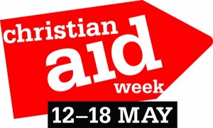Christian Aid is the international aid charity for 41 different churches across the UK and Ireland.

Christian Aid believes in life before death and seeks to support people in the world’s poorest communities by seeking to follow the teaching of Jesus Christ, who commanded his followers to love their neighbour and work for a better world.

Christian Aid stands with the most vulnerable and excluded people of the world – both in times of crisis and for the longer term.

Westburn Parish Church will once again support Christian Aid Week this May. Donation envelopes will be distributed at morning worship on Sunday 5th, 12th, 19th and 26th May. Please return these when the offering is uplifted.

If you are unable to get to church you can contact Simon Hutton (07513 838 590 or [simonhutton2007@googlemail.com](mailto:simonhutton2007@googlemail.com)) to arrange to make a donation.

**NATIONAL GUILD REPORT**

As I approach the end of my term as National Convener of the Church of Scotland Guild, I write this report after another busy period visiting Guilds and attending other organisation’s events.

It has been my pleasure to undertake all these duties but I still can’t believe that I was nominated for this position, I’ll certainly after it all ends have many happy memories.

Since the last magazine I’ve attended the following:

**March**

7th Dumbarton Riverside Afternoon Guild

9th Dunfermline Resource Day

14th Thursdays in Black (World Mission)

16th North Ayrshire Guilds Together Resource Day in Saltcoats

20th Faith in Older People Edinburgh – Loneliness and Isolation

23rd Perth & Kinross Guilds Together Resource Day

24th Hamilton North Guilds Together Songs of Praise & Communion Service

25th Mothers’ Union Scottish Episcopal Church – Ladies Day Service - Edinburgh

27th Ayr District Guilds Together – Spring Rally

**April**

4th Edinburgh Guilds Together – Balerno

9th Inverclyde Guilds Together – Inverkip

10th Leadership & Annual Gathering meetings – Edinburgh

11th Project Co-ordinators – Edinburgh

20th Walk with me with Right Rev Susan Brown, Boys’ Brigade and Girls’ Brigade Glasgow

25th National Council Edinburgh which will include the Sacrament of Communion celebrate by Rev Karen Harbison

28th Dumfries Gathering

**May**

1st Meeting in Edinburgh in connection with General Assembly

I’ve been appointed a Commissioner at the General Assembly this year, as National Convener I’ve to give the Guild report which will take place on Tuesday 21st May and at night the Guild are hosting a Big Sing at the Assembly. The hymns for this event have been chosen by the first Conveners elected after we became the Church of Scotland Guild, Mary Sherrard, Kathleen Forsyth and Catherine Nelson, Lorna Paterson, a former secretary, 2 members of the National Youth Assembly, 2 new members, an overseas delegate and as well as choosing a hymn John Christie will share a reflection with us. I’m sure we’ll have a good “sing” and evening.

I’ll report back on my week at the Assembly in the next magazine.

Once again, I thank you all for your support over the last months as I undertook this honour.

**Project Update**

Joining up the Dots £26,378.02 (Scotland)

A Chaplain for our Ports £18,222.55(Scotland)

Faith in Young People £22,320.15(Scotland)

Journeying Together £13,779.28 (Zambia)

Growing the Future £14,294.64 (Malawi)

Seema’s Project £21,473.73(India)

**Total £121,468,37**

Patricia Robertson

**GUILD REPORT APRIL 2019**

Just as in past years, by the time you read this our Guild Session will be over for 2018/2019.

We have had quite a varied programme. We have gained 1 new member. As in past years we have had speakers from two of the new projects. ‘Faith in Young People: Scotland The Boys Brigade Growing the Future: Malawi Malawi Fruits

We also contributed again to the Greenock Rotary’s ‘Smalls for all’ campaign.

We have learned about ‘The Whithorn Way’. Had a look behind the scenes at investitures, had a quilting Demo and learned something about the ‘Scots ‘language. It has been a varied programme. We had to cancel one meeting where we were to learn something about the River Clyde, but I am sure we can reschedule this.

Some of us will be meeting over the summer months as in past years on a fortnightly basis. We knit, crochet, natter over tea. If you want to come just for a natter we will be glad to see you.

Anna Seggie

**WORSHIP COMMITTEE**

The Worship Committee has been preparing a number of evening services and, since the last magazine was published, has held a service of evening hymns and vespers on 24th February which was enjoyed by those who attended. By the time you read this, a café style Christian Aid themed service will have been held on 28th April.

On the 16th June we will be holding a Songs of Praise with the Stedfast Band. We intend to invite members of our neighbouring churches to join us. We would very much like to see you there! Please see the orders of service for more details.

The music group is participating in services regularly and more involvement is planned.

Morag McCracken completed the Presbytery Worship Leaders and has received her certificate from Presbytery. Hazel Munro will be assessed for her approval at the end of April and will hopefully be joining Morag in being able to lead our Sunday worship.

The Worship Committee members prepare the Prayer and Thoughts in the Order of Service on a monthly rota.

The pew prayer cards have been translated into French and German and will be ready for the arrival of our first cruise ship passengers this summer.

The Committee meets regularly to look at worship within our congregation. If you have any ideas, comments or suggestions, we would be pleased to hear them.

Worship Committee

**Afternoon Communion**

For many years we have offered afternoon communion services four times per year on the same day as the quarterly communion services. Many people , especially those who find that they are unable to attend the morning service because of health issues or work or family commitments or just because they enjoy the more informal setting , have found these times of worship meaningful and moving . The welcome cuppa and home baking following the service which gives time and space for people to chat are also greatly appreciated. However , as fewer people have been attending these services over recent years, the Kirk Session has decided to reduce the frequency of these services from four times per year to twice per year ( in September and March ) Afternoon tea will still be provided and we hope both those who have come along in the past and other will find fellowship at these services. Home communions can also be arranged for anyone who cannot manage out to church. For more information, please contact the Minister or the Session Clerks.

Karen

**Are we nearly there yet ?**

This is a question children often ask when they are travelling by car, bus or train going on an outing or on holiday. We hope that some of you will be asking that question too as you join with friends from church on outings over the next few months

Heart & Soul – we will be travelling with others from neighbouring congregations to Heart & Soul in Edinburgh on Sun 19th May to take part in the Church of Scotland’s celebration event. There will be service in Westburn at 9.30a.m. with the bus heading off for Edinburgh at 11a.m.

Annual Outing for Older members followed by Afternoon Tea – we hope to run this popular event again in June. More details to follow.

Church Outing for all ages. Provisional date is Sat 10th August for a trip across to Millport. Again more details to follow.

Karen

**GATHERING PLACE UPDATE**

As I write this, 12th April, the Gathering Place is close to completion. Just flooring, units and furniture to finish the project. Hopefully, as you read this all will be done. It’s been an interesting voyage of discovery and anticipation, sometimes a little concern and frequently great joy as plans come together. We made a few changes to the original plan as we went along but nothing drastic. One of these changes being the decision to create a single ceiling construction within what was the vestry, vestry toilet and office areas which had three separate ceiling structures. Definitely a good decision. What you can no longer see is the three metal‘H’ beams and one re-inforced concrete beam now hidden by that new ceiling. They were fun to fit, manually! I can confirm that they were heavy, very heavy. There was also the problem of four different floor levels. Part of this problem we were able to fix with a bit of brute force (and ignorance) but the flooring people assured us when they examined the floor after our efforts that after screeding (a self levelling concrete mix) there would be no problems laying the floor. Great relief to hear that comment.

One frequently asked question was, ‘What about the Church officers? Where will they sit’? Well, that’s now obvious and I believe they are very happy with their new premises, especially as they have more space and a ready-made cupboard to store all their Church Officers ‘stuff’.

Also, many found it difficult to visualise what the finished product would look like. So, now you know.

Now the question, I’m hearing, is why we have done this at all. There are many answers to this but let me give my version before you read Karen’s. A wee clue is in the fact we have been calling it the Gathering Place. A place where people can meet informally, have a tea/coffee in relaxed and comfortable surroundings. Hopefully it will have a café come lounge type feeling about it and, as an aid to our wish to be seen as truly a Parish Church, we hope to make it open to a wide and varied mix of people and uses. If you have concerns as to how successful it will be then please feel free to volunteer your support. What we get out of this project will be a reflection of what we put in! Ask not what your Church can do for you but what can you do for your Church.

I would like to take this opportunity to thank all who took part in the construction of this area, in any way. It has been

a great team effort. I would also like to remind you that this was only possible because of the legacy left by a member of our Church, now passed. Hopefully this will be a long time enjoyed area of our Kirk, given to much use.

On closing, this has taken quite a few weeks of work to complete and as one very valuable helper pointed out (I promised Jim I wouldn’t mention his name), “Rome wasn’t built in a day”. But then, we weren’t on that job!

Ricky Martin.

Now for Karen’s bit…………..

Thanks Ricky for the update, for all his hard work on this project and his enthusiasm and ability to adapt plans to overcome any issues we faced. Thanks also to those who helped with painting and decorating, our Church Officers who managed to keep access areas open for hall users and who , as well as giving useful ideas for the ongoing work, helped by doing extra cleaning and to the Development Fund Group who have been working on the planning of this project for many months. It is exciting to see the plans coming together and to see people beginning to grasp the vision for the development of the area, saying ‘Oh I see what you mean now. It’s looking good’ As Ricky said we hope that this area will be used for Messy Church, evening services, informal gatherings, bible study, cruise ship visitors and as a place of welcome, hospitality and friendship for those popping in and out of the church. The church library and a book swap area will be available as well as furniture and activities suitable for children. There are no doubt lots of other ways that this space will be able to be used that we’ve not even thought of yet. Pop in and see it for yourself … and if it’s a nice sunny day, spend some time in our main or courtyard garden too.

Karen Harbison

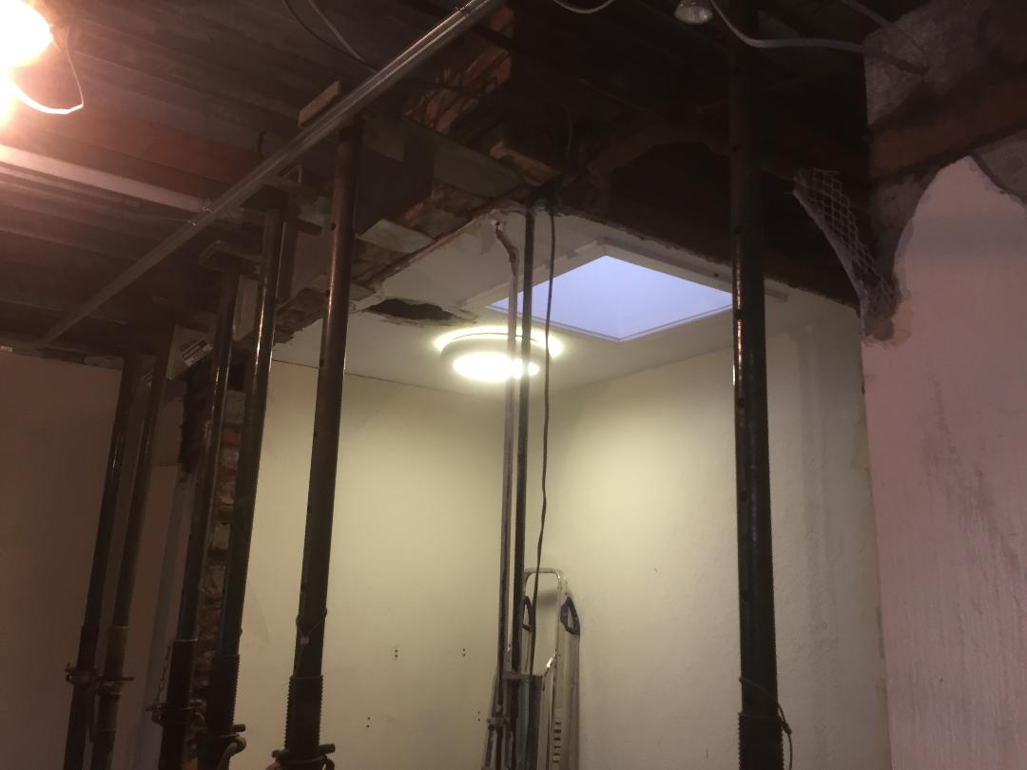

*The Beginning*

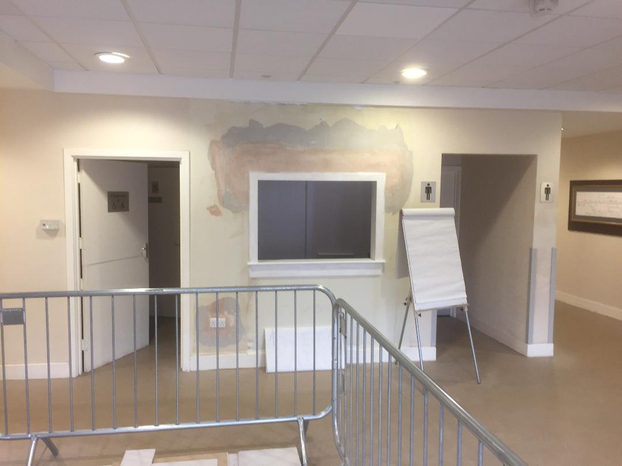

*The Middle*

See next magazine for the finished room.

**5TH SCOUT GROUP REPORT**

There are currently 9 Beavers, 3 Cubs , 22 Scouts and 3 Explorers in the group. New members will be most welcome in all sections. The scouts have been busy camping every month at Everton, Meggernie and Fordell Firs camp sites. Our latest expedition was our annual West Highland Way walk last week over 6 days. 10 scouts and 5 leaders completed the 96 mile walk. Colin and Donald have walked the West Highland Way 10 times in consecutive years

6 of the leaders Colin, Donald , Jamie , Stuart , Scott and Ben have successfully completed their Gold D.of E. Award and will receive the award at Holyrood Palace in July. It has been a very busy 6 months

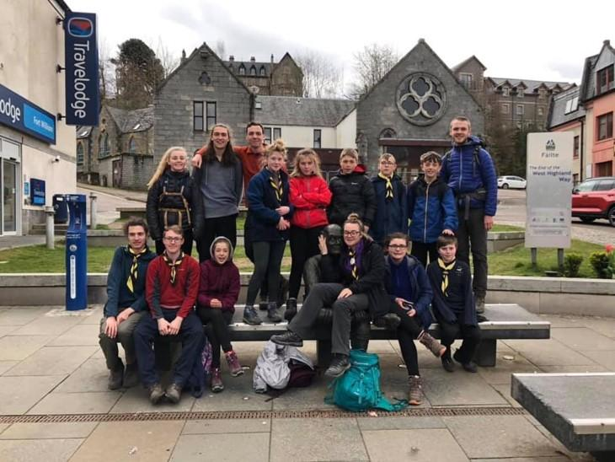

The next magazine will be due in September and as this is when most of the groups restart. Please use this issue to promote your group. It is our intention not to produce a whats on in Westburn to go out with the magazine so it is more important than ever to use this issue to promote your group.

Brian Lindsay

Magazine Editor

**STOP PRESS**

The cover picture shows Danny Cairns who has now just retired as a part of our Church Officers Team after 12 years of service. We all wish Danny all the best in his retirement and he was presented with a token of our appreciation. Danny said in his short thank you that it was not just a job but it was a privilege to being part of the Westburn team.