**WESTBURN PARISH  
 MAGAZINE**

 **SUMMER 2018**



“ **WORSHIP,FRIENDSHIP, ACTION – a kirk that cares. “**

**WELCOLME TO THE SUMMER MAGAZINE 2018**

As the Summer magazine is being prepared the weather is not yet feeling like summer is around the corner but the forecast promises a big improvement. After a very cold and snowy spring it will be good to see warm sunny days. Inspite of the snow and cold the spring flowers still appeared, the wonder of the tiny snowdrops then daffodils and tulips brightening our gardens the countryside and our lives.

Westburn continues to be very busy with all our organisations and committees working hard enjoying and sharing friendship and fellowship. We enjoy our music group and Stedfast band participating in our worship. Coffee mornings to socialise and help raise funds. A recent film show and afternoon tea organised by the fellowship committee. Once again this year we will welcome visitors from the Cruise Ships, Westburn is well admired by many visitors and we are grateful for the volunteers who help with this.

Our buildings continue to be well used by many outside groups for meetings, coffee mornings etc which is good for the community and Westburn. To help to keep things running smoothly we have our three church officers Danny, Gillian and Duncan.

Whether at home or away have a great summer hopefully enjoying lovely weather.

Brian Lindsay from the Communications Committee produces the magazine and appreciates your input helping to make the magazine interesting, please keep this up. Notification for material for the Autumn magazine will appear in the Order of Service. 1

**FROM THE MANSE**

Dear Friends

On Wednesday 22nd May 1968 the General Assembly of the Church of Scotland passed a deliverance that women should become eligible for ordination to the ministry of word and sacrament on the same terms and conditions as men. This historic decision opened the door to new opportunities and challenges and in many ways has changed the face of the Kirk. The decision came after decades of debate and the faithful endeavours of women who believed that they had the right to have their vocations tested. The petition of Mary Levison (Lusk) to the General Assembly in 1963 helped to break the impasse in the debates and discussions. Following in the footsteps of that pioneering first generation, women now comprise around 30% of ordained ministers and for 50 years have served in diverse situations and contexts across Scotland and beyond.

On Tuesday 22nd May 2018, 50 years to the day of that decision, I will be joining other women in ministry to walk in procession together up the Mound and into the quad of New College where there will be a time of recollection and thanksgiving before proceeding up the stairs to the Assembly Hall. This will be a simple, public, dignified procession to honour the pioneer women (and the men who supported their call) who first walked this way and remembering also those who knocked but were not allowed to enter and to celebrate the gifts and service of women in ordained ministry over these 50 years.

I am glad to be a Commissioner to the General Assembly of 2018 when

2

this special anniversary is marked and celebrated. All of us who are women in ministry are indebted and inspired by the struggle, perseverance, hope and faith of those who have gone before us. I’m sure like many, I will also take time to reflect on those who have inspired and supported me on my journey of faith and in my calling as a minister.

In thinking about all of this, I would encourage you to stop and think about those who have inspired you and supported you and those who continue to inspire and support you today. And if you can, face to face, by card, phone call or text, say ‘thank you’.

Yours

Karen Harbison

**FROM OUR STUDENT MINISTER**

Hello, my name is William Boyle and I’m currently training to be a Minister with the Church of Scotland. I am delighted that from August this year I will be joining you all as I complete my 15-month full time probation at Westburn Parish Church. I thought I would take this opportunity to introduce myself and tell you a bit about my journey in to Ministry.

I currently live in Greenock and my home congregation is St Margaret’s Parish Church on Finch Road. St Margaret’s has played a very big part in my life from a very young age, it is where I went through the Sunday

3

School, Boys Brigade, became a Sunday school teacher, member and then an Elder. I have been truly blessed to be part of such an encouraging and supportive congregation.

I remember when I had just left Greenock Academy that my Minister at the time had asked me if I had ever considered becoming a Minister. Back then I felt I was too young, I was very shy, lacked a lot of confidence and I just didn’t think that Ministry would be something I would ever be able to do. So, my answer was no. I began my first job in retail with Safeway in Greenock, now known as Morrison’s and then later working my way up to Manager in various Tesco Stores. My experience of retail especially management gave me the opportunity to meet people, plan and organize, manage a team, speak in front of a room full people at management meetings for example and sometimes deal with conflict situations. It really took me out of my comfort zone. When I look back on

it now, I realize that my experience in retail helped prepare me for what was to come in the future.

It was when I was working in one of the Glasgow stores a few years ago that I decided our store would support local charities and the local community. I realized just how much I loved getting out in to the community and serving others. I got a real sense of fulfillment from it, which made me stop and think about my future. Is retail management

4

really what I want to do for the rest of my life? Or is it something else I should be looking to do? It was then that a member of my team who knew I went to church said, “Why have you never considered becoming a Minister?” It was that same question that I was asked when leaving school, and that was it, something in my head just clicked. “Why have I never considered doing this?” I now couldn’t get this question out of my head.

After thinking it through and chatting with my Minister, I decided to explore my calling. I attended what is called an enquirer’s conference held in Tulliallan Police College, went on a placement with the congregation of Langbank linked with Port Glasgow St Andrews and then attended the churches National Assessment process in Dundee where I was accepted as a candidate. Going through this process affirmed my calling to Ministry and led me to make a big decision, which was to leave my job in retail management and focus solely on my calling.

The next stage was to attend University. I’m currently in my final year with the University of the Highlands and Islands. While at University you also join a congregation on placement where you spend ten hours per week working alongside the congregation and Minister. My placements have been at Old Gourock and Ashton Parish Church and Paisley Sherwood Greenlaw. I also spent 10 weeks in the summer working with

5

the chaplaincy team at the Queen Elizabeth University Hospital in Glasgow. The final stage of the process is a 15-month full time probationary placement.

I have really enjoyed working my way through this process and thank God for this opportunity to serve him and his church. I can’t wait to come and join you all in August.

With every blessing - William Boyle

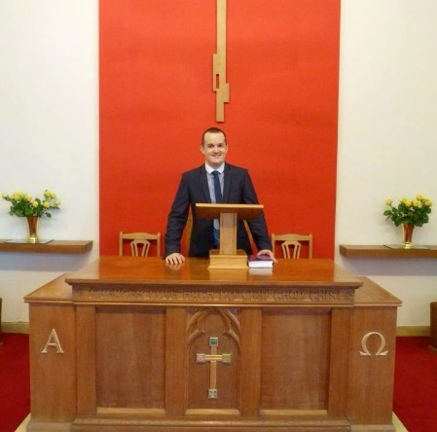

6

**NEWS FROM PRESBYTERY**

Rev Dr Peter McEnhill (Kilmacolm Old) has been nominated to succeed Rev Jim Cowan (Barrhead St Andrews) as moderator of Greenock and Paisley Presbytery with effect from September 2018. As Dr McEnhill is also presbytery clerk, a depute clerk will be appointed for the duration of his period of office.

Safeguarding training will be provided provisionally by Glasgow Presbytery until a new local trainer has been appointed. Interviews for this post are underway.

Presbytery has a COSY (Church of Scotland Youth) Facebook page, designed for young people. We are exhorted to let young people know about this.

This year’s presbytery Pray Across Scotland worship will take place on Wednesday, 16th May at 7.30 pm at Lyle Kirk’s Union Street building. The guest speaker will be Rev Teri Peterson.

Douglas Scott

**NEWS FROM THE COMMITTEES AND ORGANISATIONS**

**DISCIPLESHIP COMMITTEE**

We are at present quite a small committee, and would like to grow just a little. So, if you think that you might like to join us, please talk to one of our current members: Douglas Scott, Margaret Dempsey, Ian Ferdinand, Janette Nicolson.

7



Greenock Westburn Parish Church will once again support the work of our international aid charity this Christian Aid week.

Donation envelopes will be issued at morning worship from Sunday, 6th May 2018 and there will be opportunities to return these each Sunday in May.

If you are a UK income taxpayer please complete the ‘Gift Aid’ form and enclose it with your donation. This allows Christian Aid to claim additional money from the UK Government at no cost to you.

Thank you for your generosity.

**Simon Hutton (Tel: 07513 838 590) Convenor, Community Links Committee**

**8**



P.S. Date for your diary Saturday, 22nd September 2018 - Westburn will once again host the Greenock Christian Aid Coffee morning.

“Keep on loving one another as brothers and sisters. Do not forget to show hospitality to strangers, for by so doing some people have shown hospitality to angels

**PASTORAL CARE COMMITTEE**

1. The Committee met on 20th March 2018 and the next meeting will be on Tuesday, 8th May 2018.
2. **District 22 –** all members who are in nursing or care homes are regularly visited by the Committee. In addition, Karen, our Minister is also visiting Members in hospital and at home.
3. **June Communion Afternoon Service** – Sunday, 3rd June 2018 in the Lounge at 3.00pm. Please speak to your Elder if you wish transport.
4. **Car Run** – this year the proposal is to have the Car Run on Monday, 18th June from 2.30p to 5.30pm. If you wish to go, please speak to your District Elder, who will pass your name on to the Co-ordinator.

Bill Dempster

9

**GUILD REPORT FOR SUMMER MAGAZINE 2018**

By the time you read this, the Guild Session 2017/2018 will be over.

We have had a good year, even though for a variety of reasons our numbers have been down, although we did gain two new members. As in the past we heard from two of the National Projects for 2015-2018., Street Pastors and the Haiti Project. We had a speaker from Greenock Rotary who shared with us some of the work carried out by them. Through Greenock Rotary we have been involved in “Smalls for All” and we were able to have Mrs Roberta Lundy come and give us an insight into this project. Three young people came from “Reach for Autism “ and shared their experiences you may have seen an article in the Greenock Telegraph about their project. This year we decided that our Bring & Buy sale would go to this project and we managed to raise £81.

We have been to Japan with Guides, wheelchair mountaineering with Andy Steen and Christian Motorbiking with Rev. Terry Wright. All in all a very varied programme.

This was the final year for the Be Bold , Be Strong theme and the Project Totals as at 31st. March 2018 are as follows:

**Ascension Trust** (Street Pastors Scotland) £116,866.95

**Care for the Family** ( Let’s Stick together Scotland) £97,909.41

**Christian Aid**( Caring for Mother Earth in Bolivia) £96,461.89

**Feed the Minds** ( FGM in Kenya) £131,801.26

**Mission International** ( Haiti Project) £94,512.01

**Prospects** ( All Friends Together Scotland) £95,236.48 - TOTAL £632,788.00

I am sure you will agree a very good sum indeed.

Anna Seggie 10

**NATIONAL GUILD REPORT**

By the time you receive this magazine I’ll have attended 3 Leadership, 2 Annual Gathering Planning and National Council meetings as well as the Resource Co-ordinators’ Conference in Edinburgh. Many items have been discussed including the decision to include the Sacrament of Communion at the Annual Gathering in September. This will be the first time this has happened and of course it will be at the meeting I’m chairing so please remember me, in your prayers that it all goes to plan. The Moderate Designate Susan Brown is looking forward to the occasion and when I met with her recently she assured me it will go well. I’ll hopefully report back to you how it turned out in the next magazine.

Edinburgh has been the venue for numerous meetings outwith the Guild (which the Guild has been invited to attend), a reception at the Scottish Parliament for International Women’s Day, Christian Aid Gathering, Lady Day (Scottish Episcopalian Church) and again at the Scottish Parliament for Faith and Climate Change reception. In May I’ll be attending Heart & Soul and the Big Sing at the General Assembly, this takes place on the evening, Tuesday 22nd May after the Guild Report is presented to the General Assembly in the afternoon. The leaders of the 6 projects which finish at the end of this session have been asked to choose a hymn for this event. I’m sure this will be a great occasion once again. I also attended the Congregational Women’s Guild in Perth (equivalent of our National Guild) where there were about 80 ladies in attendance in comparison to the number attending our Gathering (over 1200). At the time of writing this report I’ll be attending an Interdenominational Meeting and the United Free Church of Scotland Ladies meeting both in Perth.

11

I’ve been invited to speak to Guild Groups and Presbyterial Councils in the east and west of the country at West Lothian Council, Cowal Guilds Together and 130th Afternoon Tea which Dumbarton Presbyterial Council held in Clydebank.

There are other dates in my diary for later in the year – Wigtown Presbyterial Council and to attend the South African Women’s Conference in Johannesberg. (I’m hoping that Stuart can come out with me and we’ll visit Venda prior to the conference).

Our new strategy for 2018-2021 “One Journey, Many Roads” with the following themes for the next 3 years

Seeking the way

Companions on the Road

The Extra Mile

The Project Co-ordinators’ will have met in Edinburgh to hear the final update of the last 6 projects and be informed of the 6 projects which fall within the strategy for the next 3 years.

They are as follows

CrossReach – Join up the Dots

Sailor’s Society- A Chaplain for our Ports

The Boys’ Brigade – Faith in Young People

World Mission Council – Journeying together Empowering teenage mothers in Zambia

12

Malawi Fruits – Growing the Future

The Free to Live Trust’s (FTLT) – Seema’s Project

As we complete the strategy “Be Bold, Be Strong” the Guild over the past 3 years have followed this strategy very well as we’ve made and suggested changes in order to move with the times. One of the risks we took was the launch of the Guild tartan (this involved having it created at a cost) which has proved very successful. It has often been said that the Guild paves the way for the Church. Once again this is true as the Church now has a tartan, when the Moderator the Right Rev Dr Browning visited the Pope he presented him with a Guild tartan scarf.

One of the tasks for the National Convener is to set the Convener’s Challenge, my choice is a cushion which is to fit in with the strategy “One Journey, Many Roads”. All councils have been asked to bring the cushion front (I didn’t want to bring around 50 cushions back to Greenock by train) to the meeting in June, then I’ll have them judged and returned in the middle of June to allow them to be made into cushions. It has been suggested that the cushion can be gifted for e.g. to the oldest Guild member or somewhere/someone of their choice

I think I’ll definitely be fitting in well with the next strategy “One Journey, Many Roads” as I travel around this country and overseas. I will keep you posted on how my travels go.

Thank you

Patricia Robertson

13

**5th. GREENOCK & DISTRICT REPORT BEAVERS CUBS SCOUTS, EXPLOYERS AND NETWORK**

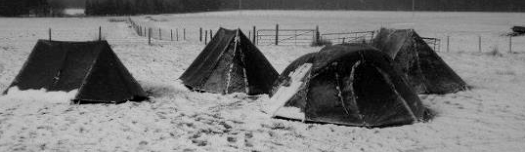

There are currently 8 beavers, 2 cubs , 29 scouts, 1 explorer and a leadership team of 15 running all four sections

**Beavers;**

Beaver numbers remain constant at 8 and now have 2 new leaders running the section. They meet on a Friday 6.30pm – 7.30pm and are working through the Beaver section badge programme.

**Cubs;**

Cubs are now meeting separately from Beavers on a Thursday night 6.30pm – 7.30pm. There are only 2 cubs at present working through the badge programme. This section requires new members urgently. Cubs took part in the Annual District Cub Camp at Everton

**Scouts;**

Scout numbers continue to increase and are now at a high of 29.

14

Scouts continue to enjoyed many camping experiencesincluding the latest six days walking the West Highland Way March- April which proved extremely challenging in the cold and snowy weather. The scouts have already had a couple of camps at Everton this winter and another at Lochearnhead Scout Station. The camps have continued with a Midnight Hike to Everton scout camp and a weekend camp at Fordell FirsScout Activity Centre. This year the summer camp will be at Hesley Wood Scout Activity Centre Sheffield.

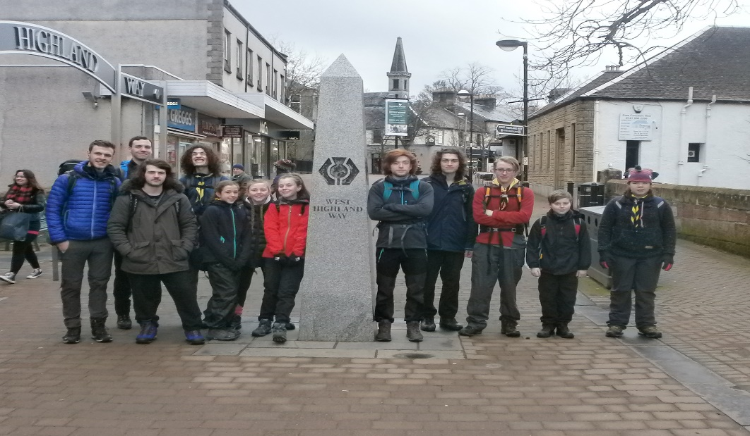

15

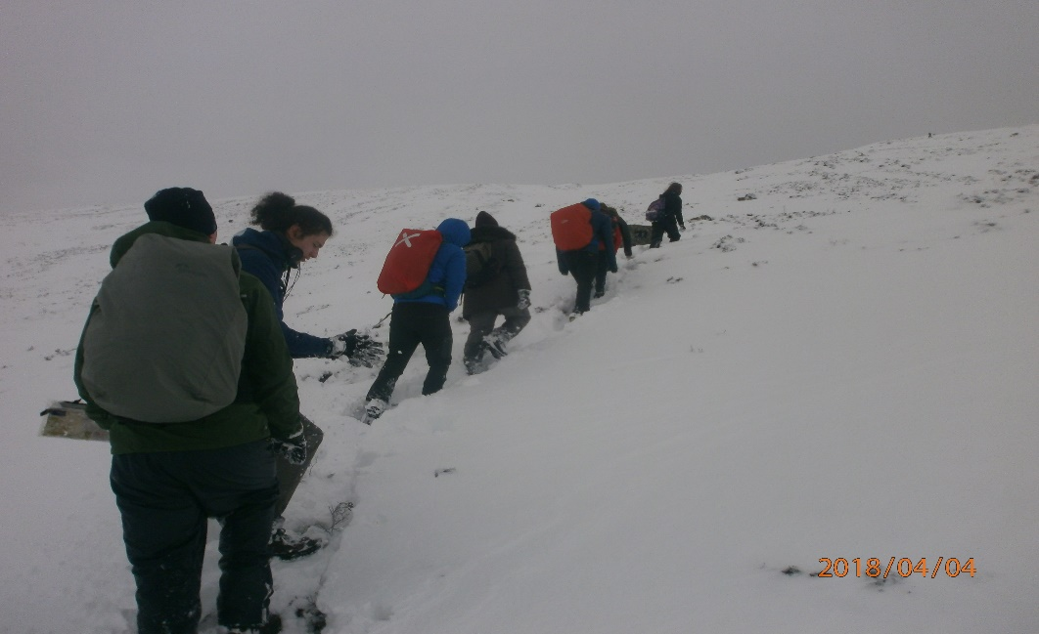

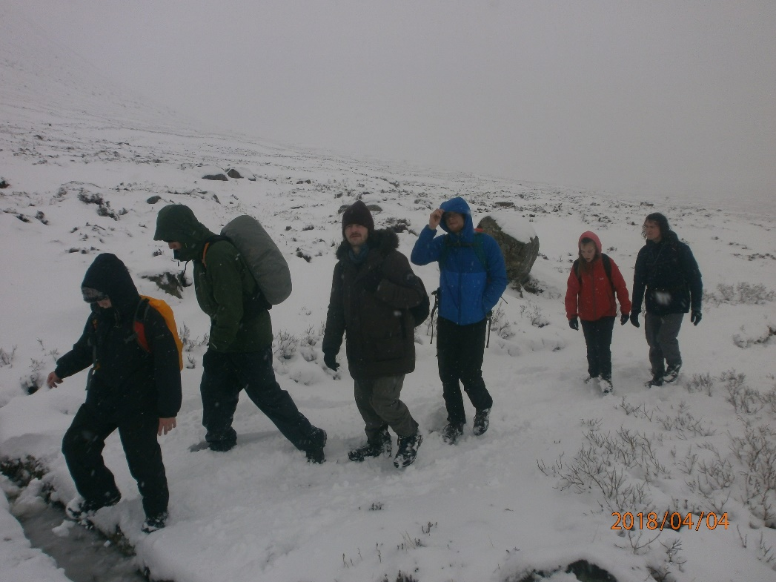

16

Explorers;

We currently only have 1 explorer all the others have moved on to become assistant section leaders or scout active support. As scouts move on the Explorer section will again grow but this is unlikely to happen for a couple of years.

Network and Leadership;

The highlight this year was the successful completion of the Explorer Belt Expedition on the Tour du Mont Blanc by Jamie, Scott, Matthew, Reef, Sam, Ben and Tyler. The team were supported by 4 leaders from our group Stuart, Colin, Donald and Campbell. Six of the group should complete their Queen Scout Award this year.

All in all it has been a very successful year for the group but we need to increase numbers in the cub and beaver sections.

**OTHER ITEMS OF INTEREST**

**STAMPS APPEAL UPDATE**

 STAMPS. We continue to collect our used stamps, which are put in a wee red basket in the foyer. This is a very simple thing to do, is very worthwhile and much appreciated. The amount raised for last year’s project is £2,194. Details for next year’s project will be on the notice board.

Evelyn Taylor 17

**TIME FOR PRAYER**

Here is a prayer from the 4th century (ie 1700 years ago). It lets us see that some of our concerns and preoccupations remain constant.

Lord, be before me to show me the way ahead. Lord, be beside me to hold me in your arms and protect me.

Lord, be below me to catch hold of me when I fall, and pull me out of the snare.

Lord, be inside me to comfort me when I’m dejected or feeling rejected.

Lord, be all around me to defend me when others pounce on me.

Lord, be always near me to bless me. And those around me everywhere. Amen.

(from Douglas Scott)



18

**SONGS OF PRAISE WITH THE STEDFAST SILVER BAND**

You are invited to a special evening of praise and fellowship on Sunday 17th June.

This will be led by the Stedfast Silver Band and we are hoping that the sun will shine and that the service will be able to take place outside in the church garden. Some well known hymns and songs from across the years will be chosen and we need you to be the choir! Refreshments will be on offer after the service to allow time to mingle and chat.

Please come along and invite family and friends to come too. More details will be available nearer the time.

**SAFEGARDING REPORT APRIL 2018**

For our returns to Presbytery we need to include the dates on which people attended Safeguarding training and we are lacking information on the dates on which those on our register attended training – except for those who have been on a training course in the last year or so. If you are a volunteer in one of our youth groups or pastoral care and know when you attended training, can you please let us know so that we can update our records.

The Church of Scotland requires all those with a PVG certificate to attending training at least once every five years in order to keep up to date with changes which have taken place. We will, of course, continue to advertise training in the Sunday orders of service, but at present there are no trainers in our Presbytery, so training is being provided by Glasgow Presbytery which is not very convenient. Hopefully, new trainers will be in place soon in our Presbytery and then we will encourage everyone who needs to attend training to do so.

19

Spring and summer are busy times for the Church of Scotland Safeguarding Service so they are asking that we allow at least eight weeks for processing applications. If any organisations are anticipating that they will have new volunteers for summer clubs or starting in the new session in the autumn, can they please contact us in plenty of time to get the applications processed.

Also reminders that you will need a separate PVG check if you are working with a church group even if you have PVG clearance through your work or other voluntary rolls, and that the Church of Scotland requires you to attend church based training, even if you have done it for another role. And if you are a member of the PVG system and working in our church, you need to inform Disclosure Scotland if you change your address and also the Church of Scotland Safeguarding Service.

If you need any advice or help on Safeguarding please contact us:

Jennifer Boag - Tel: 01475 720125 e-mail: jenniferboag@hotmail.com

Sheila Tait - Tel: 0748 418 2757 e-mail: sheilatait172@btinternet.com

Jennifer Boag and Sheila Tait

Safeguarding Co-ordinators

20