**WESTBURN PARISH  
 MAGAZINE**

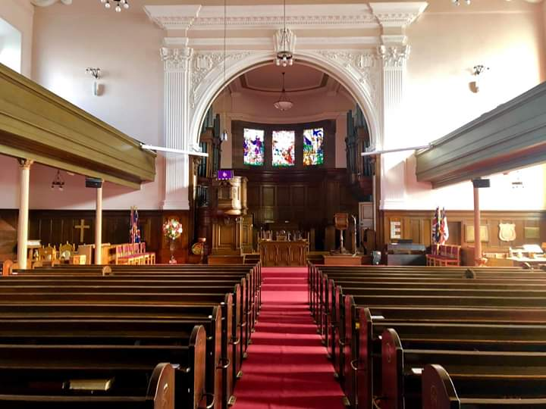

**SPRING 2020**



“ **WORSHIP,FRIENDSHIP, ACTION – a kirk that cares. “**

**Welcome to the Spring Magazine 2020**

Welcome to our Spring magazine. As the magazine is being prepared it certainly isn’t spring with lots of wind and rain and dark evenings so it will be good to welcome the spring season, with the usual signs to look forward to of brighter days and hopefully better weather, the joy of our gardens coming to life with all the colourful spring bulbs, without too much hard work.

The weather doesn’t affect what’s going on in Westburn as all the committees and organisations are meeting regularly, social events are being planned. Coffee mornings and services or events with our neighbouring congregations many of these are noted in the Order of Service each week it would be good to see you there, a warm welcome awaits you.

We also have a very active Facebook page, and Twitter account.

As spring comes so does the preparation for our Easter worship and our journey through Holy Week in preparation of the joy of celebrating our Risen lord. Karen our minister will be busy planning and preparing the services for the journey through holy Week and Easter. **Will you be prepared? will you take that journey? Will you be there?** Let’s hope so**.**

Details of Easter Week services will be in the Order of Service nearer the time.

Brian Lindsay produces the magazine and appreciates your input helping to make the magazine interesting, please keep this up. Notification for material for the Summer magazine will appear in the Order of Service.

**FROM THE MANSE**

Dear Friends

I enjoy walking… just as well as I don’t drive. I enjoy walks around Greenock, especially along the Esplanade, around the Battery Park, up the Lyle Hill and heading further down the coast along the front at Gourock or at Lunderston Bay. We have great views and scenery in this area and it’s good to take time to enjoy that. As we have our wee dog Albie, we are always on the look out for new places to go for walks.

Today (18th Jan ) we found a new walk. We headed to the top of Port Glasgow to join National Cycle Route 75.This is a route which stretches from Leith near Edinburgh to Portavadie on the Cowal Peninsula, covering a total of 114 miles, mainly on paths built on disused railway lines, canal towpaths and some riverside paths. There are sections where the cycle route uses regular roads but it’s designed to allow people to cycle safely and enjoy the countryside. We walked about 5 miles – the two and a half mile section from Port Glasgow to Kilmalcolm and back again. We met more dog walkers than cyclists and although the views from the Cut are much better, in January, after heavy rain, this was a lot less muddy!

Walking is a picture of our journey of faith and discipleship in so many ways as we trust that Jesus is always beside us, before us and behind us. We are each called to journey a bit at a time, finding good companions on the way, taking steps in the direction of God’s kingdom and appreciating and caring for God’s world and our neighbors as we go.

The prayer for the day on the Church of Scotland facebook page for 18th Jan was

With the first light of dawn – May God bless you

When the long day is done- May God bless you

In your smiles and your tears – May God bless you

In your hopes and your fears – May God bless you

Amen

On your journey this day – May God bless you

Yours

Karen

**WHAT’S BEEN HAPPENING OVER CHRISTMAS 2019**

**BLUE CHRISTMAS**

Our Blue Christmas service took place on Sunday 1st December. This was a time to remember and give thanks for loved ones who have enriched our lives and continue to mean so much to us. This year the theme was the empty place setting and everyone received a candle on a snowflake . Everyone had the opportunity to put a label on the tree with the name of a loved and short message if they wished. After the Service all were invited into the hall for a cup of tea and a chat.

**GIFT SERVICE**

At the morning service on the 8th we had our annual gift service where the children and members of the congregation donated toys for the children in need in Inverclyde. Joe of the Social Work Department thanked the congregation for their donations and assured them that the gifts would go to children who are not as fortunate as ourselves.

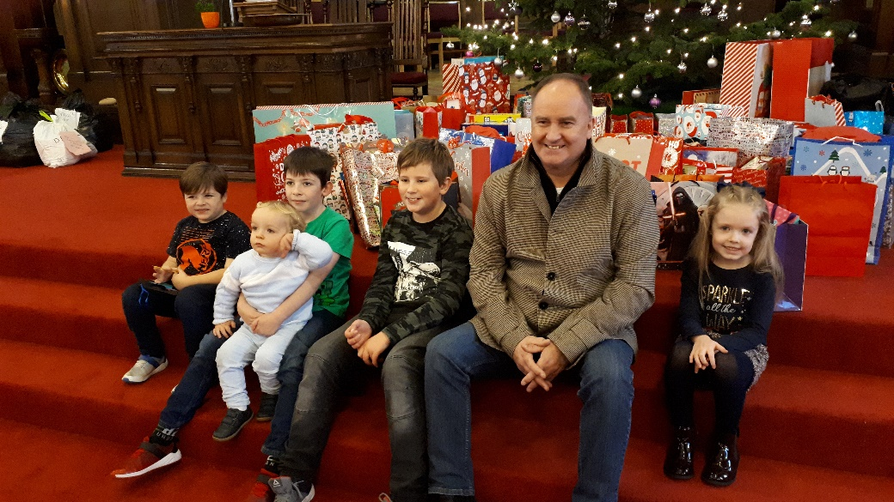

Joe with the Children in front of the Gifts.

The Rotary Club of Greenock were represented at this service by President Ann Thomson and International committee member Kenny Melville who received donations from the congregation and Brownies for their “Smalls for All” project. We later received the following acknowledgement.

“**Rotary Club of Greenock –** President Ann and fellow Rotarians would like to thank the Congregation and the Brownies for their donation to Small for All. The Congregation donated 643 pairs of pants and the Brownies donated 131 giving a total of 774 pairs of pants. To date, the Club has received 5718 pairs compared to a 2018 total of 5643.”

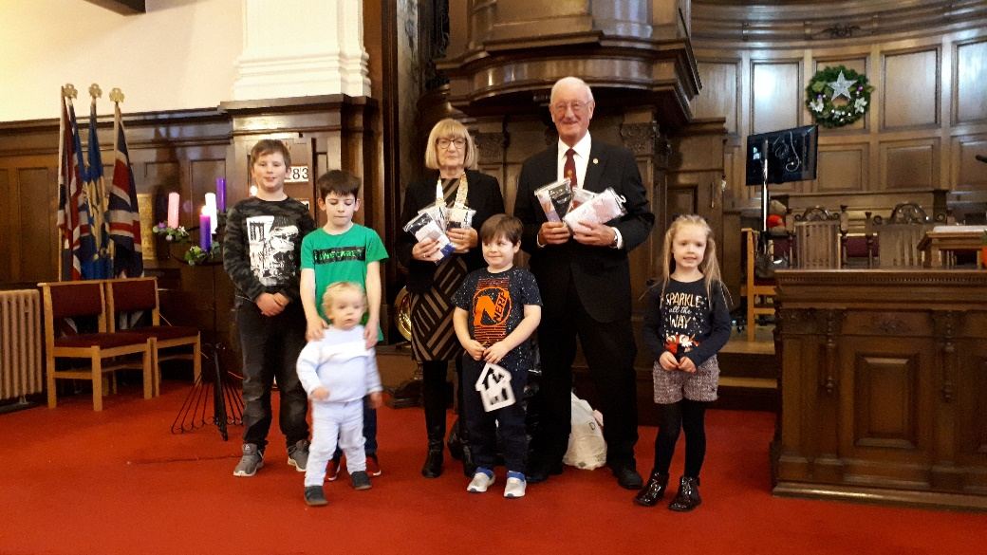

Ann & Kenny with the children with some of the donated pants.

**LIGHT UP A LIFE – ARGOWAN HOSPICE**

On the evening of the 8th December the Hospice held their annual Light up a Life service. There was singing by the Ardgowan Hospice Singers and we heard how the Hospice supported those in need of help after their loved ones have passed away. After the service the tree lights were lit. Tea and coffee was served in the Hall after the service.

**CHRISTMAS CONCERT**

On the evening of the 19th December we had our Christmas Concert with the Steadfast Silver Band and many others. We were entertained with music from the band and from Lanarkshire Mandarin and Guitar Association. We had singing from our own choir, Ardgowan Hospice Singers and a newly formed group made up of members from the Fuzzy Parish. There were two stories recited. We also joined in the singing of some Christmas Carols. An enjoyable evening was had by all.

**CHRISTMAS EVE AND CHRISTMAS DAY**

On Christmas Eve we had two services one earlier in the evening for families and a watchnight service. It After the Concert and the Watchnight Service there were retiring offerings taken. The total donated was over £850 and this was to go to the Hospice.

At the Christmas day service everyone was invited to bring a favourite present. The children who came along brought a tractor and trailer, Nerf guns, special glasses for games and a large cuddly shark. Some adults also brought their favourite gifts which included a new ring and a Dundee United almanac (no prizes for guessing who brought that with him).

**END OF ADVENT AND EPIPHANY EVENT**

Advent is the coming of Jesus Christ and what we know as the Twelve Days of Christmas. Epiphany is a Christian feast day that celebrates the revelation of God incarnate as Jesus Christ. So that’s the key to what this Service was about. It was held in St. Margaret’s Church and was taken by three of our Funny, sorry, Fuzzy Parish Ministers. There was singing for all but also the ‘No name Choir’ was on hand to entertain, both on their own and also with support to all in attendance (the congregation).

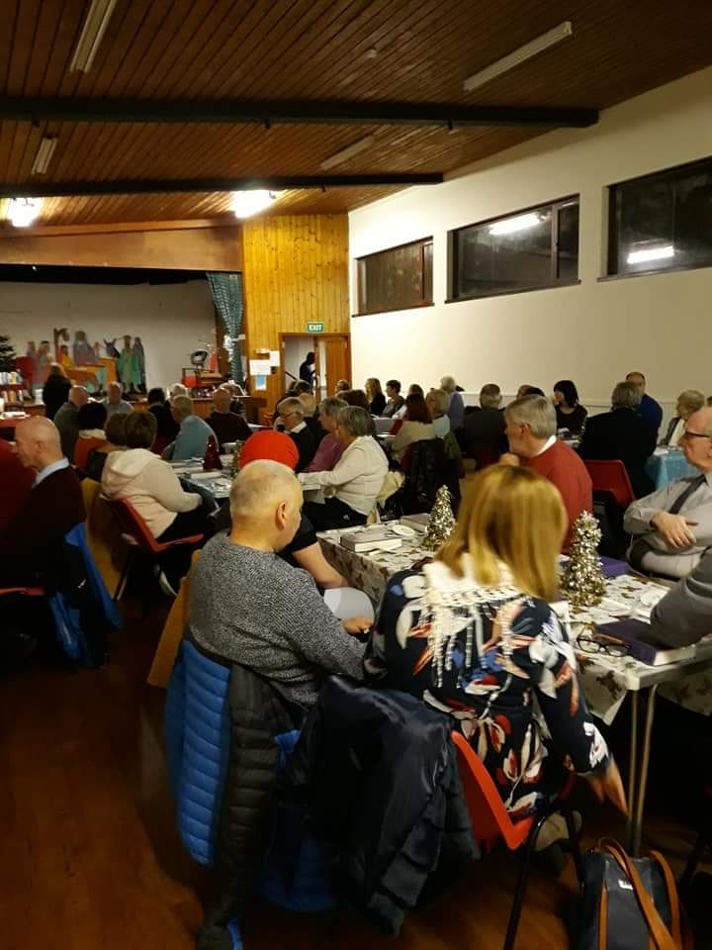

It was well supported by all the Churches, so much so that extra tables had to be put out to accommodate everyone. As explained above it was an Epiphany Service and tables were put out and, therefore by definition, we were also there to eat. We were well catered for. A very enjoyable evening of praise, fellowship and feasting. There will be more Fuzzy Parish Services coming up as the year progresses so make sure you get these dates in your diary as they become known. Thanks to all who made it such a success.

Ricky Martin

**COCKERMOUTH URC CHRISTMAS CARD**



In December 2018, the Badminton Club spent the weekend in Cockermouth.

On the Sunday, some of us went to the local URC Church and we were made very welcome, especially by Sylvie Yemaux-Ekme, who kept feeding us with sweets.

Through Elizabeth Lindsay, we have maintained contact with Sylvie and the above photo is a copy of the Christmas she sent last month.

The message on the back of the card is: Dear Elizabeth, Joyce, Billy, Jim and everyone at Westburn Parish. May Peace, Joy and the Love of God fill your hearts now and always.

Bill Dempster

**CELEBRATING THE NEW MORNING**

Satisfy us each morning with your unswerving love, so that we may rejoice and celebrate all our days.

(Psalm 90: 14)

Mornings are not my favourite time, and I suspect many would say the same. We may occasionally greet the new day with a song in our hearts, but probably more often it is with a groan of dismay. The pressures and responsibilities of daily life weigh so heavily upon us that we wake with a sense of foreboding rather than anticipation. Yet every morning is God’s gift, full of immeasurable potential and untold possibilities, if only we have eyes to see and ears to hear. Make time, when you wake, to acknowledge God’s goodness and to commit the day ahead to him. Make time to recognise that it symbolises the wonderful truth at the heart of faith: that God is looking each moment of each day to offer us new beginnings.

Lord God.

Help me to embrace the dawn of each new day as an opportunity for new beginnings. Allow me to leave behind all the yesterdays that I cannot change and show me that, by wiping the slate clean, it’s how I deal with today that really matters. With your help

and support, no day will be a problem and every day will become a challenge. Amen

Hazel

**TIME FOR PRAYER**

Through prayer maybe occasionally we can in our lives for brief moments glimpse God and experience God’s presence in our lives here and now. Let us pray.

Jesus, my friend,

With you beside me

No journey is too long, no trouble too great.

No hope is unattainable, no dream is beyond reach.

With you beside me, sharing my life – its ups and its downs—

Is to have a little piece of heaven here on earth. Amen.

from Douglas Scott

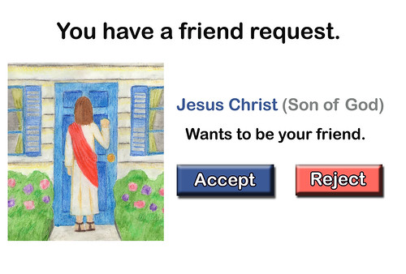

**NEWS FROM PRESBYTERY**

Part of the Radical Action Plan for the future of the church agreed by the General Assembly is to reduce the number of presbyteries from 32 to about 12. In this spirit our presbytery (Greenock and Paisley) has agreed to unite with the Presbytery of Dumbarton.

The decision to unite was taken at the December meeting of Presbytery. Meetings will take place in order to formalize detailed arrangements for the union, and I will try to report on these in due course. Meanwhile Rev Dr Alistair Shaw (minister of St Paul’s, Johnstone) will continue to act as Presbytery Clerk pro temp.

Some agreed local features of the future shape of Presbytery are:-

In Port Glasgow the union has now taken place between the congregations of St Andrew’s and St Martin’s. The united congregation will be known as Port Glasgow New.

Old Gourock and Ashton will be linked with St Ninian’s. Rev David Burt will be minister to both congregations.

St Margaret’s will enter a period of guardianship ie it will continue to function as a congregation but will not be allowed to call a minister.

It is hoped that the congregations of our “fuzzy parish” will continue to work together, and that eventually a new “hub” type of ministry will be established and developed. Recently there was a very successful joint gathering of the congregations at St Margaret’s to celebrate Epiphany together.

from Douglas Scott

**SAFEGUARDING REPORT JANUARY 2020**

By the time you read this, we will have completed the lists of those in Westburn who are working with children or vulnerable adults as we are required to do for the annual Presbytery Attestation of records. This will update last year’s records with new names and delete those who are no longer working with these groups in the church.

We would like to remind you that if you **permanently stop working** with children or protected adults in the Church of Scotland, you must advise Disclosure Scotland. Otherwise the Safeguarding Service may receive information about you that it is not entitled to have. Disclosure Scotland contact details: [DSupdate@disclosurescotland.gov.scot](mailto:DSupdate@disclosurescotland.gov.scot); 0300 020 0040; Disclosure Scotland, PO Box 250, Glasgow, G51 1YU.

Also, if you are a member of the PVG system and working in our church, you need to inform Disclosure Scotland if you change your address, and also the Church of Scotland Safeguarding Service.

We currently have no new dates for safeguarding training, but we will continue to advertise training sessions when we are informed of new dates in the weekly order of service.

If you need any advice or help on Safeguarding please contact us:

Jennifer Boag - Tel: 01475 720125 e-mail: jenniferboag@hotmail.com

Sheila Tait - Tel: 0748 418 2757 e-mail: sheilatait172@btinternet.com

Jennifer Boag and Sheila Tait

Safeguarding Co-ordinators

**WORSHIP COMMITTEE**

The service and afternoon tea held jointly with the Pastoral Care Committee took place on Sunday 27th October 2019. We sang some old favourite hymns – although some seemed to be less well-known than others! Around 60 people attended and the Worship Committee members want to thank the Pastoral Care Committee for providing the excellent afternoon tea and those who helped with transport.

We have the following plans for future service:

23 February Taize service

26 April Pet Blessing

June Songs of Praise

Lookout for further information in the Order of Service. Everyone is welcome, do come along and try something new.

Tom Ferdinand and Sheila Tait have stepped down from the Committee and we would like to thank them for their enthusiastic input and ideas, and Sheila for taking the minutes.

Bereavement prayer cards have been prepared for elders to use on bereavement visits.

The Worship Committee members continue to prepare the Prayer and Thoughts in the Order of Service on a monthly rota.

The Committee meets regularly to look at worship within our congregation. If you have any ideas, comments or suggestions, we would be pleased to hear them.

Morag McCracken and Hazel are now contributing regularly to our Sunday worship and we are enjoying their contributions. If anyone else is interested in this form of Christian service, the Presbytery will be running more Leading Worship courses in future. Please speak to Karen in the first instance.

The pew prayer cards were translated into French and German and have been handed out to our cruise ship passenger visitors along with the church information leaflet this summer. These have been well received and thanks are due to Douglas Scott for his help with the translations and Cath Barbour and Joe Craig for printing them for us.

The Committee continues to welcome any ideas, comments or suggestions about worship.

Worship Committee

**GUILD REPORT**

The second half of the Guild Programme starts on 21st. January. By the time you read this we will have probably covered January and most of February. We are starting with a flavour of Patricia’s year as National Convener. We are having a visit from the Telegraph’s Vet. We will be welcoming one of our previous students, Barbara Ann Sweetin, who is now a Minister in Forfar. We will be looking at the second of our National Projects for this year a Crossreach Project “Joining up the Dots” which is a collaborative project between Crossreach and the Guild to tackle the problem of loneliness and Social isolation in Scotland.

At the beginning of March we are holding a “Songs of Praise” evening to which we have invited members of other churches, not just women but men as well Patricia Robertson, one of our members, is going to Lusaka, Zambia for 7 days at the end of February. She will be going with another 9 Guild members from different areas of Scotland, Carol Finlay (Twinning & Local Development Secretary, World Mission) and Karen Gillon (Associate Secretary, Church of Scotland Guild). The Moderator of the General Assembly, The Right Rev Colin Sinclair & his wife will be with the group for the first 2 days.

The reason for this visit is to meet some of the girls and their children who are part of the Guild project, “Journeying Together – Empowering Teenage Mothers in Zambia” and to find out the Guild are helping these young girls to improve their lives.

We wish her safe travel and look forward to hearing what news she will share on returning.

If any of our meetings appeal to you feel free to join us, you will be most welcome. Just check the intimations in the Order of Service.

Anna Seggie

**NEW DEFIBRILLATOR**

Westburn Parish Church recently had a defibrillator installed in a secure cabinet outside the church centre.

A defibrillator is used to restart heart in the event of a cardiac arrest. Following the arrest there is a very limited window to save a patient’s life. 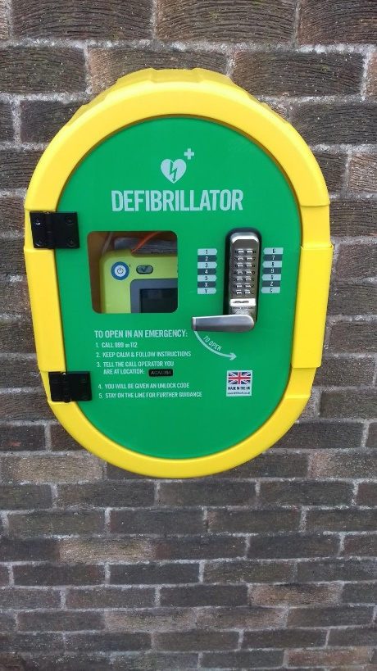

Having community defibrillators can help save lives.

You will be supplied the code to unlock when 999 is dialled to report a suspected cardiac arrest. The device is straight forward to use and requires no special training.

The costs for this were met by the final phase of the legacy used to redevelop the Hub area. Thank you also to our handymen who installed the cabinet

Simon Hutton

**VISIT TO VHUTSHILO SCHOOL 2019**

On 31st October 2019, 7 members of Westburn Parish Church left Glasgow Airport on their journey to Venda. After a long journey we were met at Johannesburg airport by Fraser McNeill. We picked up our mini bus, made our way to the hotel in Pretoria for our overnight stop before continuing to Sibasa, where we would be based during our time at the school.

This stop although not the highlight of our visit, was definitely a good way to start as we were able to share in the triumph of the South Africans in the Rugby World Cup Final. We watched the match from the rooftop garden of the hotel on a big screen (there were many around the area), once the locals realised, we were not supporting England we became their friends! At the end of the match, we left to make our way to Venda, the journey at the start was slow as the South Africans were out and about celebrating the win.

We arrived at the hotel around 7o’clock, it was good that Fraser was with us as he knows the language and roads as he travels up to Venda frequently. The next day, Sunday, we had been invited to Thathe for dinner, to meet friends Fiona & Fliss as well as members of the school board and Khatu (the person who has taken over Sue Ann’s role). We shared a meal with them and the school was the main topic discussed that night.

The next morning, we were up early as we had been asked to be at the school for around 8.30am, the reason for this was that a welcome concert had been organised for us and the chairman was there but had to get back to his own school. It was great for those of us who had been there before to meet up with old members of staff as well as meeting new members.

Yes, there had been changes but there was still the friendly atmosphere we remembered.

There is now an open barn type building where concerts and graduations take place. It is also hired out to the local community for events, this in turn brings income into the school funds.

The welcoming concert was enjoyed by all and the children were excellent with smiling faces all the time. After that we visited the children in their respective classrooms. Monica and Susan went to work with the youngest class, Sandra with the middle and Patricia with the oldest. The emphasis is still that the children learn English, as was the wish of Sue Ann. The children behaved as any others would as they tried to see how much they could get away with.

As usual they were polite, keen to please and very happy.

After the morning break, Les, Ricky & Stuart started replacing the mesh netting to create shading for the children when they were playing outside. It was apparent that this shading was necessary as the temperature during our visit was 40℃+, it was very hot for the guys working outside but the task was completed before we left.

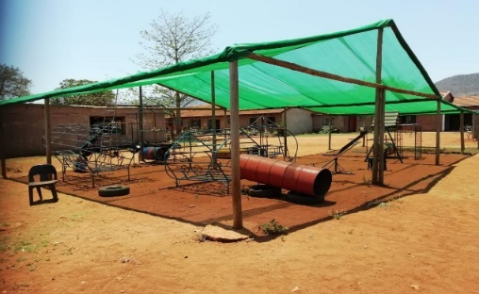

We spent 4 days working with the children both in the classroom and outside, they were very keen to please and if we high fived one, the rest of the class wanted the same attention. It was a very humbling experience when we think what the children here have access to both at home, in nurseries & schools. We found it very hot and were glad when we went back to the hotel and enjoyed the chance to use the pool.

When in the classroom, it was difficult at times as the staff didn’t always understand us. We shared ideas that we use in nurseries & schools locally. Hopefully the teachers will continue with some of the ideas and be able to introduce more skills to the children.

When speaking to the teachers it became apparent that they would like to improve their English (this is being looked at) and have the opportunity to come to Greenock to see how local nurseries & schools operate.

We have returned with ideas to look at, the link is strong and long may this continue. Monica is a member of the school board so we will be kept up to date with all that is going on.

Due to the generosity of the congregation we were able to replace the shading, buy the sound system (which will be beneficial both within the school and hiring out to the local community) and new table and chairs. Also, the jumpers from the Prayer Shawl Group, pencils from Rainbows & Brownies, white shirts and pants were distributed. In fact, the next day the children appeared at school wearing or using these items. When we asked why they had the jumpers on when it is so warm, we were told because they were new. Remember it was 40℃.

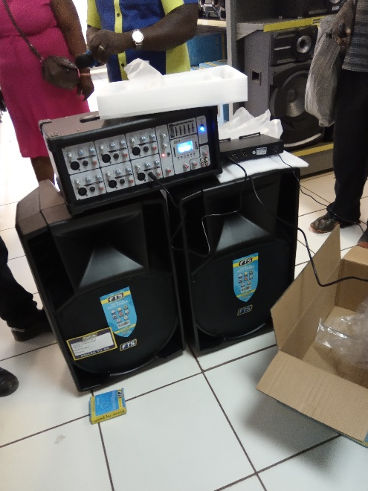

On the last afternoon we were entertained once again with singing and dancing which we joined in. Again, it was with heavy hearts that we left the school but we had lots of happy memories to bring home.

After we left Venda, visited Kruger, the group then split, with Monica & Les going to spend time with Fraser (the remaining 5 flying on to Cape Town).

While in Pretoria they met up with Woo, Sue Ann’s adopted daughter, who is now studying at the University of Pretoria. She is now getting over the death of her mum.

We have arranged an event in the church to share with you more of the stories and pictures of our visit. This will take place on Sunday 16th February after Morning Worship, with a Soup & Sandwich Lunch followed by a presentation of the trip. We hope you will be able to attend.

We thank you for your continued support and ask that you remember the school in your prayers.



The Venda Seven

**GARDEN PROJECTS**

The garden has not been having the total attention required to keep it in shape over recent years and so the plan to change that started back in spring 2019. We started with the ‘jungle’ area just in front of the main hall entrance (as hopefully you will have noticed) by removing what was mainly ivy and various weeds but also a tree trunk that was covered by the ivy and creeper plants. You will see there is currently what looks like a couple of gates in the middle of the area, between the flag stones and the grass. This will become a path in the coming months and to the left of the path, facing the grass, will be a raised garden area and in keeping with the signs in the main hall and sanctuary, this whole area will become a sensory garden. This will help people with various memory loss problems to be able to enjoy this area more fully. This is phase one.

Phase two are four trees that need attention. One tree, at the rear grass area and adjacent to West Shaw Street, is a deceased tree and needs to be removed before it decides to make its final resting place on the street below! The other three trees need an expert eye to make a decision on best plan whether that be trimming or removal, etc. This is currently in hand.

Phase three will be the area on the corner of Nelson St. and West Shaw Street. As with the ‘jungle’ this will start with an appraisal of what can be kept and what can be removed.

Phase four will be the area under the main hall windows which, at times makes opening and closing the windows a tricky operation.

Phase five will be decided once we’re making progress with phase four.

Also, and hopefully, the garden area behind the walkway between the sanctuary and the main hall has continued to give pleasure to many. Although this was all but completed a few years ago it’s really only within the last year it has been showing its true colours (thanks Ann) and it’s satisfying to see it being used as part of our Easter Service celebrations. We were also very pleased to add the plaque of commemoration to Sue Ann Cook, the founder of the Venda Project school. I think she would be very pleased and proud that we’re recognised her in this way.

More to follow in the next magazine, but in the meantime, speak to me if you want to join the flowerpot people!

Ricky Martin

P.S. Many thanks to my crew of helpers and all who have contributed in some way to all these works. Many hands……….

**HUB PROJECT**

As you’ll have noticed the Hub is now up and running. It has been used for numerous meetings and gatherings over the past nine months or so. Many have commented on how well set out and comfortable it is and, as it stands, has already been very successful.

However, more things are planned for the area and any suggestions anyone can make for usage would be greatly appreciated. With instant hot water at the sink, tea, coffee and biscuits being available I suspect that may have been a bit of an attraction. The heating of the area is the only outstanding issue still to be resolved but that is currently being looked at to find the most practical and efficient solution.

All are encouraged to use this area, whether you want to pop in for a tea or coffee with a friend or for more formal use. If the hall is open, so is the Hub. Enjoy.

Ricky Martin

**ECO-CONGREGATION SCOTLAND**

Our former neighbour, Rev David Coleman at the United Reformed Church was in September 2018 appointed Environmental Chaplain for Scotland. Many people will remember David travelling around Greenock on his bike.

David’s role is to support Christian congregations in better looking after God’s creation. It’s clear from the creation narrative, as described in Genesis, that God instructed mankind to look after the world he had created.

In recent years, environmental concerns have shot up the public agenda. Businesses, government agencies, international organisations and a great many people are now working to reduce the pollution that causes global warming and climate change.

Swedish teenager, Greta Thunburg, has won friends (and enemies) for her long term school strike to highlight the issue. In the UK environmental protesters have taken extreme measures to get their point across – blocking airports and petrol stations for example. Many have differing views on these tactics.

We can all do more to address this growing problem – reducing food waste, driving & flying less recycling/reusing packaging more. In the weeks ahead the Community Links Committee will consider how we can work to make our church more environmentally friendly.

Simon Hutton

**FOOD FOR THOUGHT**

A story I read in Facebook which some may find amusing but serious at the same time.

"It’s hilarious, all these school kids preaching to us oldies that we messed up the planet! Back in the 60’s, 70’s and 80's not a plastic bottle to be seen it was all glass that were reused, pop bottles taken back to the shop. No plastic bags, loose food was brown paper bags, all sweets were bought in 1/4lb put in a paper bag. Mothers used shopping trolleys to carry heavy stuff or used a linen bag. You walked to school from 5year old to 16year old not jumping into mummy’s 4 x 4. No McDonald’s or Burger King plastic toys, no polystyrene food boxes for you to litter the streets with, we had used newspapers to wrap our hot food in. Our milk was delivered at 5 am 6 days a week by a milkman who drove an electric vehicle! Holidays were in a caravan in Britain not an aeroplane to far off destinations. So I think these youngsters need to take

a look in a recycled mirror and think was it my wasteful generation who are messing up the planet”

Brian Lindsay

**LIBRARY**

The church library, which used to be located at the front of the sanctuary, is now more prominently and accessibly situated in the hub area of the building. The library contains a selection of books intended to appeal to a wide range of ages and tastes. You are welcome to browse and perhaps read any of the volumes while enjoying a cup of tea or coffee in the hub area and you may also borrow them to read at your convenience at home. And feel free to suggest any suitable additions for the collection to any of the Discipleship Committee members: Margaret Dempsey, Ian Ferdinand, Janette Nicolson, Douglas Scott.



**DATES FOR YOUR DIARY**

Sunday 5th April – Palm Sunday Event

Wednesday 8th, Thursday 9th & Friday 10th April

* Holy Week Services

Friday 10th April – Walk of Witnesses

Sunday 12th April – Early Service on Lyle Hill

Sunday 12th April – Easter Day Celebration

.