**WESTBURN PARISH  
 MAGAZINE**

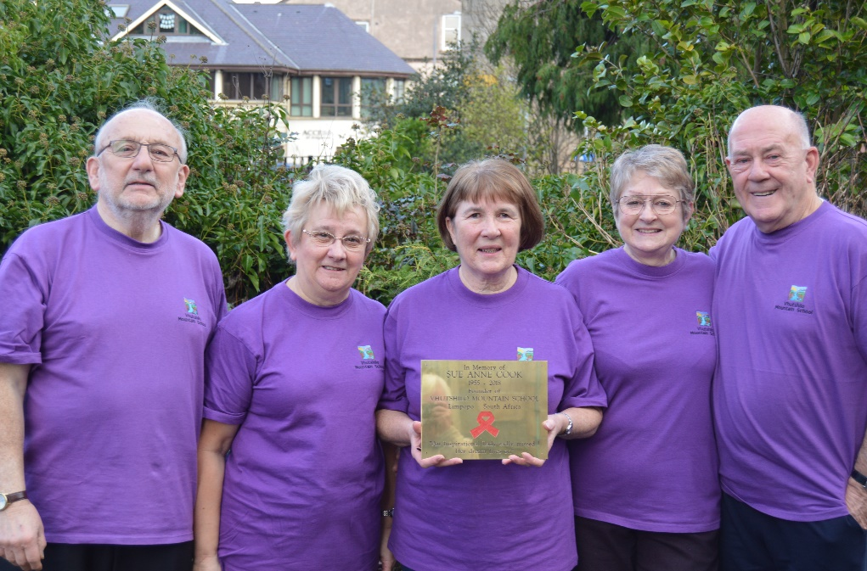

**Spring 2019**



**“WORSHIP, FRIENDSHIP, ACTION – a kirk that cares. “**

Welcome to the Easter Magazine 2019

It’s stange to be thinking about Easter so soon after advent and our many Christmas Services, building up to and celebrating the birth of our Lord. There is a lot going on in Westburn, not only our own organisations and committees being active and busy, also there are many outside groups using our halls.

The thought of spring and the gardens suddenly becoming alive with snowdrops crocus and daffodils is an exciting time, and is a reminder that soon we will be on our journey through Holy Week towards Easter, a moving but exciting time in our Christian Calendar. It would be good to see you at our Holy Week Services, details are in the magazine.

To get the magazine out to the congregation before the March Communion, Brian our Editor has to start his preparation early.

2

Thank you for your input, keep it up. We hope you enjoy reading the magazine and if you have an interesting or amusing story suitable for the magazine. Brian would love to hear from you’

Brian Lindsay our magazine Editor can be contacted at brian_lindsay22@yahoo.co.uk

**FROM THE MANSE**

Dear Friends

On Sun 20th Jan a plaque was dedicated in memory of Sue Anne Cook of Vhutshilo Mountain School, Venda, South Africa . Many of you in Westburn Parish Church have a long association with the school, supporting the work by prayers, donations, interest and compassion. Many of you remember the visit of Sue Anne and her daughter to Greenock and so will be sad to have heard of her death in November 2018. I have heard about Sue Anne and the work of the school and have been amazed to find out more over the last wee while. You can bring yourself up to date with the school and wider work by going on the website ‘Hope for Limpopo’ It seems to me, from reading about the school and the other associated projects , that much of the work is about building community, caring for the

3

vulnerable and supporting children ,recognising the uniqueness of each one.

We, who are pleased to continue to support this work, have a lot to learn from the staff, volunteers and children at Vhutshilo. For wherever we are in the world we are calledas followers of Jesus to build community, to care for the vulnerable and to support others, recognising the uniqueness of each person as a child of God.

‘Community has a grace-filled fragility about it for we do not choose our companions, but learn to receive them as a gift. Community is forged when people who are different can be embraced and where small gestures of kindness and service say ‘ I am happy to be with you’.( Rev Phil Stone )

May we know and build a community where we are.

Yours

Karen Harbison

4

**NOOMA BIBLE STUDY**

Listening to your feedback after a successful Nooma Bible Study last year, we have decided to launch an evening Bible Study starting this February and another daytime study after Easter. Our Evening Bible Study begins on Wednesday 6th February until Wednesday 13th March from 18:30 – 19:30.

**What is Nooma?** Nooma, is a series of short films that explore our world from a perspective of Jesus. We meet for relaxed and informal discussion watching a short film clip over food and refreshments. We have 6 sessions, if you can only make some and not all of those, that is okay. There is also no pressure to take part, it’s fine to just sit and take it all in. It really is very relaxed and informal. I will lead the group in prayer and discussion, but if you want to volunteer to do this, please speak with me, I won’t put any pressure on anyone to do so.

5

**The topics that we will explore are:**

Week 1 – A chance to meet up for some food and refreshments, to ask questions and find out about Nooma. Our first official topic will be Week 2

Week 2 - Why do we do the things we do?

Week 3 - Why are we so concerned with what other people think, say or look like?

Week 4 - Maybe God has blessed us with everything we have so we can bless and give to others?

Week 5 - What if there is more to prayer than God just listening and answering?

Week 6 - "Some of the central claims of the Christian faith are the source of many discussions and heated debates. But are we always debating the right things?"

6

I look forward to welcoming you to our next bible study. If you need more information or have questions, please speak to me or you can email me – [WBoyle@churchofscotland.org.uk](mailto:WBoyle@churchofscotland.org.uk)

See you there

William Boyle

**IMPORTANT PLEASE READ**

Chief Inspector Debbie Riley, Area Commander of The Police Service of Scotland, wrote to the local churches and she has asked us to share the following information as widely as possible. Please take a few minutes to read this and don’t get caught out by these cheats:

**PREVENTION ADVICE REGARDING FRAUD**

There have been many cases where perpetrators contact victims (usually the elderly) and convince them that they are from their local Bank. They advise the victim that they have observed fraudulent activity on their account and they are required to transfer money to a “safe account”. Account numbers are then given and they convince the victim to either arrange a bank transfer online or to attend at their Bank to arrange this.

7

Sometimes they insist that the victim stays on the phone to assist them – this actually prevents the Bank from phoning the victim if they are suspicious. Victims should hang up and then contact their Bank direct to check.

Banks are well aware of the scam and do contact the Police

if they suspect anything untoward however there have been occasions when transfers have been successful and this can run into thousands of pounds.

Bogus callers also attend the home addresses of the elderly and convince them to part with money for house repairs, which are often not required and are never carried out.`

Please don’t get caught out by these cheats. They use bullying tactics to try to get people to part with their savings and as they target the most vulnerable members of our society, it is a particularly despicable crime. It is not rude to hang up on these callers. If they are genuinely calling from the Bank, they will understand and allow you to call them back on the phone number that you have for your Bank. Do not use any number that they might give you during the call as this will almost certainly be a number that their bogus friend will answer on their behalf.

8

Thank you for reading this article and please keep safe this year and always.

Hazel Munro

Joint Session Clerk

**NEWS FROM PRESBYTERY**

Presbytery is concerned about the large number of vacant charges in its area, and about the increasing difficulty in providing ministerial cover for these vacant charges. This lends added urgency to the task of the Presbytery Planning Committee, which has to plot a strategy to ascertain the future shape and size of parishes in this area, especially in light of the projected drastic decline in the number of available ministers in the near future.

This problem is not confined to our own presbytery, but reflects a trend throughout the country, and this helps to explain the call for a radical plan of action as expressed at the 2018 General Assembly. So both locally and nationally we can be looking forward to the probability of some dramatic changes to the way our church operates in the not too distant future.

from Douglas Scott

9

**CHRISTMAS AT WESTBURN**

December started with our Blue Christmas Service where families who have lost someone came together to remember them by placing messages on the trees in the church that are lit throughout the month.

Our Nativity Night was a new event and it was interesting to see all the different Nativity scenes that people had brought along. Some were over 50 years old, have been bought at Christmas markets abroad, handmade and others bought because they liked them. We also enjoyed doing Christmas crafts and the usual tea and coffee.

Joe from Social Services came along on the 9th Dec and accepted the many toys that the children and adults brought along on the day. These were all going to children in homes where perhaps Santa was not going to visit.

The hospice held their annual Light up a Life Service on the evening of the 9th Dec. children from Ardgowan Primary too part in the service along with the Hospice Singers.

As a change from our Concert we held a nine lessons and carols service where the choir led us in carols and members read the lessons. This was followed by refreshments.

The children were dressed up for the All Age Nativity but a few older members also took part.

10

On Christmas Eve we had our early service where some of the children came in their pyjamas and later the Christmas Café and Watchnight Service.

At the Christmas Day Service we had a chance to wish everybody a Merry Christmas and during the service the children and some adults were able to show the members a few of the gifts that Santa had brought.

**Alter Cloth for Advent**

The Craft Class in the Church made a special Alter Cloth for the Season where out the month we added several pieces to show the whole advent story.

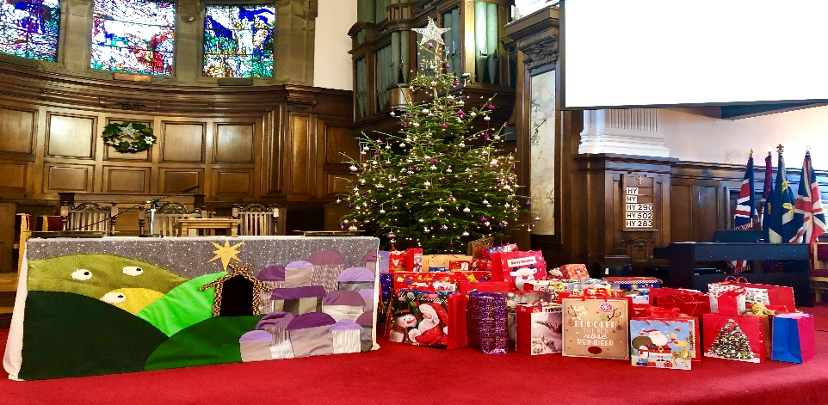

11

**RESOURCING WORSHIP TEAM, MISSION & DISCIPLESHIP COUNCIL**

**And when you pray…. Matthew 6:7a**

“How do you eat yours?” That was the question in a certain egg-shaped confectionery advert. The implication being that there is no right way to do it, but rather it’s about how you best experience the egg.

How do you pray?

Perhaps you haven’t really thought about it too much. Perhaps it’s now hard to concentrate because you’re thinking about chocolate, but regardless of appetite, past experiences, how we wrap it up or try to explain it, prayer can be rather confusing. It can often be a mystery. It can at times seem like a chore. It can even be a blessed relief.

So then, how *do* you pray?

12

Are you a morning person? Do you greet the sunrise with thanks and praise to our God? Do you utter hopeful words and try and live them throughout the day to come? Are you more spontaneous? Do you respond to life with a  ‘breath prayer’, off the cuff, as life makes you dance to its tune and in each moment you seek the steadying hand of our Creator and Sustainer?

Perhaps you find yourself needing space. Like a free-diver coming up for air after plumbing the depths. Maybe you carve out some time in your day to be still and know the presence of God. You may prefer to reflect on your day in the presence of God, as was the practice of Ignatius of Loyola, who gave us the daily examen – a way of praying that helps us recognise God’s presence in the midst of the day just lived.

The practice of prayer is part of the lifeblood of our faith. We may find ourselves in the darkest of circumstances, when prayer is the only thing that we can turn to for comfort. We might see prayer

13

as that thing we do together on a Sunday, or as the

words said on our behalf by a minister or worship leader.

Maybe it is the one thing that keeps us going, those times when we can just let God know how we are feeling. It might even be

that thing that happens by accident or that we’re unaware of until, looking back on a time of quiet, perhaps with a cup of tea or watching the world go by from our living room window, we realise that in the stillness, God was there the whole time.

Whatever your habit or preference may not really matter. What is important is that we are having the conversation, that we are opening ourselves up to God in whatever moment we can manage, that in some way prayer is part of our life. Prayer may be a constant companion on the journey, or a friend that visits once in a while, to bring comfort and solace. It may be something deeper,

14

more mysterious that is largely left unspoken, something felt, yearned for, grieved over or something long-forgotten brought to mind.

How we pray then, is not the most important thing, but

rather that the experience of prayer and the encounter with God is recognised. That our faith is tended and our relationship with God is nurtured, in precious moments. No fancy wrapping is needed and it may not always taste sweet but, in the midst of life, listening for and opening our hearts to God is indeed food for the soul.



**LET US PRAY**

In the beginning was the Word. We should remember to use words wisely as we do God’s work.

Eternal, loving god, thank you for your Word.

You have given us the power to use words, and we talk a lot… but sometimes not very wisely.

We make promises which we do not always keep.

We sometimes say things which we do not mean.

Help us to speak wisely and kindly.

Words have power, words can hurt.

One false word can poison. Help us to use words with care.

A good word at the right time, at the right place, can change the world, someone’s life.

Words can heal, and end strife.

Inspire us to use words that encourage and comfort.

Help us to avoid destructive or hurtful words and empty, spiteful gossip.

And help us to remember too that occasionally it is good to be silent. Amen.

Douglas Scott

16

**BOOKS REVIEW “1000 YEARS OF SCOTTISH CHURCHES”**

Those of you who are readers of “Life and Work” magazine will know of the regular articles by John R Hume on the history and architecture of Scottish churches, in which he gives a short history of a different building each month, together with a line drawing. Last spring, he published a series of six booklets on the history of Scottish churches under the general title of “1000 Years of Scottish Churches” covering the period from before the Reformation to 1700; 18th century churches; 1800-1843 (the Disruption); 1843-1878 (the Restoration of the Roman Catholic Hierarchy); 1878 to WWI; and Churches built since WWI.

These don’t just cover Church of Scotland churches, but include churches of other denominations and also church buildings which are no longer in use. The aim was to present “a balanced selection of different periods, denominations and architectural styles.” Each description is accompanied by a photograph and he highlights points of interest rather than giving the history of each building.

The booklets are not cheap at £10.95 each, but for anyone interested in the subject are worth seeking out. They can be

17

Purchased through the publisher’s website [www.stenlake.co.uk](http://www.stenlake.co.uk)

There are only a few churches in Inverclyde included in the booklets. However, for us in Westburn, there are three mentions of our buildings, or former buildings.

In the book on “Early 19th century churches: 1800 to the Disruption” there is a photograph of our current building, taken roughly from outside the Access Centre, entitled “The West Parish Church (Westburn Parish Church)” with a text which states “The body of this large burgh church was built in 1841 to designs by David Cousin. It was constructed to replace the 16th century Old West Church on the waterfront. The church is in the then-fashionable West End of Greenock facing up Brisbane Street. The tall and elegant steeple was added in 1853.”

Our building is also photographed from Brisbane Street in the 1843-1878 booklet where the author says “The West Parish Church (Westburn Parish Church), Greenock Renfrewshire. The construction in 1839-41 of the body of this church in the West End of Greenock has already been referred to. This view is included to show the soaring beauty of the Classical steeple added in 1855, the last of its kind to be built in

18

Scotland.” Note that the date for the steeple being built differs from that given in the previous booklet!

In the same booklet, the former St George’s North building is also included**.** Photographed across George Square, the text reads “The Middle Free Church (St George’s North Parish

Church), Greenock Renfrewshire. The tall steeple of this church was also designed as an eye-catcher, at the east end of Union Street, in the fashionable West End of Greenock. The church was designed by Salmon, Son and Ritchie of Glasgow, and built in 1870-71. The top of the steeple appears to have been modelled on that of St George’s Tron Church in Glasgow.”

Other Inverclyde churches discussed are Wellpark Mid Kirk, which receives two mentions in the booklet on 18th century churches; Lyle Kirk, Union Street is included in the 1843-1878 booklet; St John’s Episcopal Church and St Columba’s Church in Kilmacolm, which I did not know used to be called St James’, in the 1878-WWI booklet; and Hamilton Bardrainney and St Mary’s Episcopal Churches in Port Glasgow in the booklet on churches built since WWI.

Jennifer Boag

19

[](http://www.google.co.uk/url?sa=i&rct=j&q=&esrc=s&frm=1&source=images&cd=&cad=rja&docid=vnKGV4QdK-iW0M&tbnid=tQRhast9pRi7CM:&ved=0CAUQjRw&url=http://viewfielderskinechurch.org/styled-4/index.html&ei=S1YoUrScIYWi0wXP2YGgCA&bvm=bv.51773540,d.d2k&psig=AFQjCNF7mWpyEfn-04lOFLfK3ZlJvxN4pA&ust=1378461607962818)

**National Guild Report**

Since the last magazine I’ve been busy attending a variety of meetings and conferences on behalf of the Guild.

The first being the Annual Gathering in Dundee where we had Communion this was called an Agape Meal because the elements couldn’t be blessed at the streaming venues as there would be no ministers attending. This was ‘a first’ and was well received by everyone both in the Caird Hall and those watching on the live stream. This was appropriate as we were starting a new strategy, “One journey, many roads” with this session theme “Seeking the Way”. The address by the moderator Right Rev Susan Brown was humorous as well as thought provoking. We also heard from the representatives of our new projects. The National Vice Convener interviewed the Moderator of the National Youth Assembly in the afternoon after we had been entertained with African songs from Mable Sitchali from Zambia.

20

I was an observer at the Tumekutana 2018 in Johannesburg which was very interesting. We heard from a variety of speakers from different parts of Africa as well as Rev Najla Kassab, President of the World Communion of Reformed Churches. We heard some very moving addresses which made me feel very humble and thankful that I was living in the UK and not in their part of Africa.

I’ve had many opportunities to meet with Guild members from different parts of Scotland - Rhins Guilds Together - Portpatrick, Berwickshire Guilds Together - Eyemouth, Erskine Guild, St. Andrew’s Guild - Barrhead, and St. Andrew’s & St. Marnock’s - Kilmarnock. Also, we held another Roadshow where we visited Arbroath (Angus East), Forfar (Angus West), Fraserburgh (Buchan East) and Stonehaven (Kincardine & Deeside).

During Guild Week we had another Big Sing, this time in Airdrie and another Christmas Big Sing this year in Edinburgh. The offerings at these events amounted to over £3000 and will be added to the offering from the Big Sing at the General Assembly in May. The money will be sent to Malawi to help to replace a grass roof at one of their churches with a metal one.

21

At the beginning of my year as National Convener, I asked for a copy of syllabus from Guilds Together and individual Guilds. This was to enable me to visit Guilds where possible on non- official capacity, by the time you receive this magazine I hope to have visited St. Andrew Blackadder - North Berwick, Riverside Guild - Dumbarton, St. Paul’s Guild - Milngavie and St. Columba’s Guild - Kirkintilloch as they celebrate their 50th Anniversary.

In an official capacity I’ll have attended 2 Meetings in Edinburgh in the Church of Scotland office and the Side by Side event at the Scottish Parliament, the topic is -Leave No One Behind: Gender Justice, Rights and Empowerment.

Patricia Robertson

**Worship Committee**

The Worship committee of Kirk Session meets regularly to look at all aspects of worship within our congregation. If you have any ideas, comments or suggestions, we would be pleased to hear them.

The Committee has prepared a programme of evening services for the last Sundays in February and April with a further service in mid-June.

22

24th February – service of evening hymns and vespers 7pm

28th April – Christian Aid themed service

16th June – Songs of praise to which we will invite the Stedfast Band

We would very much like to see you there! Please see the orders of service for more details.

Morag McCracken has completed the Presbytery Worship Leaders and Hazel Munro will be attending the course this spring. They will be assessed by Presbytery and this will allow them to lead worship in our own church. If anyone else is interested in this course, please speak to our minister.

The Worship Committee members prepare the Prayer and Thoughts in the Order of Service on a monthly rota.

We are planning to have the pew prayer cards translated into French and German and to make these available to cruise ship passengers this summer. Thank you to Douglas Scott for the translation work.

Worship Committee

23

**Community Links –**

**Think Global, Act Local**

The Kirk Session, at its November meeting, decided to nominate the British Red Cross Yemen Crisis Appeal as the focus for our advent collections.

Thanks to your generosity just under £500 was raised at Westburn Parish Church services.

Yemen has been gripped by Civil War in recent years with various outside countries also involved it in the fighting. If the war continues, Yemen could be facing the worst famine in 100 years, according to the United Nations.

**Millions are at risk of starvation. Families have been struggling to survive without enough food.**

24

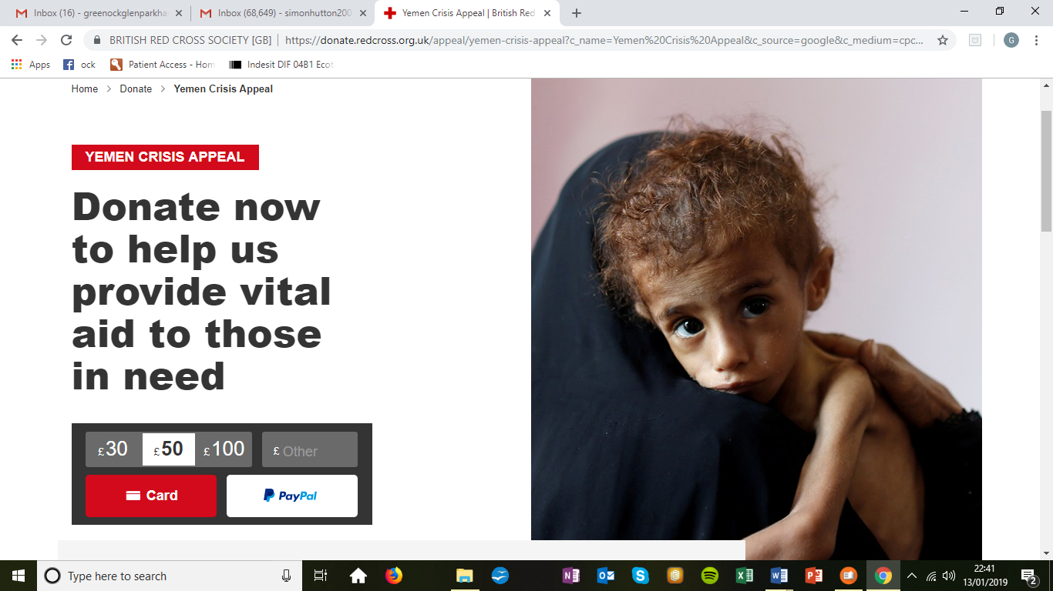Deadly clashes have left tens of thousands dead and over two million people displaced. The situation is desperate.

Medicines and medical supplies are extremely scarce, and only half of the health facilities are fully functioning.

If you missed the chance to donate you can do so directly via:

https://donate.redcross.org.uk/appeal/yemen-crisis-appeal

or by phoning [**0300 023 0815**](tel:03000230815).

25

**PASTORAL CARE COMMITTEE**

1. The Committee met on Wednesday, 12th December 2018 and will meet again on Tuesday, 12th February 2019.
2. **District 22 –** the Committee regularly visitour Members who are in nursing or care homes stretching from Cochrane House, Johnstone, Bagatelle Nursing Home, Balclutha Nursing Home, Alt-na-Craig, Bellaire Nursing Home, Glenfield Nursing Home and Larkfield View. The visits can be hard, but all are rewarding, although a small bar of chocolate does help on occasions.  
     
   In addition, Karen, our Minister is also visiting Members in hospital and at home.
3. **Christmas Gifts –** the Committee distributed Christmas gifts to all our Members in nursing or care homes. The gifts have been appreciated by the Members and their families.

Pastoral Care Committee

26

**Shawl Group**

.

We had busy year knitting for a variety of charities and our congregation requests. Compassionate Inverclyde received shawls throughout the year for the return home boxes and this will continue this year. The other charities were a homeless shelter in Glasgow, and lots of items for Sailors Society and social work.

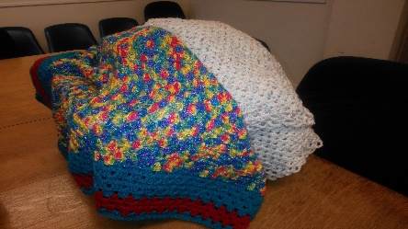 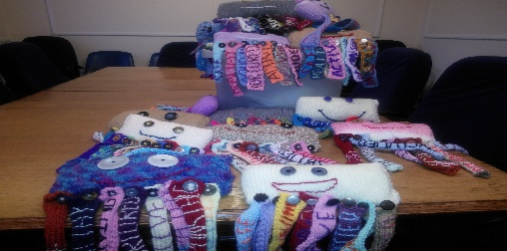

Our biggest challenge came from a small project. Karen asked if we could knit 15 octopus bodies with 8 detachable legs on each body with the words Safe-Healthy-Achieving-Nurtured-Active-Respected - Responsible-Included sewn onto individual legs. By the time 15 bodies and 120 legs were completed we were very happy to hand them over for Ardgowan Primary school.

If you know of anyone in church or community who would enjoy receiving one of our shawls please speak to any of the team or myself.

Doreen Borland.

27

**VENDA**

As most of you probably know, the sad news from Venda is that Susi finally lost her long battle with cancer and passed away on 1st November last year. Her ashes were buried in the grounds of the school (which was her wish) on International Aids Day, which seemed very fitting.

We were asked to write a short tribute from Scotland, which was read out at her funeral. The following is what we sent and I hope you feel it was appropriate

To Vhuwawo, Khatu and all at Vhutshilo Mountain School

On this very sad day, we felt we had to send our condolences to you all.

We at the Church of Scotland had the privilege of meeting Sue Anne on several occasions, when we visited the school in Venda and also when she stayed at our home in Scotland with Vhuwawo, when she had the opportunity to meet with many of the people who helped raise the money to build Vhutshilo Mountain school at Tshikombani.  We very quickly considered Sue Anne to be our friend.

28

She was a quiet but truly inspirational person, who saw a real need in her community.  Regardless of problems, she went forward with her dream. The number of children and families who have benefited and will continue to benefit from her dedication, would be impossible to count.

Sue Anne was a very special, kind and loving person. We remember, when visiting the school, the children coming along for their morning hug! Always a special moment for everyone who had the privileged to witness it.

Here in Scotland, Suzi, as everyone called her, will always be remembered with great fondness and admiration.

Our thoughts today are with her daughter Vhuwavho, all her extended family and friends, Khatu and all those who loved her best and will miss her most.

Sue Anne will always be with you and her legacy will live on in Vhutshilo Mountain School, which was her dream.

With our love and continued support,

Monica, Les and all Suzi's friends here in Scotland.

29

**Guild report for magazine**

The first half of our syllabus has flown past. We have had a variety of speakers in the first half of our syllabus. Our “Guilds Together” Rally held in Wellpark Mid Kirk had as a Speaker Mr. Jack McHugh from Freeland Church in Bridge of Weir.

We had speakers from, The Whithorn Way, Forensic Science, and The New Chocolate Factory at Port Glasgow.

We usually have speakers from two of the Guild Projects each year and this year is no different. We had a speaker from “The Boys’ Brigade” giving an insight into the National Organisation.

We had a very successful Coffee Morning in November when we raised the magnificent sum of £811.35. Thanks to all who continue to support us.

We finished off the 2018 part of our syllabus with a Christmas Afternoon Tea.

We opened in 2019 with an insight into investitures given by Mr. Alan Aitken, Captain of the 2nd. Gourock Boys’ Brigade who received an MBE in the 2006 Queen’s Birthday Honours List for his services to the Boys’ Brigade.

30

We have speakers coming to talk about Kilwinning Abbey, River Clyde, Prison Chaplaincy, from another of the Projects to name but a few.

We will close our session with an afternoon Daffodil Tea where all are welcome.

All are welcome at any of our meetings men as well as women. It would be lovely to see some new faces.

Anna Seggie

**THE STEDFAST BAND**

The band was set up in 1986 to celebrate the centenary of the Boys Brigade. However, it has evolved since then and as it says on the notice board at the front of the Church “All are welcome”. Our numbers have fluctuated over the years and we are currently strong in some sections but weak in others. So we want to recruit some new members to strengthen our weak areas, to able to perform with the best sound possible. We are looking for people between 8 and 80 (or any age) who either are experienced or novices. If you are interested or know of anyone that is, then please come along to our practice night, Thursday in the Main Hall, 7.30 – 9.30.pm. Thank you.

Ricky Martin

31

**CHURCH MUSIC GROUP**

We continue to appear at regular intervals as an enhancement to Sunday Morning Service. Those of us involved enjoy the experience and hope that you do too. However, a few more people would help to vary the service we provide. If you like to join us then please talk to any of us and we will give you a very warm welcome. The ability to provide a bit extra to our services is very satisfying but also means more involvement for those taking part, which can only be good. Also, it gives you a chance to see who is awake and who is not and if not, an opportunity to wake them up!  Please take this opportunity to display your talents while giving worship to God.

Ricky Martin

**SCOUT POST**

The congregation received a letter of thanks from 70th Greenock & District Scout Group for their support of the Group’s Christmas Post. The stamps sold and the post box at the church meant that approximately 700 stamps were sold and cards posted. This contributed to the over 4000 cards which the Group sorted and delivered, raising over 900 pounds for funds. Tommy Boag, Acting Group Scout Leader said “This

money will go a long way to helping us support the programme for the young people of the group.

32

**LENT AND HOLY WEEK**

As we begin our journey through Lent, may these words encourage and inspire you to take time to read, reflect and pray and travel with others towards the Easter dawn

Walk gently through these coming weeks

with quiet eagerness;

many have gone before you,

and by humility, quietness and persistent prayer

have found signposts to an inner harmony

and pathways to a deep-felt peace.

Holy Week Services will be on:

Sun 14th April 11a.m. – Palm Sunday

Wed 17th April 7p.m. – Holy Week Café Worship

Thurs 18th April 7p.m. – Maundy Thursday Communion

Friday 19th April 10a.m. – Good Friday Walk of Witnesses , beginning at St Mary’s Church

Friday 19th April 7p.m. – Good Friday Worship

Sun 21st April 7am – Early Service on Lyle Hill

Sun 21st April 11a.m. – All Age Easter Celebration

All welcome.

33