

**“ WORSHIP. FRIENDSHIP, ACTION, - A KIRK THAT CARES “**

Welcome to the Easter Magazine 2017

Don’t panic you don’t have to hurry out to buy Easter Eggs just yet. Easter Sunday isn’t till April 16th but Communion is on Sunday 5th March with the usual 11.00am worship in the Sanctuary and 3.00pm in the lounge, The Magazine being early lets the elders bring them when they visit.

As Easter is a very important time in our Christian calendar, it is good to take time to plan, to prepare, to be ready. Let us take time to journey through lent preparing for Holy Week and be ready to celebrate together the joy of EASTER.

We were delighted to hear that Ann Knox was accepted in her new charge and it is hoped that many of us will be there to support Ann at her Induction when the date is fixed. Ann has sent a note for inclusion in the magazine.

All of our various organisations and committees are in good spirit and busy with their activities and ongoing planning.

Brian Lindsay from the Communications Committee is now producing the Magazine and would be pleased to hear of any interesting stories and reports.

**Material for the next Magazine will be due by Friday 21st April, there will be a reminder in the Order of Service. Material should be sent to Brian at** [**brian_lindsay22@yahoo.co.uk**](mailto:brian_lindsay22@yahoo.co.uk)

***Wishing all at Westburn A Happy Easter***

**From the Manse**

Looking forward to Lent, Holy Week and Easter

To stop and think;

that is the gift God offers us in our Lent.

To pause and reflect;

that is what God lays within our reach.

To look life in the face and ask its meaning;

that is the opportunity God gives.

To see within ourselves and ask just who we are;

that is the awesome task God offers.

And then step out to meet the Easter Call.

Our journey through Lent begins on Sunday 5th March .AS well as our Sunday worship, there will be other opportunities to come together to pray, reflect, discuss… The Discipleship Committee is planning 4 Lent Bible Studies ( dates to be confirmed ) and the Worship Committee is planning Lent Reflective Spaces a time for quiet as the Church is open for prayer and reflection and a few thoughts to ponder on between 7 & 8p.m. on Wednesday evenings , beginning on 8th March.

During Holy Week, there will be services on Wednesday, Thursday and Friday evenings, beginning at 7p.m. The Wednesday evening will be a café style service in the main hall, the Thursday evening will include communion as we remember the meal Jesus shared with his friends in the upper room and the Good Friday service will be a quiet reflective service. We gather together on Easter Sunday at 6.30a.m. on the Lyle Hill, followed by breakfast in the main hall and our 11a.m. service will be a celebration of the good news of the resurrection for all ages.

We look forward to sharing these moments and weeks with you as we journey together towards the cross and on to the new dawn.

Dear Friends,

A few weeks ago I received a bundle of letters from Primary 5 pupils in Ardgowan Primary School expressing their thanks for Bubblegum & Fluff. Their words and the wee pictures they had drawn of some of the things they had seen and taken part in at Bubblegum & Fluff made me smile. (Some of the letters are displayed in the main hall ) They had all enjoyed the experience, different children highlighting the parts that had enjoyed most and saying things like; -

“ I loved the puppet show and the songs “

“Thank you for an amazing morning “

“Making the tiles was so much fun”

“Thank you for the candle. I lit it on Christmas Day”

“ Thank you for telling us stories about Christmas “

The children’s letters prompted me to reflect not only on the privilege , challenges and variety of school chaplaincy but also on the importance of thankfulness, saying thank you to God and thank you to others. Throughout the bible there are references to giving thanks and that is particularly the case in the psalms and in the letters.

“Give thanks to the Lord because he is good – his love is eternal” Psalm 136

“ I will always thank the Lord; I will never stop praising him. I will praise him for what he has done “ Psalm 34

“ In the name of our Lord Jesus Christ, always give thanks for everything to God the Father “ Ephesians 5

“ I thank my God for you every time I think of you “ Philippians 1

So thank you for all you are as God’s beloved children and all you as Christ’s followers and may thankfulness fill our hearts and minds so that other see the grace of God.

Yours

Karen

From Ann Knox

In November 2014, I first stepped into Westburn Parish Church, it was Remembrance Sunday and I sat upstairs as Karen and I had agreed that it was not the day for introductions.  However those I sat near showed me the friendly, welcoming face of Westburn that I was going to become more familiar with over my probationary period.

I am taking with me some great memories: Messy Church and the Summer Holiday Club; usually being bested by the young folk during the Children’s Talk; our worship together; chairing a Kirk Session for the first time; the special Christmas and Easter celebrations; Bible Studies; Bubblegum ‘n’ Fluff; Easter Code, our Evening Services using various formats, and who could forget the fun of the ‘Early-bird’ Christmas Fayre.

These events all helped in my learning and preparation for ministry, but it is the people of Westburn Parish Church that made my probationary placement such an interesting and encouraging time. Meeting folk in their homes, having a cup of tea (and a biscuit), planning events, and having the grace to allow me to conduct funerals for loved ones has been a privilege. I cannot thank everyone enough and I am sure that the next student who crosses your threshold will also have a challenging but enjoyable experience.

Mostly though I would like to thank Karen for her gentle guidance, patience during our weekly meetings, and her grace in letting me loose on a Sunday morning. I have come to admire her tremendous work ethic for she very rarely stops working and puts 100% of herself into her ministry, and I know that I have a friend to whom I can rely on.

For myself, the next part of my journey is beginning as I am now minister elect for

Inchinnan Parish Church, the date for my Ordination and Induction has still to be confirmed. Thank you for the well-wishes I have received, it means a great deal to me and I will keep Westburn Parish Church in my prayers as I hope you will keep me in yours.

Anne

**Time For Prayer – Douglas Scott**

If we open our hearts up to Jesus, he will accompany us at many times and in many places during our lives. Let us pray:

Jesus, you are the bread of life.

You show us that our father wants to satisfy our earthly needs.

Jesus, you are the light of the world.

You show us that our father wants to give us clarity and understanding.

Jesus, you are the door.

You show us how we can come to our father. Jesus, you are the good shepherd.

You show us how our father constantly looks out for us.

Jesus, you are the resurrection and the life.

You show us that our father is with us forever.

Jesus, you are the way, the truth and the life.

You show us the path towards real living with our father.

Jesus, you are the vine.

You show us that we are deeply rooted, connected to you and to our father,

For ever and ever. Amen

As we have used “Worship, Friendship, Action – a kirk that cares” as our Mission Statement this is how we have put this into action during Advent and how we continue to do so throughout the year.

**Big Sing** Over 950 voices joined together on Friday 18th November in our church for the 3rd National Big Sing. This was the largest attendance since starting and a great way to celebrate Guild Week. This was a fabulous occasion; I just wish everybody could have been at the front of the church to appreciate the full effect of the singing. There was a great selection of hymns and readings that reflected our Theme, “Go in Joy”

We were joined by Grey Sidira, from Livingstonia Synod Aids Project (LISAP), who shared something of their work to support people infected and affected by HIV, particularly during the current hunger crisis. Over £2500 was raised for LISAP at the Big Sing and at events held simultaneously in Edinburgh, Dingwall and Tarves.

I’ve received many compliments at the last National Council Meeting regarding this event particularly for the warm welcome received on arrival at the church and the beautiful sanctuary.

We must not forget the work undertaken by the students and staff of West College Scotland (to you and I James Watt College) in videoing the whole event. This can be viewed on the church website, by borrowing a USB stick or DVD from me.

As intimated on the Sunday after the event I’m grateful to the Minister, Kirk Session, congregation, Neil McPhee, our organist and all those in any way made the afternoon the success it was.

**Blue Christmas Service**

Then on the 27th November we held our annual Blue Christmas Service. This is where those who have lost relatives, friend’s etc can meet in what can only be described as a time of quite reflection and prayer. After the service there was Tea & Coffee where all were able to continue our time of fellowship.

**10th Anniversary**

Then we had our 10th Anniversary on Sunday 4th December 2016 when Westburn celebrated 10 years of the union between St Georges North and St Lukes which took place on 29th November 2006.

The ministers at the time of the union were Very Rev. W.C. Hewitt and Rev W.D.Hamilton and the session thought it would be appropriate to celebrate this land mark by having them take part in a service to mark the occasion.

The Service was taken by our minister Karen with Bill delivering the Sermon and Douglas leading us in the celebration of Communion.

It was appropriate that the theme for this 2nd Sunday of Advent was “Vision”. Bill in his sermon mentioned the vision that St Georges North and St.Lukes had 10 years ago and how we must continue with this vision not only for this Church but for the spreading of the word throughout the parish and beyond just as the prophets before did.

After the Service in the big hall the party continued with the cutting of the cake. All of those attending enjoyed themselves. A big thank you to all worked to make the day a big success and a special mention to Sandra Downie for the baking of the cake.

**Gift Service**

The next week we had the annual Christmas Gifts service where members of the congregation brought to the Church gifts for the children of Inverclyde who are under the care of the Social Services. These children due to family circumstances do not get a lot if anything at Christmas and these gifts will go a long way to making Christmas a lot better for them. Joe of the Social Work Department accepted these gifts on behalf of Inverclyde Social Services.

**Smalls for all**

Greenock Presbyterial Council was approached by Greenock Rotary in September asking if we would support “Smalls for All” and we agreed

“Smalls for All” is a charity which helps women and children in Africa meet their most basic hygiene and security needs. It was launched in 2009 by Maria Macnamara after she read an article about the many problems that women and girls in Zimbabwe faced due to not having any underwear.

This may seem insignificant when a country has so many problems but because many women and children in Africa can’t afford underwear, they fall victim to disease and attack. Girls who are lucky enough to have a place in school often miss 3 or 4 days a month due to their lack of underwear. If the women and girls receive pants they often walk around with their skirts tucked into their pants so men know they are wearing pants.

This appeal was well supported by the Guilds locally and Loraine Gray, a member of our church, President of Greenock Rotary came along to our Christmas meeting in Wellpark Mid Kirk to receive the pants that had been donated. This amounted to around 4000 pairs of pants along with monetary donations of £141. Although the Guilds have finished collecting the pants Rotary itself are continuing to collect.

**Gathering and Concert**

The evening started with the Gathering in the Main Hall where there was arts and crafts, Christmas music being played. Our minds were also stretched with 2 Christmas quizzes. Then we all went into the Church for the concert. We were entertained with items from the Brownies, Choir, Steadfast Band, the music group and guests. There was a retiring collection taken which raised £375 for Inverclyde Poverty Homeless. The evening finished with more tea and coffee.

**Christmas Services**

On Christmas Eve we had our Watchnight Service which was preceded by a Christmas Café where Tea coffee and mince pies were also on offer. The retiring collection was for Erskine Hospital and a sum of over £300 was raised.

Then on Christmas Day we had our Christmas Service which the Children and some of the Adults shared with us what presents they received.

“Worship, Friendship, Action,-A Kirk that cares”

In Pictures

The Big Sing

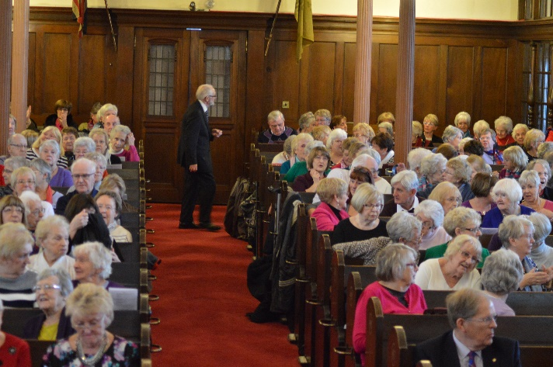

From 10th Anniversary

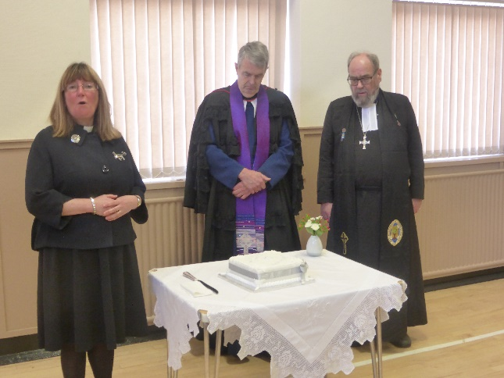

Cutting the Cake

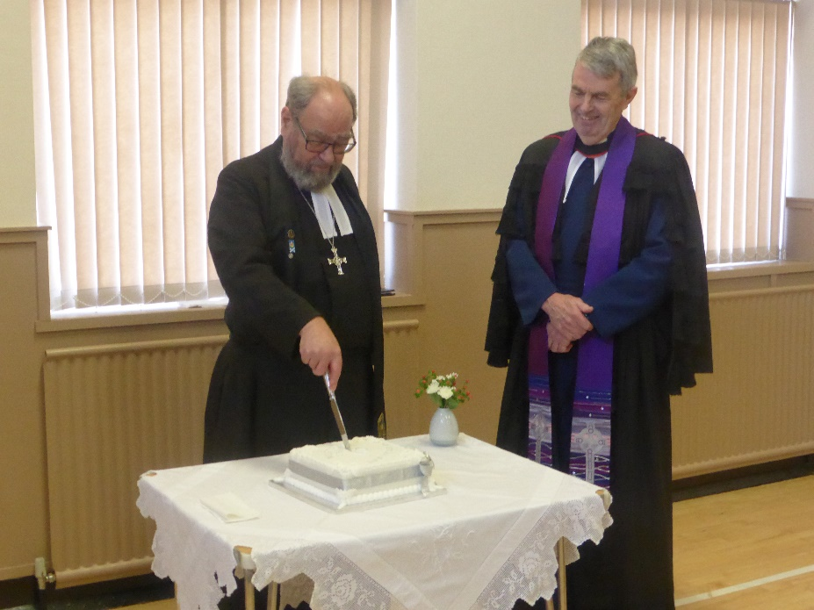

Smalls for All

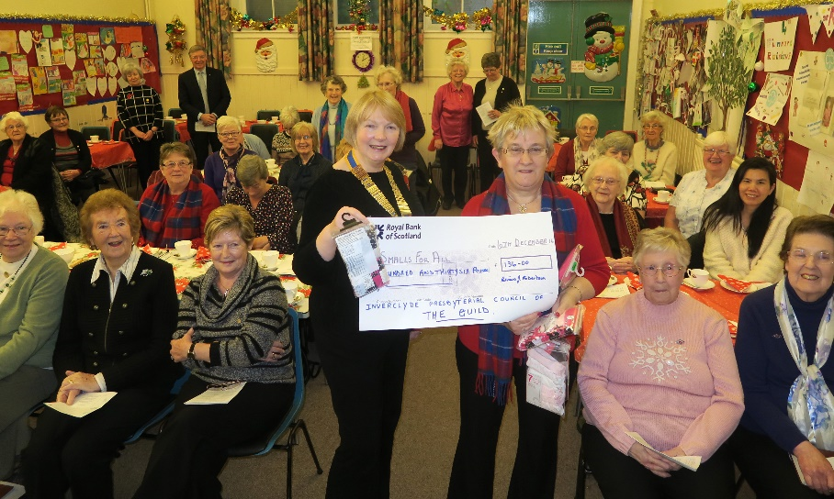

**Guild report for magazine January 2017**

The first half of our syllabus has flown past. We have had a variety of speakers in the first half of our syllabus. Our Autumn Rally held in Inverkip Church had as a Speaker Rev. David Burt, minister of Old Gourock & Ashton.

We had speakers from Leprosy Mission Scotland, Erskine, and also from Mission Aviation Fellowship, to see what this organisation does to take the word of God to isolated places is incredible.

We usually have speakers from two of the Guild Projects each year and this year is no different. We had a speaker from “Feed the Minds” – Breaking the cycle of FGM.

We had a very successful Coffee Morning in November when we raised the magnificent sum of £846.30.

We finished off the 2016 part of our syllabus with a Christmas Meal and some verses and Carols.

We open with a ‘Hymnathon’ in 2017, followed by a Burns Night and we have some interesting meetings coming up in 2017.We are having a Fashion Show on March 7th. put on by the Edinburgh Woollen Mill who are based at Cardwell Garden Centre.

We have speakers coming from C.H.A.S. from R.N.L.I. from another of the Projects to name but a few.

All are welcome at any of our meetings men as well as women. It would be lovely to see some new faces.

Anna Seggie

[](http://www.google.co.uk/url?sa=i&rct=j&q=&esrc=s&frm=1&source=images&cd=&cad=rja&docid=vnKGV4QdK-iW0M&tbnid=tQRhast9pRi7CM:&ved=0CAUQjRw&url=http://viewfielderskinechurch.org/styled-4/index.html&ei=S1YoUrScIYWi0wXP2YGgCA&bvm=bv.51773540,d.d2k&psig=AFQjCNF7mWpyEfn-04lOFLfK3ZlJvxN4pA&ust=1378461607962818)

**Presbyterial Council News**

Presbyterial Council held a successful Christmas Celebration meeting in December when we had representatives from Greenock Rotary to receive our contribution for “Smalls for All”. A fuller report is elsewhere in the magazine. We will also have had our ABM on 7th February, where we will have heard about the Guild project “Prospects”.

We are holding our Syllabus Planning meeting on 15th March when members of the local Guilds will share ideas for future meetings. Our Spring Rally this year is on 17th April and we have changed the format as we will have an evening of entertainment.

**National Guild News**

The Annual Gathering in Dundee on Saturday 3rd September was a fabulous day when we were singing and dancing in the aisles of the Caird Hall being led by The Church of Scotland Heart and Soul Band. The speakers for the day Right Rev. Dr. Russell Barr and Sally Magnusson were excellent in their own right. All those attending said it had been one of the best meetings in a long time.

Another highlight for the Greenock area this session was the “Big Sing” again a fuller report is included in the magazine.All the National Groups in Edinburgh have been working hard with their remits, the one I’m involved with have completed the Theme and Discussion Topic Guide for session2017/2018, and this will be sent to all Guilds by the end of January. At the next National Council meeting the strategy and themes for 2018/2021 will be decided. (What a thought to be planning to far in advance but needs must).

There is to be a Resource Co-ordinators meeting (this is a new group replacing the Educational Representatives which the Guild was part but no longer meet) on Friday 24th February where it is hoped those attending will pass on relevant information to the local branches. Also Resource Days will be held throughout March (run by the National team or locally) hopefully they will be well supported.

The amount raised up to the end of December 2016 for the projects for 2015-2018 is as follows:

Ascension Trust (Street Pastors Scotland) £60,246.94

Care for the Family (Let’s Stick Together Scotland) £44,945.48

Christian Aid (Caring for Mother Earth in Bolivia) £36,471.93

Feed the Minds (FGM in Kenya) £62,129.01

Mission International (Haiti Project) £38,683.14

Prospects (All Friends Together Scotland) £35,110.03

**Total £277,586.53**

I thank you for the opportunity to share with you the work undertaken by the Guild on behalf of the Church and that the Guild is being true to its motto “Whose we are and Whom we serve”

Patricia Robertson

**Inverclyde Royal Hospital – Volunteer with us**

* Do you have some spare time on your hands?
* Want to use your life experience to help others?
* You can make a big difference to patients in a hospital setting!

Patients that have been in hospital for a prolonged period of time can experience isolation and frustration due to a lack of stimulation and visitors. Volunteer visitors can make a huge difference to their experience through providing friendship, chatting, sharing activities and assisting with other tasks that will benefit patient care.

We are looking for friendly, confident volunteers with plenty of life experience to help improve the patients’ stay on long term wards at **Inverclyde Royal Hospital in Greenock.** Typical duties would involve chatting to patients, reading a magazine, exploring the patient’s personal interests, generally getting to know them, about their lives; their likes/dislikes etc. All our volunteers receive out-of-pocket expenses, induction training and regular one-to-one support from project staff.

Interested, if so, please contact

Harry Balch, Volunteer Manager

Volunteer Services,

Level 7,

West Glasgow ACH

Dalnair Street

Glasgow G3 8SJ

Tel. 0141 201 0360

Email: [harry.balch@ggc.scot.nhs.uk](mailto:harry.balch@ggc.scot.nhs.uk)

**South African Projects** form a large part of our Church caring for others outside our Parish. Our efforts are not confined to a particular time of the year.

Les has just received an e-mail from Susie in Venda and the following is an extract.

At our end of year ceremony, 36 children graduated from pre-school to Grade R. Over 200 guardians, parents and guests attended and the day was filled with music, dancing, dramas and singing. This is always a special day for me as I watch with pride and participate with joy. The tent was well decorated and the lunch of chicken, vhuswa  (porridge) ,salad and juice was enjoyed by all. Guardians/parents start early in the year to pay small amounts for this occasion, and for the chance to see their little ones facilitate and perform for this very traditional ceremony.  Local businesses also help with donations of food and cool drinks. It was an emotional and at times tearful day

.

The staff slept over so they could make an early start cooking for our World AIDS Day celebration which was held the next day (we have it like this so that the tent and chairs which we managed to get at a discounted price can be used for both ceremonies) Approximately 300 people (most of whom were youngsters) attended this heart warming and emotional day. The youngsters spoke openly about their status, the purpose of support groups and the importance of testing and not to be ashamed.  We also stood for a sombre moment of silence as candles were lit for those who had died.

Throughout both ceremonies, our little school was praised and thanked profusely for the excellent early childhood education and the positive changes in how people are perceiving the challenges of HIV/Aids. The year ended well for Vhutshilo Mountain School.

A heartfelt thanks to all our sponsors for their long-term commitment in helping us to educate our needy children.  Also very many thanks for all the individual donations which always seem to arrive at just the right time to cover an emergency.  Apologies for not naming people personally. Please wish all our friends in Scotland and very good New Year.

Love from Susi, staff and all the children at Vhutshilo Mountain School

**Westburn Church Prayer Shawl Group**

Last year our focus and projects have been on Community. We knitted Shawls and blankets for Greenock based Care Homes and for our ex-service men kin Erskine.

Following the success of the Layette sets in 2015 and with the help of congregation members we have been able again to provide the Social Work Department thought Elizabeth Hamilton a good quantity of quality layettes.

Our final gift to the community was to the local Food Bank who requested hats, scarfs and mitts mainly for children to provide warmth during the winter months.

Turning our minds to this years projects our hands ate still clicking the needles and if you know of anyone , they do not need to be a member of Westburn , who would benefit from a shawl or blanket please tell one of our group and we will be really please to assist.

Doreen Borland

**Used Stamps**

Another way of helping others is through collecting used stamps. The Church of Scotland World Mission have yearly projects in which they collect used stamps and sell them to raise funds. Until August last year they have they have raised in the region of £2000. They hope to raise around £4000 for the year which ends in February of this year. You can help by tearing of the stamps from any letters you receive and put them in the Red Box in the Church Vestibule or if you cannot make the Church you can give them to your Elder. For further information you can contact Evelyn Taylor who will be happy to assist.



**Westburn: Working towards Fair Trade**

A recent Kirk Session meeting, agreed with a proposal from the Community Links Committee that our church work towards becoming a fair trade church.

This means that we are committing to guarantee producers in developing nations a fair price for their goods. Also some money is invested in community projects.

Many products have fair trade options – tea, coffee, sugar, chocolate, cotton etc. Buying good with the “Fair Trade” mark means they meet minimum standards for growers/farmers.

In order to become a “Fair Trade” place of worship we have agree to serve fair trade tea and coffee at church meetings and events (we are not expected to enforce this rule to outside groups using our buildings).

In recent months, we have been serving fair trade Tea after Sunday Services. We are currently on the lookout for Fair Trade coffee which passes the taste test. Hopefully, we will be 100% fair trade very soon!



If you have any questions about this or are interested in helping out on the Community Links Committee, please contact Simon Hutton ([simonhutton2007@googlemail.com](mailto:simonhutton2007@googlemail.com) or 01475 745903).

Pastoral Care Committee

1. The Committee met on Tuesday, 10th January 2017 and meets again on Tuesday, 14th March 2017.
2. **District 22 –** there are 18 Members who are in nursing or care homes. These Members are regularly visited by the Committee. In addition, Karen, our Minister also visits Members in nursing and care homes, hospital and at home.
3. **Christmas Gifts** – the Committee distributed gifts to the Members in Nursing and Care Homes. The Committee has received many thanks from the Members and appreciative relatives.
4. **March Communion Afternoon Service** – Sunday, 5th March 2017 in the Lounge at 3.00pm. Members wishing transport are asked to contact Bill Dempster or any member of the Pastoral Care Committee.

**HEROES**

An evening of theatre, humour, music and storytelling celebrating HEROES and unsung HEROES in the bible, history and today. The evening will give you a chance to explore what made these people’s words and actions so special, as well as looking and laughing at our own attempts to follow in their footsteps. Featuring Adrian ad Bridget Plass, David Robinson and Rob Halligan, the show will include a mixture of sketches, monologues, poems and songs. After refreshments during the interval, we will be honouring some local unsung HEROES from our community as the Hospice Singers share some of their songs with us.

The concert will take place in Westburn Parish Church, Nelson Street, Greenock on Wed 15th Feb at 7.30p.m and is being sponsored by Westburn Parish Church, Lyle Kirk and Old Gourock and Ashton Parish Church. Tickets, priced £8, are available from these churches or by phoning 01475 721048

**Boys Brigade**

The Boys Brigade meet on a Friday night and any boy is welcome to come along and see what it is all about. The Section Times are:-

Anchor Boys 5-8 at 6 – 7.15

Junior Section 8-11 at 6 – 7.15

Company Section 11-17 at 7.15 – 10.00

For further information call John Murray on 01475 796736