



WELCOME to the Spring – Easter Magazine.

As the magazine is being prepared we have had frost and there is a covering of snow - but there are signs of spring just around the corner with the bulbs in the garden starting to shoot up and the faithful delicate snow drops, who no matter how hard the ground is or harsh the weather, always manage to delight with their appearance. There have also been daffodils available in the shops. At a recent coffee morning in Westburn vases of bright daffodils were appreciated by everyone, reminding us of the joys of spring and more importantly the expectations of EASTER.

Once again The Big Saturday event is being held in the Church on Saturday 16th February . All families in the congregation will receive an invitation with their Church magazine. Please attend to the reply on the back and come along and support this event which was a huge success last year.
Also included in the magazine is an invitation to a Family Blessing Service which will be a Celebration of Family Life - on Sunday 10th March . Members with families are urged to attend this special service and a contact for an RSVP are on the invitation.
Thanks for all who have contributed to this magazine to help make it interesting and informative for all our members.

The material for the next magazine is due by Sunday 19th April 2013
e-mail to cathbarbour@btconnect.com

© 2007

From the Interim Moderator

Suddenly it seems, the Season of Lent is upon us, and springtime beckons. At this time especially the Church celebrates the great events of Christ’s passion, death and resurrection. Eastertime is a great reminder of the resurrection theology at the centre of our Christian faith. Ours is a resurrection belief, which means that you have to let an old way of life die so that a new way might be born. And that doesn’t happen without an almighty struggle.

The story of the Emperor Moth tells of a man who came across a cocoon of an emperor moth and took it home in order to watch it open out. Eventually a small opening appeared and the moth struggled for several hours trying to force its body out. Then it seemed to stop making any progress.
Thinking he would help things along the fellow took a pair of scissors and snipped off the remainder of the cocoon so that the moth could get out. Sure enough the moth emerged – but with a swollen body and shriveled wings. He watched the moth, expecting the wings to enlarge and expand in order to support the body which would simultaneously contract to its proper size.

Neither thing happened. In fact that little moth spent the rest of its life crawling around with a swollen body and shriveled wings. It was never able to fly. Why? Because the restricting cocoon and the struggle that is required for the moth to emerge is part of the creative process. It is the creator’s way of forcing fluid from the body into the wings so that the moth, having achieved its freedom, is ready for flight. It doesn’t happen without a struggle.

It’s no different for us in our spiritual journey, if we want to become all that God intends us to be. But we’re not meant to do it on our own. We are a part of God’s family and that means supporting one another as we travel along - especially during this time of Vacancy.

One of the most difficult things about a Vacancy is the sense of loss encountered by a congregation. There’s a very real sense of having to let go of an old way of life before you can embark on a new way. It doesn’t happen without a struggle.

At the centre of that struggle is the work being undertaken by your Nominating Committee. Continue to support them with your prayers as they search for the right minister to walk with you along that new way. I commend them to you for their dedication to their task under the very able convenership of Stuart Robertson – you could not be better served.

It gives me much pleasure also in commending the office–bearers and members of Westburn Church for the way that you are responding to the challenge. (Not least by your response to the Stewardship Programme!)

Westburn Church is in good heart.

Your friend and (Locum) Minister
Morris Coull

CHURCH SERVICES TILL EASTER

February Sunday 3rd - 9.30am and 11.00am (These will be taken by Jennifer Boag )
Sunday 10th - 9.30am and 11.00am
Sunday 17th - 9.30am and 11.00am (First in Lent )
Sunday 24th - 11.00am ONLY
March Sunday 3rd - COMMUNION 11.00am and 3.00 pm (In Church Hall )
Sunday 10th - Mothering Service: Blessing Service11am ONLY
( Celebrating Family Life.)
Sunday 17th - 9.30am and 11.00am
HOLY WEEK SERVICES
March Sunday 24th - Palm Sunday 11.00am ONLY (Youth Service )
Thursday 28th – Maundy Thursday – Communion in Hall 7.00pm
Friday 29th - Good Friday Service in Church 7.00pm
Sunday 31st - Dawn Service - Lyle Hill 7.00am
( then breakfast in Church Hall )
Easter Service 11.00am
( followed by short Communion Service )

We look forward to welcoming you to any or all of these services
Pastoral Record
Baptisms
9.12.2012 Shannon and Jordan's son: Sean
27.01.2013 Lesley and Christopher's daughter: Ellie Agnes
Pastoral Committee

- The Committee met on 19th November 2012 and the next meeting will be on Monday, 11th February 2013.
- Christmas Gifts – as agreed, the Committee purchased a gift up to the value of £5 for each Member in District 22 and distributed them during December. The gifts were well received and the Committee has had very positive feedback from relatives.
District 22 – all members who are in nursing or care homes are regularly visited by the Committee. In addition, our Interim Moderator is also visiting Members in hospital and at home, including Megan Robertson in the nursing home in Saltcoats.
Christmas Cafe on Christmas Eve was another success. The Committee would like to thank the Members who donated Christmas pies, shortbread, homemaking etc, which was very well received. We would also like to thank the Ladies who manned the kitchen.
Protection of Vulnerable Adults – Norman Paterson is meeting with the Committee to complete the necessary disclosure forms.

Bill Dempster

March 3rd - Afternoon Communion

A warm invitation is extended to all to come along to

A short service of Worship with Communion
In the lounge
At 3 o’clock on Sunday 3rd March

Transport there and back will be available for anyone who needs it. If you would like a lift , then –
Speak to your elder
Or contact Ruth Gillies : Tel:- 639008

Please stay and join us afterwords for fellowship and a cup of tea.

We look forward to seeing you there.


CHURCH NEWS BOOK

If you are aware of anyone who is ill or would benefit from a visit from the minister, please make an entry in the news book with their name and address. It is helpful if you sign your entry.

Life and Work

Life and Work is available on the last Sunday of every month priced £2.00 Subscriptions available.

Please contact Shelagh Hendry Tele. 794667.
Delivery can be arranged if you are unable to get to church.

REMEMBER – If you want to advertise an event in our Local Internet Radio Station Contact :- David Faller, Inverclyde Radio direct at:-
www.inverclyderadio.com

Greenock Westburn Church Web Site
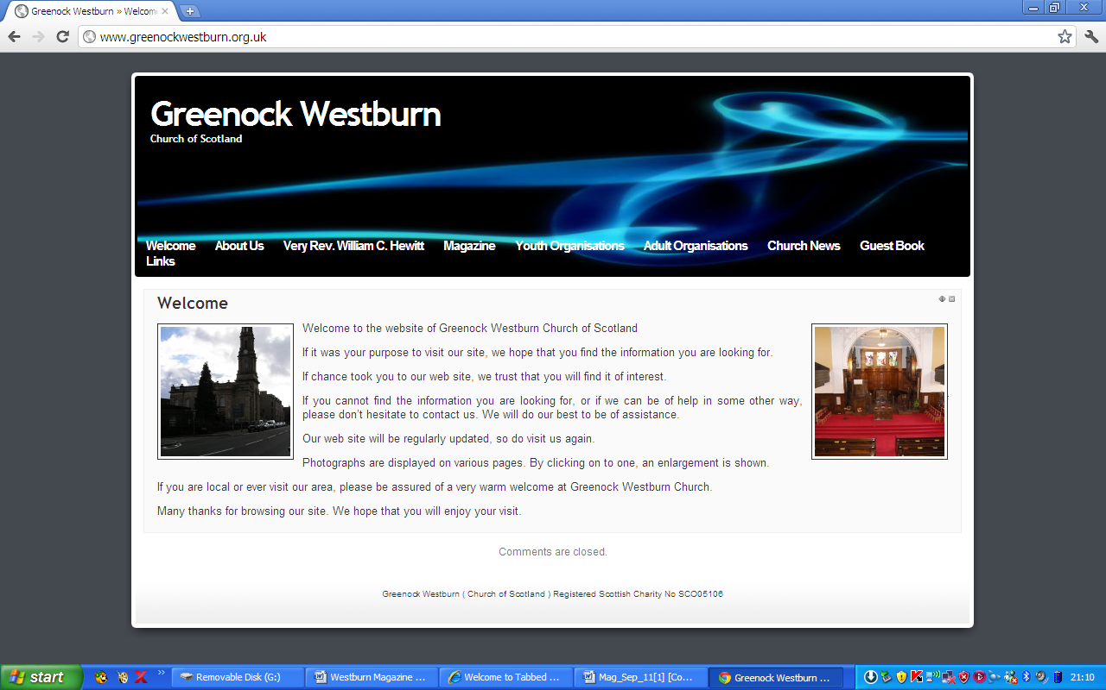
Have you put your syllabus, planned activities, or interesting comments about your organisation or group on your web page. If not it may look as though you’re not doing anything interesting. Have you looked at your page on the web, can you make it more interesting, add photographs, make comments, ask one of your members to write about what it is they enjoy about your group. Jim Bell will be happy to update your page.

A similar invitation is made to any church member who feels that they can assist in making the web site more interesting.

Our church web site can be found at - http://www.greenockwestburn.org.uk/ Please visit it and view it's contents.

Further information can obtained from Jim Bell ( 01475 799381 or all.the.bells@ntlworld.com )

Find us on FACEBOOK

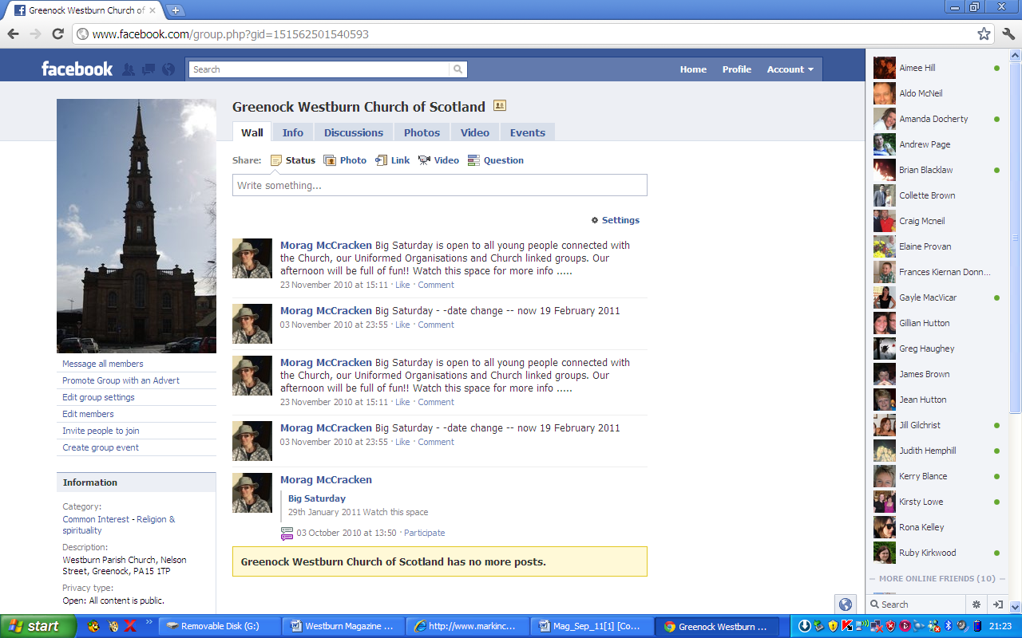
Search on FACEBOOK for “Greenock Westburn Church of Scotland” and join the social media revolution.


CHURCH FLOWERS

The Calendar for donating and list for delivering Church flowers are now available.

There are still dates available for donating and unfortunately there are many gaps for delivering. Please check the delivery list and see if there is any date you could manage to help.

This is a simple but very important task and The flowers are greatly appreciated by those who receive them.

If you would liike any further information about donating or delivering please speak to Patricia Robertson or Linda Murray
Or contact Patricia Robertson by telephone at 725451.

PRESBYTERY OF GREENOCK AND PAISLEY Nov/Dec 2012

CONGRATULATIONS – to Rev. Lorna Hood on her appointment as Moderator-Designate of 2013 General Assembly.
LEAVETAKING- Tributes were paid to Rev. James Munro and his wife Irene, a Lay Reader, for their commitment to the congregation and parish. They were an ideal partnership and both were involved in outreach work, the Guild, prayer and Bible Study. They will be sadly missed.
PRAYER SPACE FOR SCHOOLS – A presentation of how to set up a Prayer Space for schools will be led by Debbie Meheen, who works for 24/7 prayer, in the Cornerstone, Bishopton on Sun.28th April from
2–4pm.
PRESBYTERY – Noted Rev. Andrew Maclean is appointed Interim Moderator of Skelmorlie,Wemyss Bay and Inverkip and
Rev. Ian Fraser at Old Gourock and Ashton.
BUSINESS COMMITTEE – Morag Mackintosh is appointed as a Trustee at Inverclyde Family Centre.
Presbytery granted practising certificates to Rev. C. Murdoch and D. Young and noted they will retain their seats in Presbytery.
COMMUNITY INTERESTS – There are at least THREE FOOD BANKS operating within Presbytery bounds.
A steering group to explore the provision of “Faith in Through Care”
For recently released prisoners in Inverclyde has been set up and Dr.James Kelly is Presbytery Representative.
PROPERTY – Greenock:Westburn manse has been inspected and structural work identified in quinquennial survey report has almost been completed. Minor finishing work remains outstanding and will be undertaken soon, along with redecoration, provision of floorcoverings and installations of white goods, all of which will require to be completed before the manse is ready for occupation. The manse will be inspected again once this is finished before occupation is recommended.
SAFEGUARDING – Congregations are instructed to comply with the new requirements regarding Safeguarding Registers.
Our Presbytery Safeguarding Advisors expressed concern about the number of co-ordinators and Kirk Sessions who have not done the mandatory training updates yet.
ZIMBABWE –Presbytery commended SMART Community Project’s Young volunteers who visited Zimbabwe as part of a twinning relationship with Mbare church and who were fitting ambassadors for such a successful visit.

Margaret Crawford
Representative Elder


USED STAMPS

Please continue to bring your used stamps, there is a little red basket in the centre vestibule.

The money which is raised through donating our used stamps is very worthwhile and Evelyn Taylor keeps us up to date with the amounts raised and the projects World Mission are able to be involved with.

GREENOCK WESTBURN CHURCH
PROPERTY COMMITTEE REPORT
MAGAZINE – SPRING 2013

As you will be aware, redecoration work has been completed and the flagstone pathways have been lifted and re-laid. There have been many positive comments regarding the general appearance.

With the involvement of contractors, identified work likely to proceed in the near future is refurbishment of the ladies toilet, redecoration of the centre hall foyer, south boundary wall repairs and repairs to roughcasting at rear of main halls.

With regard to the centre hall foyer, floor cracks will require to be investigated prior to any redecoration.

Discussion is ongoing with members of the Guild re installing window blinds in the main hall.

Work being carried out by volunteer labour continues. Currently, the most noticeable is the staining of the sanctuary floor. This puts the final touch to the internal decoration except that
the gallery floor will not be stained until next autumn.

Volunteer labour contributes to a substantial cost saving in church expenditure.

At the manse, exterior and interior renovation work has been carried out. Further interior decoration has still to be carried out. This will be done when we have called a Sole Nominee.

Jim Bell

Property Convener

Church Cleaning

After an appeal a list was made up of 24 people who volunteered to help clean the church once a month. This has resulted in each team undertaking this task 4 times a year. The times this takes place is Wednesday morning, Wednesday evening, Thursday morning and Friday morning. If you feel you could help with this please contact me either at the church or phone 725451.

Thank you

Patricia Robertson

PRAYTIME

People pray in very different ways and styles, not because there are right ways and wrong ways, but because we are all different, with different experiences and backgrounds.

But the one essential ingredient for all our prayers is faith.
Our faith is the fuel that powers our prayers, giving them focus, meaning and purpose.

Here is a short tale from America.
After an unusually prolonged period of drought, which had been badly affecting the operations and livelihood of the local farming community, the congregation met together in their church to hold a special service of intercessory prayer for rain.
Before the minister began to pray, he expressed his disappointment that so many were lacking in faith: not one of them had brought along a raincoat or umbrella for the journey home!

Let us remember to pray in good faith, assured that our prayer will be answered, though admittedly sometimes in unexpected ways.

Douglas Scott, presbytery prayer coordinator:

TIME FOR PRAYER

Here is a prayer written by Alexander Solzhenitsyn, one of the great authors of the 20th century. He lived in what used to be called the USSR, a country which had tried to eliminate all Christian faith, and indeed all religious belief of any kind. He spent much time in prison for criticising the government, his writings were banned and eventually he was expelled from the country, and had to live in exile. Yet, look at the first two lines of this prayer, and see how strong and unshakeable is his belief. In today’s society, where there is so much doubt, despair and scepticism, maybe these words from Solzhenitsyn can inspire and encourage us to live in hope and assurance.

How easy, Lord, it is for me to live with you.
How easy it is for me to believe in you.
When my understanding is perplexed by doubts
or on the point of giving up,
when the most intelligent men see no further
than the coming evening,
and know not what they shall do tomorrow,
you send me a clear assurance that you are there
and that you will ensure that not all the roads of goodness are barred.
From the heights of earthly fame I look back in wonder
at the road that led through hopelessness to this place
whence I can send mankind a reflection of your radiance.
And whatever I in this life may reflect,
that you will give me;
and whatever I shall not attain,
that, plainly, you have purposed for others.

Amen.

Douglas Scott

Positive Results of Stewardship Campaign

In the Summer 2012 Magazine, the Stewardship Committee introduced the up-coming Stewardship Campaign by including a leaflet headed “Challenge to the Church” printed by the National Stewardship Programme together with a breakdown of our 2011 Income and Expenditure figures here in Westburn.
We then moved on to The Gathering which was held in September with all members of the congregation being invited to a presentation and display held after the Sunday service. This appears to have been well received by those who attended.

I am pleased to say that the response to the presentation has been very positive and the effect on the three key areas of givings, standing orders and Gift Aid is as follows:-

Givings
By the end of 2013 when we shall see the effect of a full year’s givings since the campaign I anticipate that we are on course to see an increase of around £17,000 or 20% on 2011 collections of £85,500.

Standing Orders
We have increased our standing orders by more than 50% to the current number of 145, more than 130 of them monthly. Why does this matter? From the Church’s point of view, standing orders are easy to administrate and give us regular income for budgeting purposes. The uptake of standing orders suggests that members are also finding this a convenient method of payment and anyone who wishes to switch to this method, now or in the future, should contact me.

Gift Aid
As a charity, the Church is entitled to claim back from the UK Government, Income Tax paid by its donors on any contributions they make. This gives our congregation an extra 25p for every £1 donated, at no cost to the donor. I would ask all tax payers if they have not already signed a Gift Aid Declaration to do so now.

50 new people have signed up for Gift Aid, increasing the number to around 190 and we anticipate a claim of over £19,000 in 2013 which is more than £4,000 in excess of the equivalent figure in 2010. As a result of a change in legislation, everybody is required to sign a new Gift Aid Declaration, so I would ask that anyone who has not signed a new form either during or since the campaign should contact me to sign a new form.

I hope that like me, you find these figures encouraging and I would take this opportunity to thank everyone who supported the campaign and those who continue to support our congregation in any way.

If for any reason you were unable to respond at the time of the campaign but wish to do so now or require further information about Gift Aid, standing orders or any other aspect of giving, please contact me.
My telephone number is given on the back page of this magazine or you can write to me either at the Church or at 35 Newton Street Greenock PA16 8SB.

Thanks again for your support.

Alastair Munro
Stewardship Committee Member and Congregation Treasurer

Future Focus Follow-up Report

Lesley Hamilton-Messer and Iain Campbell (Facilitators) met with the Interim Moderator and some 30 Elders on Thursday 17th January 2013 at 7pm to discuss the Future Focus Report.
A full review of the report was made with an opportunity for questions and discussion.
The facilitators shared a number of examples of emerging church activities that have achieved a measure of success elsewhere and might be worth considering here in Westburn Church and community.

The Future Focus Report was undertaken to provide a basis for drafting an Action Plan for development and implementation by the church and to that end the meeting agreed to bring forward to the Kirk Session the following Recommendation:

That the Kirk Session appoint an Action Group to bring forward priorities for action arising from the Future Focus Report.

The Action Group to comprise of Douglas Scott, Convener , and members Jennifer Boag, Simon Hutton, Alan Gallacher, Morag McCracken, Sheila Tait and Ricky Martin.

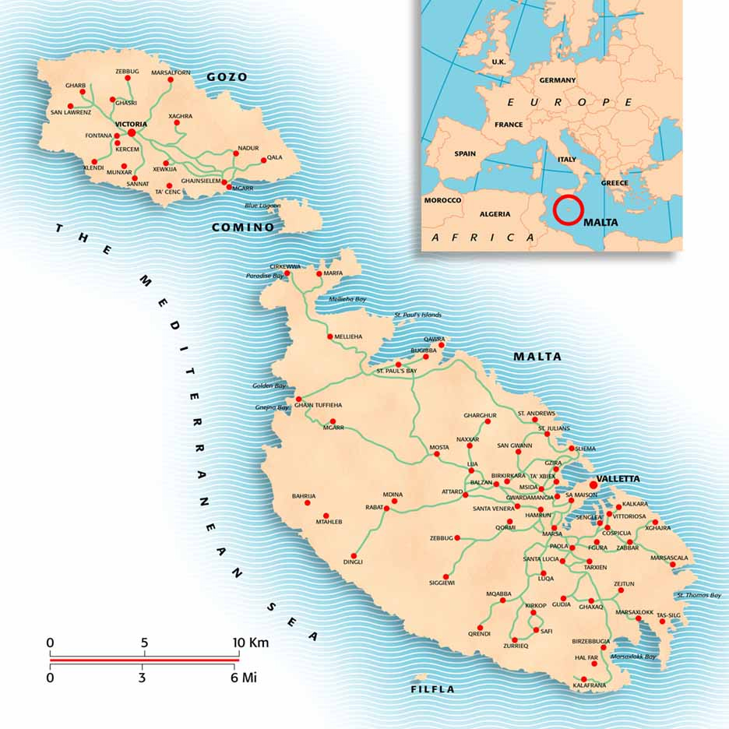
Sun cream, sun glasses, ferry tickets – ready for church!

In July last year I had the pleasure of visiting, Saint Andrew’s Scots Kirk on the Maltese Islands in the heart of the Mediterranean. The congregation is a partnership between the Church of Scotland and the Methodist Church of Great Britain.

The advent of Christianity on the Island of Malta dates back to the arrival of Saint Paul - who was shipwrecked on route to Rome. The inhabitants have remanded devoutly Christian ever since. Indeed there are 365 Roman Catholic parishes in Malta – one for every day of the year.

Malta’s strategic importance at the centre of the Mediterranean made it a sought after jewel in the crown for many foreign powers. Protestant worship arrived on the island during the period of British Rule (1800-1974) when a variety of ministers were sent to serve the substantial British military presence.

While Anglican, Lutheran and other churches exist, Saint Andrew’s Scots Kirk is the only reformed church in Malta, providing English language services to regular worshippers from four – sometimes five – continents. The diverse congregation includes British ex-pats, holiday makers, African refugees as well as local Maltese people.

The church is based in the capital Valletta – a short ferry ride from the resort of Sliema – and the building is shared with a German Lutheran congregation who hold afternoon services following the Church of Scotland worship.

The current minister is the Rev. Doug McRoberts - formally of Keith North Parish Church in Banffshire. On his retirement, he will be replaced by a Methodist preacher. Interestingly prayer requests were noted in a little red book and these requests were incorporated into ‘Prayers for Intercession’ at each week’s service. Visitors and members were invited to add to this little red book and the congregation pledged to remain faithful in prayer to each request.
I am visiting Malta again this summer and I am looking forward to attending Saint Andrew’s Scots Kirk again. For more information go online to www.saintandrewsmalta.com.

Please remember the ministry and mission of the congregation of Saint’s Andrews Scots Kirk in Valletta in your prayers for others.

Simon Hutton

CHURCH FETE
Important date for your diary !!
The Nominating Committee has suggested that we should hold a church fete. Previously the two former congregations have held successful fetes. It was thought to be a good idea especially to increase fellowship within the congregation.
Initially and to take this forward, a small committee consisting of Doreen Borland, Patricia Robertson and Jim Bell has been formed.
It is proposed that it takes place on Saturday 25th May from 10.00 – 4.00 making use of the church, halls and grounds. Preparatory work would include setting up on the Friday evening.
A list of potential events is being prepared. It is the intention to ask all church related organisations to participate.

Any church member who feels that they can contribute to the planning and organisation is invited to speak to Doreen, Patricia or Jim.

39th Greenock Guides

After their Christmas break, the Guides have started back. We have been acting out our own versions of Burn's poems and decorating cup cakes. This session we have lots of exciting activities for the girls to undertake. We will be preparing for Thinking Day by researching a country that has Guiding. We will then present our infomration and provide food from our chosen country. We will be learning some dance moves during our hip hop night and we will make mum something nice for Mother's day. This is just a little sample of what we get up to. If you, or you know someone that would like to find out what else we get up, come along on Tuesday nights at 7:30pm. More details from Marjorie 01475 727328
Marjorie McWhirr (nee MacLeod)

SOCIAL COMMITTEE

The Social Committee have been planning a programme of suggested events listed below.

Feb/March – Ceilidh, Concert

April/May _ Fashion Swap, Tea Party

June _ Treasure Hunt/Supper evening

July/August _ Bowling Night

September _ Family Quiz

Oct/Nov _ Pantomime, Christmas Craft

December _ Christmas Concert

Contact any Social Committee member for information about any of the above events.

We hope there is something in our programme for everyone. If not please let us know what interest you and event you’d like to try.

We need your support in all of our events and will be delighted to share fellowship and fun with you. We look forward to hearing your comments.

The Ceilidh has already been confirmed for 2nd March – further details will be in the Order of Service.

Social Committee

400 “Fish ‘n Chip Babies –
Thank you

A huge thank you to all the knitters involved with our Westburn project. 400 outfits have been sent to areas in Africa! All that achieved in a few weeks late last year is giving cover and comfort to at least that number of babies, embracing them with love knitted into each stitch.

As you may already know, we knew how many baby outfits we received but we can only guess as to the number of knitters who became involved! What started out as an internal Westburn response to an overseas need, took wings within Greenock, and then through our families, friends, and their families and work colleagues Paisley, Glasgow, Lanarkshire and beyond also heard the needles clicking for “Fish and Chip” baby garments. Pictured over is the amazing array of wonderfully coloured garments.

Thank you to all who worked so hard to produce such a fantastic result for this particular project. This project is over, but the knitting continues under the new stewardship of Ann/Susan Skedd and Dorothy Murray.

Thank you once again

Doreen Borland

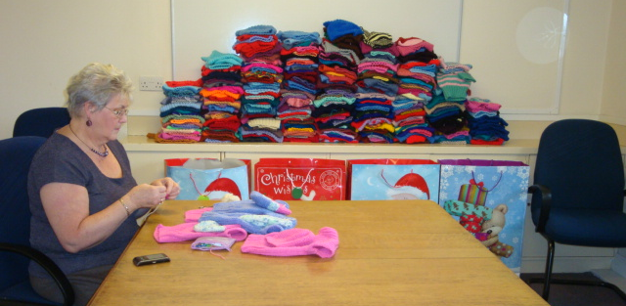


WESTBURN CHURCH MEMBERS – “STEPPING OUT IN FAITH”
IN 2013

“Westburn Westie” the lead dog

We are often told that exercise is good for us and, that for most of us, our easiest and best exercise is walking. It’s certainly likely to be our most immediate and cheapest form of exercise. Westburn Social Committee would like to turn our everyday walking into a more Church-wide, social, beneficial activity.

In Westburn we are within the Greenock and Paisley Presbytery of the Church of Scotland. However, in mainland Europe there are 13 CofS “branches” of the Scottish Kirk making up the European Presbytery. We could, by counting our steps daily, without even going out on organised walks, “virtually visit” each one of those of our Sister Churches on a virtual-tour, hence the title “Stepping out in Faith!.” Westburn Westie would virtually step out with us!

Most of us would be surprised by the number of steps we take each week. Some for fun like, golf or bowls (well maybe these are too serious to be treated as fun). Some out of necessity, like walking the dog or doing the shopping.. We also mount up our cumulative steps doing the housework, the garden or walking to the bus. Some of us even walk just for the simple pleasure of it!

What would be involved? How would we start? The only equipment we would each need is a Pedometer to attach to our waistband (or socks) each day. At night we would note and record the number of steps taken that day. Each Sunday our weekly step total could be delivered, emailed or phoned to the Church Collator to be turned into miles. A map of Europe in the Main Hall would show the progress week by week. As the virtual miles approach each of the 13 Churches, contact would be made and greetings and messages exchanged.

It is intended that our recorded walking will begin on 7th April. The virtual route will be
Greenock > Amsterdam > Rotterdam > Bochum > Budapest > Rome > Malta > Lausanne> Geneva > Fuengirola > Gibraltar > Lisbon > Paris > Brussels > then Nelson Street for Tea!

Arrangements will be made for would-be Steppers to “sign in” on 24th and 31st March. If Pedometers are required (for a small sum) please contact members of the Social Committee or phone Doreen on 706034, preferably during February or early March.

Further short intimations regarding Stepping out in Faith will be issued through the Order of Service on appropriate Sundays prior to April.

LET’S HELP WESTBURN WESTIE DO EUROPE

VENDA REPORT

To the Congregation
Westburn Church

Dear Members

Enclosed please find progress reports and work samples from Dowelani and Khabuba. Also a group photograph.
Dowelani enjoys playing with the construction toys and building blocks. He loves listening to stories although as his attention span is short, he quickly becornes bored and will start to tease his peers. He is full of energy and is always first out the door when it's time for outside activities. He loves playing soccer, and jumping on the trampoline.
I am not sure if you ever received a history of KHABUBA LUGISAM : {DoB: 15/07/2009}
He lives in Tshikombani village with his mother, 5 year old brother, and 1 year old sister' There are also 3 uncles aged 15, 17 and 19 years. Khabubu's, mother, Munzhedzi is 27 years old and is the sole breadwinner of these school going youngsters. Her mother died in 2009 from HIV/AIDS and Munzhedzi left her husband in Johannesbuig to come and look after her children and her late sister's children. Khabuba's father is unemployed, and does not pay any maintenance.
Munzhedzi works as a hairdresser but they depend on the government grants to survive.
Khabuba is a shy youngster. He rarely talks and is always on the outskirts of the group. He is obedient and follows instructions. He likes to draw and do jigsaw puzzles. His favourite outdoor activities are playing in the sandpit and jumping on the trampoline. He is always worried about being clean and will often dash inside to wash his hands. I call him my "rasta” man as he often has dreadlocks.

Thank you for sponsoring these 2 children and ensuring that they get a good start to their educational careers.

Warm regards,
Suzie

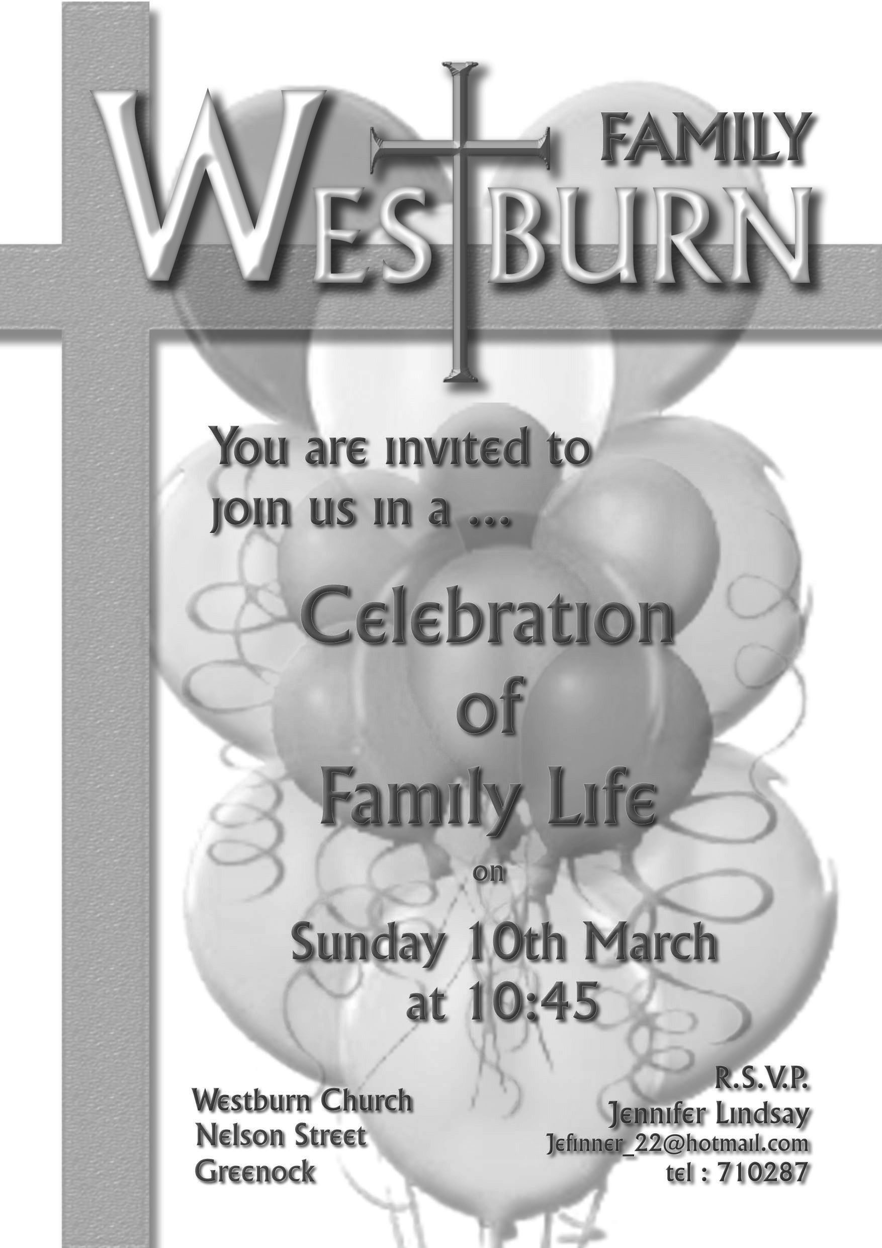
Susie

GUILD
The guild have had a very busy time since the last magazine, we hosted a very successful Songs of Praise organised by Greenock Presbyterial Council. As well as enjoying singing the hymns chosen by guilds in council, and the fellowship afterwards in the hall gave those attending a chance to meet up with friends.
Our annual Coffee Morning was very successful when the sum of
£ 866.80 was raised, thanks to everybody who helped raise this amount.
We attended council’s Christmas meeting which was organised by Irene Munro (who did part of our training as a reader with us). This in fact was Irene’s last meeting as her husband retires from the Hamilton Bardrainney on Sunday 27th January 2013, and is retiring to Conon Bridge.
This session we will have heard about 2 of the projects, Comfort for Rwanda and Heart for Art. Those projects will receive a donation from our funds this session.
We were indebted to David Stirling, Andrew Pearson and Liz Smith for agreeing to attend the guild when one of our speakers had to cancel due to illness. It was interesting hearing about the Beacon Arts Centre which had held an open day the weekend before. A trip on the Norfolk Broads and a visit from Revd. Morris Coull at our ABM is just part of our syllabus for this session. Members of Lyle Kirk members will join us in February to hear about behind the scenes at the musical festival.
The guild will celebrate 125 years of the National Guild in March and our final meeting this session will see us going out for a meal. (We do like our food!)
By the time you receive this magazine members will have had the opportunity to attend the ABM of Presbyterial Council and The Very Rev Dr Andrew McLellan will tell us about one of our other projects - Out of Africa ……. into Malta. We will also have the chance to hear about another project at the Spring Rally.
I will tell you about another two of the projects the guild will be supporting during the next 3 years
Out of Africa …….. into Malta World Mission Council) CofS)
They have arrived exhausted, grieving the loss of husbands, wives or children on their journey through the Sahara, then Libya’s conflicts and across the Mediterranean to Malta. The island which welcomed St. Paul then puts them into detention; into open centres where the tents and “cabins” (old shipping containers) breed disease in the baking heat of summer, and misery in the damp cold of winter.

OUT OF AFRICA …. INTO MALTA is St. Andrew’s Scots Church, in partnership with others, like Red Cross Malta, responding to these deep human needs. It could be providing cool boxes in summer to keep heat, dirt and rats at bay; or snowsuits (yes, really!!) in winter to keep little children warm and dry; or tit could be offering companionship and friendship to people who have absolutely nothing and no-one.
The greatest need is to help families to leave the camps behind. So MALTA MICROFINANCE aims to help family groups stand on their own feet again. It seeks to offer people ways to rebuild their own, and their families, lives. The support given by the guilds will transform lives out of all proportion.

Julius Project Scottish Churches Housing Action
For three years from 2012, Scottish Churches Housing Action will develop new projects to offer befriending and mentoring for homeless people. Volunteers will help sustain tenancies, preventing a return to homelessness. ‘Julius treated Paul kindly….’ (Acts 27:3) Julius stood by Paul and the other prisoners when their ship ran aground on his journey from Sidon and the crew wanted to kill them. He brought them safe to shore. This project will find and train volunteers to stand by homeless people and see them safe in the storms of life.

Four befriending/mentoring projects will be established in different parts of Scotland over the coming three years, empowering at least 80 people each year to find their way through the problems of homelessness. The projects will mobilise, train volunteers and help homeless people to establish and sustain positive social networks.
Funding from guilds will help: create new, much needed services in four separate parts of Scotland. Empower vulnerable people and help prevent a return to homelessness and create volunteering opportunities and spread good practice.
Anyone wishing to attend at any of our meetings will be given a warm welcome.
Patricia Robertson
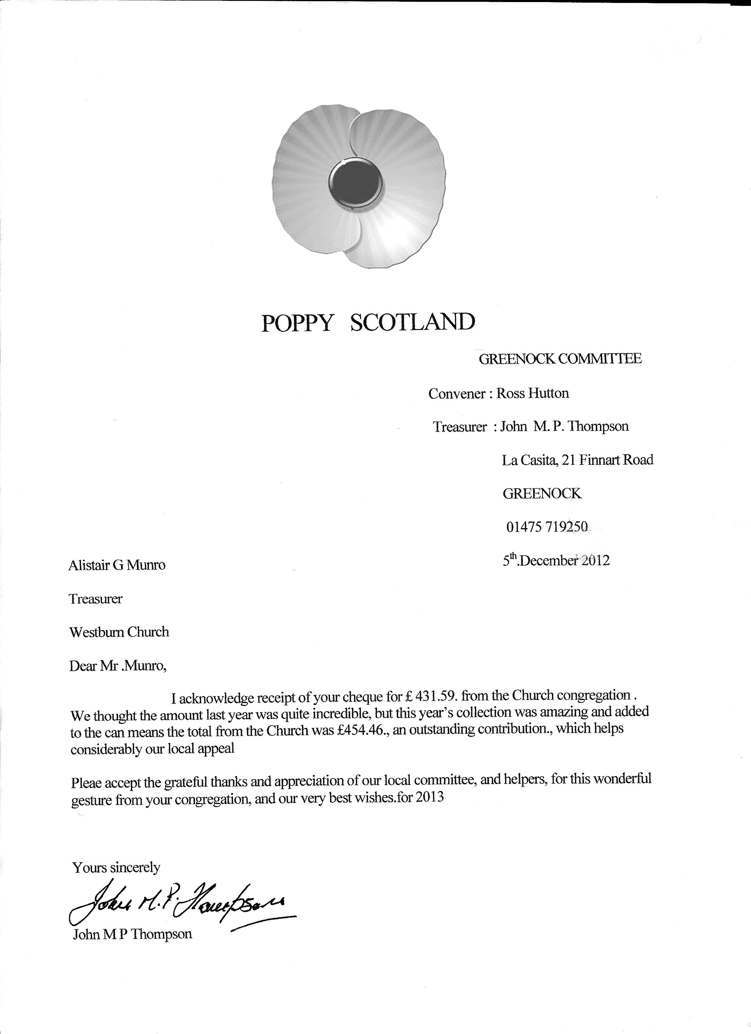
FROM THE ROLL-KEEPER

DEATHS
Mrs. | M. | Wilson | 7 Buccleugh St. | 1 | died Nov.
Mrs. | M. | Maclean | 48 Newark St. | 8 | died Nov.
Mrs. | I. | Anderson | 104 Rankin Ct. | 14 | died Nov.
Mr | I. | Douglas | 2 Maple Rd. | 14 | died Nov. Adherent
Mrs. | S. | Fox | F2 13 Lyle St.. | 17 | died Dec.
Mrs. | S. | McMillan | Balclutha | 22 | died Nov.
Mr. | D. | Craig | 134 Old Inverkip Rd. | Sup. | died Jan.
CHANGES OF ADDRESS
Mrs. | M. | Hair | 2 Drumslea, Newark St. | 8 | stays D8
Mrs. | M. | Nairn | 1/1 64 Belville St. | 19 | from D17
Mr.&Mrs. | J. | Morrison | 20 Albert Rd. from 51 | 11 | stays D11
Mr. | M. | Todd | Glenfield | 22 | from D8
DISJUNCTION
Mrs. | F. | Sweeney | 18 Lurgenbouy Rd., Castlederg, Co. Tyrone, NI
 |  |  | to 2nd Presbyterian Church, Castlederg.
FROM RESPONSES TO STEWARDSHIP CAMPAIGN
TRANSFERRED TO SUPPLEMENTARY ROLL
Mr. | D. | Brown | 30 Caledonia Dr., Kingston Dock | 19
Mrs. | N. | Davidson | 8 Octavia Cotts. | 19
Mr.&Mrs. | J. | Lightbody | 46 Weir St. | 19
Mrs. | J. | Woods | 84 Bawhirley Rd. | 19
Mrs. | L. | Clark | 22 Dempster St | 30

IN ORDER TO KEEP CHURCH RECORDS UP TO DATE, IT WOULD BE GREATLY APPRECIATED IF ANY MEMBER WHO IS MOVING INFORMS THEIR ELDER, THE
SESSION CLERK OR THE ROLL-KEEPER OF THEIR NEW ADDRESS.

