**WESTBURN PARISH  
 MAGAZINE**

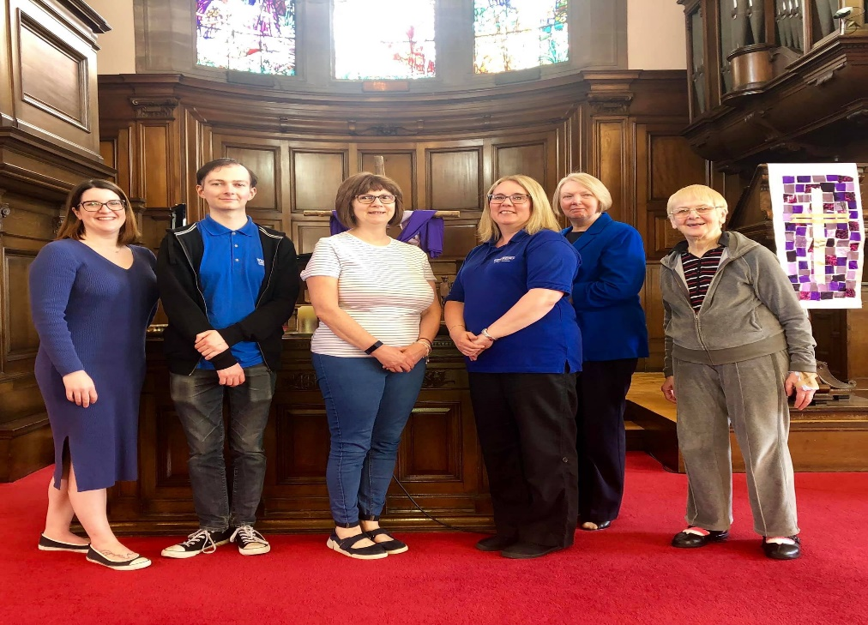

**AUTUMN 2019**



“ **WORSHIP,FRIENDSHIP, ACTION – a kirk that cares. “**

**Welcome to the Autumn Magazine 2019**

With the lovely summer we had let’s hope everyone had an enjoyable and restful time, whether at home or away. If you were away we hope you enjoyed visiting new places, if at home perhaps enjoying BBQ’s , nice walks and enjoying our local scenery.

The Cruise ship visitors enjoyed visiting Westburn again this year, enjoying our history and the sanctuary was well admired. Thanks to all those who volunteered.

Our children (and teachers) are back to school and a new term has already begun. It’s the same for Westburn as our Ministers Convenors and Leaders of committees and organisations have been working

hard to prepare our winter activities. Worship, Social Events, Guild Syllabus, Organisations activities. There is lots going on in Westburn, check it out and

enjoy friendship and fellowship, a warm welcome awaits you.

We are delighted William had now passed his finals and is now at the stage to be called to a church, we wish William good luck wherever he will be called to serve God our good wishes and love go with him and we look forward to following his journey.

Brian Lindsay from the Communications Committee produces the magazine and appreciates your input helping to make the magazine interesting, please keep this up.

**FROM THE MANSE**

Dear Friends

As part of our summer holidays this year, Calum and I went to Belfast for a few days. We managed to squeeze quite a lot into those days, visiting well known tourist attractions like the Titanic Exhibition and the Giant’s Causeway as well as different places in Belfast. One of those places was CS Lewis Square, where there are sculptures of some of the characters from The Narnia Chronicles and the East Side Visitor Centre highlighting the stories of some well known people who come originally from that part of Belfast. You could also walk by the house where CS Lewis

was born in 1898. CS Lewis wrote many books and has been called both an author and theologian. The Narnia Chronicles are probably his most well known works and the films brought the stories to a whole new audience. The sculptures reminded me that those stories, like so many others, certainly hold truths, beauty and deep meaning from which we can learn much. At the same time as this visit, we at Westburn Parish Church, in our Sunday worship were reading some of the stories of Dr Seuss , and reflecting on how those stories helped us to connect with stories from the bible and important Christian themes.

May we always be ready to learn and grow through the stories we read and through the story tellers in our midst.

A few words from CS Lewis to help us on our way

From a conversation between Lucy and Mr and Mrs Beaver about Aslan in The Lion , the Witch and the Wardrobe

“If there’s anyone who can appear before Aslan without their knees knocking, they’re either braver than most or just silly “ said Mrs Beaver. “Then he isn’t safe “ said Lucy. “ Safe” said Mr Beaver “don’t you hear what Mrs Beaver tells you ? Who said

anything about safe.’Course he isn’t safe. But he’s good. He’s the King I tell you “

Aslan to Lucy from The Voyage of the Dawn Treader

“ But I will not tell you how long or short the way will be, only that it lies across a river. But do not fear that for I am the great Bridge Builder “

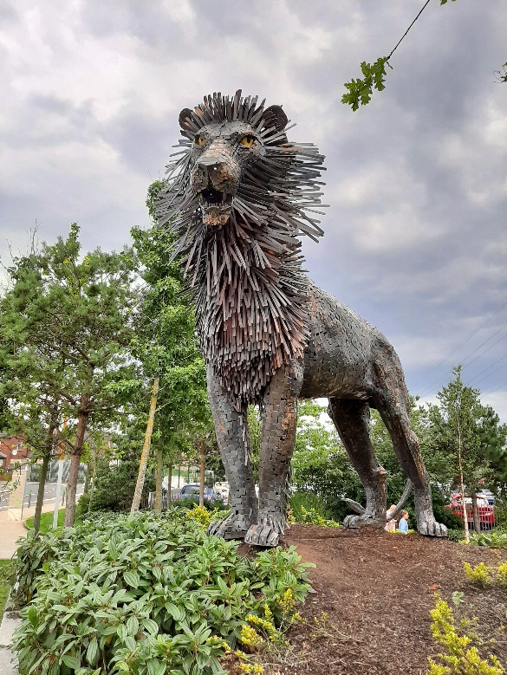

Yours

Karen

**FROM WILLIAM – (Dementia Update)**

Hi everyone, I cannot believe that as I sit and write this article for the magazine it is only a few days until my final review. Where has the time gone? After my review I can then apply for my own congregation in August, preach as sole nominee in September and my final week with you all will be the week beginning 28th October.

As you will be aware something that I have felt passionately about since becoming probationer here is ensuring our church is a dementia friendly church. I mentioned in the last issue some of the ways in which we are making this happen, from new signage, dementia friends training and recruiting dementia champions for example.

I am delighted to update you all and say that our new dementia signage is now up around the church and I

am really pleased with how they look. The cost of this was £432 which is well worth the money to ensure our church is dementia friendly. I am delighted to let you all know that Tesco Petrol Station in Port Glasgow have donated £200 towards this cost which has come from charity work they carry out in the store. This has meant that we have come way under our £500 budget which will now allow our dementia champions to attend a very useful conference in Edinburgh. I want to say a huge thank you to Tesco for this support, we really do appreciate it.

Our dementia champions have also just been through a useful resource put together by Faith in Older people Scotland with its aim of ensuring our church is dementia friendly.

In June we held a sponsored walk in aid of Adams House in Elderslie, a specialist dementia care home run by Church of Scotland Crossreach. Our Sponsored walk was up at the Greenock Cut, thank you to everyone who came along including Albie the dog, we all had a great day and of course thank you to all of you for helping us raise £827. The team at Adams house were absolutely delighted. We were also delighted that Adams House brought some residents down to our Afternoon tea, which was held in June, hopefully this is the start of a new working relationship with them.

As you know throughout my time here at the church, I have volunteered at the Friday Friendship group run by Alzheimer Scotland and their dementia champion Sean. Sadly, we were given the tragic news in May that Sean had passed away. This came as a huge shock to us all. Myself, Doreen, Andrew and Dorothy all attended his memorial Mass in St Joseph’s.

Sean was a kind, caring and compassionate individual who made a real difference not just to people living with dementia but their carers too and not just here in Inverclyde but his time in the USA too. He was of great support to me and it is thanks to him and his advice that we now have suitable signs on order, the right colours in our new hub, a dementia noticeboard, dementia champions and much more. Myself and those he has come in to contact with have been privileged to have known him and will miss him.

As I come to the end of my time here in Westburn I am delighted that our new dementia champions will continue to keep dementia high on the agenda and ensure that Westburn Parish Church continues to be dementia friendly.

Every Blessing

William

Student Minister

**PACK OF CARDS**

With armistice coming up again in November I came across the words that Max Bygraves recorded.

A young soldier sat all alone in the trenches, no guns were firing, no bombs falling and no mines going off. It was a Sunday. As he spread out a pack of cards, an army sergeant appeared and shouted, “Why are you not with the rest of your platoon?” the soldier replied, “I wanted to stay behind to spend some time with the Lord.” Looks like you are playing cards.” “No Sir .

Since I have no Bible, I decided to talk to the Lord using this deck of Cards……………

**See the ACE-** that reminds me of the one God

**The TWO –** is the two parts of the bible – The Old & New Testaments.

**The THREE –** reminds me of the Father, Son and Holy Spirit.

**The FOUR –** stands for the four gospels, Mathew, Mark, Luke and John.

**FIVE**- is for the foolish virgins.

**SIX –** is for the days God created

**SEVEN –** is for the seventh day He rested.

**EIGHT –** is for Noah and his wife, their three sons and three wives, all saved in the Flood.

**NINE-** reminds me of the 9 lepers who never thanked Jesus, unlike the tenth leper who did.

**TEN** – stands for the 10 Commandments.

The **JOCKER**- reminds me of Satan and his tricks.

The **QUEEN** – the mother of CHRIST.

The **KING -**of all kings.

When I count all the dots on the cards I get a total of 365 the number of days in the year. There are 52 weeks in a year and 52 cards in a pack. There are 4 seasons and 4 suites in a pack. Each suite has 13 cards and the seasons have 13 weeks. So this deck of cards reminds me of all the things we have to be thankful for.

The sergeant stood and then said “Soldier, can I borrow that deck of cards.

A deck of cards how powerful is the message in something so simple.

More up to date is a Poem I heard which was penned by Jack Glenny who has given me permission to use.

**Burns day in Afghanistan**

When freedoms sons and daughters fight

Against a vicious evil might

That scorns a’ things we hold as right

Oor troups stand firm.

When roadside bombs and snipers’ guns

Bring death to daughters and to sons,

On ilka face the grief stain runs,

Oor nation squirms.

As we wha live sae trig in peace

Watch whilst war dead rolls increase

We will pray this carnage soon will cease

God end this hell.

There’s horror hear in Kandahar

Kabul hauds death in many a car

Yon Helman’s dust nay hing afar

It’s stench we smell.

This isn’t what God had in mind

When first he fashioned humankind.

How can we mortals be sae blind

As bring sic gloom.

So let us pray for strength and power

Burnsians, urge the hale world o’er

“Show sense dear freens; let reason flower”

Then peace can bloom.

**TIME FOR PRAYER**

In our lives it is good to be able to trust others. Our faith tells us that we can always trust God and be open with him. Let us pray to God in faith and trust.

As you, God, are my way, my truth and my life,

with you I share my worries and anxieties, as I trust that you will help to relieve me of them.

To you I confess my mistakes and misdeeds, and have faith and hope that you don’t condemn me.

To you I reveal my concerns, confusions and bewilderment, confident that you will help me to resolve them.

To you sometimes I convey my doubts, because I believe that you will respond to them and help me to overcome them.

To you, God, I entrust my secrets, because I know that they are safe with you.

You, God are my way, my truth and my life. Amen.

from Douglas Scott



**BIBLE STUDY**

Are there ever times when you cannot figure out what God is up to? Do you sometimes wonder whether our lives really matter? Does our faith help us to understand the world that we live in? Is our world getting better or worse? Is God’s way the best way?

These are examples of the kind of questions that we think about together at Bible Study meetings. There are no simple answers, and each of us has a different perspective based on our own experiences. It can be good to listen to what other people think or to get your own thoughts off your chest. And maybe even modify them in the light of what you hear.

Bible Study meetings are an opportunity for us to share our views or simply to listen to others in a friendly atmosphere of mutual respect, fuelled by snacks provided by our friendly catering team.

These meetings take place at various times during the year. Please look out for bulletins about dates, times and venue, and think about joining us at any or all of our meetings.



from the Discipleship Committee

**WORSHIP COMMITTEE**

We were delighted with the success of the Songs of Praise with the Stedfast Band which was held on 16th June, followed by strawberries and ice cream in the hall. Members of neighbouring churches joined us and there was a great atmosphere. If you missed it, make sure you don’t miss it next year, as we plan to make this a regular event.

We are pleased that both Morag McCracken and Hazel Munro have now completed the Presbytery Leading Worship course and have received their certificates from Presbytery. They are now able to contribute to our Sunday worship regularly and we are enjoying their contributions.

Another Leading Worship course is likely to be held in the spring on 2020. If anyone is interested in attending, now that you know what is involved, please speak to Karen in the first instance.

The pew prayer cards were translated into French and German and have been handed out to our cruise ship passenger visitors along with the church information leaflet this summer. These have been well received and thanks are due to Douglas Scott for his help with the translations and Cath Barbour and Joe Craig for printing them for us.

We are planning a prayer walk service round the church premises on the evening of 25th August on the theme of Walking and Praying Together – which may be past by the time you read this. There are also plans for an afternoon tea in October which would feature worship using hymns which have been suggested on the Playlist for Life, reviving old favourites which we sing less often nowadays. Look out for further information on that and future new opportunities for worship in the order of service.

The variety of styles of music and instruments taking part in worship has been well received. The plan is to continue with a similar mix going forward.

The Committee would welcome any ideas, comments or suggestions about worship.

Worship Committee

**COMMUNITY LINKS UPDATE**

During May’s Christian Aid week Westburn raised £1111 plus an extra £169 by UK Gift Aid. This figure was boosted by holding a ‘Big Breakfast’ before the Sunday service on 12th May. Thanks to everyone who supported this event and our fundraising.





The Greenock Committee of Christian Aid will hold their annual coffee morning between 10am – 12 noon on Saturday, 14th September 2019.

This years event will be held at the Greenock West United Reform Church in George Square. Tickets priced £2.50.

**PASTORAL CARE**

Around 80 people including helpers and the Hospice Singers enjoyed the Afternoon Tea held on Monday 24th June. The members of the congregation enjoyed meeting up with people they hadn’t seen for a while, it was great to hear the buzz of conversation taking place. We were delighted that the Hospice Singers were available to come along to entertain us particularly with songs that we could join in.

A huge thanks to all who in any way helped to make it the afternoon a success.

The committee meet again late August to discuss further events that could take place and to get an update on members in the care homes who they visit.

Patricia Robertson

**SAFEGUARDING REPORT AUGUST 2019**

New dates have been announced for Safeguarding training for volunteers as follows:

Sunday 8th September 2019 in Paisley St Marks Oldhall from 2pm until 4.30 pm

Sunday 6th October 2019 in Johnstone St Pauls from 2pm until 4.30pm.

Anyone wishing to attend, please contact us as soon as possible. Unfortunately none of these venues is in our area, but hopefully there will be some shortly.

All volunteers working with children and in the Pastoral Care Committee are reminded that they MUST undertake training and that it should be repeated at least every five years. Things do change and it is advisable to have the most up to date information.

If you have any new volunteers starting work in this session, they cannot do so until their PVG check has been completed, so if you have anyone new, please get in touch so that their PVG forms can be completed as soon as possible.

The Church of Scotland publishes plenty of Safeguarding guidance on its website and that is where the most up to date information can be found. <https://www.churchofscotland.org.uk/about_us/safeguarding_service>

If you need any advice or help on Safeguarding please contact us:

Jennifer Boag - Tel: 01475 720125 e-mail: jenniferboag@hotmail.com

Sheila Tait - Tel: 0748 418 2757 e-mail: sheilatait172@btinternet.com

Jennifer Boag and Sheila Tait

Safeguarding Co-ordinators

**NEWS FROM PRESBYTERY**

Hazel Munro received a certificate from Presbytery after having completed a course in leading worship.

Presbytery recently welcomed a guest speaker from Inverclyde Child Contact Centre. Presbytery continues to commend this organisation and to urge support from congregations.

Presbytery has written to the Council of Assembly to urge it to consider introducing a more equitable and sustainable system for funding the needs of the church. Presbytery is of the opinion that the current system places unfair burdens on congregations, especially those which are in vacancy, and believes that there will have to be a rationalisation of the central councils of the Church.

Much of Presbytery’s energy remains focussed on devising a feasible and acceptable plan for future ministry. Here are some examples of current thinking.

The Ministries Council of the Church of Scotland has suggested to Presbytery that we should aim for a total of 25-27 ministerial posts by the end of 2023. This would be a reduction of 38% from Presbytery’s current plan.

Presbytery is preparing a number of unions in the Paisley area with the aim of reducing the number of posts in Paisley to 8.

It is proposed that 2 of the congregations in Port Glasgow be united: St Andrew’s and St Martin’s.

Ongoing discussions about the future shape of ministry and organisation include consideration of developing our potential fuzzy parish in West Inverclyde as a sort of hub ministry. It is possible that this will be expanded to include all of Greenock in the hub.

from Douglas Scott

**UPDATE FROM VENDA**

Vhutshilo Mountain School continues to thrive,  after what  Khatu ( who has been appointed as the new director  of the school)  describes  as '  a very difficult and unsettling time', since Susi 's  death last year.She states that they have  ' gathered  their strength ' ,with the help of the community,  who were also heartbroken, as everyone was very attached to Susi. Khatu says that the support she received from her friends here at Westburn meant so much and the school and board members send a huge thank you.

At present there are 61 children (ranging from 18 months to 5 years) at the school and it buzzes with noise, laughter and singing - so life goes on!

In November, a group from Westburn have decided to visit the school in Venda. Along with ourselves, Stuart and Patricia Robertson, Sandra Downie and Susan and Ricky Martin are heading for South Africa.  I'm sure when we come back we'll have lots of stories to share and we'll be sure to take lots of pictures.

Monica and Les

**GUILD REPORT**

As in previous years about a dozen of us have been meeting over the summer knitting and nattering. The new session starts on 1st. October with our 'at home' evening where we catch up with what has been happening over the months since we last met.

We have been putting our programme together for 2019-2020 and hope it will appeal to members old and new. You will be most welcome at all or just a few. If all goes to plan by the time you read this we will have held a soup and sandwich lunch to raise some money for the Guild National Projects. We have decided to hold our Coffee Morning in the second half of our syllabus. The date for this being 22nd.February 2020. Our syllabus still has a couple of blank spaces which will soon be filled. Here is a flavour.

Programme 2019

Oct. 1st At Home

Oct. 8th. Opening Night

Oct. 15th.

Oct. 21st. Autumn Rally

Oct. 29th. Carishea Soap

Nov. 5th.

Nov. 12th. Sparkling Drinks

Nov. 19th. Seema Trust (Project)

Nov. 26th. Disbursement of Funds

Nov. 30th. (Sunday) Baking Stall

Dec. 3rd. Christmas Celebrations

Dec. 10th. Afternoon Tea (In House).

Anna Seggie

**PRAYER SHAWL GROUP**

Our knitting group meets every two weeks on a Tuesday morning from 10-12. We are continuing to support Compassionate Inverclyde and Sailors Society and of course Westburn congregation. Each year we attempt to have a Christmas project this year part of it will include School in Venda. If you know of anyone that could receive a shawl speak to anyone in the group.

Doreen Borland

**CRAFT GROUP**

Are you a crafter? Do you have talents and ideas to share? Do you like meeting other people?

Then the Craft Group could be just the thing for you

The Craft Group meets on the second Thursday of every month at 7p.m. We are a small and friendly group of people who like crafting, chatting and cake. We share our ideas and works in progress with each other. We learn from each other. We make things to sell to raise funds for our congregation or for other charities e.g. Christian Aid. We make banners to decorate our church and add another dimension to our worship.

Our next project is a welcome banner for the Hub area. Please speak to Karen for more information or just come along and join us. We would love to see you.



**NATIONAL COUNCIL REPORT**

I am writing this report as the past National Convener of the Church of Scotland Guild, I find it hard to think my year has past already. Since the last report I’ve attended the General Assembly which was very interesting and at times daunting. I’m referring to the afternoon of Tuesday 21st May when I had to deliver the Guild Report for the session, I was fortunate that I was able to complete the task as it was the last report of the day. At the end of the report I had to answer some questions which according to the General & Associate Secretary I coped with. Also during my time at the |General Assembly Stuart & I were invited to attend various events – lunch at the Palace of Holyrood on the Sunday with the Lord High Commissioner, lunch with the Moderator of the General Assembly on the day I presented the Guild Report (Stuart was invited to sit in the Moderator’s gallery when I presented the report) and we attended the Beating of the Retreat reception on the Thursday night again at Holyrood and I attended the 150th Anniversary of CrossReach reception in Holyrood. It is definitely a week I’ll never forget.

The “Big Sing” which took place on the evening after I had delivered the Guild Report, we had a very good ‘sing’ and the offering was £3,437.05 which was given plus the offerings of the other 2 ‘Big Sings’ of this session to a church in Mzuzu, Malawi on Sunday 4th August to replace their roof, the new National Convener will have visited it by the time you receive this magazine. This was my last official duty as National Convener as at the end of the General Assembly the next convener takes office, although the handing over of the National Convener’s badge didn’t take place until the Guilds Together Conveners’ conference on 5th June.

I had another Guilds Together meeting to attend after I had demitted office as I was given the invite while I was in office, this was in North Berwick and the speakers for the evening were the Very Rev Lorna Hood OBE & Kezia Dugdale MSP speaking about Srebrenica which was very heart breaking to hear about.

I’ve been invited to talk at various Guild meetings next session although it will not be as demanding as last session.

At the beginning of my appointment I said I wanted to visit as many Guilds as possible, I calculated how many miles I had travelled during my term of office, it amounted to 26,236 miles this includes my overseas visits. At home the total was 5,018 which includes meetings, this fits in with the Guild theme One Journey, Many Roads as I’ve definitely been on that journey.

Again I’m grateful to those who had faith in appointing me as National Convener 2018/2019 and those who helped me in various ways at this time. If I have any updates which I think you should know about I’ll include them in future magazines.

**Project Update**

Joining up the Dots £46,526.05

A Chaplain for our Ports £31,508.12

Faith in Young People £55,386.32

Journeying Together £30,083.17

Growing the Future £33,907.71

Seema’s Project £42,252.28

**Total £239,663,65**

Patricia Robertson

**SCOUT REPORT**

All sections start back on the first Thursday after the schools return from holiday. We currently have vacancies for a beaver leader and a cub leader to run both sections.

It has been a very good and busy year so far with all the young people enjoying a wide range of events and activities. 6 of the leaders also were presented with their Gold D. of E. at Holyrood Palace by Prince Edward On Friday 5th July. The scouts have just returned from summer camp at Bonaly Scout Activity Centre and had a great time.

Thursday 6pm to 7pm Beavers

                   7pm to 8pm Cubs

                   8pm to 9.45pm Scouts

