**WESTBURN PARISH  
 MAGAZINE**

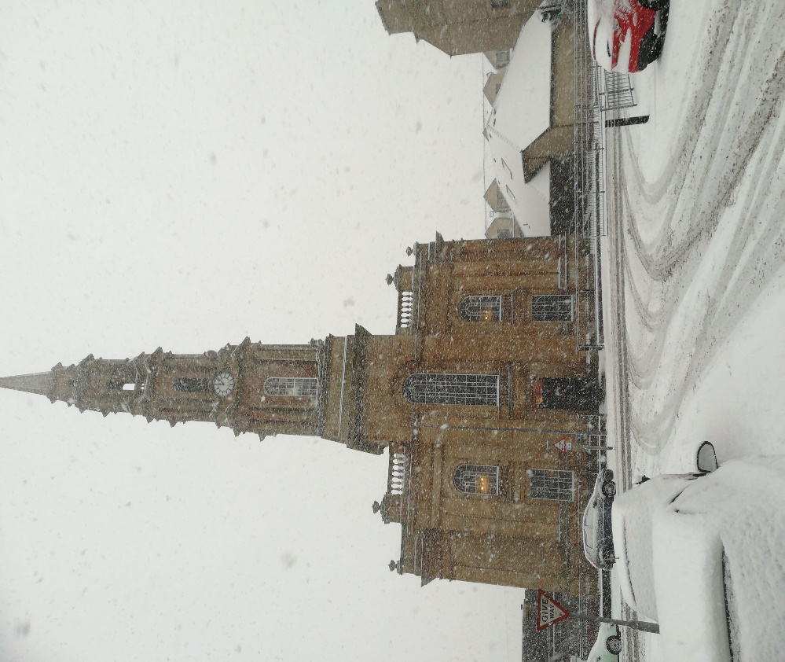

**Spring 2018**



**“WORSHIP, FRIENDSHIP, ACTION – a kirk that cares. “**

Welcome to the Easter Magazine 2018

It’s amazing how quickly the months pass, we are no sooner into a new year and all the organisations are involved in their 2018 programmes and activities. It’s the same with the magazine. To get the magazine out to the congregation before the March Communion, Brian our Editor has to start his preparation early. We hope you enjoy reading the magazine and if you have an interesting or amusing story suitable for the magazine. Brian would love to hear from you.

Already the nights are getting lighter and the bulbs are peeping through helping to remind us that spring is on it’s way. The thought of spring with snowdrops crocus, daffodils and the garden becoming alive is exciting and before we know it we will be on our journey through Holy Week towards Easter . An exciting time in our Christian Calender . It would be good to see you at our Holy Week Services, details are in the Magazine.

Brian Lindsay our magazine Editor can be contacted at [brian_lindsay22@yahoo.couk](mailto:brian_lindsay22@yahoo.couk)

1

Looking forward to Lent, Holy Week and Easter

As material for this magazine is being written and the magazine being brought together and printed, snow and temperatures of -4 degrees are being forecast. The days are still short and the dark nights still long. Even so, I can see the beginnings of what will be daffodils starting to appear near the front fence. When you receive this magazine hopefully more signs of spring will be appearing. As followers of Jesus, as ones who trust the God of new beginnings, we are always looking for signs of life, new life, life in all its fullness and so even now we begin to prepare for Easter.

Lent calls us

to journey along a Way

that stretches into unseen distances,

to hold to a Truth

that is great beyond our fullest understanding,

and embrace a Life

that calls us to maturity.

Lent calls us to follow Jesus

who is the Way, the Truth and the Life.

Our journey through Lent begins on Sunday 18th February. As well as our Sunday worship, we hope there will be other opportunities to come together to pray, reflect, discuss…look out for more information in weekly intimations.

During Holy Week , there will be services on Wednesday, Thursday and Friday evenings , beginning at 7p.m. The Wednesday evening will be a café style service in the main hall, the Thursday evening will include communion as we remember the meal Jesus shared with his friends in the upper room and the Good Friday service will be a quiet reflective service. We gather together on Easter Sunday at 7a.m. on the Lyle Hill, followed by breakfast in the main hall and our 11a.m. service will be a celebration of the good news of the resurrection for all ages.

2

We look forward to sharing these moments and weeks with you as we journey together towards the cross and on to the new dawn.

Karen Harbison

Dear Friends,

I am sure that many of you have in your kitchen drawer or in a notebook or in a polypocket somewhere in your house a collection of wee quotes and sayings and poems that you have found helpful, meaningful, inspirational, comforting, challenging, encouraging and that now and again you have a look through it and add something to it. Some people keep their favourites in their purses or wallets or diaries. I have a couple of notebooks and looking through them recently I found this prayer which I would like to share with you , in the hope that it might be something that finds its way into your treasured words bringing help, meaning, inspiration, comfort, challenge or encouragement.

The Knot Prayer

Dear God

Please untie the knots

that are in my mind, my heart and my life.

Remove the have nots, the can nots and the do nots that I have in my mind.

Erase all the will nots, may nots, might nots that may find a home in my heart.

Release me from the could nots, would nots and should nots that obstruct my life.

And most of all, dear God, I ask that you remove from my mind, my heart and my life all of the ‘am nots’ that I have allowed to hold me back, especially the thought that I am not good enough. Amen

3

God loves us with a love that is broad and long, high and deep, a love that welcomes us in and calls us to see beyond the ’nots’ that we make and to live and work together for God’s kingdom. May that love be at the heart of all we are and do as we serve God and our neighbour in this place.

Yours

Karen

TIME FOR PRAYER

A topic of increasing concern for everyone in all parts of the world is the protection of our environment.

Eternal Loving God,

We pray for your creation, to which we belong, from which we gain life, yet which we destroy. We pray for the earth, whose miraculous fertility and fruitfulness we cover with concrete. We pray for the seas, which provide us with nourishment and opportunities for leisure, yet which we constantly pollute.

We pray for the forests, where we love to wander, but which are dying because of our emissions. We pray for the plants, the flowers and the trees, which brighten our gardens but which we besmirch.

We pray for the animals, domestic and wild, which we unheedingly torment.

God, open our eyes to the beauty of your creation and lead us to live in harmony with nature and our surroundings: for our sakes, for our fellow creatures, the animals and plants and for those to come after us. Amen.

from Douglas Scott



4

What’s been happening at Westburn

Sunday 10th December – Blue Christmas

We held our 4th Blue Sunday Christmas service. This was well attended with around 60 attending. Karen used the Snowflake as the theme this year. There are no two snowflakes the same. When we came to putting the names of those we wished to remember on blue card with a snowflake on the back we were all given a snowflake some of which were made by members of the Craft group for all to take home and to remember those that have gone on before us. After the service we all enjoyed a cup of tea or coffee with a selection of cakes. This was another way in which we as a congregation are reaching out to our parish and local community.

Thursday 21st December – Christmas Concert

The evening started with a café where there was crafts, quiz and Christmas tunes played in the background. We then went into the Church where we were entertained by the Steadfast Band, Brownies ,Drama, Music Group, Choir with guests and three solo singers. This was a very enjoyable night and finished with a further time of fellowship with tea and coffee in the Lounge. There was a collection and this raised £301 for Family Contact Centre. .

Sunday 24th December – Watchnight Service

We started the evening in the Lounge with Christmas pies with tea and coffee. We then went into the church to sing Christmas Carols followed by the service. There was a retiring collection and this raised £189 for Samaratans .

Monday 25th December – Christmas day Service

This was well attended when the children showed of their best presents as did some of the congregation.

5

This is a poem by Brian Bilston which was published in the Huffington Post I discovered it in the “Upper Cowal Courier”, the church magazine for the churches in Strachur, Strathlachlan, Lochgoilhead and Cairndow.

REFUGEES

They have no need of our help

So do not tell me

These haggard faces could belong to you or me

Should life have dealt a different hand

We need to see them for who they really are

Chancers and scroungers

Layabouts and loungers

With bombs up their sleeves

Cut-throats and thieves

They are not

Welcome here

We should make them

Go back to where they came from

They cannot

Share our food

Share our homes

Share our countries

Instead let us

Build a wall to keep them out

It is not okay to say

These are people just like us

A place should only belong to those who are born there

Do not be so stupid to think that

The world can be looked at another way

**(now read from bottom to top)**

6

Life as a Session Clerk

Since Elizabeth and I took over as joint Session Clerks, there are 2 questions that I am asked more than any others.

The first question asks if the job is what we expected it to be. The answer is yes because we did not take on the role without first checking out what was involved. So what is the job?

According to the Church of Scotland website “The Session Clerk has long been seen to occupy a position of special significance. To the minister the Session Clerk is his or her “right hand man” even when the position is held by a woman. To the other office-bearers the Session Clerk is chief among them, even though not necessarily senior in age or length of service. To the congregation the Session Clerk is the person who, more than any other, embodies the congregation, and is the link between it and the minister.”

The main duties involve calling and preparing for Kirk Session meetings and keeping the minutes, dealing with correspondence, being responsible for all records of the congregation and submitting them annually to Presbytery for attestation, organising Communion and generally ensuring that the Kirk Session functions effectively through the district and committee structure that we operate. Westburn Church is in the fortunate position of having various people who do different aspects of the work so that Elizabeth and I are not left to do it all ourselves – Jennifer Boag is the minute taker at Kirk Session meetings and Jim Barbour is the church rollkeeper – although either of us can fill in as required.

Our biggest challenge to being the link between ourselves and the minister is not always knowing what is going on. We are only as good as the information that is given to us and this is where we would ask for your help. If you know of someone who is unwell and needs a visit from the

7

minister or their elder, share this information with us - please don't assume that we know already. We would rather be told several times over than find out later that a member of the congregation has been left unattended when we could have offered support.

The second questions asks us how are we doing as Session Clerks.

The answer to that is for others to judge. We will continue to do the job to the best of our ability and, with your support and the grace of God, I feel sure that we will succeed.

Hazel Munro

Joint Session Clerk

Tel: 01475 723691

**New Keyboard in the Church**

In November we were very pleased to have a new keyboard in the church. The instrument is a Yamaha YDP 163 Digital Piano. The purchase of the instrument was made possible by a generous donation and we are very grateful for that. It is situated on the chancel where it is more or less permanent, although it could be moved occasionally for special events. In comparison with many modern keyboards it is relatively simple with a small but extremely good range of sounds (eg. – piano, electric piano, harpsichord, strings etc. ). This makes it ideal for the purposes of leading some of the music in worship and also for events such as concerts, school services and the like. It also has functions such as the ability to transpose up and down, which is especially useful for singers, and it goes through the sound system in the sanctuary.

People in the church should have already heard it in action in worship and particularly in the Christmas Concert where it played a prominent role.

It will be especially useful to the Music Group when they are doing music for worship. I am particularly happy not to have to transport a keyboard

8

and stand from home any longer! It should also be noted that this in no way diminishes the use of the organ in worship, and the organ continues to be the main instrument on a Sunday morning.

Thanks very much to those who were on the subgroup who helped with exploring all this and with choosing the instrument - Neil McPhee, Hazel Munro and Stuart Robertson. Thanks also to Findlay McAllister and Ricky Martin who advised on connecting it to the sound system.

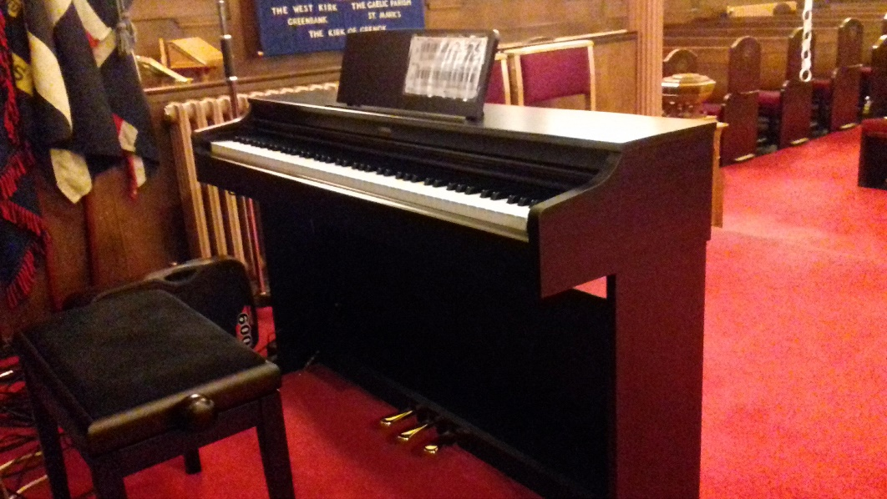

.

Calum Harbison

9

**Westburn Plaques**

Recently many of the memorial plaques at various places in Westburn Church have been photographed and the names they contain listed. This information has been put together in a book which can be viewed at the Church Library. The plaques have been brought from many of the different churches which have come together over the years to make today's Westburn Church.

This particular plaque (number 7 in the book) is from the former St George's Church in Greenock which was situated at the corner of George Square and Kilblain Street. It is a memorial to the 27 men connected with that congregation who gave their lives in World War I.

Here is a list of their names:-

Edward Alexander, James Anderson, Fred Broom, James Caddy, John L Davies, John O Fowler

James Harvey, David Herd, James Kerr, William Knox, Robert D McClumpha, James McCreath

Robert McDonald, Thomas McEwan, David R E MacKail, Daniel MacKinnon, John M K Paterson

Joseph S Paterson, George Reid, William L Reid, Alex N Russell, James G Scott, William A Smith

George Sutherland, James H Weir, William Weir, Edward Whiteford

10

If you would recognise any of the names and wish to share their stories, or would like more information then please get in touch. Don't forget to have a look at the book to see the names on the other plaques around Westburn.

More information about those from the Greenock area who gave their lives in World War I and about the war itself can be found at the McLean Museum's website Inverclyde's Great War (www.inverclydeww1.org).

Liz Smith

([lizsmithunion@gmail.com](mailto:lizsmithunion@gmail.com))

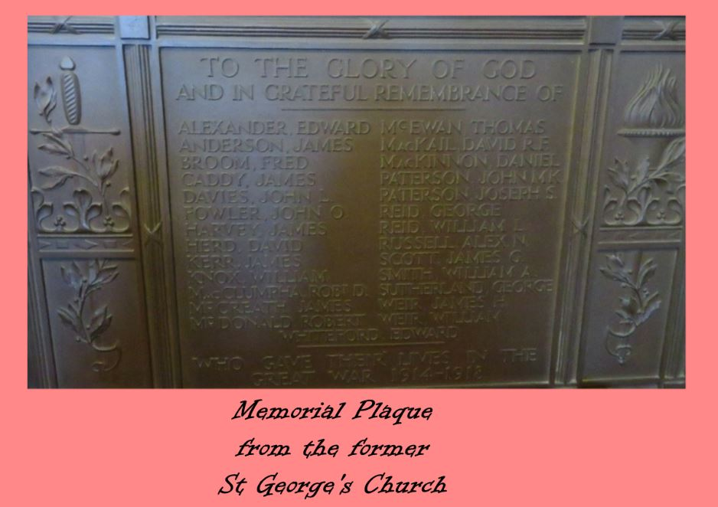

11

Prayer Shawl Group

2017 was a busy year for the Westburn Shawl Group. Over the year we knitted piles of hats , gloves, neck warmers even a few balaclavas. for the Sailors Society. It was also with pleasure we knitted and crocheted shawls and blankets which were donated to Compassionate Inverclyde, and we will continue with this project during 2018. Social work were not forgotten our gifts this year were different. During the year items of a baby bath and stand, bouncy chair ,toy box were donated to us and we filled them with suitable things for either a baby or toddler. All of our projects were well received. Thanks also goes to the members of the church who helped knit for a sailor.

If you know of anyone who would benefit from receiving a shawl or a blanket please talk to any  member of the group.

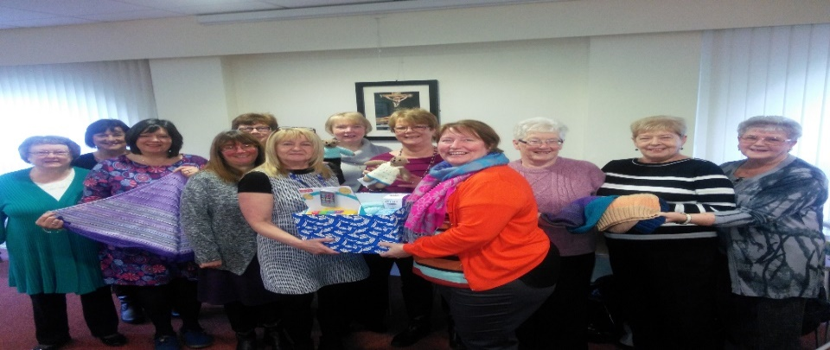

Doreen Borland

12

**Property Committee**

At the start of Autumn 2017 we were notified by Inverclyde Council that the Clocks Faces had been examined and were found to be in a condition that should be addressed in the near future due to the fixtures holding the clock faces in place being corroded.

Inverclyde Council stated that as owners we were responsible and that we should attend to the repairs.

Naturally we asked the Church of Scotland in Edinburgh for advice, unfortunately the advice we received was that that the council was correct and that we are responsible for the clocks.

The work to be carried out included the removal of all 4 clock faces and the void left be made wind and watertight, the clocks and the fixings were to be repaired and made good and then the clock faces reinstated. The cost of this work was estimated at £32,253 + vat, this cost does not include a Road Traffic Management Plan that has also to be put in place as one half of the road requires to be closed to allow the necessary lifting equipment to be used.

We applied for a grant for this work, unfortunately our application was unsuccessful.

In the meantime a decision has been made by the Kirk Session that in the interest of safety we have the clock faces removed and held in storage by the Smith of Derby, who are the clock specialists, until we have the funds available to have the repairs carried out and the clock faces reinstated.

Away from the above, a range of minor works in and around the Church have been ongoing; I would like to thank the church member who volunteered to decorate the Lounge, volunteers contribute to considerable savings in church expenditure. If any member has a hidden talent, and would like to assist in any way, please contact Gilbert at 01475 716310.

Gilbert McCracken

13

**Worship Committee**

**Evening Services**

Over the last couple of years the Worship Committee have helped plan evening worship. There have been different styles and themes to try and offer something for everyone. Themes have included favourite hymns, wedding, Taizé, favourite psalms and most recently Burns.

It would be great to see more people come along to these services.

Our evening services for the next few months will be:

* 25 February Taizé
* 28, 29 & 30 March Holy Week
* 17 June an outdoor praise service with the Stedfast band

We would like to take this opportunity to tell you a wee bit more about the Taizé style service on 25 February.

The Taizé Community is an [ecumenical](https://en.wikipedia.org/wiki/Ecumenical) [Christian](https://en.wikipedia.org/wiki/Christian) [monastic](https://en.wikipedia.org/wiki/Monasticism) community in [Taizé](https://en.wikipedia.org/wiki/Taiz%C3%A9,_Sa%C3%B4ne-et-Loire), [France](https://en.wikipedia.org/wiki/France). It is composed of more than one hundred brothers, from both [Catholic](https://en.wikipedia.org/wiki/Catholicism) and [Protestant](https://en.wikipedia.org/wiki/Protestantism) traditions, who originate from about thirty countries across the world. The Community’s songs are sung in many languages and the music emphasizes simple phrases, usually lines

from [Psalms](https://en.wikipedia.org/wiki/Psalms) or other pieces of [Scripture](https://en.wikipedia.org/wiki/Scripture), repeated and sometimes sung in canon. Many songs from the Taizé Community can be found in the current edition of our hymnary including ‘Stay with me’ and ‘Jesus

14

remember me’. Another very well known Taizé song, which appeared in Songs of God’s People, is ‘Oh Lord hear my prayer’.

The committee are always interested in new ideas and would love to hear from you if you have a suggestion.

We look forward to welcoming you at an evening service soon.

**Fellowship Committee.**

We will be organising another Golden Oldie Film Show and scrumptious Afternoon Tea in the spring. Come along and bring a friend or two. Transport can be arranged if required.

Details in Order of Service soon

**Pastoral Care Committee**

1. The Committee meeting scheduled for Tuesday 16th January 2018 was cancelled due to the weather.
2. **District 22 –** the Committee regularly visitour Members who are in nursing or care homes stretching from Marchmont Care Home in Port Glasgow to Seabank Care Home in Saltcoats along with Bagatelle Nursing Home, Balclutha Nursing Home, Alt-na-Craig, Bellaire Nursing Home, and Glenfield Nursing Home. The visits can be hard, but all are rewarding, although a small bar of chocolate does help on occasions. In addition, Karen, our Minister is also visiting Members in hospital and at home.

15

1. **Christmas Gifts** – the Committee distributed gifts to the Members in Nursing and Care Homes. The Committee has received many thanks from the Members and appreciative relatives.
2. **March Communion Afternoon Service** – Sunday, 4th March 2017 in the Lounge at 3.00pm. If you wish transport to and from Church in the afternoon, can you contact your Elder or any member of the Pastoral Care Committee.

Bill Dempster

**VENDA**

Vhutshilo Mountain School continues to thrive, with record numbers of babies and little ones needing to be fed, clothed, nurtured and educated. The need is always there and the continued support received from Westburn, helps make all these things possible.

At present, the school is in the very capable hands of Khatu, who has worked very closely with Susie over the past ten years or so.

As some of you may know, Susie has been in poor health for a few years and at present, is in Johannesburg, undergoing yet another course of treatment. Please remember her in your prayers.

Monica and Les

# **Guild Report for Magazine**

The first half of our syllabus 2017/2018 has been and gone quite swiftly.

We have had some interesting evenings hearing and seeing , wheelchair mountaineering, British sailors’ society, film making by students one of whom is involved in our Girls Brigade.

16

One of the National Projects is Street Pastors and we heard about the work of the local street Pastors in Inverclyde.

Once again we had a very successful Coffee Morning raising the sum of £764.15

Our 2018 programme began with Major Lynne Farmer of the Regent Street Citadel of the Salvation Army giving us an insight into their work locally.

We have some interesting speakers coming up. Smalls for All, Food in the Bible, Christian Motor bikers, Reach for Autism to name a few

Our meetings are open to all, men and women, please come along if there is something you would like to hear about .

Anna Seggie

**Safeguarding Report January 2018**

The Church of Scotland Safeguarding Committee has begun a Review to be carried out over the coming months and has appointed three consultants to take the task forward: Rt. Rev. John Christie, Chris Robinson and Ranald Mair, all of whom have direct knowledge and experience of Safeguarding within the Church. The Church’s Child Protection and Safeguarding procedures have proven very effective over the past 20 years, but we need to ensure the arrangements we have are sustainable into the future and that our Policy, Procedure and Practice is up to date with all current legislation, and good practice guidelines.

The aim is to consult as widely as possible, through face to face meetings, a survey, and the invitation for people to make written submissions. From this, it is hoped to identify: what is working well and does not require radical change; what requires attention to remain fit

17

for purpose going forwards; and what new Safeguarding challenges may need to be responded to in our policies and training. It is hoped to share initial findings at the General Assembly in May 2018, and indicate areas of work to be carried forward.

If anyone would like to contribute to this review, they can contact the Safeguarding Service directly or speak to either of us about it.

The Church of Scotland Safeguarding Service are in the process of updating their handbooks. The latest versions can always be found on the church website:

<http://www.churchofscotland.org.uk/about_us/safeguarding_service/key-publications>

The annual return to Presbytery will be required in February and we will be compiling the list for this year before then. We need to record when people have attended training and General Assembly has also ruled that people should attend refresher training at least every five years in order to keep up to date with changes in legislation and practice.

We will continue to advertise training sessions for elders who have not yet attended and for volunteers when we are informed of new dates.

Just a reminder that if you are a member of the PVG system and working in our church, you need to inform Disclosure Scotland if you change your address and also the Church of Scotland Safeguarding Service.

If you need any advice or help on Safeguarding please contact us:

Jennifer Boag - Tel: 01475 720125 e-mail: jenniferboag@hotmail.com

Sheila Tait - Tel: 0748 418 2757 e-mail: sheilatait172@btinternet.com

Jennifer Boag and Sheila Tait

Safeguarding Co-ordinators

18

**Outreach Committee**

Local Christians raise more than £5000 for global charity  
  
Greenock Christian Aid Committee held their annual coffee morning in  
Westburn Parish Church in September. The Nelson Street congregation was delighted to welcome people from across the district. Attendees – who enjoyed tea, coffee and home baking - raised a significant sum of  
£655.  
  
A particular success was the craft stall which raised more than £100  
as people purchased homemade greetings cards made by Rev. Karen  
Harbison and members of the local craft group.  
  
All funds raised will go to support the work of the Christian Aid  
internationally. Christian Aid is the official international  
development charity for 41 churches in the UK and Ireland. All funds  
raised will support its ongoing work in the world's poorest  
communities.  
  
The Greenock Committee beings together congregations across the town to co-ordinated fundraising efforts. The committee is looking for more churches and other groups to get involved in the Christian Aid  
fundraising. The committee is led by John  
Clark of Greenock West United Reformed Church.

John.said:  
  
“September’s Coffee Morning was a big success. Our events unite local  
congregations in the shared aim of supporting the world’s poorest  
communities.  
  
“The need for Christian Aid has never been greater with the escalating  
violence in Myanmar forcing 400,000 Rohingya Muslims to flee to

19

Bangladesh - fearing for their lives. Christian Aid works corporately  
with other agencies to provide food, water and shelter where it is  
needed.  
  
“In addition to the September Coffee Morning we also undertake  
fundraising appeals during Christian Aid week every May. This May the  
Greenock committee raised a magnificent sum of £4500 during its  
appeal. Thank you to everyone locally who donated to this cause.”  
  
For more information about Greenock Christian Aid or to get involved  
please contact the Greenock Westburn contact Simon Hutton ([simonhutton2007@googlemail.com](mailto:simonhutton2007@googlemail.com))

**5th. Greenock & District**

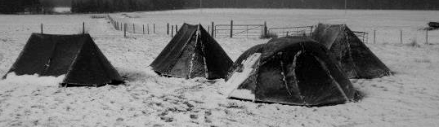

**Annual Report Beavers Cubs Scouts, explorers and network**

There are currently 6 beavers, 2 cubs , 24 scouts, 1 explorer and a leadership team of 15 running all four sections

Beavers;

Beaver numbers remain constant at 6 and now have 2 new leaders running the section. The meet on a Friday 6.30pm – 7.30pm and are working through the Beaver section badge programme.

20

Cubs;

Cubs are now meeting separately from Beavers on a Thursday night 6.30pm – 7.30pm. There are only 2 cubs at present working through the badge programme. This section requires new members urgently. Cubs took part in the Annual District Cub Camp at Everton

Scouts;

Scout numbers have increased from a low of 2 in 2016 to our present number of over 20

Last year the scouts enjoyed many camping experiences including the usual six days walking the West Highland Way in April and anadventurous Summer Camp at Meggernie Scout Activity Centre Perthshire in August. The scouts have already had a couple of camps at Everton this winter and another at Lochearnhead Scout Station. The Squirrel Climbing Club has restarted and each patrol has had an outing to Glasgow Climbing Centre with more planned on a monthly basis. We hope to organize a camp every month for the scouts. This year the summer camp will be at Hesley Wood Scout Activity Centre Sheffield.

Explorers;

We currently only have 1 explorer all the others have moved on to become assistant section leaders or scout active support. As scouts move on the Explorer section will again grow but this is unlikely to happen for a couple of years.

Network and Leadership;

The highlight this year was the successful completion of the Explorer Belt Expedition on the Tour du Mont Blanc by Jamie, Scott, Matthew, Reef, Sam, Ben and Tyler. The team were supported by 4 leaders from our group Stuart, Colin, Donald and Campbell. Six of the group should complete their Queen Scout Award this year.

21

All in all it has been a very successful year for the group but we **need to increase numbers in the cub and beaver sections**

Network and Support team on the Tour du Mont Blanc

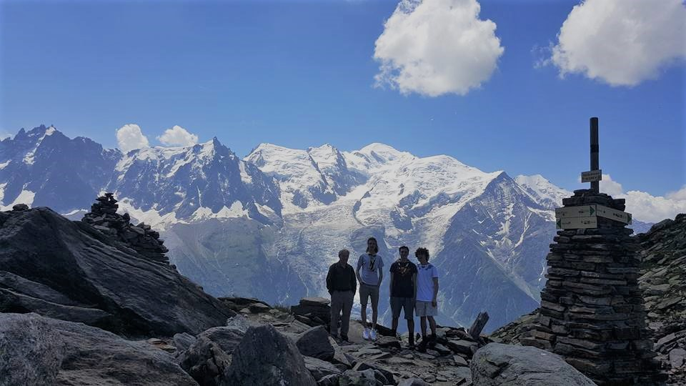 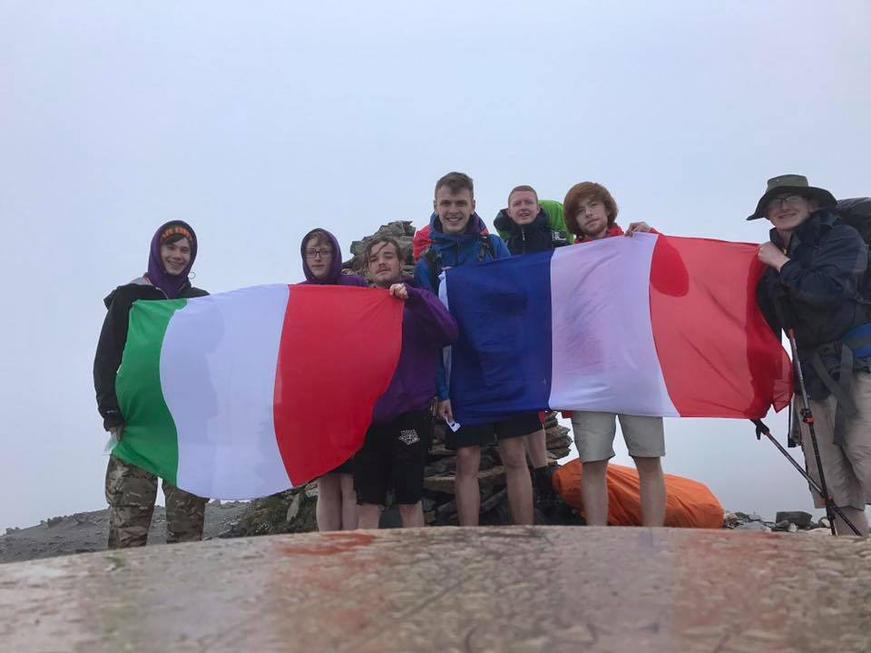

22

**NEWS FROM PRESBYTERY**

In response to the General Assembly’s instruction to promote and prioritise prayer, at November’s meeting presbytery devoted some time to prayer in groups.

At December’s meeting the budget for the coming year was finalised.

In January presbytery does not meet.

from Douglas Scott

[](http://www.google.co.uk/url?sa=i&rct=j&q=&esrc=s&frm=1&source=images&cd=&cad=rja&docid=vnKGV4QdK-iW0M&tbnid=tQRhast9pRi7CM:&ved=0CAUQjRw&url=http://viewfielderskinechurch.org/styled-4/index.html&ei=S1YoUrScIYWi0wXP2YGgCA&bvm=bv.51773540,d.d2k&psig=AFQjCNF7mWpyEfn-04lOFLfK3ZlJvxN4pA&ust=1378461607962818)

**Updates from the National Guild**

Several meetings have taken place since the last magazine but I’ll not mention them all as it could take up all the space in the magazine.

We had a very interesting and thought provoking Annual Gathering with the theme “Go in Love” in Dundee on 2nd September when we were addressed by the Moderator and Dr. Pam Cairns. The Moderator spoke to us with a blend of the serious and humour and gave us a positive message of love to carry forward into our daily lives. He also praised us for highlighting the work we undertake including “trafficking and FGM” as recent examples of waking up the Church and the wider world, to issues that are uncomfortable and difficult.

We went down memory lane when led by Iain Whyte, General Secretary and Karen Gillon, Associate Secretary in hymns we sang in Sunday school or at Summer Missions. A lady in the audience came up on to the

23

platform to help out with the actions.

After lunch we opened with the singing of ‘He came down that we may have love’ led by the Heart and Soul Band who then entertained us once again. Dr. Pam Cairns gave a very moving insight into her life and the work of her charity ‘The Free to Live Trust’.

Among the 2000 people in attendance was our youngest member, Esther Nisbet, as well as our oldest member, Sheila Wyles of 103 years.

The next strategy for the years 2018-2021 is “One Journey, Many Roads”. The first year’s theme will be “Seeking the Way with the next 2 themes for the remaining years are 2019/2020 Companions on the Way and The Extra Mile 2020-2021.

The Leadership team have started planning next year’s Annual Gathering, I chair this meeting as if everything goes to plan I’ll be leading this year’s Annual Gathering. I said this as it is unusual for the National Vice Convener not to become the next National Convener but as I keep saying there is always the first time.

The National Council met for the first time since the summer break in October, the next one is to be held on 15th February. The Outreach Group met in October to choose the six projects for the next strategy, unfortunately I can’t tell what they are. They will be announced at the Project Co-ordinators Conference in April next year. Watch this space! As I said previously there have also been other meetings

.

The Guild was invited to be represented at the following meetings, I was delighted to accept these requests, World Mission ‘Women in Faith, The Mothers’ Union AGM and a meeting between the Guild and Faith in Older People.

I have spoken at Glasgow South East Presbyterial Council and addressed the congregation of St. John’s & Kings Park Church, Dalkeith during the

24

Guild Dedication Service which the Guild led on 19th November.

A highlight since my last report has the be the Roadshows which were held in Tarbert, Loch Fyne, Fort William, Kyle of Lochalsh and Stornoway. The crossings from Uig, Skye to Tarbert, Harris and Stornoway to Ullapool were reasonable calm or perhaps it was due to the travel pills I had taken. The total mileage for the trip was over 600 miles.

The “Big Sing” in Inverness was well supported particularly as the weather that day was not very good. In fact one member of the Leadership team didn’t make it due to the snow. Then there was the “Christmas Big Sing” on Friday 1st December in St. George’s Tron, Glasgow. This event was oversubscribed and at one point it was thought we would have to hold 3 sittings. However it was decided to hold 2 sittings. We are delighted that this event proved to be popular. The offerings at these 2 events raised £4,000 with donations from a Lowland Guild who held a “Christmas Big Sing” locally and from our own Guild allowing another bore hole to be provided at the teacher training college accommodation where the Guild helped furnish 10 of the 20 bedrooms as the one already there only allowed 10 bedrooms to be available.

Patricia Robertson

25

**!!!!!!!!!!!!!!!!!!!!STOP PRESS!!!!!!!!!!!!!!!!**

**Souper Sunday 14th January 2018**

The Messy Church team decided to have a Souper Sunday to raise funds for Marys Meals. It cost Mary Meals £13.40 to feed a child a hot meal every day for a year. We raised £400 on the Sunday which is enough to feed 29 children for a year.

A good effort by everybody.

26

**Useful Numbers**

|  |  |  |
| --- | --- | --- |
| **Office Bearers** |  |  |
| **Minister** | **Rev Karen Harbison MA.BD.** | **721048** |
| **Joint Session Clerks** | **Miss Elizabeth Irvine** | **790369** |
|  | **Miss Hazel Munro** | **723691** |
| **Treasurer** | **Mr Alastair Munro** | **801057** |
| **Organist** | **Mr Neil McPhee** | **07903 106628** |
| **Roll Keeper** | **Mr Jim Barbour** | **723861** |
| **Church Officers** | **Mr Danny Cairns** | **07505 826037** |
|  | **Mrs Gillian McAlister** | **07968 042438** |
|  | **Mr Duncan Harbison** | **721048** |
| **Presbytery Representative** | **Mr Douglas Scott** | **795279** |
| **Church Telephone** |  | **720257** |